UNITED STATES
SECURITIES AND EXCHANGE COMMISSION
WASHINGTON, D.C. 20549
FORM 10-Q
☒ |  |  | QUARTERLY REPORT PURSUANT TO SECTION 13 OR 15(d) OF THE SECURITIES EXCHANGE ACT OF 1934
For the quarterly period ended March 31, 2026
OR
☐ |  |  | TRANSITION REPORT PURSUANT TO SECTION 13 OR 15(d) OF THE SECURITIES EXCHANGE ACT OF 1934
For the transition period from to
Commission file number 001-33998
Churchill Downs Incorporated
(Exact name of registrant as specified in its charter)
Kentucky |  |  |  |  |  |  |  |  |  |  |  | 61-0156015
(State or other jurisdiction of incorporation or organization) |  |  |  |  |  |  |  |  |  |  |  | (I.R.S. Employer Identification No.)
600 North Hurstbourne Parkway, Suite 400
Louisville, |  |  | Kentucky |  |  |  |  |  |  |  |  | 40222
(Address of Principal Executive Offices) |  |  |  |  |  |  |  |  |  |  |  | (Zip Code)
(502) 636-4400
Registrant's telephone number, including area code
Securities registered pursuant to Section 12(b) of the Act:
Title of each class |  |  | Trading Symbol(s) |  |  | Name of each exchange on which registered
Common Stock, No Par Value |  |  | CHDN |  |  | The Nasdaq Global Select Market LLC
Indicate by check mark whether the registrant (1) has filed all reports required to be filed by Section 13 or 15(d) of the Securities Exchange Act of 1934 during the preceding 12 months (or for such shorter period that the registrant was required to file such reports), and (2) has been subject to such filing requirements for the past 90 days. Yes ☒ No ☐
Indicate by check mark whether the registrant has submitted electronically every Interactive Data File required to be submitted pursuant to Rule 405 of Regulation S-T (§232.405 of this chapter) during the preceding 12 months (or for such shorter period that the registrant was required to submit such files). Yes ☒ No ☐
Indicate by check mark whether the registrant is a large accelerated filer, an accelerated filer, a non-accelerated filer, a smaller reporting company, or an emerging growth company. See definitions of "large accelerated filer," "accelerated filer," "smaller reporting company," and "emerging growth company" in Rule 12b-2 of the Exchange Act.
Large accelerated filer |  |  | ☒ |  |  |  |  |  | Accelerated filer |  |  | ☐
Non-accelerated filer |  |  | ☐ |  |  |  |  |  | Smaller reporting company |  |  | ☐
 |  |  |  |  |  |  |  |  | Emerging growth company |  |  | ☐
If an emerging growth company, indicate by check mark if the registrant has elected not to use the extended transition period for complying with any new or revised financial accounting standards provided pursuant to Section 13(a) of the Exchange Act. ☐
Indicate by check mark whether the registrant is a shell company (as defined in Rule 12b-2 of the Exchange Act). Yes ☐ No ☒
The number of shares outstanding of registrant’s common stock at April 15, 2026 was 69,696,908 shares.

CHURCHILL DOWNS INCORPORATED
INDEX TO QUARTERLY REPORT ON FORM 10-Q
For the Quarter Ended March 31, 2026

 |  |  | Part I-FINANCIAL INFORMATION
Item 1. |  |  | Financial Statements (Unaudited)
 |  |  | Condensed Consolidated Statements of Comprehensive Income for the three months ended March 31, 2026 and 2025 |  |  | 3
 |  |  | Condensed Consolidated Balance Sheets at March 31, 2026 and December 31, 2025 |  |  | 4
 |  |  | Condensed Consolidated Statements of Shareholders' Equity for the three months ended March 31, 2026 and 2025 |  |  | 5
 |  |  | Condensed Consolidated Statements of Cash Flows for the three months ended March 31, 2026 and 2025 |  |  | 6
 |  |  | Notes to Condensed Consolidated Financial Statements |  |  | 8
Item 2. |  |  | Management's Discussion and Analysis of Financial Condition and Results of Operations |  |  | 25
Item 3. |  |  | Quantitative and Qualitative Disclosures About Market Risk |  |  | 34
Item 4. |  |  | Controls and Procedures |  |  | 34
 |  |  | Part II-OTHER INFORMATION
Item 1. |  |  | Legal Proceedings |  |  | 35
Item 1A. |  |  | Risk Factors |  |  | 35
Item 2. |  |  | Unregistered Sales of Equity Securities and Use of Proceeds |  |  | 35
Item 3. |  |  | Defaults Upon Senior Securities |  |  | 35
Item 4. |  |  | Mine Safety Disclosures |  |  | 35
Item 5. |  |  | Other Information |  |  | 35
Item 6. |  |  | Exhibits |  |  | 36
 |  |  | Signatures |  |  | 37

FORM 10-Q FOR THE QUARTERLY PERIOD ENDED MARCH 31, 2026
2

PART I. FINANCIAL INFORMATION

ITEM 1. FINANCIAL STATEMENTS

CHURCHILL DOWNS INCORPORATED
CONDENSED CONSOLIDATED STATEMENTS OF COMPREHENSIVE INCOME
(Unaudited)
 |  |  | Three Months Ended March 31,
(in millions, except per common share data) |  |  | 2026 |  |  |  |  |  | 2025
Net revenue:
Live and Historical Racing |  |  | $ | 297 |  |  |  |  | $ | 273
Wagering Services and Solutions |  |  | 109 |  |  |  |  |  | 107
Gaming |  |  | 257 |  |  |  |  |  | 263
All Other |  |  | — |  |  |  |  |  | —
Total net revenue |  |  | 663 |  |  |  |  |  | 643
Operating expense:
Live and Historical Racing |  |  | 199 |  |  |  |  |  | 190
Wagering Services and Solutions |  |  | 68 |  |  |  |  |  | 67
Gaming |  |  | 188 |  |  |  |  |  | 192
All Other |  |  | 5 |  |  |  |  |  | 4
Selling, general and administrative expense |  |  | 59 |  |  |  |  |  | 55
Transaction expense, net |  |  | 1 |  |  |  |  |  | —
Total operating expense |  |  | 520 |  |  |  |  |  | 508
Operating income |  |  | 143 |  |  |  |  |  | 135
Other (expense) income:
Interest expense, net |  |  | (72) |  |  |  |  |  | (72)
Equity in income of unconsolidated affiliates |  |  | 36 |  |  |  |  |  | 33
Miscellaneous, net |  |  | 6 |  |  |  |  |  | —
Total other (expense) income |  |  | (30) |  |  |  |  |  | (39)
Income from operations before provision for income taxes |  |  | 113 |  |  |  |  |  | 96
Income tax provision |  |  | (30) |  |  |  |  |  | (19)
Net income |  |  | 83 |  |  |  |  |  | 77
Net income attributable to noncontrolling interest |  |  | — |  |  |  |  |  | —
Net income and comprehensive income attributable to  Churchill Downs Incorporated |  |  | $ | 83 |  |  |  |  | $ | 77
Net income attributable to Churchill Downs Incorporated per common share data:
Basic net income |  |  | $ | 1.16 |  |  |  |  | $ | 1.02
Diluted net income |  |  | $ | 1.16 |  |  |  |  | $ | 1.02
Weighted average shares outstanding:
Basic |  |  | 70 |  |  |  |  |  | 74
Diluted |  |  | 70 |  |  |  |  |  | 74
The accompanying notes are an integral part of the condensed consolidated financial statements.

FORM 10-Q FOR THE QUARTERLY PERIOD ENDED MARCH 31, 2026
3

CHURCHILL DOWNS INCORPORATED
CONDENSED CONSOLIDATED BALANCE SHEETS
(Unaudited)
(in millions) |  |  | March 31, 2026 |  |  |  |  |  | December 31, 2025
ASSETS
Current assets:
Cash and cash equivalents |  |  | $ | 200 |  |  |  |  | $ | 201
Restricted cash |  |  | 91 |  |  |  |  |  | 88
Accounts receivable, net |  |  | 99 |  |  |  |  |  | 93
Income taxes receivable |  |  | 6 |  |  |  |  |  | 17
Other current assets |  |  | 56 |  |  |  |  |  | 44
Total current assets |  |  | 452 |  |  |  |  |  | 443
Property and equipment, net |  |  | 2,910 |  |  |  |  |  | 2,919
Investment in and advances to unconsolidated affiliates |  |  | 685 |  |  |  |  |  | 685
Goodwill |  |  | 900 |  |  |  |  |  | 900
Other intangible assets, net |  |  | 2,516 |  |  |  |  |  | 2,515
Other assets |  |  | 22 |  |  |  |  |  | 23
Total assets |  |  | $ | 7,485 |  |  |  |  | $ | 7,485
LIABILITIES AND SHAREHOLDERS' EQUITY
Current liabilities:
Accounts payable |  |  | $ | 218 |  |  |  |  | $ | 184
Accrued expenses and other current liabilities |  |  | 397 |  |  |  |  |  | 400
Current deferred revenue |  |  | 158 |  |  |  |  |  | 55
Current maturities of long-term debt |  |  | 63 |  |  |  |  |  | 63
Dividends payable |  |  | — |  |  |  |  |  | 31
Total current liabilities |  |  | 836 |  |  |  |  |  | 733
Long-term debt, net of current maturities and loan origination fees |  |  | 1,783 |  |  |  |  |  | 1,986
Notes payable, net of debt issuance costs |  |  | 3,082 |  |  |  |  |  | 3,081
Non-current deferred revenue |  |  | 15 |  |  |  |  |  | 15
Deferred income taxes |  |  | 539 |  |  |  |  |  | 520
Other liabilities |  |  | 86 |  |  |  |  |  | 94
Total liabilities |  |  | 6,341 |  |  |  |  |  | 6,429
Commitments and contingencies
Redeemable noncontrolling interest |  |  | 48 |  |  |  |  |  | 46
Shareholders' equity:
Preferred stock |  |  | — |  |  |  |  |  | —
Common stock |  |  | 3 |  |  |  |  |  | —
Retained earnings |  |  | 1,094 |  |  |  |  |  | 1,011
Accumulated other comprehensive loss |  |  | (1) |  |  |  |  |  | (1)
Total Churchill Downs Incorporated shareholders' equity |  |  | 1,096 |  |  |  |  |  | 1,010
Total liabilities and shareholders' equity |  |  | $ | 7,485 |  |  |  |  | $ | 7,485

The accompanying notes are an integral part of the condensed consolidated financial statements.

FORM 10-Q FOR THE QUARTERLY PERIOD ENDED MARCH 31, 2026
4

CHURCHILL DOWNS INCORPORATED
CONDENSED CONSOLIDATED STATEMENTS OF SHAREHOLDERS' EQUITY
(Unaudited)
 |  |  | Common Stock |  |  |  |  |  |  |  |  |  |  |  | Retained  Earnings |  |  |  |  |  | Accumulated Other Comprehensive Loss |  |  |  |  |  |  |  |  |  |  |  |  |  |  |  | Total Shareholders' Equity
(in millions) |  |  | Shares |  |  |  |  |  | Amount
Balance, December 31, 2025 |  |  | 70 |  |  |  |  |  | $ | — |  |  |  |  | $ | 1,011 |  |  |  |  | $ | (1) |  |  |  |  |  |  |  |  |  |  |  |  |  |  | $ | 1,010
Net income attributable to Churchill Downs Incorporated |  |  |  |  |  |  |  |  |  |  |  |  |  |  | 83 |  |  |  |  |  |  |  |  |  |  |  |  |  |  |  |  |  |  |  |  |  | 83
Taxes paid related to net share settlement of stock awards |  |  |  |  |  |  |  |  | (3) |  |  |  |  |  |  |  |  |  |  |  |  |  |  |  |  |  |  |  |  |  |  |  |  |  |  |  | (3)
Stock-based compensation |  |  |  |  |  |  |  |  | 4 |  |  |  |  |  |  |  |  |  |  |  |  |  |  |  |  |  |  |  |  |  |  |  |  |  |  |  | 4
Other |  |  |  |  |  |  |  |  | 2 |  |  |  |  |  |  |  |  |  |  |  |  |  |  |  |  |  |  |  |  |  |  |  |  |  |  |  | 2
Balance, March 31, 2026 |  |  | 70 |  |  |  |  |  | $ | 3 |  |  |  |  | $ | 1,094 |  |  |  |  | $ | (1) |  |  |  |  |  |  |  |  |  |  |  |  |  |  | $ | 1,096
 |  |  | Common Stock |  |  |  |  |  |  |  |  |  |  |  | Retained  Earnings |  |  |  |  |  | Accumulated Other Comprehensive Loss |  |  |  |  |  |  |  |  |  | Total Shareholders' Equity
(in millions) |  |  | Shares |  |  |  |  |  | Amount
Balance, December 31, 2024 |  |  | 74 |  |  |  |  |  | $ | — |  |  |  |  | $ | 1,085 |  |  |  |  | $ | (1) |  |  |  |  |  |  |  |  | $ | 1,084
Net income attributable to Churchill Downs Incorporated |  |  |  |  |  |  |  |  |  |  |  |  |  |  | 77 |  |  |  |  |  |  |  |  |  |  |  |  |  |  |  | 77
Repurchase of common stock |  |  | (1) |  |  |  |  |  | (1) |  |  |  |  |  | (89) |  |  |  |  |  |  |  |  |  |  |  |  |  |  |  | (90)
Taxes paid related to net share settlement of stock awards |  |  |  |  |  |  |  |  | (4) |  |  |  |  |  |  |  |  |  |  |  |  |  |  |  |  |  |  |  |  |  | (4)
Stock-based compensation |  |  |  |  |  |  |  |  | 5 |  |  |  |  |  |  |  |  |  |  |  |  |  |  |  |  |  |  |  |  |  | 5
Balance, March 31, 2025 |  |  | 73 |  |  |  |  |  | $ | — |  |  |  |  | $ | 1,073 |  |  |  |  | $ | (1) |  |  |  |  |  |  |  |  | $ | 1,072
The accompanying notes are an integral part of the condensed consolidated financial statements.

FORM 10-Q FOR THE QUARTERLY PERIOD ENDED MARCH 31, 2026
5

CHURCHILL DOWNS INCORPORATED
CONDENSED CONSOLIDATED STATEMENTS OF CASH FLOWS
(Unaudited)
 |  |  | Three Months Ended March 31,
(in millions) |  |  | 2026 |  |  |  |  |  | 2025
Cash flows from operating activities:
Net income |  |  | $ | 83 |  |  |  |  | $ | 77
Adjustments to reconcile net income to net cash provided by operating activities:
Depreciation and amortization |  |  | 56 |  |  |  |  |  | 59
Distributions from unconsolidated affiliates |  |  | 36 |  |  |  |  |  | 31
Equity in income of unconsolidated affiliates |  |  | (36) |  |  |  |  |  | (33)
Stock-based compensation |  |  | 5 |  |  |  |  |  | 4
Deferred income taxes |  |  | 19 |  |  |  |  |  | —
Amortization of operating lease assets |  |  | 2 |  |  |  |  |  | 2
Other |  |  | 2 |  |  |  |  |  | 2
Changes in operating assets and liabilities:
Income taxes |  |  | 11 |  |  |  |  |  | 19
Deferred revenue |  |  | 103 |  |  |  |  |  | 94
Other assets and liabilities |  |  | 14 |  |  |  |  |  | (8)
Net cash provided by operating activities |  |  | 295 |  |  |  |  |  | 247
Cash flows from investing activities:
Capital maintenance expenditures |  |  | (19) |  |  |  |  |  | (13)
Capital project expenditures |  |  | (40) |  |  |  |  |  | (67)
Other |  |  | (2) |  |  |  |  |  | —
Net cash used in investing activities |  |  | (61) |  |  |  |  |  | (80)
Cash flows from financing activities:
Proceeds from borrowings under long-term debt obligations |  |  | 245 |  |  |  |  |  | 220
Repayments of borrowings under long-term debt obligations |  |  | (449) |  |  |  |  |  | (251)
Payment of dividends |  |  | (31) |  |  |  |  |  | (31)
Repurchase of common stock |  |  | — |  |  |  |  |  | (87)
Taxes paid related to net share settlement of stock awards |  |  | (3) |  |  |  |  |  | (4)
Change in bank overdraft |  |  | 6 |  |  |  |  |  | 5
Net cash used in financing activities |  |  | (232) |  |  |  |  |  | (148)
Net increase in cash, cash equivalents and restricted cash |  |  | 2 |  |  |  |  |  | 19
Cash, cash equivalents and restricted cash, beginning of period |  |  | 289 |  |  |  |  |  | 252
Cash, cash equivalents and restricted cash, end of period |  |  | $ | 291 |  |  |  |  | $ | 271
The accompanying notes are an integral part of the condensed consolidated financial statements.

FORM 10-Q FOR THE QUARTERLY PERIOD ENDED MARCH 31, 2026
6

CHURCHILL DOWNS INCORPORATED
CONDENSED CONSOLIDATED STATEMENTS OF CASH FLOWS (Continued)
(Unaudited)
 |  |  | Three Months Ended March 31,
(in millions) |  |  | 2026 |  |  |  |  |  | 2025
Supplemental disclosures of cash flow information:
Cash paid for interest |  |  | $ | 43 |  |  |  |  | $ | 45
Cash paid for income taxes |  |  | — |  |  |  |  |  | 1
Cash received from income tax refunds |  |  | — |  |  |  |  |  | 1
Schedule of non-cash operating, investing and financing activities:
Property and equipment additions included in accounts payable and accrued expenses |  |  | $ | 17 |  |  |  |  | $ | 48
Right-of-use assets obtained in exchange for lease obligations in operating leases |  |  | — |  |  |  |  |  | 6
Repurchase of common stock included in accrued expense and other current liabilities |  |  | — |  |  |  |  |  | 6
The accompanying notes are an integral part of the condensed consolidated financial statements.

FORM 10-Q FOR THE QUARTERLY PERIOD ENDED MARCH 31, 2026
7

Churchill Downs Incorporated
Notes to Condensed Consolidated Financial Statements
(Unaudited)

1. DESCRIPTION OF BUSINESS
Basis of Presentation
Churchill Downs Incorporated (the "Company" or "CDI") financial statements are presented in conformity with the requirements of this Quarterly Report on Form 10-Q and consequently do not include all of the disclosures normally required by U.S. generally accepted accounting principles ("GAAP") or those normally made in our Annual Report on Form 10-K. The December 31, 2025 Condensed Consolidated Balance Sheet data was derived from audited financial statements but does not include all disclosures required by GAAP.
The following information is unaudited. All per share amounts assume dilution unless otherwise noted. This report should be read in conjunction with our Annual Report on Form 10-K for the year ended December 31, 2025.
In the opinion of management, all adjustments necessary for a fair statement of this information have been made, and all such adjustments are of a normal, recurring nature.
In August 2025, the Company completed the acquisition of 90% of the outstanding equity interests of PPE Casino Resorts NH Holdings, LLC in Salem, New Hampshire ("Casino Salem"). The Company has assumed responsibility for the development of a charitable gaming, entertainment and dining destination at this location. Refer to Note 3, Acquisitions, and Note 11, Redeemable Noncontrolling Interest, for further information on the transaction.
We conduct our business through three reportable segments: Live and Historical Racing, Wagering Services and Solutions, and Gaming. The Wagering Services and Solutions segment was previously known as the TwinSpires segment. We aggregate our other businesses as well as certain corporate operations in All Other. We report net revenue and operating expense associated with these reportable segments in the accompanying Condensed Consolidated Statements of Comprehensive Income.

2. RECENT ACCOUNTING PRONOUNCEMENTS
Recent Accounting Pronouncements - Effective in 2026 or thereafter
In October 2023, the Financial Accounting Standards Board ("FASB") issued Accounting Standards Update ("ASU") 2023-06, Disclosure Improvements: Codification Amendments in Response to the Securities and Exchange Commission’s ("SEC") Disclosure Update and Simplification Initiative, to amend certain disclosure and presentation requirements for a variety of topics within FASB's Accounting Standards Codification ("ASC"). These amendments align the requirements in the ASC regarding the removal of certain disclosure requirements set out in Regulation S-X and Regulation S-K, announced by the SEC. The effective date for each amended topic in the ASC is either the date on which the SEC’s removal of the related disclosure requirement from Regulation S-X or Regulation S-K becomes effective, or on June 30, 2027, if the SEC has not removed the requirements by that date. Early adoption is prohibited. The Company is currently evaluating the impact of this standard on the consolidated financial statements and related disclosures.
In November 2024, FASB issued ASU 2024-03, Income Statement—Reporting Comprehensive Income—Expense Disaggregation Disclosures (Subtopic 220-40): Disaggregation of Income Statement Expenses. Under ASU 2024-03, a public entity would be required to disclose information about purchases of inventory, employee compensation, depreciation, intangible asset amortization, and depletion for each income statement line item that contains those expenses. This standard is effective for annual reporting periods beginning after December 15, 2026 and interim reporting periods beginning after December 15, 2027. Early adoption is permitted. The Company is currently assessing the impact of this standard on the consolidated financial statements and related disclosures.
In July 2025, the FASB issued ASU 2025-05, Financial Instruments - Credit Losses: Measurement of Credit Losses for Accounts Receivable and Contract Assets (Topic 326). The update permits entities to elect a practical expedient for estimating expected credit losses on current trade receivables and current contract assets by assuming that conditions existing at the balance sheet date will remain unchanged over the life of those assets. The updated standard is effective for fiscal years beginning after December 15, 2025, and interim periods beginning after December 15, 2026, with early adoption permitted. The Company is currently assessing the impact of this standard on the consolidated financial statements and related disclosures.
In September 2025, the FASB issued ASU 2025-06, Intangibles—Goodwill and Other—Internal-Use Software (Subtopic 350-40): Targeted Improvements to the Accounting for Internal-Use Software, which modernizes the accounting for internal-use software. The update removes all references to software development stages and requires capitalization of software costs when management has committed to the software project and it is probable the software will be completed and perform its intended use. This standard is effective for annual reporting periods beginning after December 15, 2027, and interim reporting
FORM 10-Q FOR THE QUARTERLY PERIOD ENDED MARCH 31, 2026
8

Churchill Downs Incorporated
Notes to Condensed Consolidated Financial Statements
(Unaudited)
periods within those annual reporting periods. The Company is currently assessing the impact of this standard on the consolidated financial statements and related disclosures.
In December 2025, the FASB issued ASU 2025-11, Interim Reporting (Topic 270): Narrow-Scope Improvements, which clarifies certain interim reporting guidance. The update is effective for fiscal years beginning after December 15, 2027, and interim periods within those fiscal years. The Company is currently assessing the impact of this standard on the consolidated financial statements and related disclosures.

3. ACQUISITIONS
Casino Salem
On August 27, 2025, the Company completed its acquisition of 90% of the outstanding equity interests of Casino Salem (the "Salem Transaction") for a base purchase price of $180 million, and the transaction was treated as an asset acquisition because substantially all the value of the gross assets acquired was concentrated in the gaming rights. In conjunction with the acquisition, the Company recorded a $197 million indefinite-lived gaming rights intangible, which represented the fair value of the gaming rights at the date of acquisition.
The fair value of the gaming rights acquired in the transaction was determined using the Greenfield Method, which is an income approach methodology that calculates the present value of the gaming rights intangible asset based on a projected cash flow stream. This method assumes that the gaming rights intangible asset provides the opportunity to develop a gaming facility in a specified region, and that the present value of the projected cash flows is a result of the realization of advantages contained in these rights. Under this methodology, the acquirer is expected to absorb all start-up costs, as well as incur all expenses pertaining to the acquisition and/or the creation of all tangible and intangible assets. The estimated future revenue, future operating expenses, start-up costs, and discount rate were the primary inputs in the valuation. The gaming rights intangible asset was assigned an indefinite useful life based on the Company's expected use of the asset and determination that no legal, regulatory, contractual, competitive, economic, or other factors limit the useful life of the gaming rights.

4. GOODWILL AND OTHER INTANGIBLE ASSETS
Goodwill was $900 million as of March 31, 2026 and December 31, 2025.
Other intangible assets are comprised of the following:
 |  |  | March 31, 2026 |  |  |  |  |  |  |  |  |  |  |  |  |  |  |  |  |  | December 31, 2025
(in millions) |  |  | Gross Carrying Amount |  |  |  |  |  | Accumulated Amortization |  |  |  |  |  | Net Carrying Amount |  |  |  |  |  | Gross Carrying Amount |  |  |  |  |  | Accumulated Amortization |  |  |  |  |  | Net Carrying Amount
Definite-lived intangible assets |  |  | $ | 98 |  |  |  |  | $ | (44) |  |  |  |  | $ | 54 |  |  |  |  | $ | 96 |  |  |  |  | $ | (42) |  |  |  |  | $ | 54
Indefinite-lived intangible assets |  |  |  |  |  |  |  |  |  |  |  |  |  |  | 2,462 |  |  |  |  |  |  |  |  |  |  |  |  |  |  |  |  |  | 2,461
Total |  |  |  |  |  |  |  |  |  |  |  |  |  |  | $ | 2,516 |  |  |  |  |  |  |  |  |  |  |  |  |  |  |  |  | $ | 2,515
The Company is continuing to monitor the current economic conditions and the impacts on the results of operations of Presque Isle Downs and Casino ("Presque Isle") due to historical impairments recorded in prior periods related to the gaming rights and trademark. Future economic conditions could have a negative impact on the estimates and assumptions utilized in our asset impairment assessments. These potential impacts could increase the risk of a future impairment of assets at Presque Isle.

5. INCOME TAXES
The Company’s effective income tax rate of 26.7% for the three months ended March 31, 2026 was higher than the U.S. federal statutory rate of 21.0% primarily resulting from the impact of state income taxes and non-deductible expenses.
The Company’s effective income tax rate of 19.4% for the three months ended March 31, 2025 was lower than the U.S. federal statutory rate of 21.0% primarily resulting from a $6 million benefit from the remeasurement of deferred income tax liabilities, as a result of certain entity classification elections that were made in the first quarter of 2025 that decreased income attributable to states with higher tax rates compared to prior year, partially offset by the impact of state income taxes and non-deductible expenses.

FORM 10-Q FOR THE QUARTERLY PERIOD ENDED MARCH 31, 2026
9

Churchill Downs Incorporated
Notes to Condensed Consolidated Financial Statements
(Unaudited)
6. SHAREHOLDERS' EQUITY
Stock Repurchase Programs
On July 22, 2025, the Board of Directors of the Company approved a common stock repurchase program of up to $500 million (the "July 2025 Stock Repurchase Program"). The July 2025 Stock Repurchase Program includes and is not in addition to the $169 million previously remaining under the March 2025 Stock Repurchase Program. Share repurchases may be made at management’s discretion from time to time in the open market (either with or without a 10b5-1 plan) or through privately negotiated transactions. The repurchase program has no time limit and may be suspended or discontinued at any time. We had approximately $430 million of repurchase authority remaining under the July 2025 Stock Repurchase Program at March 31, 2026, based on trade date.
On March 12, 2025, the Board of Directors of the Company approved a new common stock repurchase program of up to $500 million (the "March 2025 Stock Repurchase Program"). The March 2025 Stock Repurchase Program included and was not in addition to any unspent amount remaining under the prior authorizations from the 2021 Stock Repurchase Program. As described above, the March 2025 Stock Repurchase Program has since been replaced by the July 2025 Stock Repurchase Program.
During the three months ended March 31, 2026 and 2025, we repurchased the following shares under our stock repurchase programs:
 |  |  |  |  |  | Three Months Ended March 31,
(in millions, except share data) |  |  |  |  |  | 2026 |  |  |  |  |  |  |  |  |  |  |  | 2025
Repurchase Program |  |  |  |  |  | Shares |  |  |  |  |  | Aggregate Purchase Price |  |  |  |  |  | Shares |  |  |  |  |  | Aggregate Purchase Price
July 2025 Stock Repurchase Program |  |  |  |  |  | — |  |  |  |  |  | $ | — |  |  |  |  | — |  |  |  |  |  | $ | —
March 2025 Stock Repurchase Program |  |  |  |  |  | — |  |  |  |  |  | — |  |  |  |  |  | 586,238 |  |  |  |  |  | 65
2021 Stock Repurchase Program |  |  |  |  |  | — |  |  |  |  |  | — |  |  |  |  |  | 212,012 |  |  |  |  |  | 24
Total |  |  |  |  |  | — |  |  |  |  |  | $ | — |  |  |  |  | 798,250 |  |  |  |  |  | $ | 89

7. STOCK-BASED COMPENSATION PLANS
On February 18, 2025, our Board of Directors approved the replacement of the Churchill Downs Incorporated 2016 Omnibus Stock Incentive Plan (the "2016 Plan") with a new plan, the Churchill Downs Incorporated 2025 Omnibus Stock and Incentive Plan (the "2025 Plan"). The 2025 Plan was approved by shareholders at the Company's 2025 Annual Meeting of Shareholders held on April 22, 2025. We have stock-based employee compensation plans with awards outstanding under the 2016 Plan, the 2025 Plan and the Executive Long-Term Incentive Compensation Plan, which was adopted pursuant to the 2016 Plan. No further awards will be granted under the 2016 Plan. Our total stock-based compensation expense, which includes expenses related to restricted stock awards ("RSAs"), restricted stock unit awards ("RSUs"), performance share unit awards ("PSUs"), and stock options associated with our employee stock purchase plan was $5 million for the three months ended March 31, 2026 and $4 million for the three months ended March 31, 2025. At March 31, 2026 and December 31, 2025, the Company had $11 million and $21 million, respectively, recorded as liability-classified awards, which are included in accrued expense and other liabilities in the accompanying Condensed Consolidated Balance Sheets.
During the three months ended March 31, 2026, the Company awarded RSUs to employees, as well as RSUs and PSUs to certain named executive officers ("NEOs"). The vesting criteria for the PSU awards granted in 2026 were based on a three-year service period with two performance conditions and a market condition related to relative total shareholder return ("TSR") consistent with prior year grants. The total compensation cost we will recognize under the PSUs is determined using the Monte Carlo valuation methodology, which factors in the value of the TSR market condition when determining the grant date fair value of the PSU. Compensation cost for each PSU is recognized during the performance and service period based on the probable achievement of the two performance criteria. The PSUs can be converted into shares of our common stock at the time the PSU award value is finalized.
FORM 10-Q FOR THE QUARTERLY PERIOD ENDED MARCH 31, 2026
10

Churchill Downs Incorporated
Notes to Condensed Consolidated Financial Statements
(Unaudited)
A summary of the RSUs and PSUs granted during 2026 is presented below (units in thousands):
Grant Year |  |  |  |  |  | Award Type |  |  |  |  |  | Number of Units Awarded(1) |  |  |  |  |  | Vesting Terms
2026 |  |  |  |  |  | RSU |  |  |  |  |  | 218 |  |  |  |  |  | Vest equally over three service periods ending in 2029
2026 |  |  |  |  |  | PSU |  |  |  |  |  | 122 |  |  |  |  |  | Three-year performance and service period ending in 2028
(1) PSUs reflect the target number of units for the original PSU grant.

8. DEBT
The following table presents our total debt outstanding:
(in millions) |  |  | March 31, 2026 |  |  |  |  |  | December 31, 2025
Term Loan B-1 due 2028 |  |  | $ | 285 |  |  |  |  | $ | 286
Term Loan A due 2029 |  |  | 1,097 |  |  |  |  |  | 1,112
Revolver |  |  | 469 |  |  |  |  |  | 657
2027 Senior Notes |  |  | 600 |  |  |  |  |  | 600
2028 Senior Notes |  |  | 700 |  |  |  |  |  | 700
2030 Senior Notes |  |  | 1,200 |  |  |  |  |  | 1,200
2031 Senior Notes |  |  | 600 |  |  |  |  |  | 600
Total debt |  |  | 4,951 |  |  |  |  |  | 5,155
Current maturities of long-term debt |  |  | (63) |  |  |  |  |  | (63)
Unamortized premium and deferred finance charges |  |  | (23) |  |  |  |  |  | (25)
Total debt, net of current maturities and costs |  |  | $ | 4,865 |  |  |  |  | $ | 5,067

Credit Agreement
At March 31, 2026, the Company’s senior secured credit facility (as amended from time to time, the "Credit Agreement") consisted of a $1.2 billion revolving credit facility (the "Revolver"), $285 million senior secured term loan B-1 (the "Term Loan B-1"), $1.1 billion senior secured term loan A (the "Term Loan A"), and $100 million swing line commitment. On July 3, 2024, the Company closed an amendment of the Credit Agreement to (i) extend the maturity date of the Revolver and Term Loan A from 2027 to 2029 subject to an earlier "springing maturity" if certain indebtedness in respect of outstanding notes or other material indebtedness having a maturity date prior to July 3, 2029, is not refinanced or extended to a date after July 3, 2029, at least 91 days prior to such other debt’s stated maturity date, and (ii) amend certain other provisions of the Credit Agreement.
On February 14, 2025, the Company announced that it closed the seventh amendment of the Credit Agreement. The seventh amendment to the Credit Agreement (i) reduced the interest rate margin applicable to the Term Loan B-1 by 0.25% from Secured Overnight Financing Rate ("SOFR") plus 200 basis points to SOFR plus 175 basis points, (ii) eliminated the 0.10% credit spread adjustment previously applicable to the Term Loan B-1, and (iii) made certain other amendments to the Credit Agreement.
The Term Loan B-1 requires quarterly payments of 0.25% of the original $300 million balance and may be subject to additional mandatory prepayment from excess cash flow on an annual basis per the provisions of the Credit Agreement.
The Revolver and Term Loan A bear interest at SOFR plus 10 basis points, plus a variable applicable margin which is determined by the Company's net leverage ratio. As of March 31, 2026, that applicable margin was 150 basis points, which was based on the pricing grid in the Credit Agreement. The Company had $722 million available borrowing capacity under the Revolver, after consideration of $8 million in outstanding letters of credit, as of March 31, 2026.
The Company is required to pay a commitment fee on the unused portion of the Revolver, as determined by a pricing grid based on the consolidated total net secured leverage ratio of the Company. For the period ended March 31, 2026, the Company's commitment fee rate was 0.25%.
FORM 10-Q FOR THE QUARTERLY PERIOD ENDED MARCH 31, 2026
11

Churchill Downs Incorporated
Notes to Condensed Consolidated Financial Statements
(Unaudited)
2027 Senior Notes
As of March 31, 2026, we had $600 million in aggregate principal amount of 5.500% senior unsecured notes that mature on April 1, 2027 (the "2027 Senior Notes"). The 2027 Senior Notes were issued at par in a private offering to qualified institutional buyers, with interest payable in arrears on April 1st and October 1st of each year, commencing on October 1st, 2019. The Company may redeem some or all of the 2027 Senior Notes at redemption prices set forth in the 2027 Indenture.
2028 Senior Notes
As of March 31, 2026, we had a total of $700 million in aggregate principal amount of 4.750% senior unsecured notes (the "2028 Senior Notes") maturing on January 15, 2028. The 2028 Senior Notes consist of $500 million notes issued at par and $200 million notes issued at 103.25%. The 2028 Senior Notes were issued in a private offering to qualified institutional buyers, with interest payable in arrears on January 15th and July 15th of each year, commencing on July 15th, 2018. The 3.25% premium is being amortized through interest expense, net over the term of the notes. The Company may redeem some or all the 2028 Senior Notes at redemption prices set forth in the 2028 Indenture.
2030 Senior Notes
As of March 31, 2026, we had $1.2 billion in aggregate principal amount of 5.750% senior unsecured notes that mature on April 1, 2030 (the "2030 Senior Notes"). The 2030 Senior Notes were issued at par in a private offering to qualified institutional buyers, with interest payable in arrears on April 1st and October 1st of each year, commencing on October 1st, 2022. The Company may redeem some or all the 2030 Senior Notes at redemption prices set forth in the 2030 Indenture.
2031 Senior Notes
As of March 31, 2026, we had $600 million in aggregate principal amount of 6.750% senior unsecured notes that mature on May 1, 2031 (the "2031 Senior Notes"). The 2031 Senior Notes were issued at par in a private offering to qualified institutional buyers, with interest payable in arrears on May 1st and November 1st of each year, commencing on November 1st, 2023. The Company may redeem some or all of the 2031 Senior Notes at redemption prices set forth in the 2031 Indenture.
The Company is exploring options to fund upcoming senior note maturities through a combination of cash on hand, cash generated from operations, available capacity under its revolving credit facility, and raising funds via debt markets. Our ability to raise debt and the terms under which we would fund the obligations are subject to our ability to access the debt markets and other economic conditions.

9. REVENUE FROM CONTRACTS WITH CUSTOMERS
Performance Obligations
As of March 31, 2026, our Live and Historical Racing segment had remaining performance obligations on contracts with a duration greater than one year relating to television rights, sponsorships, personal seat licenses, and admissions, with an aggregate transaction price of $270 million. The revenue we expect to recognize on these remaining performance obligations is $80 million for the remainder of 2026, $62 million in 2027, $38 million in 2028, and the remainder thereafter.
As of March 31, 2026, our remaining performance obligations on contracts with a duration greater than one year in segments other than Live and Historical Racing were not material.
Contract Assets and Contract Liabilities
As of March 31, 2026 and December 31, 2025, contract assets were not material.
As of March 31, 2026 and December 31, 2025, contract liabilities were $185 million and $80 million, respectively, which are included in current deferred revenue, non-current deferred revenue, and accrued expense in the accompanying Condensed Consolidated Balance Sheets. Contract liabilities primarily relate to the Live and Historical Racing segment and the increase was primarily due to deferred revenue related to the 152nd Kentucky Derby. We recognized $6 million of revenue during the three months ended March 31, 2026, which was included in the contract liabilities balance at December 31, 2025. We recognized $6 million of revenue during the three months ended March 31, 2025, which was included in the contract liabilities balance at December 31, 2024.
FORM 10-Q FOR THE QUARTERLY PERIOD ENDED MARCH 31, 2026
12

Churchill Downs Incorporated
Notes to Condensed Consolidated Financial Statements
(Unaudited)
Disaggregation of Revenue
The Company has included its disaggregated revenue disclosures as follows:
•For the Live and Historical Racing segment, revenue is disaggregated between Churchill Downs Racetrack and historical racing properties given that Churchill Downs Racetrack revenue primarily revolves around live racing events, while our other Live and Historical Racing properties' revenues primarily revolve around historical racing. This segment is also disaggregated by location given the geographic economic factors that affect the revenue of service offerings. Within the Live and Historical Racing segment, revenue is further disaggregated between live and simulcast racing, historical racing, racing event-related services, gaming, and other services.
• For the Wagering Services and Solutions segment, revenue is disaggregated between live and simulcast racing, gaming, and other services.
• For the Gaming segment, revenue is disaggregated by location given the geographic economic factors that affect the revenue of Gaming service offerings. Within the Gaming segment, revenue is further disaggregated between live and simulcast racing, historical racing, racing event-related services, gaming, and other services.
FORM 10-Q FOR THE QUARTERLY PERIOD ENDED MARCH 31, 2026
13

Churchill Downs Incorporated
Notes to Condensed Consolidated Financial Statements
(Unaudited)
We believe that these disclosures depict how the amount, nature, timing, and uncertainty of cash flows are affected by economic factors. The tables below present net revenue from external customers and intercompany revenue from each of our segments:
 |  |  | Three Months Ended March 31,
(in millions) |  |  | 2026 |  |  |  |  |  | 2025
Net revenue from external customers:
Live and Historical Racing:
Churchill Downs Racetrack |  |  | $ | 3 |  |  |  |  | $ | 4
Louisville |  |  | 55 |  |  |  |  |  | 52
Northern Kentucky |  |  | 36 |  |  |  |  |  | 31
Southwestern Kentucky |  |  | 44 |  |  |  |  |  | 41
Western Kentucky |  |  | 19 |  |  |  |  |  | 12
Virginia |  |  | 133 |  |  |  |  |  | 130
New Hampshire |  |  | 7 |  |  |  |  |  | 3
Total Live and Historical Racing |  |  | $ | 297 |  |  |  |  | $ | 273
Wagering Services and Solutions: |  |  | $ | 109 |  |  |  |  | $ | 107
Gaming:
Florida |  |  | $ | 24 |  |  |  |  | $ | 25
Iowa |  |  | 24 |  |  |  |  |  | 24
Indiana |  |  | 33 |  |  |  |  |  | 32
Louisiana |  |  | 36 |  |  |  |  |  | 45
Maine |  |  | 25 |  |  |  |  |  | 24
Maryland |  |  | 21 |  |  |  |  |  | 21
Mississippi |  |  | 24 |  |  |  |  |  | 25
New York |  |  | 46 |  |  |  |  |  | 43
Pennsylvania |  |  | 24 |  |  |  |  |  | 24
Total Gaming |  |  | $ | 257 |  |  |  |  | $ | 263
All Other |  |  | — |  |  |  |  |  | —
Net revenue from external customers |  |  | $ | 663 |  |  |  |  | $ | 643
Intercompany net revenues:
Live and Historical Racing |  |  | $ | 4 |  |  |  |  | $ | 4
Wagering Services and Solutions |  |  | 9 |  |  |  |  |  | 9
Gaming |  |  | 5 |  |  |  |  |  | 4
All Other |  |  | 2 |  |  |  |  |  | 2
Eliminations |  |  | (20) |  |  |  |  |  | (19)
Intercompany net revenue |  |  | $ | — |  |  |  |  | $ | —
FORM 10-Q FOR THE QUARTERLY PERIOD ENDED MARCH 31, 2026
14

Churchill Downs Incorporated
Notes to Condensed Consolidated Financial Statements
(Unaudited)
 |  |  | Three Months Ended March 31, 2026
(in millions) |  |  | Live and Historical Racing |  |  |  |  |  | Wagering Services and Solutions |  |  |  |  |  | Gaming |  |  |  |  |  | Total Segments |  |  |  |  |  | All Other |  |  |  |  |  | Total
Net revenue from external customers
Pari-mutuel:
Live and simulcast racing |  |  | $ | 11 |  |  |  |  | $ | 81 |  |  |  |  | $ | 10 |  |  |  |  | $ | 102 |  |  |  |  | $ | — |  |  |  |  | $ | 102
Historical racing(a) |  |  | 257 |  |  |  |  |  | — |  |  |  |  |  | — |  |  |  |  |  | 257 |  |  |  |  |  | — |  |  |  |  |  | 257
Racing event-related services |  |  | 1 |  |  |  |  |  | — |  |  |  |  |  | 1 |  |  |  |  |  | 2 |  |  |  |  |  | — |  |  |  |  |  | 2
Gaming(a) |  |  | 4 |  |  |  |  |  | 6 |  |  |  |  |  | 218 |  |  |  |  |  | 228 |  |  |  |  |  | — |  |  |  |  |  | 228
Other(a) |  |  | 24 |  |  |  |  |  | 22 |  |  |  |  |  | 28 |  |  |  |  |  | 74 |  |  |  |  |  | — |  |  |  |  |  | 74
Total |  |  | $ | 297 |  |  |  |  | $ | 109 |  |  |  |  | $ | 257 |  |  |  |  | $ | 663 |  |  |  |  | $ | — |  |  |  |  | $ | 663

 |  |  | Three Months Ended March 31, 2025
(in millions) |  |  | Live and Historical Racing |  |  |  |  |  | Wagering Services and Solutions |  |  |  |  |  | Gaming |  |  |  |  |  | Total Segments |  |  |  |  |  | All Other |  |  |  |  |  | Total
Net revenue from external customers
Pari-mutuel:
Live and simulcast racing |  |  | $ | 11 |  |  |  |  | $ | 80 |  |  |  |  | $ | 11 |  |  |  |  | $ | 102 |  |  |  |  | $ | — |  |  |  |  | $ | 102
Historical racing(a) |  |  | 237 |  |  |  |  |  | — |  |  |  |  |  | 9 |  |  |  |  |  | 246 |  |  |  |  |  | — |  |  |  |  |  | 246
Racing event-related services |  |  | 1 |  |  |  |  |  | — |  |  |  |  |  | 1 |  |  |  |  |  | 2 |  |  |  |  |  | — |  |  |  |  |  | 2
Gaming(a) |  |  | 3 |  |  |  |  |  | 4 |  |  |  |  |  | 214 |  |  |  |  |  | 221 |  |  |  |  |  | — |  |  |  |  |  | 221
Other(a) |  |  | 21 |  |  |  |  |  | 23 |  |  |  |  |  | 28 |  |  |  |  |  | 72 |  |  |  |  |  | — |  |  |  |  |  | 72
Total |  |  | $ | 273 |  |  |  |  | $ | 107 |  |  |  |  | $ | 263 |  |  |  |  | $ | 643 |  |  |  |  | $ | — |  |  |  |  | $ | 643
(a) Food and beverage, hotel, and other services furnished to customers for free as an inducement to wager or through the redemption of our customers' loyalty points are recorded at the estimated standalone selling prices in other revenue with a corresponding offset recorded as a reduction in historical racing pari-mutuel revenue for HRMs or gaming revenue for our casino properties. These amounts were $16 million for the three months ended March 31, 2026 and $14 million for the three months ended March 31, 2025.

FORM 10-Q FOR THE QUARTERLY PERIOD ENDED MARCH 31, 2026
15

Churchill Downs Incorporated
Notes to Condensed Consolidated Financial Statements
(Unaudited)
10. SUPPLEMENTAL BALANCE SHEET INFORMATION
Accounts receivable, net
Accounts receivable is comprised of the following:
(in millions) |  |  | March 31, 2026 |  |  |  |  |  | December 31, 2025
Trade receivables |  |  | $ | 33 |  |  |  |  | $ | 34
Simulcast and online wagering receivables |  |  | 40 |  |  |  |  |  | 34
Other receivables |  |  | 31 |  |  |  |  |  | 30
 |  |  | 104 |  |  |  |  |  | 98
Allowance for credit losses |  |  | (5) |  |  |  |  |  | (5)
Total |  |  | $ | 99 |  |  |  |  | $ | 93
Other current assets
(in millions) |  |  | March 31, 2026 |  |  |  |  |  | December 31, 2025
Inventory |  |  | $ | 11 |  |  |  |  | $ | 12
Prepaid technology costs |  |  | 15 |  |  |  |  |  | 7
Prepaid insurance and taxes |  |  | 8 |  |  |  |  |  | 7
Other prepaid costs |  |  | 19 |  |  |  |  |  | 14
Insurance deposits and other |  |  | 3 |  |  |  |  |  | 4
Total |  |  | $ | 56 |  |  |  |  | $ | 44
Accrued expenses and other current liabilities
Accrued expenses and other current liabilities consisted of the following:
(in millions) |  |  | March 31, 2026 |  |  |  |  |  | December 31, 2025
Account wagering deposits liability |  |  | $ | 61 |  |  |  |  | $ | 68
Accrued salaries and related benefits |  |  | 34 |  |  |  |  |  | 55
Purses payable |  |  | 46 |  |  |  |  |  | 40
Accrued interest |  |  | 76 |  |  |  |  |  | 48
Accrued fixed assets |  |  | 14 |  |  |  |  |  | 27
Accrued gaming liabilities |  |  | 35 |  |  |  |  |  | 35
Accrued insurance |  |  | 17 |  |  |  |  |  | 15
Accrued property taxes |  |  | 20 |  |  |  |  |  | 15
Current lease liabilities |  |  | 8 |  |  |  |  |  | 8
Other |  |  | 86 |  |  |  |  |  | 89
Total |  |  | $ | 397 |  |  |  |  | $ | 400

11. REDEEMABLE NONCONTROLLING INTEREST
In April 2024, the Company closed on the sale of 49% of United Tote, a wholly owned subsidiary of CDI, to NYRA. NYRA's interest includes certain embedded redemption features, such as a put right, that are not exclusively within the Company’s control. NYRA's interest is treated as redeemable noncontrolling interest and is presented outside of permanent equity on the Company’s Condensed Consolidated Balance Sheets.
In August 2025, the Company closed on the purchase of 90% of Casino Salem, a joint venture with SL Salem, LLC and JPF Casino Enterprises, LLC (collectively, the "Casino Salem Minority Interest Holders"). The Casino Salem Minority Interest Holders' interests include certain embedded redemption features, such as put rights, that are not exclusively within the Company’s control. The Casino Salem Minority Interest Holders' interests are treated as redeemable noncontrolling interest and are not included in the permanent equity on the Company’s Condensed Consolidated Balance Sheets.
FORM 10-Q FOR THE QUARTERLY PERIOD ENDED MARCH 31, 2026
16

Churchill Downs Incorporated
Notes to Condensed Consolidated Financial Statements
(Unaudited)
The redeemable noncontrolling interest is initially accounted for at fair value and subsequently adjusted to the greater of the redemption value or the carrying value. Redeemable noncontrolling interest adjustments of carrying value to redemption value are reflected in retained earnings and are also included as an adjustment to income available to the Company’s shareholders in the calculation of earnings per share (See Note 15, Net Income Per Common Share Computations). The table below depicts changes in the Company’s redeemable noncontrolling interest balance.
(in millions)
Balance, December 31, 2025 |  |  | $ | 46
Redemption value adjustment |  |  | 2
Balance, March 31, 2026 |  |  | $ | 48

12. INVESTMENTS IN AND ADVANCES TO UNCONSOLIDATED AFFILIATES
Investments in and advances to unconsolidated affiliates as of March 31, 2026 and December 31, 2025 primarily consisted of interests in Rivers Casino Des Plaines ("Rivers Des Plaines") and Miami Valley Gaming and Racing ("MVG").
Rivers Casino Des Plaines
The ownership of Rivers Des Plaines is comprised of the following: (1) the Company owns 61.3%, (2) High Plaines Gaming, LLC ("High Plaines"), an affiliate of Rush Street Gaming, LLC, owns 36.0%, and (3) Casino Investors, LLC owns 2.7%. Both the Company and High Plaines have participating rights over Rivers Des Plaines, and both must consent to certain operating, investing and financing decisions. As a result, we account for Rivers Des Plaines using the equity method. As of March 31, 2026, the net aggregate basis difference between the Company’s investment in Rivers Des Plaines and the amounts of the underlying equity in net assets was $833 million.
Our investment in Rivers Des Plaines was $573 million as of March 31, 2026 and December 31, 2025. The Company received distributions from Rivers Des Plaines of $25 million and $21 million for the three months ended March 31, 2026 and 2025, respectively.
Miami Valley Gaming and Racing
The Company owns a 50% interest in MVG and Delaware North Companies Gaming & Entertainment Inc. ("DNC") owns the remaining 50% interest in MVG. Since both the Company and DNC have participating rights over MVG, and both must consent to certain operating, investing, and financing decisions, we account for MVG using the equity method.
Our investment in MVG was $112 million as of March 31, 2026 and December 31, 2025. The Company received distributions from MVG of $11 million and $10 million for the three months ended March 31, 2026 and 2025, respectively.
Summarized Financial Results for our Unconsolidated Affiliates
Summarized below are the financial results for our unconsolidated affiliates.
 |  |  | Three Months Ended March 31,
(in millions) |  |  | 2026 |  |  |  |  |  | 2025
Net revenue |  |  | $ | 216 |  |  |  |  | $ | 205
Operating and SG&A expense |  |  | 137 |  |  |  |  |  | 130
Depreciation and amortization |  |  | 6 |  |  |  |  |  | 6
Operating income |  |  | 73 |  |  |  |  |  | 69
Interest and other, net |  |  | (10) |  |  |  |  |  | (11)
Net income |  |  | $ | 63 |  |  |  |  | $ | 58
FORM 10-Q FOR THE QUARTERLY PERIOD ENDED MARCH 31, 2026
17

Churchill Downs Incorporated
Notes to Condensed Consolidated Financial Statements
(Unaudited)
(in millions) |  |  | March 31, 2026 |  |  |  |  |  | December 31, 2025
Assets
Current assets |  |  | $ | 108 |  |  |  |  | $ | 109
Property and equipment, net |  |  | 312 |  |  |  |  |  | 315
Other assets, net |  |  | 266 |  |  |  |  |  | 265
Total assets |  |  | $ | 686 |  |  |  |  | $ | 689
Liabilities and Members' Deficit
Current liabilities |  |  | $ | 112 |  |  |  |  | $ | 89
Long-term debt |  |  | 777 |  |  |  |  |  | 803
Members' deficit |  |  | (203) |  |  |  |  |  | (203)
Total liabilities and members' deficit |  |  | $ | 686 |  |  |  |  | $ | 689

13. FAIR VALUE OF ASSETS AND LIABILITIES
We endeavor to utilize the best available information in measuring fair value. Financial assets and liabilities are classified based on the lowest level of input that is significant to the fair value measurement. The following methods and assumptions are used to estimate the fair value of each class of financial instruments for which it is practicable to estimate.
Restricted Cash
Our restricted cash accounts held in money market and interest-bearing accounts qualify for Level 1 in the fair value hierarchy, which includes unadjusted quoted market prices in active markets for identical assets.
Debt
The fair value of the Company’s 2031 Senior Notes, 2030 Senior Notes, 2028 Senior Notes, and 2027 Senior Notes are estimated based on unadjusted quoted prices for identical or similar liabilities in markets that are not active and as such are Level 2 measurements. The fair values of the Company's Term Loan B-1, Term Loan A, and Revolver under the Credit Agreement approximate the gross carrying value of the variable rate debt and as such are Level 2 measurements.

FORM 10-Q FOR THE QUARTERLY PERIOD ENDED MARCH 31, 2026
18

Churchill Downs Incorporated
Notes to Condensed Consolidated Financial Statements
(Unaudited)
The carrying amounts and estimated fair values by input level of the Company's financial instruments are as follows:
 |  |  | March 31, 2026
(in millions) |  |  | Carrying Amount |  |  |  |  |  | Fair Value |  |  |  |  |  | Level 1 |  |  |  |  |  | Level 2 |  |  |  |  |  | Level 3
Financial assets:
Restricted cash |  |  | $ | 91 |  |  |  |  | $ | 91 |  |  |  |  | $ | 91 |  |  |  |  | $ | — |  |  |  |  | $ | —
Financial liabilities:
Term Loan B-1 |  |  | 284 |  |  |  |  |  | 285 |  |  |  |  |  | — |  |  |  |  |  | 285 |  |  |  |  |  | —
Term Loan A |  |  | 1,093 |  |  |  |  |  | 1,097 |  |  |  |  |  | — |  |  |  |  |  | 1,097 |  |  |  |  |  | —
Revolver |  |  | 469 |  |  |  |  |  | 469 |  |  |  |  |  | — |  |  |  |  |  | 469 |  |  |  |  |  | —
2027 Senior Notes |  |  | 599 |  |  |  |  |  | 598 |  |  |  |  |  | — |  |  |  |  |  | 598 |  |  |  |  |  | —
2028 Senior Notes |  |  | 699 |  |  |  |  |  | 689 |  |  |  |  |  | — |  |  |  |  |  | 689 |  |  |  |  |  | —
2030 Senior Notes |  |  | 1,191 |  |  |  |  |  | 1,185 |  |  |  |  |  | — |  |  |  |  |  | 1,185 |  |  |  |  |  | —
2031 Senior Notes |  |  | 593 |  |  |  |  |  | 611 |  |  |  |  |  | — |  |  |  |  |  | 611 |  |  |  |  |  | —
 |  |  | December 31, 2025
(in millions) |  |  | Carrying Amount |  |  |  |  |  | Fair Value |  |  |  |  |  | Level 1 |  |  |  |  |  | Level 2 |  |  |  |  |  | Level 3
Financial assets:
Restricted cash |  |  | $ | 88 |  |  |  |  | $ | 88 |  |  |  |  | $ | 88 |  |  |  |  | $ | — |  |  |  |  | $ | —
Financial liabilities:
Term Loan B-1 |  |  | 284 |  |  |  |  |  | 286 |  |  |  |  |  | — |  |  |  |  |  | 286 |  |  |  |  |  | —
Term Loan A |  |  | 1,108 |  |  |  |  |  | 1,112 |  |  |  |  |  | — |  |  |  |  |  | 1,112 |  |  |  |  |  | —
Revolver |  |  | 657 |  |  |  |  |  | 657 |  |  |  |  |  | — |  |  |  |  |  | 657 |  |  |  |  |  | —
2027 Senior Notes |  |  | 599 |  |  |  |  |  | 599 |  |  |  |  |  | — |  |  |  |  |  | 599 |  |  |  |  |  | —
2028 Senior Notes |  |  | 699 |  |  |  |  |  | 696 |  |  |  |  |  | — |  |  |  |  |  | 696 |  |  |  |  |  | —
2030 Senior Notes |  |  | 1,190 |  |  |  |  |  | 1,211 |  |  |  |  |  | — |  |  |  |  |  | 1,211 |  |  |  |  |  | —
2031 Senior Notes |  |  | 593 |  |  |  |  |  | 622 |  |  |  |  |  | — |  |  |  |  |  | 622 |  |  |  |  |  | —

14. CONTINGENCIES
We are involved in litigation arising in the ordinary course of conducting business. We carry insurance for workers' compensation claims from our employees and general liability for claims from independent contractors, customers, and guests. We are self-insured up to an aggregate stop loss for our general liability and workers' compensation coverages.
We review all litigation on an ongoing basis when making accrual and disclosure decisions. For certain legal proceedings, we cannot reasonably estimate losses or a range of loss, if any, particularly for proceedings that are in the early stages of development or where the plaintiffs seek indeterminate damages. Various factors, including but not limited to, the outcome of potentially lengthy discovery and the resolution of important factual questions, may need to be determined before probability can be established or before a loss or range of loss can be reasonably estimated. In accordance with current accounting standards for loss contingencies and based upon information currently known to us, we establish reserves for litigation when it is probable that a loss associated with a claim or proceeding has been incurred and the amount of the loss or range of loss can be reasonably estimated. When no amount within the range of loss is a better estimate than any other amount, we accrue the minimum amount of the estimable loss. To the extent that such litigation against us may have an exposure to a loss in excess of the amount we have accrued, we believe that such excess would not be material to our consolidated financial condition, results of operations, or cash flows. Legal fees are expensed as incurred.
If the loss contingency in question is not both probable and reasonably estimable, we do not establish an accrual and the matter will continue to be monitored for any developments that would make the loss contingency both probable and reasonably estimable. In the event that a legal proceeding results in a substantial judgment against us, or settlement by us, there can be no assurance that any resulting liability or financial commitment would not have a material adverse impact on our business.

FORM 10-Q FOR THE QUARTERLY PERIOD ENDED MARCH 31, 2026
19

Churchill Downs Incorporated
Notes to Condensed Consolidated Financial Statements
(Unaudited)
15. NET INCOME PER COMMON SHARE COMPUTATIONS
The following is a reconciliation of the numerator and denominator of the net income per common share computations:
 |  |  | Three Months Ended March 31,
(in millions, except per share data) |  |  | 2026 |  |  |  |  |  | 2025
Numerator for basic and diluted net income per common share:
Net income attributable to Churchill Downs Incorporated |  |  | $ | 83 |  |  |  |  | $ | 77
Adjustments related to redeemable noncontrolling interest |  |  | 2 |  |  |  |  |  | 1
Net income attributable to common shareholders |  |  | $ | 81 |  |  |  |  | $ | 76
Denominator for net income per common share:
Basic |  |  | 70 |  |  |  |  |  | 74
Plus dilutive effect of stock awards |  |  | — |  |  |  |  |  | —
Diluted |  |  | 70 |  |  |  |  |  | 74
Net income per common share data:
Basic net income |  |  | $ | 1.16 |  |  |  |  | $ | 1.02
Diluted net income |  |  | $ | 1.16 |  |  |  |  | $ | 1.02

16. SEGMENT INFORMATION
We manage our operations through three reportable segments: Live and Historical Racing, Wagering Services and Solutions, and Gaming. Our operating segments reflect the internal management reporting used by our chief operating decision maker, our Chief Executive Officer, to evaluate results of operations and to assess performance and allocate resources.
Eliminations include the elimination of intersegment transactions. We utilize non-GAAP measures, including EBITDA (earnings before interest, taxes, depreciation and amortization) and Adjusted EBITDA. Our chief operating decision maker utilizes Adjusted EBITDA to evaluate segment performance, develop strategy, and allocate resources. Adjusted EBITDA includes the following adjustments, as applicable in each period:
Adjusted EBITDA includes our portion of EBITDA from our equity investments and the portion of EBITDA attributable to a noncontrolling interest.
Adjusted EBITDA excludes:
•Transaction expense, net which includes:
–Acquisition, disposition, and property sale related charges;
–Other transaction expense, including legal, accounting, and other deal-related expense;
•Stock-based compensation expense;
•Rivers Des Plaines' impact on our investments in unconsolidated affiliates from legal reserves and transaction costs;
•Asset impairments, net;
•Gain on property sales;
•Legal reserves;
•Pre-opening expense; and
•Other charges, recoveries and expenses
FORM 10-Q FOR THE QUARTERLY PERIOD ENDED MARCH 31, 2026
20

Churchill Downs Incorporated
Notes to Condensed Consolidated Financial Statements
(Unaudited)
We utilize the Adjusted EBITDA metric to provide a more accurate measure of our core operating results and enable management and investors to evaluate and compare from period to period our operating performance in a meaningful and consistent manner. Adjusted EBITDA should not be considered as an alternative to operating income as an indicator of performance, as an alternative to cash flows from operating activities as a measure of liquidity, or as an alternative to any other measure provided in accordance with GAAP. Our calculation of Adjusted EBITDA may be different from the calculation used by other companies and, therefore, comparability may be limited. For segment reporting, Adjusted EBITDA includes intercompany revenue and expense totals that are eliminated in the accompanying Condensed Consolidated Statements of Comprehensive Income.
The tables below present net revenue from external customers, Adjusted EBITDA by segment and reconciles comprehensive income to Adjusted EBITDA:
Net revenue by segment is comprised of the following:
 |  |  | Three Months Ended March 31,
(in millions) |  |  | 2026 |  |  |  |  |  | 2025
Live and Historical Racing |  |  | $ | 297 |  |  |  |  | $ | 273
Wagering Services and Solutions |  |  | 109 |  |  |  |  |  | 107
Gaming |  |  | 257 |  |  |  |  |  | 263
All Other |  |  | — |  |  |  |  |  | —
Net Revenue |  |  | $ | 663 |  |  |  |  | $ | 643

FORM 10-Q FOR THE QUARTERLY PERIOD ENDED MARCH 31, 2026
21

Churchill Downs Incorporated
Notes to Condensed Consolidated Financial Statements
(Unaudited)
Adjusted EBITDA by segment is comprised of the following:
 |  |  | Three Months Ended March 31, 2026
(in millions) |  |  | Live and Historical Racing |  |  |  |  |  | Wagering Services and Solutions |  |  |  |  |  | Gaming
Revenues |  |  | $ | 301 |  |  |  |  | $ | 118 |  |  |  |  | $ | 262
Pari-mutuel taxes and purses |  |  | (76) |  |  |  |  |  | (4) |  |  |  |  |  | (11)
Gaming taxes |  |  | (2) |  |  |  |  |  | — |  |  |  |  |  | (75)
Marketing and advertising |  |  | (12) |  |  |  |  |  | (2) |  |  |  |  |  | (8)
Salaries and benefits |  |  | (36) |  |  |  |  |  | (8) |  |  |  |  |  | (43)
Content expense |  |  | (1) |  |  |  |  |  | (43) |  |  |  |  |  | (1)
Selling, general and administrative expense |  |  | (11) |  |  |  |  |  | (4) |  |  |  |  |  | (12)
Maintenance, insurance and utilities |  |  | (12) |  |  |  |  |  | (2) |  |  |  |  |  | (10)
Gaming equipment rental and technology costs |  |  | (14) |  |  |  |  |  | (1) |  |  |  |  |  | (4)
Food and beverage costs |  |  | (4) |  |  |  |  |  | — |  |  |  |  |  | (5)
Other operating expense(1) |  |  | (20) |  |  |  |  |  | (9) |  |  |  |  |  | (17)
Equity in income of unconsolidated affiliates |  |  | — |  |  |  |  |  | — |  |  |  |  |  | 46
Other income |  |  | — |  |  |  |  |  | — |  |  |  |  |  | 1
Adjusted EBITDA |  |  | $ | 113 |  |  |  |  | $ | 45 |  |  |  |  | $ | 123
 |  |  | Three Months Ended March 31, 2025
(in millions) |  |  | Live and Historical Racing |  |  |  |  |  | Wagering Services and Solutions |  |  |  |  |  | Gaming
Revenues |  |  | $ | 277 |  |  |  |  | $ | 116 |  |  |  |  | $ | 267
Pari-mutuel taxes and purses |  |  | (72) |  |  |  |  |  | (4) |  |  |  |  |  | (15)
Gaming taxes |  |  | (2) |  |  |  |  |  | — |  |  |  |  |  | (72)
Marketing and advertising |  |  | (14) |  |  |  |  |  | (1) |  |  |  |  |  | (8)
Salaries and benefits |  |  | (32) |  |  |  |  |  | (8) |  |  |  |  |  | (44)
Content expense |  |  | (1) |  |  |  |  |  | (44) |  |  |  |  |  | (2)
Selling, general and administrative expense |  |  | (11) |  |  |  |  |  | (5) |  |  |  |  |  | (11)
Maintenance, insurance and utilities |  |  | (10) |  |  |  |  |  | (1) |  |  |  |  |  | (9)
Gaming equipment rental and technology costs |  |  | (12) |  |  |  |  |  | (1) |  |  |  |  |  | (4)
Food and beverage costs |  |  | (4) |  |  |  |  |  | — |  |  |  |  |  | (4)
Other operating expense(1) |  |  | (17) |  |  |  |  |  | (11) |  |  |  |  |  | (17)
Equity in income of unconsolidated affiliates |  |  | — |  |  |  |  |  | — |  |  |  |  |  | 43
Other income |  |  | — |  |  |  |  |  | — |  |  |  |  |  | —
Adjusted EBITDA |  |  | $ | 102 |  |  |  |  | $ | 41 |  |  |  |  | $ | 124
(1) Other operating expense primarily includes supplies, regulatory licenses and fees, property taxes, and third-party service fees and costs.

FORM 10-Q FOR THE QUARTERLY PERIOD ENDED MARCH 31, 2026
22

Churchill Downs Incorporated
Notes to Condensed Consolidated Financial Statements
(Unaudited)

 |  |  | Three Months Ended March 31,
(in millions) |  |  | 2026 |  |  |  |  |  | 2025
Reconciliation of Comprehensive Income to Adjusted EBITDA:
Net income and comprehensive income attributable to Churchill Downs Incorporated |  |  | $ | 83 |  |  |  |  | $ | 77
Net income attributable to noncontrolling interest |  |  | — |  |  |  |  |  | —
Net income |  |  | 83 |  |  |  |  |  | 77
Adjustments:
Depreciation and amortization |  |  | 56 |  |  |  |  |  | 59
Interest expense |  |  | 72 |  |  |  |  |  | 72
Income tax provision |  |  | 30 |  |  |  |  |  | 19
Stock-based compensation expense |  |  | 5 |  |  |  |  |  | 4
Pre-opening expense |  |  | 3 |  |  |  |  |  | 4
Other expenses, net |  |  | 2 |  |  |  |  |  | —
Transaction expense, net |  |  | 1 |  |  |  |  |  | —
Other income, expense:
Interest, depreciation and amortization expense related to equity investments |  |  | 9 |  |  |  |  |  | 10
Other charges and recoveries, net |  |  | (4) |  |  |  |  |  | —
Total adjustments |  |  | 174 |  |  |  |  |  | 168
Adjusted EBITDA |  |  | $ | 257 |  |  |  |  | $ | 245
Adjusted EBITDA by segment:
Live and Historical Racing |  |  | $ | 113 |  |  |  |  | $ | 102
Wagering Services and Solutions |  |  | 45 |  |  |  |  |  | 41
Gaming |  |  | 123 |  |  |  |  |  | 124
Total segment Adjusted EBITDA |  |  | 281 |  |  |  |  |  | 267
All Other |  |  | (24) |  |  |  |  |  | (22)
Total Adjusted EBITDA |  |  | $ | 257 |  |  |  |  | $ | 245
The table below presents total capital expenditures for each of our segments:
 |  |  | Three Months Ended March 31,
(in millions) |  |  | 2026 |  |  |  |  |  | 2025
Capital expenditures:
Live and Historical Racing |  |  | $ | 50 |  |  |  |  | $ | 67
Wagering Services and Solutions |  |  | 5 |  |  |  |  |  | 7
Gaming |  |  | 4 |  |  |  |  |  | 5
Total segment capital expenditures |  |  | 59 |  |  |  |  |  | 79
All Other |  |  | — |  |  |  |  |  | 1
Total capital expenditures |  |  | $ | 59 |  |  |  |  | $ | 80

Our chief operating decision maker does not review disaggregated assets by segment. The measure of segment assets is reported on the balance sheet as total consolidated assets.

FORM 10-Q FOR THE QUARTERLY PERIOD ENDED MARCH 31, 2026
23

Churchill Downs Incorporated
Notes to Condensed Consolidated Financial Statements
(Unaudited)
17. SUBSEQUENT EVENTS
On April 21, 2026 the Company announced that it entered into a definitive agreement to acquire the intellectual property, including all trademarks and associated rights, of the Preakness Stakes and Black-Eyed Susan Stakes (the “Preakness IP Rights”) from 1/ST Maryland LLC, an affiliate of 1/ST Racing, for a purchase price of $85 million, subject to customary closing conditions. The Preakness IP Rights are subject to an Exclusive License Agreement pursuant to which the Company will license to the State of Maryland the intellectual property rights necessary to conduct the running of the Preakness Stakes and Black-Eyed Susan Stakes in exchange for an annual fee.

FORM 10-Q FOR THE QUARTERLY PERIOD ENDED MARCH 31, 2026
24

ITEM 2. MANAGEMENT’S DISCUSSION AND ANALYSIS OF FINANCIAL CONDITION AND RESULTS OF OPERATIONS
This report contains various "forward-looking statements" within the meaning of the Private Securities Litigation Reform Act of 1995 (the "Act"), which provides certain "safe harbor" provisions for forward-looking statements. All forward-looking statements made in this report are made pursuant to the Act. The reader is cautioned that such forward-looking statements are based on information available at the time and / or management’s good faith belief with respect to future events and are subject to risks and uncertainties that could cause actual performance or results to differ materially from those expressed in the statements. Forward-looking statements speak only as of the date that the statement was made. We assume no obligation to update forward-looking information to reflect actual results, changes in assumptions or changes in other factors affecting forward-looking information. Forward-looking statements are typically identified by the use of terms such as "anticipate," "believe," "could," "estimate," "expect," "intend," "may," "might," "plan," "predict," "project," "seek," "should," "will," "scheduled", and similar words or similar expressions (or negative versions of such words or expressions), although some forward-looking statements are expressed differently.
Although we believe that the expectations reflected in such forward-looking statements are reasonable, we can give no assurance that such expectations will prove to be correct. Important factors that could cause actual results to differ materially from expectations include the following:
•the occurrence of extraordinary events, such as terrorist attacks, public health threats, civil unrest, and inclement weather, including as a result of climate change;
•the effect of economic conditions on our consumers' confidence and discretionary spending or our access to credit, including the impact of inflation;
•changes in, or new interpretations of, applicable tax laws or rulings that could result in additional tax liabilities;
•the impact of any pandemics, epidemics, or outbreaks of infectious diseases, and related economic matters on our results of operations, financial conditions, and prospects;
•lack of confidence in the integrity of our core businesses or any deterioration in our reputation;
•negative shifts in public opinion regarding gambling that could result in increased regulation of, or new restrictions on, the gaming industry;
•loss of key or highly skilled personnel, as well as general disruptions in the general labor market;
•the impact of significant competition, and the expectation that competition levels will increase;
•changes in consumer preferences, attendance, wagering, and sponsorships;
•risks associated with equity investments, strategic alliances, and other third-party agreements;
•inability to respond to rapid technological changes in a timely manner;
•concentration and evolution of slot machine and historical racing machine ("HRM") manufacturing and other technology conditions that could impose additional costs;
•failure to enter into or maintain agreements with industry constituents, including horsemen and other racetracks;
•cybersecurity risk, including cyber-security breaches, or loss or misuse of our confidential information as a result of a breach including customers’ personal information, or IT system operational disruptions, could lead to government enforcement actions or other litigation;
•costs of compliance with increasingly complex laws and regulations regarding data privacy and protection of personal information;
•reliance on our technology services and catastrophic events, system failures, errors or defects disrupting our operations;
•inability to identify, complete, or fully realize the benefits of, our proposed acquisitions, divestitures, development of new venues or the expansion of existing facilities on time, on budget, or as planned;
•difficulty in integrating recent or future acquisitions into our operations;
•cost overruns and other uncertainties associated with the development of new venues and the expansion of existing facilities;
FORM 10-Q FOR THE QUARTERLY PERIOD ENDED MARCH 31, 2026
25

•general risks related to real estate ownership and significant expenditures, including risks related to environmental liabilities;
•personal injury litigation related to injuries occurring at our racetracks;
•compliance with the Foreign Corrupt Practices Act or other similar laws and regulations, or applicable anti-money laundering regulations;
•payment-related risks, such as risk associated with fraudulent credit card or debit card use;
•work stoppages and labor problems;
•risks related to pending or future legal proceedings and other actions;
•highly regulated operations and changes in the regulatory environment could adversely affect our business;
•restrictions in our debt facilities limiting our flexibility to operate our business;
•failure to comply with the financial ratios and other covenants in our debt facilities and other indebtedness;
•increases to interest rates, disruption in the credit markets or changes to our credit ratings may adversely affect our business;
•increase in our insurance costs, or inability to obtain similar insurance coverage in the future, and any inability to recover under our insurance policies for damages sustained at our properties in the event of inclement weather and casualty events; and
•other factors described under the heading "Risk Factors" in our most recent Annual Report on Form 10-K and in other filings we make with the Securities and Exchange Commission.
We do not undertake any obligation to update or revise any forward-looking statements, whether as a result of new information, future events or otherwise, except as required by law.
The following information is unaudited. Tabular dollars are in millions, except per share amounts. All per share amounts assume dilution unless otherwise noted. This report should be read in conjunction with our Annual Report on Form 10-K for the year ended December 31, 2025, including Part I - Item 1A, "Risk Factors" of our Form 10-K for a discussion regarding some of the reasons that actual results may be materially different from those we anticipate.

FORM 10-Q FOR THE QUARTERLY PERIOD ENDED MARCH 31, 2026
26

Our Business
Churchill Downs Incorporated ("CDI" or the "Company") has been creating extraordinary entertainment experiences for over 150 years, beginning with the Company’s most iconic and enduring asset, the Kentucky Derby. Headquartered in Louisville, Kentucky, CDI has expanded through the development of live and historical racing entertainment venues, the growth of the horse racing online wagering business, expanded pari-mutuel content and technology services to B2C platforms, and the operation and development of regional casino gaming properties.
We conduct our business through three reportable segments: Live and Historical Racing, Wagering Services and Solutions, and Gaming. We aggregate our other businesses as well as certain corporate operations in All Other.
Key Indicators to Evaluate Business Results and Financial Condition
Our management monitors a variety of key indicators to evaluate our business results and financial condition. These indicators include changes in net revenue, operating expense, operating income, earnings per share, outstanding debt balance, operating cash flow, and capital spend.
Our consolidated financial statements have been prepared in conformity with U.S. generally accepted accounting principles ("GAAP"). We also use non-GAAP measures, including EBITDA (earnings before interest, taxes, depreciation and amortization) and Adjusted EBITDA. We believe that the use of Adjusted EBITDA as a key performance measure of results of operations enables management and investors to evaluate and compare from period to period our operating performance in a meaningful and consistent manner. Our chief operating decision maker utilizes Adjusted EBITDA to evaluate segment performance, develop strategy, and allocate resources. Adjusted EBITDA is a supplemental measure of our performance that is not required by, or presented in accordance with, GAAP. Adjusted EBITDA should not be considered as an alternative to, or more meaningful than, net income (as determined in accordance with GAAP) as a measure of our operating results.
Adjusted EBITDA is defined as earnings before interest, taxes, depreciation and amortization, adjusted for the following:
Adjusted EBITDA includes our portion of EBITDA from our equity investments and the portion of EBITDA attributable to noncontrolling interests.
Adjusted EBITDA excludes:
•Transaction expense, net which includes:
–Acquisition, disposition, and property sale related charges; and
–Other transaction expense, including legal, accounting, and other deal-related expense;
•Stock-based compensation expense;
•Rivers Des Plaines' impact on our investments in unconsolidated affiliates from legal reserves and transaction costs;
•Asset impairments, net;
•Gain on property sales;
•Legal reserves;
•Pre-opening expense; and
•Other charges, recoveries and expenses
For segment reporting, Adjusted EBITDA includes intercompany revenue and expense totals that are eliminated in the Condensed Consolidated Statements of Comprehensive Income. See the Reconciliation of Comprehensive Income to Adjusted EBITDA included in this section for additional information.

Governmental Regulations and Legislative Changes
We are subject to various federal, state, and international laws and regulations that affect our businesses. The ownership, operation, and management of our Live and Historical Racing, Wagering Services and Solutions, and Gaming segments, as well as our other operations, are subject to regulation under the laws and regulations of each of the jurisdictions in which we operate. The ownership, operation, and management of our businesses and properties are also subject to legislative actions at both the federal and state level. The following update on our regulatory and legislative actions should be read in conjunction with our Annual Report on Form 10-K for the year ended December 31, 2025, including Part I - Item 1, "Business" for a discussion of regulatory and legislative changes.
FORM 10-Q FOR THE QUARTERLY PERIOD ENDED MARCH 31, 2026
27

Specific State Gaming Regulations
Louisiana
In Louisiana, the 2021 Historical Horse Racing Act (the "2021 HHR Act") allows off-track betting facilities ("OTBs") to have up to 50 HRMs in each OTB. The Company installed approximately 500 HRMs across our 13 OTBs after the 2021 HHR Act was approved. On October 25, 2022, a number of individual plaintiffs associated with video poker and truck stops, filed a lawsuit in the 19th Judicial District Court in East Baton Rouge, Louisiana against certain racetracks in Louisiana, including our Fair Grounds Race Course and Slots business, alleging that the 2021 HHR Act was unconstitutional to the extent it purports to permit historical racing in a parish without a referendum.
On February 23, 2024, the judge issued a ruling in favor of plaintiffs granting summary judgment stating that: (i) historical horseracing is a new form of gaming not specifically authorized by law prior to 1996; (ii) historical horseracing may not be conducted in any parish of the state unless voters approve it through referendum; and (iii) the 2021 HHR Act that authorized historical horseracing is unconstitutional. The Louisiana Supreme Court opinion affirming the ruling of the District Court became final and enforceable May 8, 2025. The Company discontinued its HRM operations in Louisiana on May 8, 2025 and moved the HRMs in the Louisiana OTBs to other HRM venues, primarily located in Virginia. The reduction in revenues resulting from the removal of the HRMs from our OTBs in Louisiana has negatively impacted the comparability of the 2026 Louisiana results to the prior year. The results of the HRMs in Louisiana operations were reported in our Gaming segment.

Consolidated Financial Results
The following table reflects our net revenue, operating income, net income attributable to Churchill Downs Incorporated, Adjusted EBITDA, and certain other financial information:
 |  |  | Three Months Ended March 31,
(in millions) |  |  | 2026 |  |  |  |  |  | 2025 |  |  |  |  |  | Change
Net revenue |  |  | $ | 663 |  |  |  |  | $ | 643 |  |  |  |  | $ | 20
Operating income |  |  | 143 |  |  |  |  |  | 135 |  |  |  |  |  | 8
Operating income margin |  |  | 22 |  | % |  |  |  | 21 |  | %
Net income attributable to Churchill Downs Incorporated |  |  | 83 |  |  |  |  |  | 77 |  |  |  |  |  | 6
Adjusted EBITDA |  |  | 257 |  |  |  |  |  | 245 |  |  |  |  |  | 12
Three Months Ended March 31, 2026, Compared to Three Months Ended March 31, 2025
•Net revenue increased $20 million driven by a $24 million increase from the Live and Historical Racing segment primarily due to continued growth at our HRM venues and a $2 million increase from Wagering Services and Solutions, partially offset by a $6 million decrease from the Gaming segment primarily driven by the cessation of HRM operations in Louisiana in May 2025.
•Operating income increased $8 million driven by a $15 million increase from the Live and Historical Racing segment and a $1 million increase in the Wagering Services and Solutions segment. These increases were partially offset by a $2 million decrease in the Gaming segment operating income, a $1 million increase in All Other operating expenses, a $4 million increase in selling, general and administrative expenses, and a $1 million increase in transaction expenses.
•Net income attributable to Churchill Downs Incorporated increased $6 million. The following impacted the comparability of the Company's net income for the three months ended March 31, 2026 compared to the three months ended March 31, 2025: a $3 million after-tax decrease in other recoveries, partially offset by a $2 million after-tax increase in transaction, pre-opening, and other expenses. Excluding these items, net income increased $5 million primarily due to a $3 million after-tax increase from the results of our operations, and a $2 million after-tax increase in equity income from our unconsolidated affiliates.
•Adjusted EBITDA increased $12 million driven by a $11 million increase from the Live and Historical Racing segment and a $4 million increase from the Wagering Services and Solutions segment. These increases were partially offset by a $1 million decrease from the Gaming segment and a $2 million decrease in All Other.

FORM 10-Q FOR THE QUARTERLY PERIOD ENDED MARCH 31, 2026
28

Revenue by Segment
The following table presents net revenue for our segments, including intercompany revenue:
 |  |  | Three Months Ended March 31, |  |  |  |  |  |  |  |  |  |  |  | Change
(in millions) |  |  | 2026 |  |  |  |  |  | 2025
Live and Historical Racing |  |  | $ | 301 |  |  |  |  | $ | 277 |  |  |  |  | $ | 24
Wagering Services and Solutions |  |  | 118 |  |  |  |  |  | 116 |  |  |  |  |  | 2
Gaming |  |  | 262 |  |  |  |  |  | 267 |  |  |  |  |  | (5)
All Other |  |  | 2 |  |  |  |  |  | 2 |  |  |  |  |  | —
Eliminations |  |  | (20) |  |  |  |  |  | (19) |  |  |  |  |  | (1)
Net Revenue |  |  | $ | 663 |  |  |  |  | $ | 643 |  |  |  |  | $ | 20
Three Months Ended March 31, 2026, Compared to Three Months Ended March 31, 2025
•Live and Historical Racing revenue increased $24 million due to a $17 million increase from our Kentucky HRM venues, a $5 million increase from our Virginia HRM venues, and a $3 million increase from our New Hampshire venues, partially offset by a $1 million decrease from Churchill Downs Racetrack. The Kentucky HRM increase was due to a $6 million increase from our Western Kentucky venues, a $4 million increase from our Northern Kentucky venues, a $4 million increase from our Southwestern Kentucky venues, and a $3 million increase from our Louisville venues. The Virginia HRM increase was primarily due to a $5 million net increase from our Northern Virginia venues and a $1 million increase from our Western Virginia venue, partially offset by a $1 million net decrease from our Central Virginia venues primarily from increased competition and unfavorable weather.
•Wagering Services and Solutions revenue increased $2 million primarily from our retail sports betting business.
•Gaming revenue decreased $5 million due to a $9 million decrease primarily from the cessation of HRM operations in Louisiana in May 2025 and a $2 million decrease primarily from our Florida and Mississippi properties. These decreases were partially offset by a $6 million increase primarily from our New York, Indiana, and Maryland properties.
•All Other revenue is consistent with the prior year. All intercompany captive revenue is eliminated in consolidation.

Consolidated Operating Expense
The following table is a summary of our consolidated operating expense:
 |  |  | Three Months Ended March 31, |  |  |  |  |  |  |  |  |  |  |  | Change
(in millions) |  |  | 2026 |  |  |  |  |  | 2025
Gaming taxes and purses |  |  | $ | 170 |  |  |  |  | $ | 165 |  |  |  |  | $ | 5
Salaries and benefits |  |  | 86 |  |  |  |  |  | 86 |  |  |  |  |  | —
Content expense |  |  | 38 |  |  |  |  |  | 38 |  |  |  |  |  | —
Selling, general and administrative expense |  |  | 59 |  |  |  |  |  | 55 |  |  |  |  |  | 4
Depreciation and amortization |  |  | 56 |  |  |  |  |  | 59 |  |  |  |  |  | (3)
Marketing and advertising |  |  | 21 |  |  |  |  |  | 24 |  |  |  |  |  | (3)
Maintenance, insurance and utilities |  |  | 27 |  |  |  |  |  | 21 |  |  |  |  |  | 6
Property and other taxes |  |  | 10 |  |  |  |  |  | 7 |  |  |  |  |  | 3
Transaction expense, net |  |  | 1 |  |  |  |  |  | — |  |  |  |  |  | 1
Other operating expense |  |  | 52 |  |  |  |  |  | 53 |  |  |  |  |  | (1)
Total expense |  |  | $ | 520 |  |  |  |  | $ | 508 |  |  |  |  | $ | 12
Three Months Ended March 31, 2026, Compared to Three Months Ended March 31, 2025
Operating expenses increased $12 million for the three months ended March 31, 2026 compared to March 31, 2025 primarily due to the opening of Marshall Yards in Kentucky in February 2026.

FORM 10-Q FOR THE QUARTERLY PERIOD ENDED MARCH 31, 2026
29

Adjusted EBITDA
We believe that the use of Adjusted EBITDA as a key performance measure of the results of operations enables management and investors to evaluate and compare from period to period our operating performance in a meaningful and consistent manner. Adjusted EBITDA is a supplemental measure of our performance that is not required by or presented in accordance with GAAP. Adjusted EBITDA should not be considered as an alternative to operating income as an indicator of performance, as an alternative to cash flows from operating activities as a measure of liquidity, or as an alternative to any other measure provided in accordance with GAAP.
 |  |  | Three Months Ended March 31, |  |  |  |  |  |  |  |  |  |  |  | Change
(in millions) |  |  | 2026 |  |  |  |  |  | 2025
Live and Historical Racing |  |  | $ | 113 |  |  |  |  | $ | 102 |  |  |  |  | $ | 11
Wagering Services and Solutions |  |  | 45 |  |  |  |  |  | 41 |  |  |  |  |  | 4
Gaming |  |  | 123 |  |  |  |  |  | 124 |  |  |  |  |  | (1)
Total Segment Adjusted EBITDA |  |  | 281 |  |  |  |  |  | 267 |  |  |  |  |  | 14
All Other |  |  | (24) |  |  |  |  |  | (22) |  |  |  |  |  | (2)
Total Adjusted EBITDA |  |  | $ | 257 |  |  |  |  | $ | 245 |  |  |  |  | $ | 12
Three Months Ended March 31, 2026, Compared to Three Months Ended March 31, 2025
•Live and Historical Racing Adjusted EBITDA increased $11 million due to a $9 million increase from our Kentucky HRM venues, a $3 million net increase from our Virginia HRM venues, and a $1 million net increase from our New Hampshire venues, partially offset by $2 million decrease at Churchill Downs Racetrack. The Kentucky HRM increase was due to a $3 million increase from our Western Kentucky venues, a $3 million increase from our Northern Kentucky venues, and a $3 million increase from our Louisville venues. The Virginia HRM increase was primarily due to a $7 million net increase from our Northern Virginia venues, partially offset by a $4 million net decrease from our Central Virginia venues primarily from increased competition and unfavorable weather.
•Wagering Services and Solutions Adjusted EBITDA increased $4 million primarily from lower legal expenses in our Horse Racing business and growth in our retail sports betting business.
•Gaming Adjusted EBITDA decreased $1 million. Our wholly-owned gaming properties decreased $3 million primarily from the cessation of HRMs in Louisiana in May 2025 that was partially offset by an increase from our New York property. Our equity investments increased $2 million from strong performance at Rivers Des Plaines in Illinois and Miami Valley Gaming in Ohio.
•All Other Adjusted EBITDA decreased $2 million primarily due to claim development within our captive insurance company.
FORM 10-Q FOR THE QUARTERLY PERIOD ENDED MARCH 31, 2026
30

Reconciliation of Comprehensive Income to Adjusted EBITDA
 |  |  | Three Months Ended March 31, |  |  |  |  |  |  |  |  |  |  |  | Change
(in millions) |  |  | 2026 |  |  |  |  |  | 2025
Net income and comprehensive income attributable to Churchill Downs Incorporated |  |  | $ | 83 |  |  |  |  | $ | 77 |  |  |  |  | $ | 6
Net income attributable to noncontrolling interest |  |  | — |  |  |  |  |  | — |  |  |  |  |  | —
Net income |  |  | 83 |  |  |  |  |  | 77 |  |  |  |  |  | 6
Adjustments:
Depreciation and amortization |  |  | 56 |  |  |  |  |  | 59 |  |  |  |  |  | (3)
Interest expense |  |  | 72 |  |  |  |  |  | 72 |  |  |  |  |  | —
Income tax provision |  |  | 30 |  |  |  |  |  | 19 |  |  |  |  |  | 11
Stock-based compensation expense |  |  | 5 |  |  |  |  |  | 4 |  |  |  |  |  | 1
Pre-opening expense |  |  | 3 |  |  |  |  |  | 4 |  |  |  |  |  | (1)
Other expense, net |  |  | 2 |  |  |  |  |  | — |  |  |  |  |  | 2
Transaction expense, net |  |  | 1 |  |  |  |  |  | — |  |  |  |  |  | 1
Other income, expense:
Interest, depreciation and amortization expense related to equity investments |  |  | 9 |  |  |  |  |  | 10 |  |  |  |  |  | (1)
Other charges and recoveries, net |  |  | (4) |  |  |  |  |  | — |  |  |  |  |  | (4)
Total adjustments |  |  | 174 |  |  |  |  |  | 168 |  |  |  |  |  | 6
Adjusted EBITDA |  |  | $ | 257 |  |  |  |  | $ | 245 |  |  |  |  | $ | 12

Consolidated Balance Sheet
The following is a summary of our overall financial position:
(in millions) |  |  | March 31, 2026 |  |  |  |  |  | December 31, 2025 |  |  |  |  |  | Change
Total assets |  |  | $ | 7,485 |  |  |  |  | $ | 7,485 |  |  |  |  | $ | —
Total liabilities |  |  | 6,341 |  |  |  |  |  | 6,429 |  |  |  |  |  | (88)
Total equity |  |  | 1,096 |  |  |  |  |  | 1,010 |  |  |  |  |  | 86
Significant items affecting the comparability of our Condensed Consolidated Balance Sheets include:
•Total assets remained consistent for the comparable periods.
•Total liabilities decreased $88 million driven primarily by paydowns of the Revolver and payment of the annual dividend, partially offset by an increase in deferred revenue related to advance ticket sales and sponsorships for the Kentucky Oaks and Derby.
•Total equity increased $86 million driven by net income.

Liquidity and Capital Resources
The following table is a summary of our liquidity and cash flows:
(in millions) |  |  | Three Months Ended March 31, |  |  |  |  |  |  |  |  |  |  |  | Change
Cash flows from: |  |  | 2026 |  |  |  |  |  | 2025
Operating activities |  |  | $ | 295 |  |  |  |  | $ | 247 |  |  |  |  | $ | 48
Investing activities |  |  | (61) |  |  |  |  |  | (80) |  |  |  |  |  | 19
Financing activities |  |  | (232) |  |  |  |  |  | (148) |  |  |  |  |  | (84)
FORM 10-Q FOR THE QUARTERLY PERIOD ENDED MARCH 31, 2026
31

Three Months Ended March 31, 2026, Compared to the Three Months Ended March 31, 2025
•Cash flows provided by operating activities increased $48 million driven primarily by a decrease in cash used for working capital and an increase in net income and deferred taxes. We anticipate that cash flows from operations and availability of borrowings under our credit facility over the next twelve months will be adequate to fund our business operations and capital expenditures.
•Cash flows used in investing activities decreased $19 million primarily driven by decreased capital expenditures in 2026.
•Cash flows used in financing activities increased $84 million primarily driven by an increase in paydowns of the Revolver offset by the reduction of share repurchases in 2026.
We have announced several project capital investments, including the following: Finish Line Suites, The Mansion, and Victory Run at Churchill Downs Racetrack, and plans to redevelop Casino Salem into Rockingham Grand Casino in New Hampshire. We currently expect our project capital to be approximately $180 to $220 million in 2026, although this amount may vary significantly based on the timing of work completed, unanticipated delays, and timing of payments to third parties.
Common Stock Repurchase Program
On July 22, 2025, the Board of Directors of the Company approved a common stock repurchase program of up to $500 million (the "July 2025 Stock Repurchase Program"). The July 2025 Stock Repurchase Program includes and is not in addition to the $169 million previously remaining under the prior March 2025 Stock Repurchase Program. Share repurchases may be made at management’s discretion from time to time in the open market (either with or without a 10b5-1 plan) or through privately negotiated transactions. The repurchase program has no time limit and may be suspended or discontinued at any time. We had approximately $430 million of repurchase authority remaining under the July 2025 Stock Repurchase Program at March 31, 2026, based on trade date.
On March 12, 2025, the Board of Directors of the Company approved a common stock repurchase program of up to $500 million (the "March 2025 Stock Repurchase Program"). The March 2025 Stock Repurchase Program included and was not in addition to any unspent amount remaining under the prior authorization. As described above, the March 2025 Stock Repurchase Program has since been replaced by the July 2025 Stock Repurchase Program.

Credit Facilities and Indebtedness
The following table presents our debt outstanding:
(in millions) |  |  | March 31, 2026 |  |  |  |  |  | December 31, 2025 |  |  |  |  |  | Change
Revolver |  |  | $ | 469 |  |  |  |  | $ | 657 |  |  |  |  | $ | (188)
Term Loan B-1 due 2028 |  |  | 285 |  |  |  |  |  | 286 |  |  |  |  |  | (1)
Term Loan A due 2029 |  |  | 1,097 |  |  |  |  |  | 1,112 |  |  |  |  |  | (15)
2027 Senior Notes |  |  | 600 |  |  |  |  |  | 600 |  |  |  |  |  | —
2028 Senior Notes |  |  | 700 |  |  |  |  |  | 700 |  |  |  |  |  | —
2030 Senior Notes |  |  | 1,200 |  |  |  |  |  | 1,200 |  |  |  |  |  | —
2031 Senior Notes |  |  | 600 |  |  |  |  |  | 600 |  |  |  |  |  | —
Total debt |  |  | 4,951 |  |  |  |  |  | 5,155 |  |  |  |  |  | (204)
Current maturities of long-term debt |  |  | (63) |  |  |  |  |  | (63) |  |  |  |  |  | —
Total debt, net of current maturities |  |  | 4,888 |  |  |  |  |  | 5,092 |  |  |  |  |  | (204)
Issuance costs, net of premiums and discounts |  |  | (23) |  |  |  |  |  | (25) |  |  |  |  |  | 2
Net debt |  |  | $ | 4,865 |  |  |  |  | $ | 5,067 |  |  |  |  | $ | (202)
Credit Agreement
At March 31, 2026, the Company’s senior secured credit facility (as amended from time to time, the "Credit Agreement") consisted of a $1.2 billion revolving credit facility (the "Revolver"), $285 million senior secured term loan B-1 (the "Term Loan B-1"), $1.1 billion senior secured term loan A (the "Term Loan A"), and $100 million swing line commitment. On July 3, 2024, the Company closed an amendment of the Credit Agreement to (i) extend the maturity date of the Revolver and Term Loan A from 2027 to 2029 and (ii) amend certain other provisions to the Credit Agreement.
FORM 10-Q FOR THE QUARTERLY PERIOD ENDED MARCH 31, 2026
32

On February 14, 2025, the Company announced that it closed the seventh amendment of the Credit Agreement. The seventh amendment to the Credit Agreement (i) reduced the interest rate margin applicable to the Term Loan B-1 by 0.25%, from Secured Overnight Financing Rate ("SOFR") plus 200 basis points to SOFR plus 175 basis points, (ii) eliminated the 0.10% credit spread adjustment previously applicable to the Term Loan B-1, and (iii) made certain other amendments to the Credit Agreement, as set forth therein.
Term Loan B-1 requires quarterly payments of 0.25% of the original $300 million balance. The Term Loan B-1 may be subject to additional mandatory prepayment from excess cash flow on an annual basis per the provisions of the Credit Agreement.
The Revolver and Term Loan A bear interest at SOFR plus 10 basis points, plus a variable applicable margin which is determined by the Company's net leverage ratio. As of March 31, 2026, that applicable margin was 150 basis points, which was based on the pricing grid in the Credit Agreement. The Company had $722 million available borrowing capacity under the Revolver, after consideration of $8 million in outstanding letters of credit, as of March 31, 2026.
The Company is required to pay a commitment fee on the unused portion of the Revolver as determined by a pricing grid based on the consolidated total net secured leverage ratio of the Company. For the period ended March 31, 2026, the Company's commitment fee rate was 0.25%.
The estimated contractual payments, including interest, under the Credit Agreement for the next twelve months are estimated to be $161 million assuming no change in the weighted average borrowing rate of 5.30%, which was in place as of March 31, 2026. During the three months ended March 31, 2026, we had repayments of principal and interest on the Credit Agreement of $475 million.
2027 Senior Notes
As of March 31, 2026, we had $600 million in aggregate principal amount of 5.500% senior unsecured notes that mature on April 1, 2027 (the "2027 Senior Notes"). The 2027 Senior Notes were issued at par in a private offering to qualified institutional buyers, with interest payable in arrears on April 1st and October 1st of each year, commencing on October 1st, 2019. The Company may redeem some or all of the 2027 Senior Notes at redemption prices set forth in the 2027 Indenture.
2028 Senior Notes
As of March 31, 2026, we had a total of $700 million in aggregate principal amount of 4.750% senior unsecured notes (the "2028 Senior Notes") maturing on January 15, 2028. The 2028 Senior Notes consist of $500 million notes issued at par and $200 million notes issued at 103.25%. The 2028 Senior Notes were issued in a private offering to qualified institutional buyers, with interest payable in arrears on January 15th and July 15th of each year, commencing on July 15th, 2018. The 3.25% premium is being amortized through interest expense, net over the term of the notes. The Company may redeem some or all the 2028 Senior Notes at redemption prices set forth in the 2028 Indenture.
2030 Senior Notes
As of March 31, 2026, we had $1.2 billion in aggregate principal amount of 5.750% senior unsecured notes that mature on April 1, 2030 (the "2030 Senior Notes"). The 2030 Senior Notes were issued at par in a private offering to qualified institutional buyers, with interest payable in arrears on April 1st and October 1st of each year, commencing on October 1st, 2022. The Company may redeem some or all the 2030 Senior Notes at redemption prices set forth in the 2030 Indenture.
2031 Senior Notes
As of March 31, 2026, we had $600 million in aggregate principal amount of 6.750% senior unsecured notes that mature on May 1, 2031 (the "2031 Senior Notes"). The 2031 Senior Notes were issued at par in a private offering to qualified institutional buyers, with interest payable in arrears on May 1st and November 1st of each year, commencing on November 1st, 2023. The Company may redeem some or all of the 2031 Senior Notes at redemption prices set forth in the 2031 Indenture.

Leases
The Company leases certain real estate and other property. Most of our building and land leases have terms of 2 to 10 years and include one or more options to renew, with renewal terms that can extend the lease term from 1 to 5 years or more. Certain of our lease agreements include lease payments based on a percentage of net gaming revenue and others include periodic rental payment adjustments for inflation. As of March 31, 2026, minimum rent payable under operating leases was $53 million, with $7 million due in the next twelve months. As of March 31, 2026, minimum rent payable accounted for as financing obligations was $33 million, with $4 million due in the next twelve months.
Other Contractual Obligations
The Company has other contractual obligations with commitments of $11 million, $2 million of which is due within the next twelve months.
FORM 10-Q FOR THE QUARTERLY PERIOD ENDED MARCH 31, 2026
33

The Company is exploring options to fund upcoming senior note maturities through a combination of cash on hand, cash generated from operations, available capacity under its revolving credit facility, and raising funds via debt markets. Our ability to raise debt and the terms under which we would fund the obligations are subject to our ability to access the debt markets and other economic conditions.

ITEM 3. QUANTITATIVE AND QUALITATIVE DISCLOSURES ABOUT MARKET RISK
We are exposed to market risks arising from adverse changes in:
•general economic trends; and
•interest rate and credit risk.
General economic trends
Our business is sensitive to consumer confidence and reductions in consumers' discretionary spending, which may result from challenging economic conditions, interest rate fluctuations, unemployment levels and other changes in the economy. Demand for entertainment and leisure activities is sensitive to consumers’ disposable incomes, which can be adversely affected by economic conditions and unemployment levels. This could result in fewer patrons visiting our racetracks, HRM entertainment venues, online wagering sites, and gaming facilities, and/or may impact our customers’ ability to wager with the same frequency and to maintain wagering levels.
Interest rate and credit risk
Our primary exposure to market risk relates to changes in interest rates. On March 31, 2026, we had $1.9 billion outstanding under our Credit Agreement, which bears interest at SOFR based variable rates. We are exposed to market risk on variable rate debt due to potential adverse changes in these rates. Assuming the outstanding balance of the debt facility remains constant, a one-percentage point increase in the SOFR rate would reduce net income and cash flows from operating activities by $14 million.

ITEM 4. CONTROLS AND PROCEDURES
Evaluation of Disclosure Controls and Procedures
We maintain disclosure controls and procedures designed to ensure that information required to be disclosed in our reports that we file or submit under the Securities Exchange Act of 1934, as amended, is recorded, processed, summarized, and reported within the time periods specified in the Securities and Exchange Commission rules and forms, and that such information is accumulated and communicated to our management, including our Chief Executive Officer and Chief Financial Officer, as appropriate, to allow timely decisions regarding required disclosures.
As required by the Securities and Exchange Commission Rule 13a-15(e), we carried out an evaluation, under the supervision and with the participation of management, including our Chief Executive Officer and Chief Financial Officer, of the effectiveness of the design and operation of our disclosure controls and procedures as of March 31, 2026. Based upon the foregoing, our Chief Executive Officer and Chief Financial Officer concluded that our disclosure controls and procedures were effective.
Changes in Internal Control over Financial Reporting
During the quarter ended March 31, 2026, the Company completed the implementation of a new financial reporting system. In connection with the implementation, the Company modified and enhanced our controls and reporting capabilities. Management believes the controls are appropriately designed and will continue to evaluate the effectiveness of its information technology and overall controls. There have been no other changes in our internal control over financial reporting, as defined in Rule 13a-15(f) of the Act, during the period covered by this report that have materially affected, or are reasonably likely to materially affect, our internal control over financial reporting.

FORM 10-Q FOR THE QUARTERLY PERIOD ENDED MARCH 31, 2026
34

PART II. OTHER INFORMATION

ITEM 1. LEGAL PROCEEDINGS
We are involved in ordinary routine litigation matters which are incidental to our business. Refer to Note 14, Contingencies, in the notes to our condensed consolidated financial statements, for further information.

ITEM 1A. RISK FACTORS
There have been no material changes to our risk factors previously disclosed in Part I, Item 1A of our Annual Report on Form 10-K for the year ended December 31, 2025.

ITEM 2. UNREGISTERED SALES OF EQUITY SECURITIES AND USE OF PROCEEDS
Issuer Purchases of Common Stock
The following table provides information with respect to shares of common stock that we repurchased during the quarter ended March 31, 2026:
Period |  |  |  |  |  | Total Number of Shares Purchased (1)(2) |  |  |  |  |  | Average Price Paid Per Share |  |  |  |  |  | Total Number of Shares Purchased as Part of Publicly Announced Plans or Programs (1) |  |  |  |  |  | Approximate Dollar Value of Shares That May Yet Be Purchased Under the Plans or Programs (in millions) (1)
January 2026 |  |  |  |  |  | — |  |  |  |  |  | $ | — |  |  |  |  | — |  |  |  |  |  | $ | 430.0
February 2026 |  |  |  |  |  | 29,826 |  |  |  |  |  | 92.86 |  |  |  |  |  | — |  |  |  |  |  | 430.0
March 2026 |  |  |  |  |  | 313 |  |  |  |  |  | 93.29 |  |  |  |  |  | — |  |  |  |  |  | 430.0
Total |  |  |  |  |  | 30,139 |  |  |  |  |  | $ | 92.86 |  |  |  |  | —
(1)On July 22, 2025, the Board of Directors of the Company approved a common stock repurchase program of up to $500 million (the "July 2025 Stock Repurchase Program"). The July 2025 Stock Repurchase Program includes and is not in addition to the $169 million previously remaining under the March 2025 Stock Repurchase Program authorization. Share repurchases may be made at management's discretion from time to time in the open market (either with or without a 10b5-1 plan) or through privately negotiated transactions. The repurchase program has no time limit and may be suspended or discontinued at any time.
(2)Includes shares withheld to pay taxes on the vesting of restricted stock, restricted stock units, and performance share units or to pay taxes on the exercise of stock options granted to employees.

ITEM 3. DEFAULTS UPON SENIOR SECURITIES
Not applicable.

ITEM 4. MINE SAFETY DISCLOSURES
Not applicable.

ITEM 5. OTHER INFORMATION
During the fiscal quarter ended March 31, 2026, none of the Company’s directors or executive officers adopted or terminated any contract, instruction or written plan for the purchase or sale of Company securities that was intended to satisfy the affirmative defense conditions of Rule 10b5-1 or any non-Rule 10b5-1 trading arrangement.

FORM 10-Q FOR THE QUARTERLY PERIOD ENDED MARCH 31, 2026
35

ITEM 6. EXHIBITS
Number |  |  |  |  |  | Description |  |  |  |  |  | By reference to:
10.01 |  |  |  |  |  | Churchill Downs Incorporated Performance Share Unit Agreement Form pursuant to the 2025 Omnibus Stock and Incentive Plan*†
10.02 |  |  |  |  |  | Churchill Downs Incorporated Restricted Share Unit Agreement Form pursuant to the 2025 Omnibus Stock and Incentive Plan*†
31(a) |  |  |  |  |  | Certification of Chief Executive Officer Pursuant to Section 302 of the Sarbanes-Oxley Act of 2002*
31(b) |  |  |  |  |  | Certification of Principal Financial Officer Pursuant to Section 302 of the Sarbanes-Oxley Act of 2002*
32 |  |  |  |  |  | Certification of Chief Executive Officer and Principal Financial Officer Pursuant to 18 U.S.C. Section 1350, As Adopted Pursuant to Section 906 of the Sarbanes-Oxley Act of 2002 (furnished pursuant to Rule 13a – 14(b))**
101.INS |  |  |  |  |  | XBRL Instance Document - the instance document does not appear in the Interactive Data File because its XBRL tags are embedded within the Inline XBRL document
101.SCH |  |  |  |  |  | Inline XBRL Taxonomy Extension Schema Document*
101.CAL |  |  |  |  |  | Inline XBRL Taxonomy Extension Calculation Linkbase Document*
101.DEF |  |  |  |  |  | Inline XBRL Taxonomy Extension Definition Linkbase Document*
101.LAB |  |  |  |  |  | Inline XBRL Taxonomy Extension Label Linkbase Document*
101.PRE |  |  |  |  |  | Inline XBRL Taxonomy Extension Presentation Linkbase Document*
104 |  |  |  |  |  | Cover Page Interactive Data File (embedded as Inline XBRL and contained in Exhibit 101)
 |  |  |  |  |  | † Management contract or compensatory plan or arrangement
 |  |  |  |  |  | *filed herewith
 |  |  |  |  |  | **furnished herewith

FORM 10-Q FOR THE QUARTERLY PERIOD ENDED MARCH 31, 2026
36

SIGNATURES

Pursuant to the requirements of the Securities Exchange Act of 1934, the registrant has duly caused this report to be signed on its behalf by the undersigned thereunto duly authorized.
 |  |  | CHURCHILL DOWNS INCORPORATED
April 22, 2026 |  |  | /s/ William C. Carstanjen
 |  |  | William C. Carstanjen
 |  |  | Chief Executive Officer
 |  |  | (Principal Executive Officer)
April 22, 2026 |  |  | /s/ Marcia A. Dall
 |  |  | Marcia A. Dall
 |  |  | Executive Vice President and Chief Financial Officer
 |  |  | (Principal Financial and Accounting Officer)

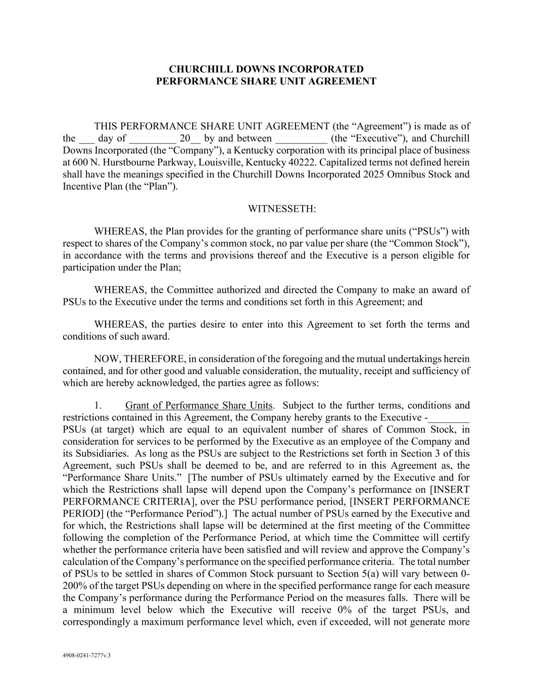
FORM 10-Q FOR THE QUARTERLY PERIOD ENDED MARCH 31, 2026
37

4908-0241-7277v.3 CHURCHILL DOWNS INCORPORATED PERFORMANCE SHARE UNIT AGREEMENT THIS PERFORMANCE SHARE UNIT AGREEMENT (the “Agreement”) is made as of the ___ day of _________ 20__ by and between __________ (the “Executive”), and Churchill Downs Incorporated (the “Company”), a Kentucky corporation with its principal place of business at 600 N. Hurstbourne Parkway, Louisville, Kentucky 40222. Capitalized terms not defined herein shall have the meanings specified in the Churchill Downs Incorporated 2025 Omnibus Stock and Incentive Plan (the “Plan”). WITNESSETH: WHEREAS, the Plan provides for the granting of performance share units (“PSUs”) with respect to shares of the Company’s common stock, no par value per share (the “Common Stock”), in accordance with the terms and provisions thereof and the Executive is a person eligible for participation under the Plan; WHEREAS, the Committee authorized and directed the Company to make an award of PSUs to the Executive under the terms and conditions set forth in this Agreement; and WHEREAS, the parties desire to enter into this Agreement to set forth the terms and conditions of such award. NOW, THEREFORE, in consideration of the foregoing and the mutual undertakings herein contained, and for other good and valuable consideration, the mutuality, receipt and sufficiency of which are hereby acknowledged, the parties agree as follows: 1. Grant of Performance Share Units. Subject to the further terms, conditions and restrictions contained in this Agreement, the Company hereby grants to the Executive -________ PSUs (at target) which are equal to an equivalent number of shares of Common Stock, in consideration for services to be performed by the Executive as an employee of the Company and its Subsidiaries. As long as the PSUs are subject to the Restrictions set forth in Section 3 of this Agreement, such PSUs shall be deemed to be, and are referred to in this Agreement as, the “Performance Share Units.” [The number of PSUs ultimately earned by the Executive and for which the Restrictions shall lapse will depend upon the Company’s performance on [INSERT PERFORMANCE CRITERIA], over the PSU performance period, [INSERT PERFORMANCE PERIOD] (the “Performance Period”).] The actual number of PSUs earned by the Executive and for which, the Restrictions shall lapse will be determined at the first meeting of the Committee following the completion of the Performance Period, at which time the Committee will certify whether the performance criteria have been satisfied and will review and approve the Company’s calculation of the Company’s performance on the specified performance criteria. The total number of PSUs to be settled in shares of Common Stock pursuant to Section 5(a) will vary between 0- 200% of the target PSUs depending on where in the specified performance range for each measure the Company’s performance during the Performance Period on the measures falls. There will be a minimum level below which the Executive will receive 0% of the target PSUs, and correspondingly a maximum performance level which, even if exceeded, will not generate more

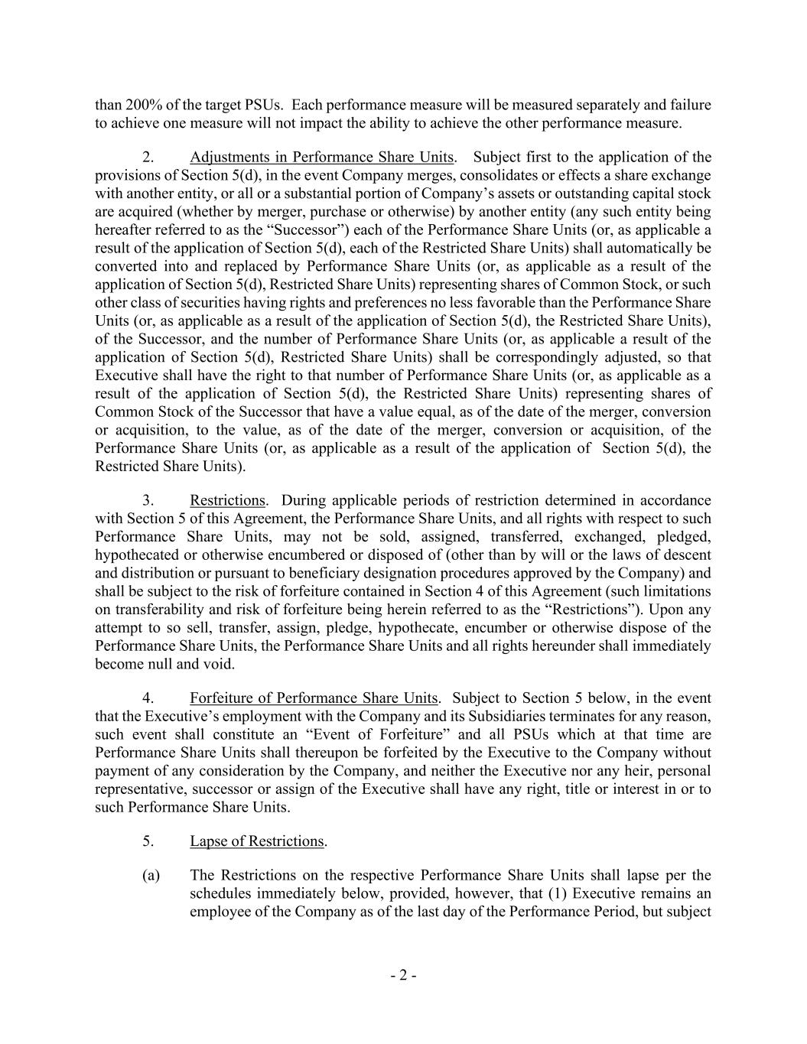
- 2 - than 200% of the target PSUs. Each performance measure will be measured separately and failure to achieve one measure will not impact the ability to achieve the other performance measure. 2. Adjustments in Performance Share Units. Subject first to the application of the provisions of Section 5(d), in the event Company merges, consolidates or effects a share exchange with another entity, or all or a substantial portion of Company’s assets or outstanding capital stock are acquired (whether by merger, purchase or otherwise) by another entity (any such entity being hereafter referred to as the “Successor”) each of the Performance Share Units (or, as applicable a result of the application of Section 5(d), each of the Restricted Share Units) shall automatically be converted into and replaced by Performance Share Units (or, as applicable as a result of the application of Section 5(d), Restricted Share Units) representing shares of Common Stock, or such other class of securities having rights and preferences no less favorable than the Performance Share Units (or, as applicable as a result of the application of Section 5(d), the Restricted Share Units), of the Successor, and the number of Performance Share Units (or, as applicable a result of the application of Section 5(d), Restricted Share Units) shall be correspondingly adjusted, so that Executive shall have the right to that number of Performance Share Units (or, as applicable as a result of the application of Section 5(d), the Restricted Share Units) representing shares of Common Stock of the Successor that have a value equal, as of the date of the merger, conversion or acquisition, to the value, as of the date of the merger, conversion or acquisition, of the Performance Share Units (or, as applicable as a result of the application of Section 5(d), the Restricted Share Units). 3. Restrictions. During applicable periods of restriction determined in accordance with Section 5 of this Agreement, the Performance Share Units, and all rights with respect to such Performance Share Units, may not be sold, assigned, transferred, exchanged, pledged, hypothecated or otherwise encumbered or disposed of (other than by will or the laws of descent and distribution or pursuant to beneficiary designation procedures approved by the Company) and shall be subject to the risk of forfeiture contained in Section 4 of this Agreement (such limitations on transferability and risk of forfeiture being herein referred to as the “Restrictions”). Upon any attempt to so sell, transfer, assign, pledge, hypothecate, encumber or otherwise dispose of the Performance Share Units, the Performance Share Units and all rights hereunder shall immediately become null and void. 4. Forfeiture of Performance Share Units. Subject to Section 5 below, in the event that the Executive’s employment with the Company and its Subsidiaries terminates for any reason, such event shall constitute an “Event of Forfeiture” and all PSUs which at that time are Performance Share Units shall thereupon be forfeited by the Executive to the Company without payment of any consideration by the Company, and neither the Executive nor any heir, personal representative, successor or assign of the Executive shall have any right, title or interest in or to such Performance Share Units. 5. Lapse of Restrictions. (a) The Restrictions on the respective Performance Share Units shall lapse per the schedules immediately below, provided, however, that (1) Executive remains an employee of the Company as of the last day of the Performance Period, but subject

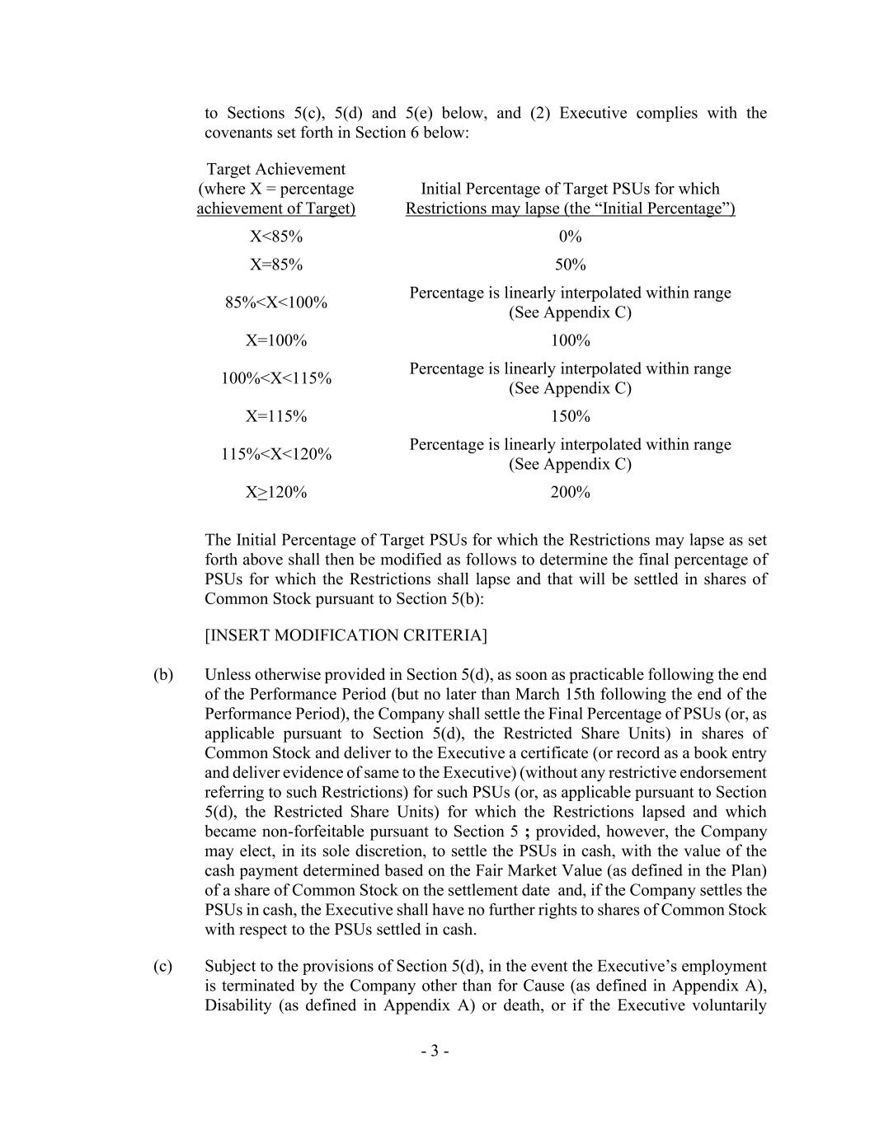
- 3 - to Sections 5(c), 5(d) and 5(e) below, and (2) Executive complies with the covenants set forth in Section 6 below: Target Achievement (where X = percentage achievement of Target) Initial Percentage of Target PSUs for which Restrictions may lapse (the “Initial Percentage”) X<85% 0% X=85% 50% 85%<X<100% Percentage is linearly interpolated within range (See Appendix C) X=100% 100% 100%<X<115% Percentage is linearly interpolated within range (See Appendix C) X=115% 150% 115%<X<120% Percentage is linearly interpolated within range (See Appendix C) X>120% 200% The Initial Percentage of Target PSUs for which the Restrictions may lapse as set forth above shall then be modified as follows to determine the final percentage of PSUs for which the Restrictions shall lapse and that will be settled in shares of Common Stock pursuant to Section 5(b): [INSERT MODIFICATION CRITERIA] (b) Unless otherwise provided in Section 5(d), as soon as practicable following the end of the Performance Period (but no later than March 15th following the end of the Performance Period), the Company shall settle the Final Percentage of PSUs (or, as applicable pursuant to Section 5(d), the Restricted Share Units) in shares of Common Stock and deliver to the Executive a certificate (or record as a book entry and deliver evidence of same to the Executive) (without any restrictive endorsement referring to such Restrictions) for such PSUs (or, as applicable pursuant to Section 5(d), the Restricted Share Units) for which the Restrictions lapsed and which became non-forfeitable pursuant to Section 5 ; provided, however, the Company may elect, in its sole discretion, to settle the PSUs in cash, with the value of the cash payment determined based on the Fair Market Value (as defined in the Plan) of a share of Common Stock on the settlement date and, if the Company settles the PSUs in cash, the Executive shall have no further rights to shares of Common Stock with respect to the PSUs settled in cash. (c) Subject to the provisions of Section 5(d), in the event the Executive’s employment is terminated by the Company other than for Cause (as defined in Appendix A), Disability (as defined in Appendix A) or death, or if the Executive voluntarily

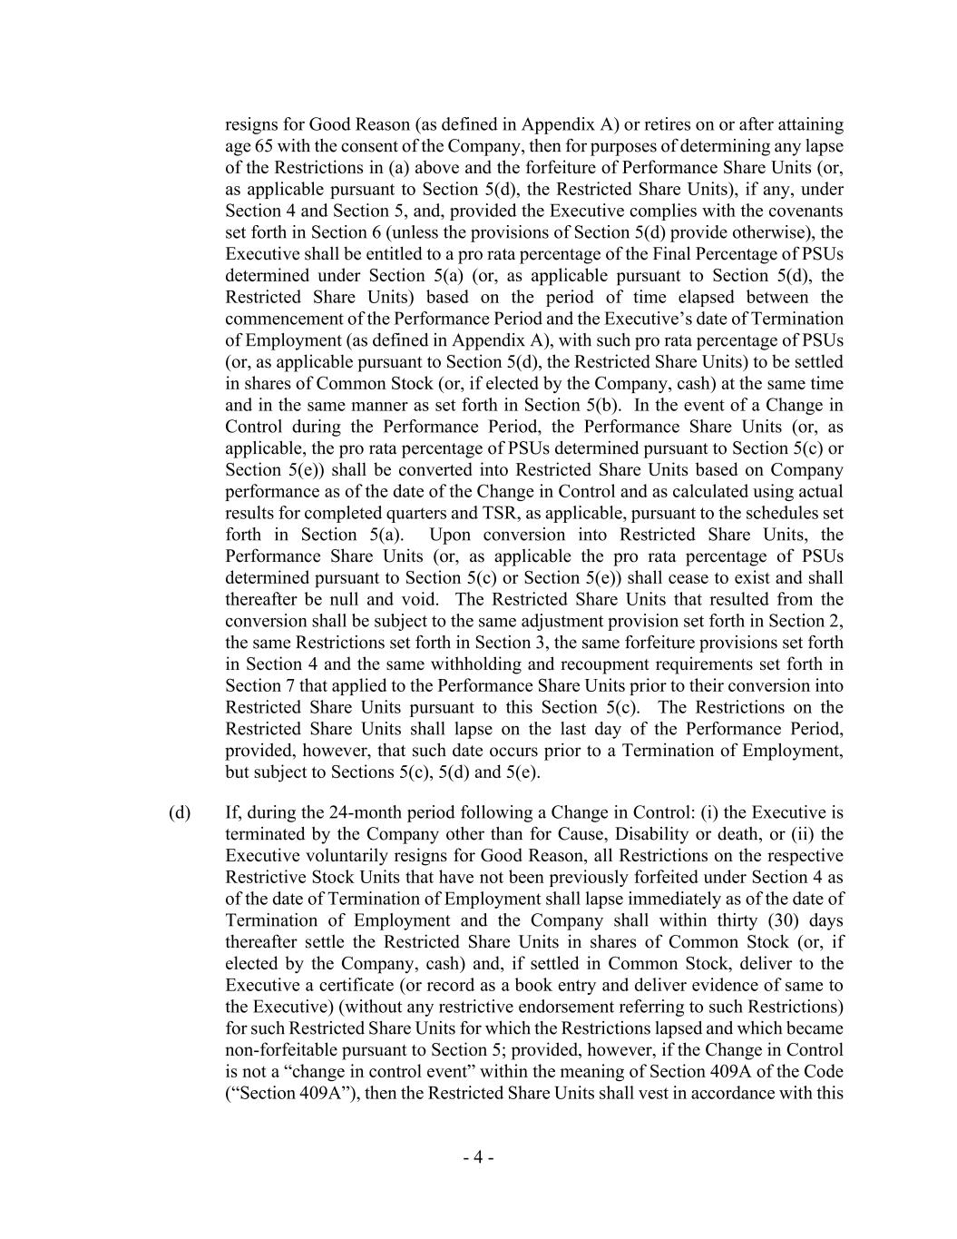
- 4 - resigns for Good Reason (as defined in Appendix A) or retires on or after attaining age 65 with the consent of the Company, then for purposes of determining any lapse of the Restrictions in (a) above and the forfeiture of Performance Share Units (or, as applicable pursuant to Section 5(d), the Restricted Share Units), if any, under Section 4 and Section 5, and, provided the Executive complies with the covenants set forth in Section 6 (unless the provisions of Section 5(d) provide otherwise), the Executive shall be entitled to a pro rata percentage of the Final Percentage of PSUs determined under Section 5(a) (or, as applicable pursuant to Section 5(d), the Restricted Share Units) based on the period of time elapsed between the commencement of the Performance Period and the Executive’s date of Termination of Employment (as defined in Appendix A), with such pro rata percentage of PSUs (or, as applicable pursuant to Section 5(d), the Restricted Share Units) to be settled in shares of Common Stock (or, if elected by the Company, cash) at the same time and in the same manner as set forth in Section 5(b). In the event of a Change in Control during the Performance Period, the Performance Share Units (or, as applicable, the pro rata percentage of PSUs determined pursuant to Section 5(c) or Section 5(e)) shall be converted into Restricted Share Units based on Company performance as of the date of the Change in Control and as calculated using actual results for completed quarters and TSR, as applicable, pursuant to the schedules set forth in Section 5(a). Upon conversion into Restricted Share Units, the Performance Share Units (or, as applicable the pro rata percentage of PSUs determined pursuant to Section 5(c) or Section 5(e)) shall cease to exist and shall thereafter be null and void. The Restricted Share Units that resulted from the conversion shall be subject to the same adjustment provision set forth in Section 2, the same Restrictions set forth in Section 3, the same forfeiture provisions set forth in Section 4 and the same withholding and recoupment requirements set forth in Section 7 that applied to the Performance Share Units prior to their conversion into Restricted Share Units pursuant to this Section 5(c). The Restrictions on the Restricted Share Units shall lapse on the last day of the Performance Period, provided, however, that such date occurs prior to a Termination of Employment, but subject to Sections 5(c), 5(d) and 5(e). (d) If, during the 24-month period following a Change in Control: (i) the Executive is terminated by the Company other than for Cause, Disability or death, or (ii) the Executive voluntarily resigns for Good Reason, all Restrictions on the respective Restrictive Stock Units that have not been previously forfeited under Section 4 as of the date of Termination of Employment shall lapse immediately as of the date of Termination of Employment and the Company shall within thirty (30) days thereafter settle the Restricted Share Units in shares of Common Stock (or, if elected by the Company, cash) and, if settled in Common Stock, deliver to the Executive a certificate (or record as a book entry and deliver evidence of same to the Executive) (without any restrictive endorsement referring to such Restrictions) for such Restricted Share Units for which the Restrictions lapsed and which became non-forfeitable pursuant to Section 5; provided, however, if the Change in Control is not a “change in control event” within the meaning of Section 409A of the Code (“Section 409A”), then the Restricted Share Units shall vest in accordance with this

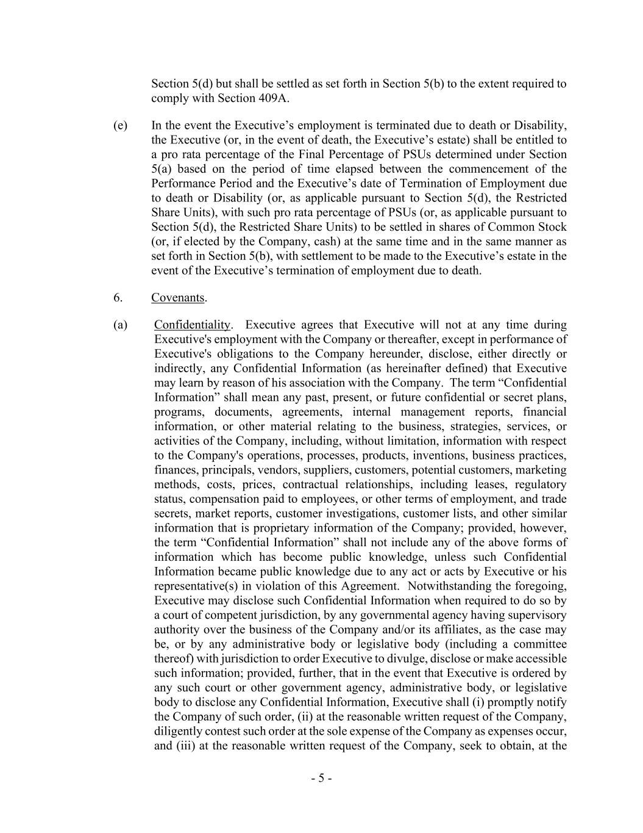
- 5 - Section 5(d) but shall be settled as set forth in Section 5(b) to the extent required to comply with Section 409A. (e) In the event the Executive’s employment is terminated due to death or Disability, the Executive (or, in the event of death, the Executive’s estate) shall be entitled to a pro rata percentage of the Final Percentage of PSUs determined under Section 5(a) based on the period of time elapsed between the commencement of the Performance Period and the Executive’s date of Termination of Employment due to death or Disability (or, as applicable pursuant to Section 5(d), the Restricted Share Units), with such pro rata percentage of PSUs (or, as applicable pursuant to Section 5(d), the Restricted Share Units) to be settled in shares of Common Stock (or, if elected by the Company, cash) at the same time and in the same manner as set forth in Section 5(b), with settlement to be made to the Executive’s estate in the event of the Executive’s termination of employment due to death. 6. Covenants. (a) Confidentiality. Executive agrees that Executive will not at any time during Executive's employment with the Company or thereafter, except in performance of Executive's obligations to the Company hereunder, disclose, either directly or indirectly, any Confidential Information (as hereinafter defined) that Executive may learn by reason of his association with the Company. The term “Confidential Information” shall mean any past, present, or future confidential or secret plans, programs, documents, agreements, internal management reports, financial information, or other material relating to the business, strategies, services, or activities of the Company, including, without limitation, information with respect to the Company's operations, processes, products, inventions, business practices, finances, principals, vendors, suppliers, customers, potential customers, marketing methods, costs, prices, contractual relationships, including leases, regulatory status, compensation paid to employees, or other terms of employment, and trade secrets, market reports, customer investigations, customer lists, and other similar information that is proprietary information of the Company; provided, however, the term “Confidential Information” shall not include any of the above forms of information which has become public knowledge, unless such Confidential Information became public knowledge due to any act or acts by Executive or his representative(s) in violation of this Agreement. Notwithstanding the foregoing, Executive may disclose such Confidential Information when required to do so by a court of competent jurisdiction, by any governmental agency having supervisory authority over the business of the Company and/or its affiliates, as the case may be, or by any administrative body or legislative body (including a committee thereof) with jurisdiction to order Executive to divulge, disclose or make accessible such information; provided, further, that in the event that Executive is ordered by any such court or other government agency, administrative body, or legislative body to disclose any Confidential Information, Executive shall (i) promptly notify the Company of such order, (ii) at the reasonable written request of the Company, diligently contest such order at the sole expense of the Company as expenses occur, and (iii) at the reasonable written request of the Company, seek to obtain, at the

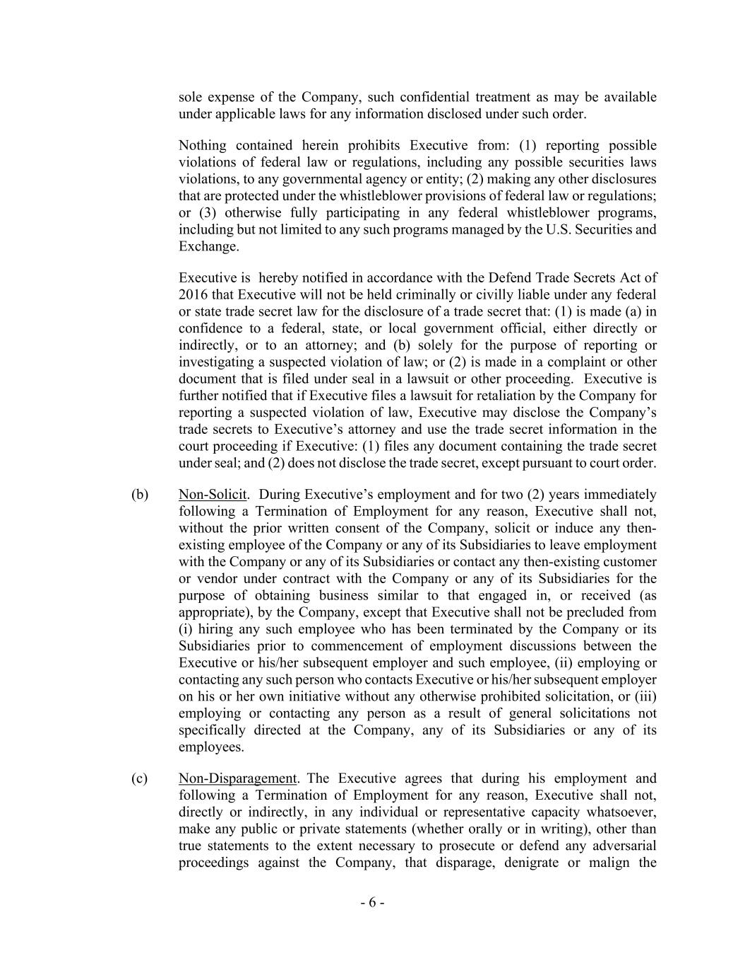
- 6 - sole expense of the Company, such confidential treatment as may be available under applicable laws for any information disclosed under such order. Nothing contained herein prohibits Executive from: (1) reporting possible violations of federal law or regulations, including any possible securities laws violations, to any governmental agency or entity; (2) making any other disclosures that are protected under the whistleblower provisions of federal law or regulations; or (3) otherwise fully participating in any federal whistleblower programs, including but not limited to any such programs managed by the U.S. Securities and Exchange. Executive is hereby notified in accordance with the Defend Trade Secrets Act of 2016 that Executive will not be held criminally or civilly liable under any federal or state trade secret law for the disclosure of a trade secret that: (1) is made (a) in confidence to a federal, state, or local government official, either directly or indirectly, or to an attorney; and (b) solely for the purpose of reporting or investigating a suspected violation of law; or (2) is made in a complaint or other document that is filed under seal in a lawsuit or other proceeding. Executive is further notified that if Executive files a lawsuit for retaliation by the Company for reporting a suspected violation of law, Executive may disclose the Company’s trade secrets to Executive’s attorney and use the trade secret information in the court proceeding if Executive: (1) files any document containing the trade secret under seal; and (2) does not disclose the trade secret, except pursuant to court order. (b) Non-Solicit. During Executive’s employment and for two (2) years immediately following a Termination of Employment for any reason, Executive shall not, without the prior written consent of the Company, solicit or induce any then- existing employee of the Company or any of its Subsidiaries to leave employment with the Company or any of its Subsidiaries or contact any then-existing customer or vendor under contract with the Company or any of its Subsidiaries for the purpose of obtaining business similar to that engaged in, or received (as appropriate), by the Company, except that Executive shall not be precluded from (i) hiring any such employee who has been terminated by the Company or its Subsidiaries prior to commencement of employment discussions between the Executive or his/her subsequent employer and such employee, (ii) employing or contacting any such person who contacts Executive or his/her subsequent employer on his or her own initiative without any otherwise prohibited solicitation, or (iii) employing or contacting any person as a result of general solicitations not specifically directed at the Company, any of its Subsidiaries or any of its employees. (c) Non-Disparagement. The Executive agrees that during his employment and following a Termination of Employment for any reason, Executive shall not, directly or indirectly, in any individual or representative capacity whatsoever, make any public or private statements (whether orally or in writing), other than true statements to the extent necessary to prosecute or defend any adversarial proceedings against the Company, that disparage, denigrate or malign the

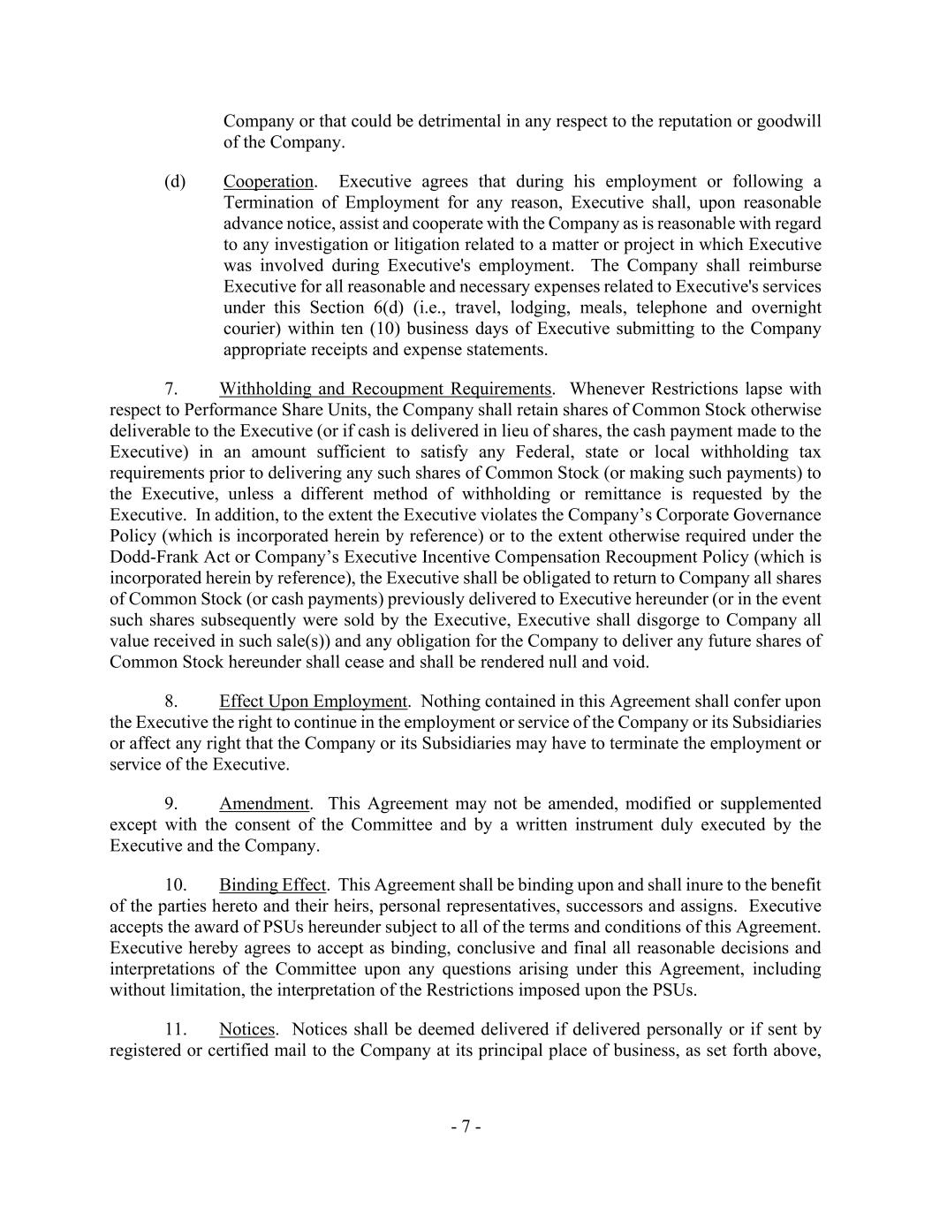
- 7 - Company or that could be detrimental in any respect to the reputation or goodwill of the Company. (d) Cooperation. Executive agrees that during his employment or following a Termination of Employment for any reason, Executive shall, upon reasonable advance notice, assist and cooperate with the Company as is reasonable with regard to any investigation or litigation related to a matter or project in which Executive was involved during Executive's employment. The Company shall reimburse Executive for all reasonable and necessary expenses related to Executive's services under this Section 6(d) (i.e., travel, lodging, meals, telephone and overnight courier) within ten (10) business days of Executive submitting to the Company appropriate receipts and expense statements. 7. Withholding and Recoupment Requirements. Whenever Restrictions lapse with respect to Performance Share Units, the Company shall retain shares of Common Stock otherwise deliverable to the Executive (or if cash is delivered in lieu of shares, the cash payment made to the Executive) in an amount sufficient to satisfy any Federal, state or local withholding tax requirements prior to delivering any such shares of Common Stock (or making such payments) to the Executive, unless a different method of withholding or remittance is requested by the Executive. In addition, to the extent the Executive violates the Company’s Corporate Governance Policy (which is incorporated herein by reference) or to the extent otherwise required under the Dodd-Frank Act or Company’s Executive Incentive Compensation Recoupment Policy (which is incorporated herein by reference), the Executive shall be obligated to return to Company all shares of Common Stock (or cash payments) previously delivered to Executive hereunder (or in the event such shares subsequently were sold by the Executive, Executive shall disgorge to Company all value received in such sale(s)) and any obligation for the Company to deliver any future shares of Common Stock hereunder shall cease and shall be rendered null and void. 8. Effect Upon Employment. Nothing contained in this Agreement shall confer upon the Executive the right to continue in the employment or service of the Company or its Subsidiaries or affect any right that the Company or its Subsidiaries may have to terminate the employment or service of the Executive. 9. Amendment. This Agreement may not be amended, modified or supplemented except with the consent of the Committee and by a written instrument duly executed by the Executive and the Company. 10. Binding Effect. This Agreement shall be binding upon and shall inure to the benefit of the parties hereto and their heirs, personal representatives, successors and assigns. Executive accepts the award of PSUs hereunder subject to all of the terms and conditions of this Agreement. Executive hereby agrees to accept as binding, conclusive and final all reasonable decisions and interpretations of the Committee upon any questions arising under this Agreement, including without limitation, the interpretation of the Restrictions imposed upon the PSUs. 11. Notices. Notices shall be deemed delivered if delivered personally or if sent by registered or certified mail to the Company at its principal place of business, as set forth above,

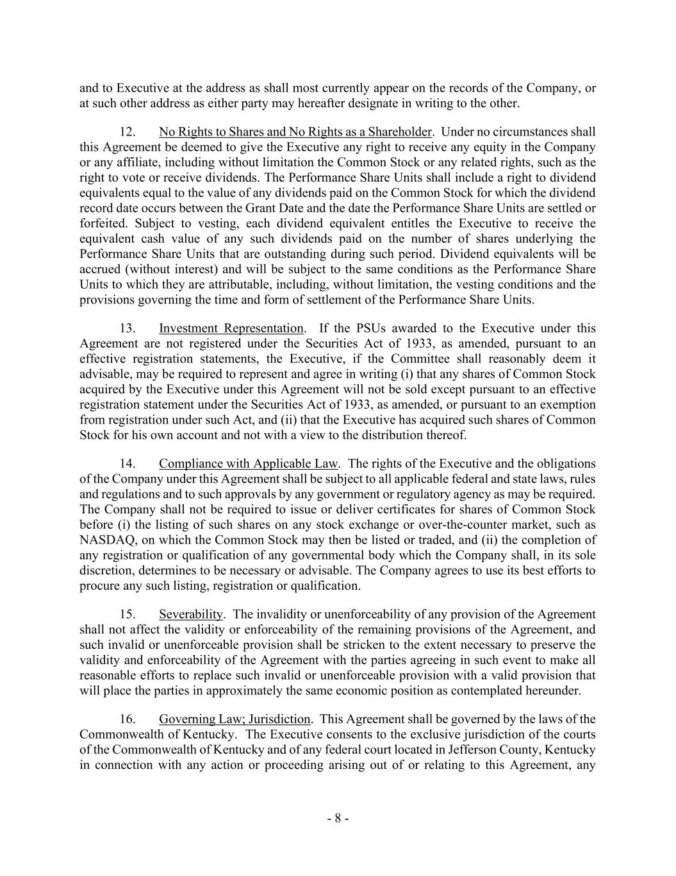
- 8 - and to Executive at the address as shall most currently appear on the records of the Company, or at such other address as either party may hereafter designate in writing to the other. 12. No Rights to Shares and No Rights as a Shareholder. Under no circumstances shall this Agreement be deemed to give the Executive any right to receive any equity in the Company or any affiliate, including without limitation the Common Stock or any related rights, such as the right to vote or receive dividends. The Performance Share Units shall include a right to dividend equivalents equal to the value of any dividends paid on the Common Stock for which the dividend record date occurs between the Grant Date and the date the Performance Share Units are settled or forfeited. Subject to vesting, each dividend equivalent entitles the Executive to receive the equivalent cash value of any such dividends paid on the number of shares underlying the Performance Share Units that are outstanding during such period. Dividend equivalents will be accrued (without interest) and will be subject to the same conditions as the Performance Share Units to which they are attributable, including, without limitation, the vesting conditions and the provisions governing the time and form of settlement of the Performance Share Units. 13. Investment Representation. If the PSUs awarded to the Executive under this Agreement are not registered under the Securities Act of 1933, as amended, pursuant to an effective registration statements, the Executive, if the Committee shall reasonably deem it advisable, may be required to represent and agree in writing (i) that any shares of Common Stock acquired by the Executive under this Agreement will not be sold except pursuant to an effective registration statement under the Securities Act of 1933, as amended, or pursuant to an exemption from registration under such Act, and (ii) that the Executive has acquired such shares of Common Stock for his own account and not with a view to the distribution thereof. 14. Compliance with Applicable Law. The rights of the Executive and the obligations of the Company under this Agreement shall be subject to all applicable federal and state laws, rules and regulations and to such approvals by any government or regulatory agency as may be required. The Company shall not be required to issue or deliver certificates for shares of Common Stock before (i) the listing of such shares on any stock exchange or over-the-counter market, such as NASDAQ, on which the Common Stock may then be listed or traded, and (ii) the completion of any registration or qualification of any governmental body which the Company shall, in its sole discretion, determines to be necessary or advisable. The Company agrees to use its best efforts to procure any such listing, registration or qualification. 15. Severability. The invalidity or unenforceability of any provision of the Agreement shall not affect the validity or enforceability of the remaining provisions of the Agreement, and such invalid or unenforceable provision shall be stricken to the extent necessary to preserve the validity and enforceability of the Agreement with the parties agreeing in such event to make all reasonable efforts to replace such invalid or unenforceable provision with a valid provision that will place the parties in approximately the same economic position as contemplated hereunder. 16. Governing Law; Jurisdiction. This Agreement shall be governed by the laws of the Commonwealth of Kentucky. The Executive consents to the exclusive jurisdiction of the courts of the Commonwealth of Kentucky and of any federal court located in Jefferson County, Kentucky in connection with any action or proceeding arising out of or relating to this Agreement, any

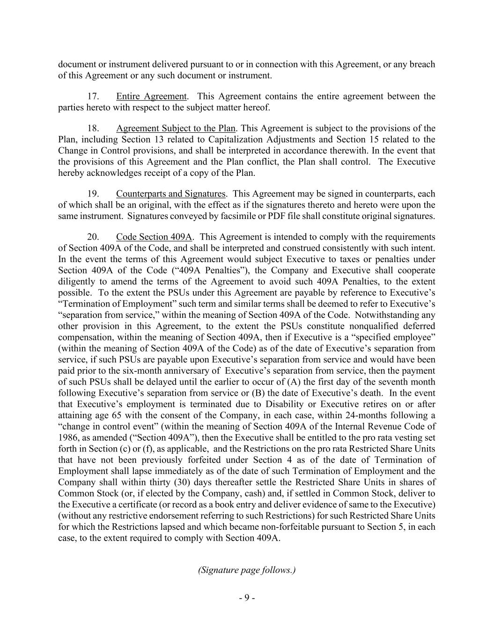
- 9 - document or instrument delivered pursuant to or in connection with this Agreement, or any breach of this Agreement or any such document or instrument. 17. Entire Agreement. This Agreement contains the entire agreement between the parties hereto with respect to the subject matter hereof. 18. Agreement Subject to the Plan. This Agreement is subject to the provisions of the Plan, including Section 13 related to Capitalization Adjustments and Section 15 related to the Change in Control provisions, and shall be interpreted in accordance therewith. In the event that the provisions of this Agreement and the Plan conflict, the Plan shall control. The Executive hereby acknowledges receipt of a copy of the Plan. 19. Counterparts and Signatures. This Agreement may be signed in counterparts, each of which shall be an original, with the effect as if the signatures thereto and hereto were upon the same instrument. Signatures conveyed by facsimile or PDF file shall constitute original signatures. 20. Code Section 409A. This Agreement is intended to comply with the requirements of Section 409A of the Code, and shall be interpreted and construed consistently with such intent. In the event the terms of this Agreement would subject Executive to taxes or penalties under Section 409A of the Code (“409A Penalties”), the Company and Executive shall cooperate diligently to amend the terms of the Agreement to avoid such 409A Penalties, to the extent possible. To the extent the PSUs under this Agreement are payable by reference to Executive’s “Termination of Employment” such term and similar terms shall be deemed to refer to Executive’s “separation from service,” within the meaning of Section 409A of the Code. Notwithstanding any other provision in this Agreement, to the extent the PSUs constitute nonqualified deferred compensation, within the meaning of Section 409A, then if Executive is a “specified employee” (within the meaning of Section 409A of the Code) as of the date of Executive’s separation from service, if such PSUs are payable upon Executive’s separation from service and would have been paid prior to the six-month anniversary of Executive’s separation from service, then the payment of such PSUs shall be delayed until the earlier to occur of (A) the first day of the seventh month following Executive’s separation from service or (B) the date of Executive’s death. In the event that Executive’s employment is terminated due to Disability or Executive retires on or after attaining age 65 with the consent of the Company, in each case, within 24-months following a “change in control event” (within the meaning of Section 409A of the Internal Revenue Code of 1986, as amended (“Section 409A”), then the Executive shall be entitled to the pro rata vesting set forth in Section (c) or (f), as applicable, and the Restrictions on the pro rata Restricted Share Units that have not been previously forfeited under Section 4 as of the date of Termination of Employment shall lapse immediately as of the date of such Termination of Employment and the Company shall within thirty (30) days thereafter settle the Restricted Share Units in shares of Common Stock (or, if elected by the Company, cash) and, if settled in Common Stock, deliver to the Executive a certificate (or record as a book entry and deliver evidence of same to the Executive) (without any restrictive endorsement referring to such Restrictions) for such Restricted Share Units for which the Restrictions lapsed and which became non-forfeitable pursuant to Section 5, in each case, to the extent required to comply with Section 409A. (Signature page follows.)


- 10 - IN WITNESS WHEREOF, the Company and the Executive have executed and delivered this Agreement as of the date first above written. EXECUTIVE CHURCHILL DOWNS INCORPORATED By: Name: Title:

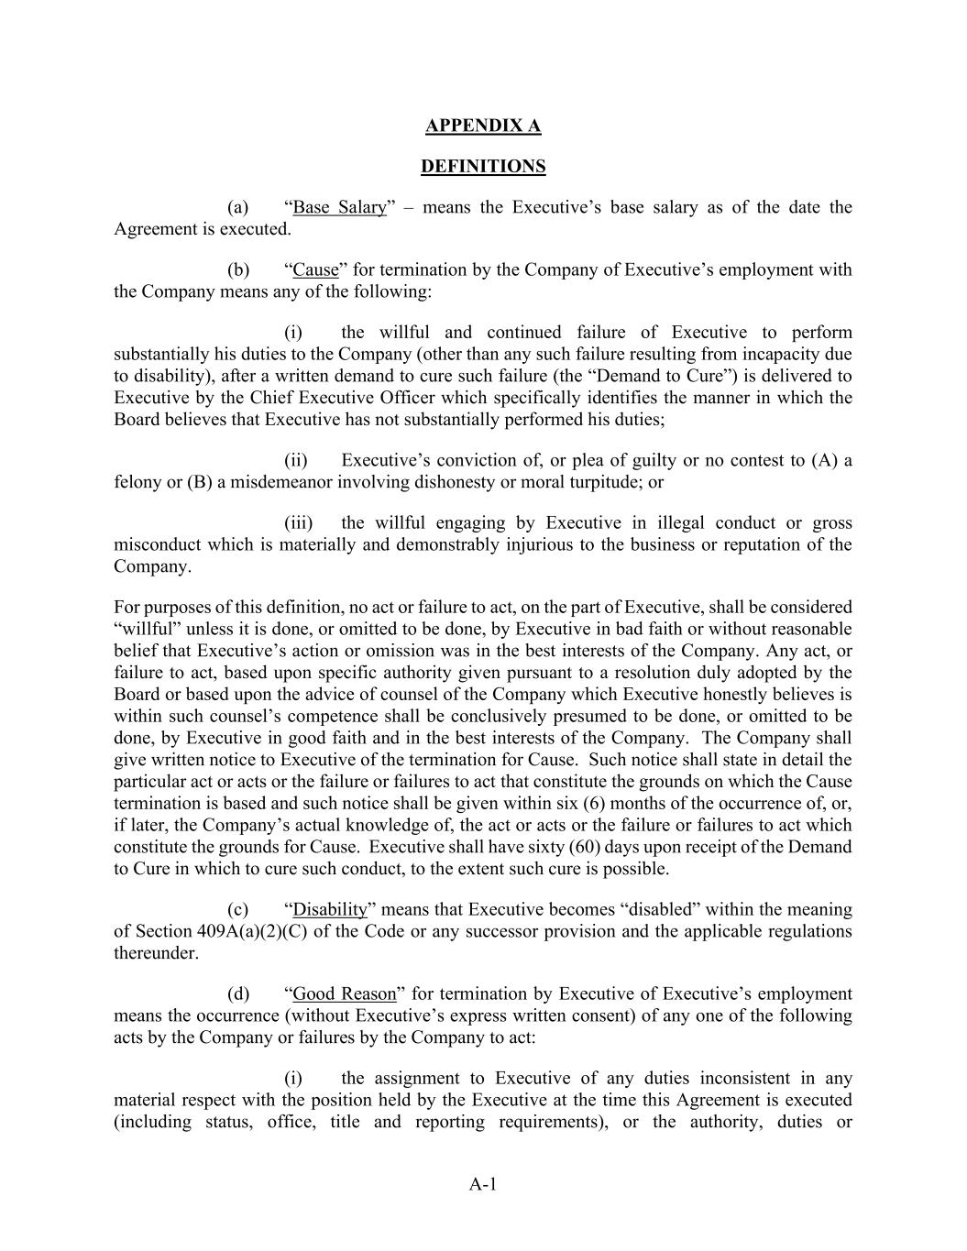
A-1 APPENDIX A DEFINITIONS (a) “Base Salary” – means the Executive’s base salary as of the date the Agreement is executed. (b) “Cause” for termination by the Company of Executive’s employment with the Company means any of the following: (i) the willful and continued failure of Executive to perform substantially his duties to the Company (other than any such failure resulting from incapacity due to disability), after a written demand to cure such failure (the “Demand to Cure”) is delivered to Executive by the Chief Executive Officer which specifically identifies the manner in which the Board believes that Executive has not substantially performed his duties; (ii) Executive’s conviction of, or plea of guilty or no contest to (A) a felony or (B) a misdemeanor involving dishonesty or moral turpitude; or (iii) the willful engaging by Executive in illegal conduct or gross misconduct which is materially and demonstrably injurious to the business or reputation of the Company. For purposes of this definition, no act or failure to act, on the part of Executive, shall be considered “willful” unless it is done, or omitted to be done, by Executive in bad faith or without reasonable belief that Executive’s action or omission was in the best interests of the Company. Any act, or failure to act, based upon specific authority given pursuant to a resolution duly adopted by the Board or based upon the advice of counsel of the Company which Executive honestly believes is within such counsel’s competence shall be conclusively presumed to be done, or omitted to be done, by Executive in good faith and in the best interests of the Company. The Company shall give written notice to Executive of the termination for Cause. Such notice shall state in detail the particular act or acts or the failure or failures to act that constitute the grounds on which the Cause termination is based and such notice shall be given within six (6) months of the occurrence of, or, if later, the Company’s actual knowledge of, the act or acts or the failure or failures to act which constitute the grounds for Cause. Executive shall have sixty (60) days upon receipt of the Demand to Cure in which to cure such conduct, to the extent such cure is possible. (c) “Disability” means that Executive becomes “disabled” within the meaning of Section 409A(a)(2)(C) of the Code or any successor provision and the applicable regulations thereunder. (d) “Good Reason” for termination by Executive of Executive’s employment means the occurrence (without Executive’s express written consent) of any one of the following acts by the Company or failures by the Company to act: (i) the assignment to Executive of any duties inconsistent in any material respect with the position held by the Executive at the time this Agreement is executed (including status, office, title and reporting requirements), or the authority, duties or

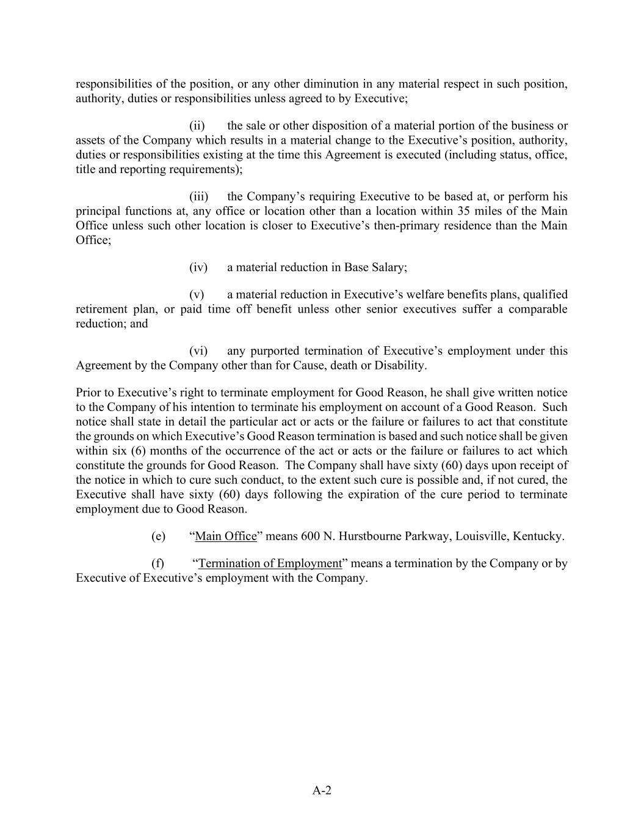
A-2 responsibilities of the position, or any other diminution in any material respect in such position, authority, duties or responsibilities unless agreed to by Executive; (ii) the sale or other disposition of a material portion of the business or assets of the Company which results in a material change to the Executive’s position, authority, duties or responsibilities existing at the time this Agreement is executed (including status, office, title and reporting requirements); (iii) the Company’s requiring Executive to be based at, or perform his principal functions at, any office or location other than a location within 35 miles of the Main Office unless such other location is closer to Executive’s then-primary residence than the Main Office; (iv) a material reduction in Base Salary; (v) a material reduction in Executive’s welfare benefits plans, qualified retirement plan, or paid time off benefit unless other senior executives suffer a comparable reduction; and (vi) any purported termination of Executive’s employment under this Agreement by the Company other than for Cause, death or Disability. Prior to Executive’s right to terminate employment for Good Reason, he shall give written notice to the Company of his intention to terminate his employment on account of a Good Reason. Such notice shall state in detail the particular act or acts or the failure or failures to act that constitute the grounds on which Executive’s Good Reason termination is based and such notice shall be given within six (6) months of the occurrence of the act or acts or the failure or failures to act which constitute the grounds for Good Reason. The Company shall have sixty (60) days upon receipt of the notice in which to cure such conduct, to the extent such cure is possible and, if not cured, the Executive shall have sixty (60) days following the expiration of the cure period to terminate employment due to Good Reason. (e) “Main Office” means 600 N. Hurstbourne Parkway, Louisville, Kentucky. (f) “Termination of Employment” means a termination by the Company or by Executive of Executive’s employment with the Company.


C-1 APPENDIX B TARGET METRICS FOR PERFORMANCE PERIOD

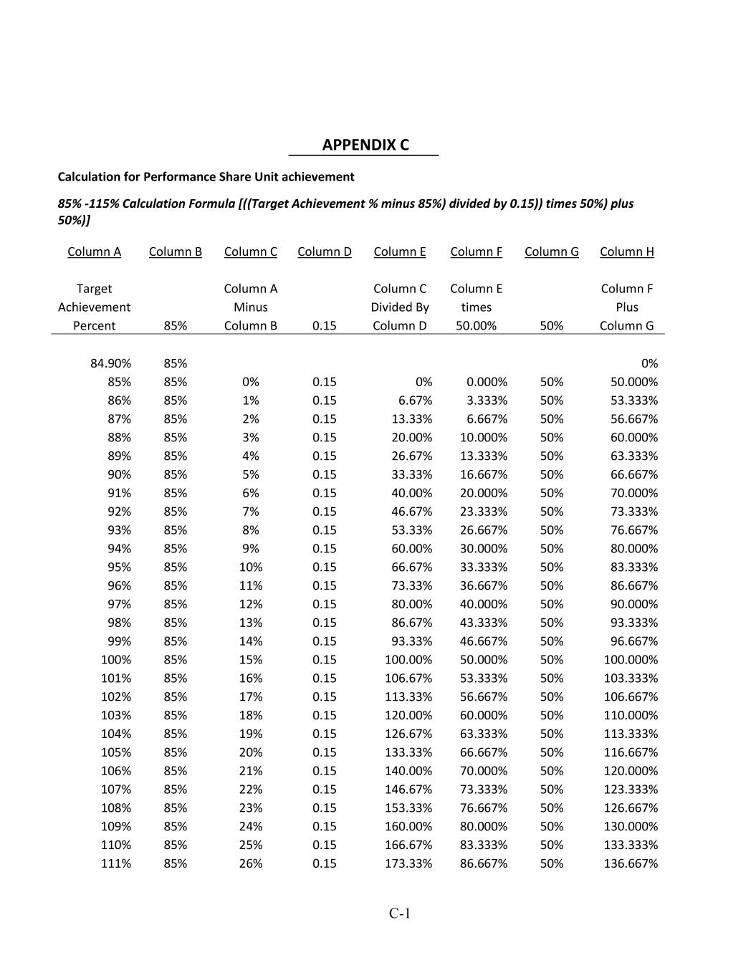
C-1 APPENDIX C Calculation for Performance Share Unit achievement 85% -115% Calculation Formula [((Target Achievement % minus 85%) divided by 0.15)) times 50%) plus 50%)] Column A Column B Column C Column D Column E Column F Column G Column H Target Column A Column C Column E Column F Achievement Minus Divided By times Plus Percent 85% Column B 0.15 Column D 50.00% 50% Column G 84.90% 85% 0% 85% 85% 0% 0.15 0% 0.000% 50% 50.000% 86% 85% 1% 0.15 6.67% 3.333% 50% 53.333% 87% 85% 2% 0.15 13.33% 6.667% 50% 56.667% 88% 85% 3% 0.15 20.00% 10.000% 50% 60.000% 89% 85% 4% 0.15 26.67% 13.333% 50% 63.333% 90% 85% 5% 0.15 33.33% 16.667% 50% 66.667% 91% 85% 6% 0.15 40.00% 20.000% 50% 70.000% 92% 85% 7% 0.15 46.67% 23.333% 50% 73.333% 93% 85% 8% 0.15 53.33% 26.667% 50% 76.667% 94% 85% 9% 0.15 60.00% 30.000% 50% 80.000% 95% 85% 10% 0.15 66.67% 33.333% 50% 83.333% 96% 85% 11% 0.15 73.33% 36.667% 50% 86.667% 97% 85% 12% 0.15 80.00% 40.000% 50% 90.000% 98% 85% 13% 0.15 86.67% 43.333% 50% 93.333% 99% 85% 14% 0.15 93.33% 46.667% 50% 96.667% 100% 85% 15% 0.15 100.00% 50.000% 50% 100.000% 101% 85% 16% 0.15 106.67% 53.333% 50% 103.333% 102% 85% 17% 0.15 113.33% 56.667% 50% 106.667% 103% 85% 18% 0.15 120.00% 60.000% 50% 110.000% 104% 85% 19% 0.15 126.67% 63.333% 50% 113.333% 105% 85% 20% 0.15 133.33% 66.667% 50% 116.667% 106% 85% 21% 0.15 140.00% 70.000% 50% 120.000% 107% 85% 22% 0.15 146.67% 73.333% 50% 123.333% 108% 85% 23% 0.15 153.33% 76.667% 50% 126.667% 109% 85% 24% 0.15 160.00% 80.000% 50% 130.000% 110% 85% 25% 0.15 166.67% 83.333% 50% 133.333% 111% 85% 26% 0.15 173.33% 86.667% 50% 136.667%

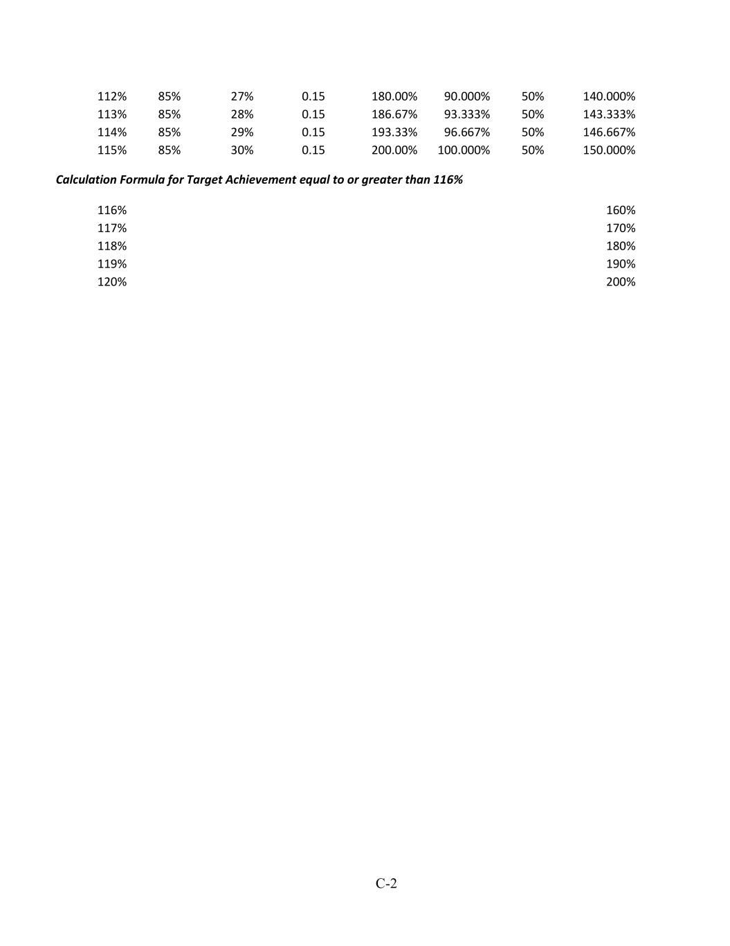
C-2 112% 85% 27% 0.15 180.00% 90.000% 50% 140.000% 113% 85% 28% 0.15 186.67% 93.333% 50% 143.333% 114% 85% 29% 0.15 193.33% 96.667% 50% 146.667% 115% 85% 30% 0.15 200.00% 100.000% 50% 150.000% Calculation Formula for Target Achievement equal to or greater than 116% 116% 160% 117% 170% 118% 180% 119% 190% 120% 200%


C-3

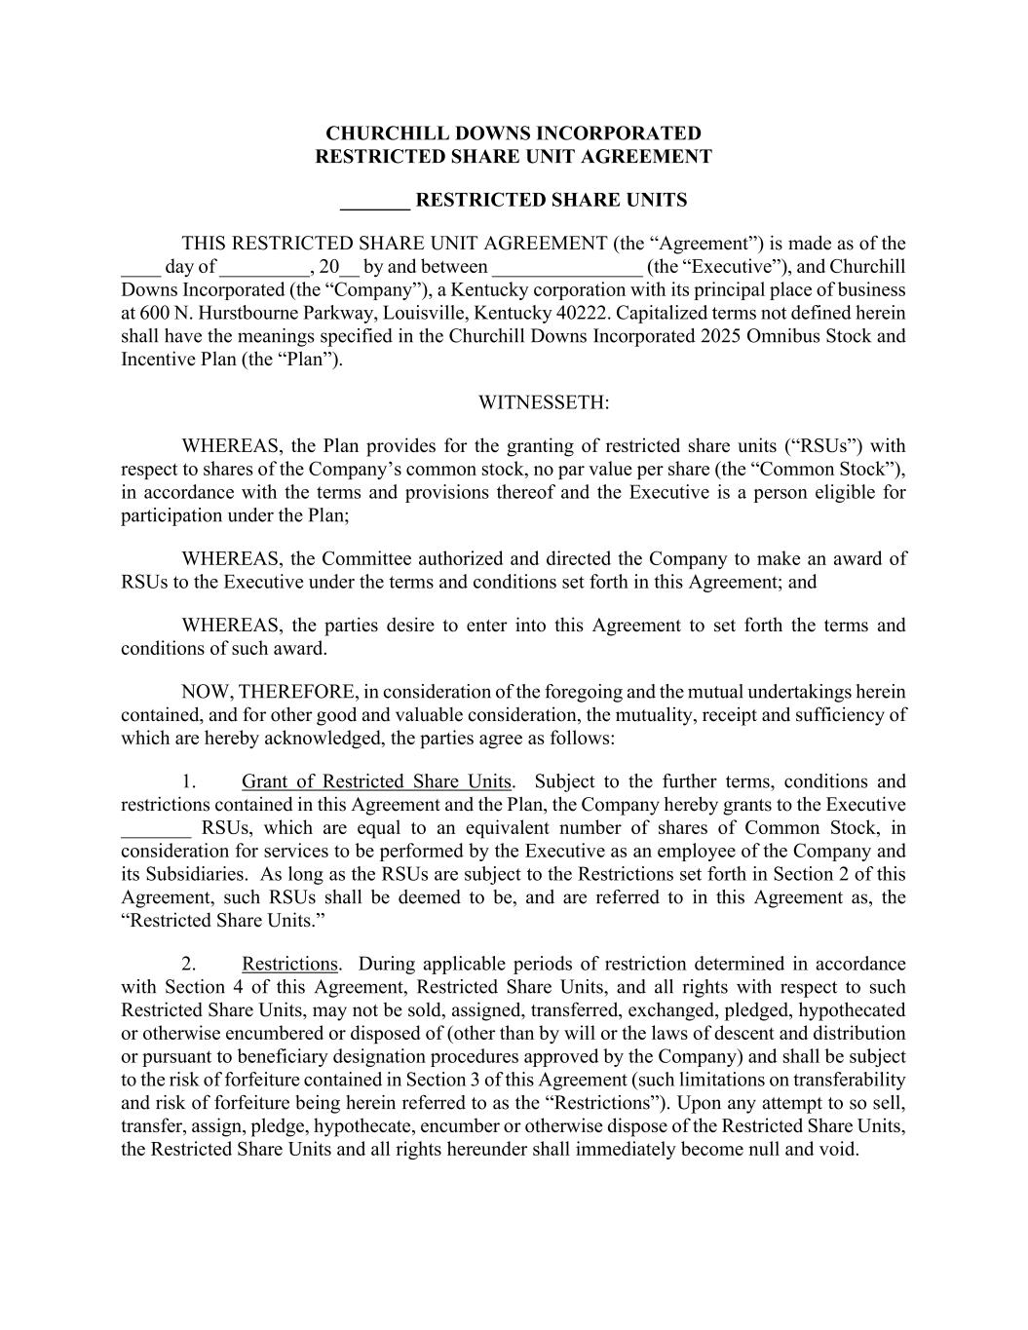
CHURCHILL DOWNS INCORPORATED RESTRICTED SHARE UNIT AGREEMENT _______ RESTRICTED SHARE UNITS THIS RESTRICTED SHARE UNIT AGREEMENT (the “Agreement”) is made as of the ____ day of _________, 20__ by and between _______________ (the “Executive”), and Churchill Downs Incorporated (the “Company”), a Kentucky corporation with its principal place of business at 600 N. Hurstbourne Parkway, Louisville, Kentucky 40222. Capitalized terms not defined herein shall have the meanings specified in the Churchill Downs Incorporated 2025 Omnibus Stock and Incentive Plan (the “Plan”). WITNESSETH: WHEREAS, the Plan provides for the granting of restricted share units (“RSUs”) with respect to shares of the Company’s common stock, no par value per share (the “Common Stock”), in accordance with the terms and provisions thereof and the Executive is a person eligible for participation under the Plan; WHEREAS, the Committee authorized and directed the Company to make an award of RSUs to the Executive under the terms and conditions set forth in this Agreement; and WHEREAS, the parties desire to enter into this Agreement to set forth the terms and conditions of such award. NOW, THEREFORE, in consideration of the foregoing and the mutual undertakings herein contained, and for other good and valuable consideration, the mutuality, receipt and sufficiency of which are hereby acknowledged, the parties agree as follows: 1. Grant of Restricted Share Units. Subject to the further terms, conditions and restrictions contained in this Agreement and the Plan, the Company hereby grants to the Executive _______ RSUs, which are equal to an equivalent number of shares of Common Stock, in consideration for services to be performed by the Executive as an employee of the Company and its Subsidiaries. As long as the RSUs are subject to the Restrictions set forth in Section 2 of this Agreement, such RSUs shall be deemed to be, and are referred to in this Agreement as, the “Restricted Share Units.” 2. Restrictions. During applicable periods of restriction determined in accordance with Section 4 of this Agreement, Restricted Share Units, and all rights with respect to such Restricted Share Units, may not be sold, assigned, transferred, exchanged, pledged, hypothecated or otherwise encumbered or disposed of (other than by will or the laws of descent and distribution or pursuant to beneficiary designation procedures approved by the Company) and shall be subject to the risk of forfeiture contained in Section 3 of this Agreement (such limitations on transferability and risk of forfeiture being herein referred to as the “Restrictions”). Upon any attempt to so sell, transfer, assign, pledge, hypothecate, encumber or otherwise dispose of the Restricted Share Units, the Restricted Share Units and all rights hereunder shall immediately become null and void.

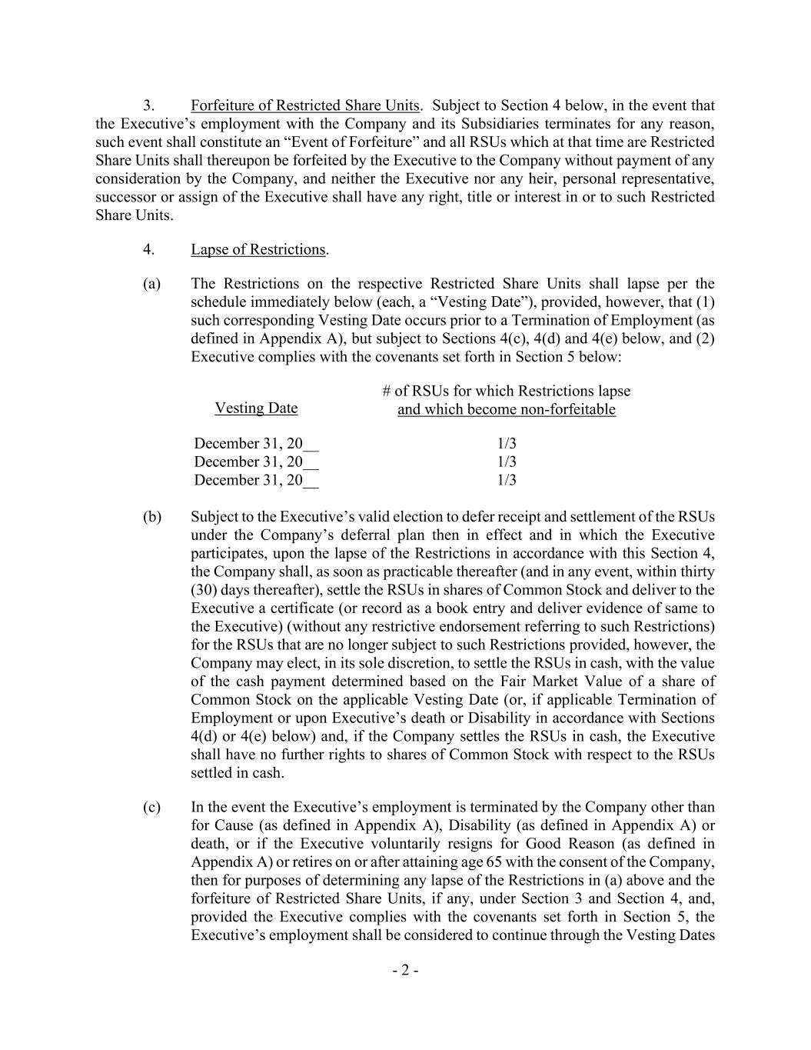
- 2 - 3. Forfeiture of Restricted Share Units. Subject to Section 4 below, in the event that the Executive’s employment with the Company and its Subsidiaries terminates for any reason, such event shall constitute an “Event of Forfeiture” and all RSUs which at that time are Restricted Share Units shall thereupon be forfeited by the Executive to the Company without payment of any consideration by the Company, and neither the Executive nor any heir, personal representative, successor or assign of the Executive shall have any right, title or interest in or to such Restricted Share Units. 4. Lapse of Restrictions. (a) The Restrictions on the respective Restricted Share Units shall lapse per the schedule immediately below (each, a “Vesting Date”), provided, however, that (1) such corresponding Vesting Date occurs prior to a Termination of Employment (as defined in Appendix A), but subject to Sections 4(c), 4(d) and 4(e) below, and (2) Executive complies with the covenants set forth in Section 5 below: Vesting Date # of RSUs for which Restrictions lapse and which become non-forfeitable December 31, 20__ 1/3 December 31, 20__ 1/3 December 31, 20__ 1/3 (b) Subject to the Executive’s valid election to defer receipt and settlement of the RSUs under the Company’s deferral plan then in effect and in which the Executive participates, upon the lapse of the Restrictions in accordance with this Section 4, the Company shall, as soon as practicable thereafter (and in any event, within thirty (30) days thereafter), settle the RSUs in shares of Common Stock and deliver to the Executive a certificate (or record as a book entry and deliver evidence of same to the Executive) (without any restrictive endorsement referring to such Restrictions) for the RSUs that are no longer subject to such Restrictions provided, however, the Company may elect, in its sole discretion, to settle the RSUs in cash, with the value of the cash payment determined based on the Fair Market Value of a share of Common Stock on the applicable Vesting Date (or, if applicable Termination of Employment or upon Executive’s death or Disability in accordance with Sections 4(d) or 4(e) below) and, if the Company settles the RSUs in cash, the Executive shall have no further rights to shares of Common Stock with respect to the RSUs settled in cash. (c) In the event the Executive’s employment is terminated by the Company other than for Cause (as defined in Appendix A), Disability (as defined in Appendix A) or death, or if the Executive voluntarily resigns for Good Reason (as defined in Appendix A) or retires on or after attaining age 65 with the consent of the Company, then for purposes of determining any lapse of the Restrictions in (a) above and the forfeiture of Restricted Share Units, if any, under Section 3 and Section 4, and, provided the Executive complies with the covenants set forth in Section 5, the Executive’s employment shall be considered to continue through the Vesting Dates

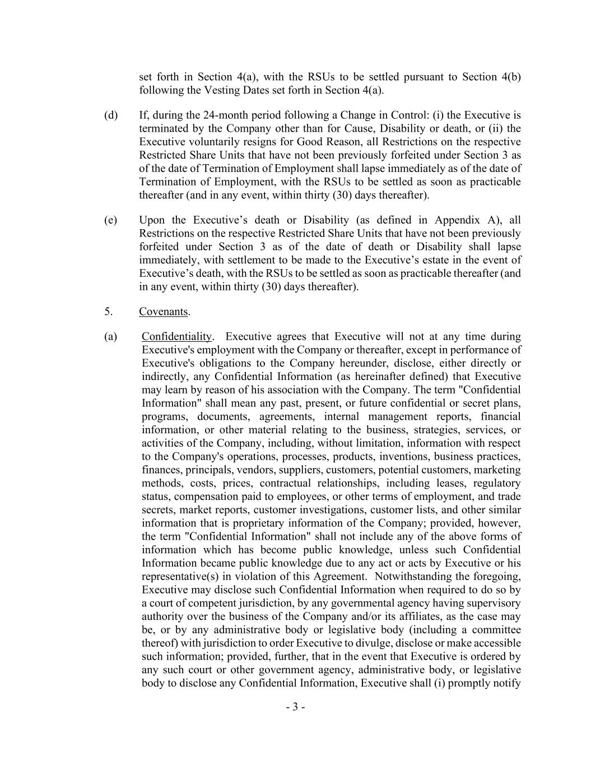
- 3 - set forth in Section 4(a), with the RSUs to be settled pursuant to Section 4(b) following the Vesting Dates set forth in Section 4(a). (d) If, during the 24-month period following a Change in Control: (i) the Executive is terminated by the Company other than for Cause, Disability or death, or (ii) the Executive voluntarily resigns for Good Reason, all Restrictions on the respective Restricted Share Units that have not been previously forfeited under Section 3 as of the date of Termination of Employment shall lapse immediately as of the date of Termination of Employment, with the RSUs to be settled as soon as practicable thereafter (and in any event, within thirty (30) days thereafter). (e) Upon the Executive’s death or Disability (as defined in Appendix A), all Restrictions on the respective Restricted Share Units that have not been previously forfeited under Section 3 as of the date of death or Disability shall lapse immediately, with settlement to be made to the Executive’s estate in the event of Executive’s death, with the RSUs to be settled as soon as practicable thereafter (and in any event, within thirty (30) days thereafter). 5. Covenants. (a) Confidentiality. Executive agrees that Executive will not at any time during Executive's employment with the Company or thereafter, except in performance of Executive's obligations to the Company hereunder, disclose, either directly or indirectly, any Confidential Information (as hereinafter defined) that Executive may learn by reason of his association with the Company. The term "Confidential Information" shall mean any past, present, or future confidential or secret plans, programs, documents, agreements, internal management reports, financial information, or other material relating to the business, strategies, services, or activities of the Company, including, without limitation, information with respect to the Company's operations, processes, products, inventions, business practices, finances, principals, vendors, suppliers, customers, potential customers, marketing methods, costs, prices, contractual relationships, including leases, regulatory status, compensation paid to employees, or other terms of employment, and trade secrets, market reports, customer investigations, customer lists, and other similar information that is proprietary information of the Company; provided, however, the term "Confidential Information" shall not include any of the above forms of information which has become public knowledge, unless such Confidential Information became public knowledge due to any act or acts by Executive or his representative(s) in violation of this Agreement. Notwithstanding the foregoing, Executive may disclose such Confidential Information when required to do so by a court of competent jurisdiction, by any governmental agency having supervisory authority over the business of the Company and/or its affiliates, as the case may be, or by any administrative body or legislative body (including a committee thereof) with jurisdiction to order Executive to divulge, disclose or make accessible such information; provided, further, that in the event that Executive is ordered by any such court or other government agency, administrative body, or legislative body to disclose any Confidential Information, Executive shall (i) promptly notify

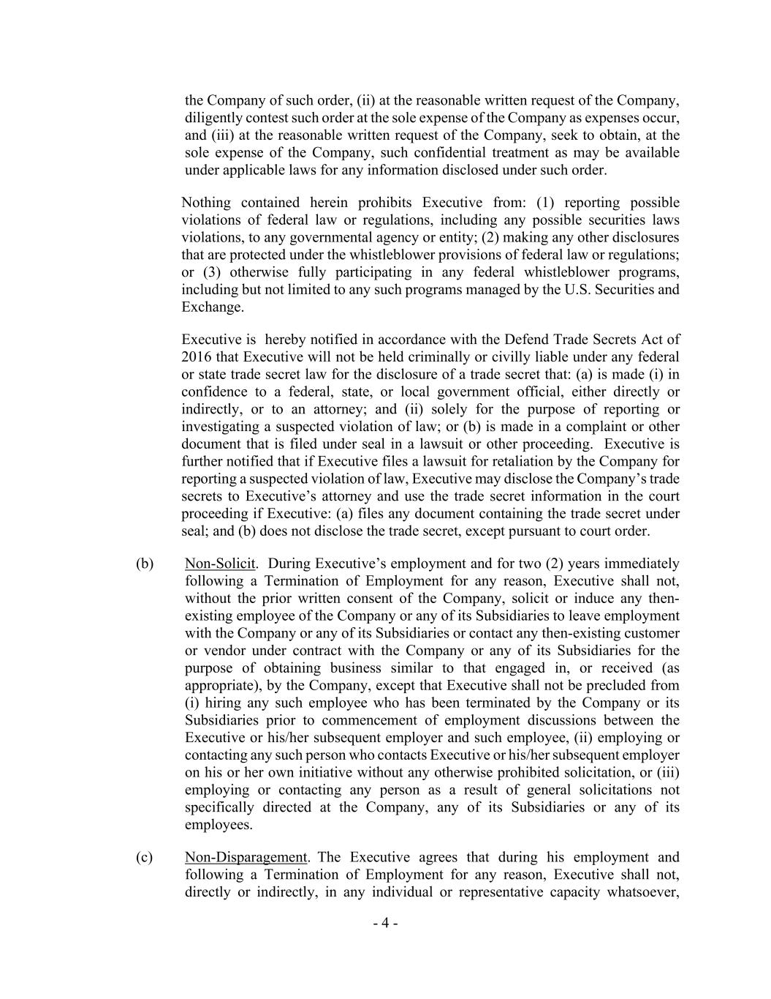
- 4 - the Company of such order, (ii) at the reasonable written request of the Company, diligently contest such order at the sole expense of the Company as expenses occur, and (iii) at the reasonable written request of the Company, seek to obtain, at the sole expense of the Company, such confidential treatment as may be available under applicable laws for any information disclosed under such order. Nothing contained herein prohibits Executive from: (1) reporting possible violations of federal law or regulations, including any possible securities laws violations, to any governmental agency or entity; (2) making any other disclosures that are protected under the whistleblower provisions of federal law or regulations; or (3) otherwise fully participating in any federal whistleblower programs, including but not limited to any such programs managed by the U.S. Securities and Exchange. Executive is hereby notified in accordance with the Defend Trade Secrets Act of 2016 that Executive will not be held criminally or civilly liable under any federal or state trade secret law for the disclosure of a trade secret that: (a) is made (i) in confidence to a federal, state, or local government official, either directly or indirectly, or to an attorney; and (ii) solely for the purpose of reporting or investigating a suspected violation of law; or (b) is made in a complaint or other document that is filed under seal in a lawsuit or other proceeding. Executive is further notified that if Executive files a lawsuit for retaliation by the Company for reporting a suspected violation of law, Executive may disclose the Company’s trade secrets to Executive’s attorney and use the trade secret information in the court proceeding if Executive: (a) files any document containing the trade secret under seal; and (b) does not disclose the trade secret, except pursuant to court order. (b) Non-Solicit. During Executive’s employment and for two (2) years immediately following a Termination of Employment for any reason, Executive shall not, without the prior written consent of the Company, solicit or induce any then- existing employee of the Company or any of its Subsidiaries to leave employment with the Company or any of its Subsidiaries or contact any then-existing customer or vendor under contract with the Company or any of its Subsidiaries for the purpose of obtaining business similar to that engaged in, or received (as appropriate), by the Company, except that Executive shall not be precluded from (i) hiring any such employee who has been terminated by the Company or its Subsidiaries prior to commencement of employment discussions between the Executive or his/her subsequent employer and such employee, (ii) employing or contacting any such person who contacts Executive or his/her subsequent employer on his or her own initiative without any otherwise prohibited solicitation, or (iii) employing or contacting any person as a result of general solicitations not specifically directed at the Company, any of its Subsidiaries or any of its employees. (c) Non-Disparagement. The Executive agrees that during his employment and following a Termination of Employment for any reason, Executive shall not, directly or indirectly, in any individual or representative capacity whatsoever,

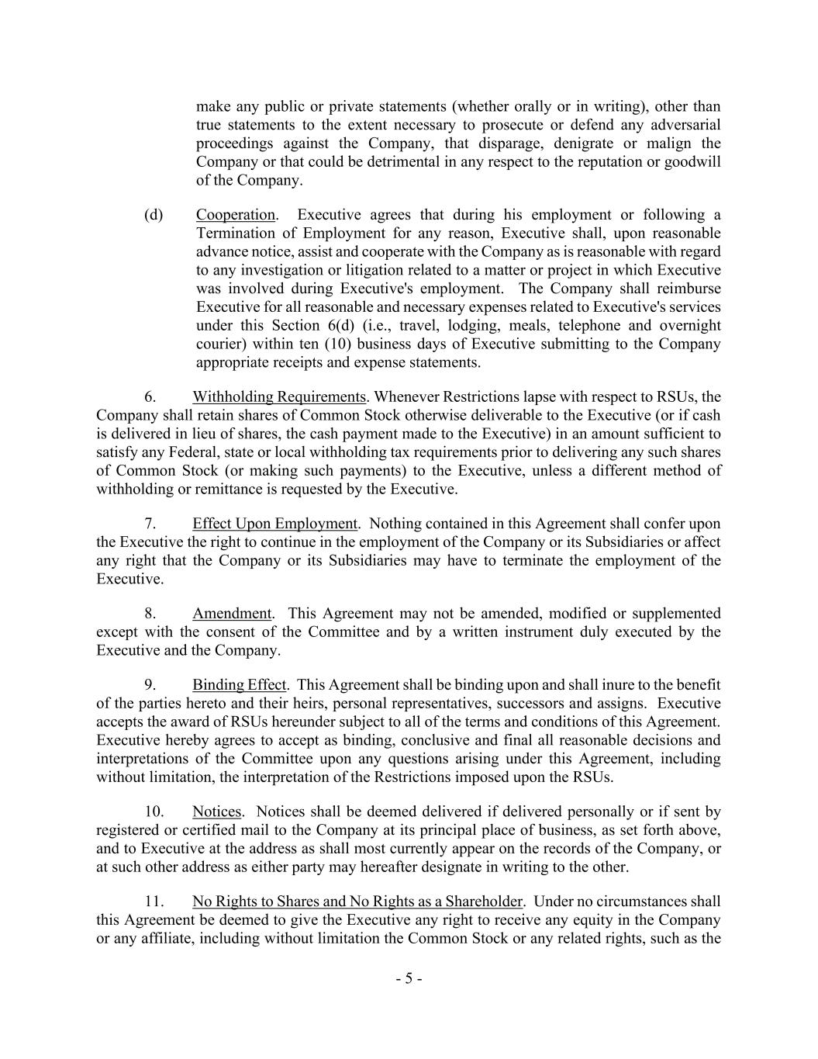
- 5 - make any public or private statements (whether orally or in writing), other than true statements to the extent necessary to prosecute or defend any adversarial proceedings against the Company, that disparage, denigrate or malign the Company or that could be detrimental in any respect to the reputation or goodwill of the Company. (d) Cooperation. Executive agrees that during his employment or following a Termination of Employment for any reason, Executive shall, upon reasonable advance notice, assist and cooperate with the Company as is reasonable with regard to any investigation or litigation related to a matter or project in which Executive was involved during Executive's employment. The Company shall reimburse Executive for all reasonable and necessary expenses related to Executive's services under this Section 6(d) (i.e., travel, lodging, meals, telephone and overnight courier) within ten (10) business days of Executive submitting to the Company appropriate receipts and expense statements. 6. Withholding Requirements. Whenever Restrictions lapse with respect to RSUs, the Company shall retain shares of Common Stock otherwise deliverable to the Executive (or if cash is delivered in lieu of shares, the cash payment made to the Executive) in an amount sufficient to satisfy any Federal, state or local withholding tax requirements prior to delivering any such shares of Common Stock (or making such payments) to the Executive, unless a different method of withholding or remittance is requested by the Executive. 7. Effect Upon Employment. Nothing contained in this Agreement shall confer upon the Executive the right to continue in the employment of the Company or its Subsidiaries or affect any right that the Company or its Subsidiaries may have to terminate the employment of the Executive. 8. Amendment. This Agreement may not be amended, modified or supplemented except with the consent of the Committee and by a written instrument duly executed by the Executive and the Company. 9. Binding Effect. This Agreement shall be binding upon and shall inure to the benefit of the parties hereto and their heirs, personal representatives, successors and assigns. Executive accepts the award of RSUs hereunder subject to all of the terms and conditions of this Agreement. Executive hereby agrees to accept as binding, conclusive and final all reasonable decisions and interpretations of the Committee upon any questions arising under this Agreement, including without limitation, the interpretation of the Restrictions imposed upon the RSUs. 10. Notices. Notices shall be deemed delivered if delivered personally or if sent by registered or certified mail to the Company at its principal place of business, as set forth above, and to Executive at the address as shall most currently appear on the records of the Company, or at such other address as either party may hereafter designate in writing to the other. 11. No Rights to Shares and No Rights as a Shareholder. Under no circumstances shall this Agreement be deemed to give the Executive any right to receive any equity in the Company or any affiliate, including without limitation the Common Stock or any related rights, such as the

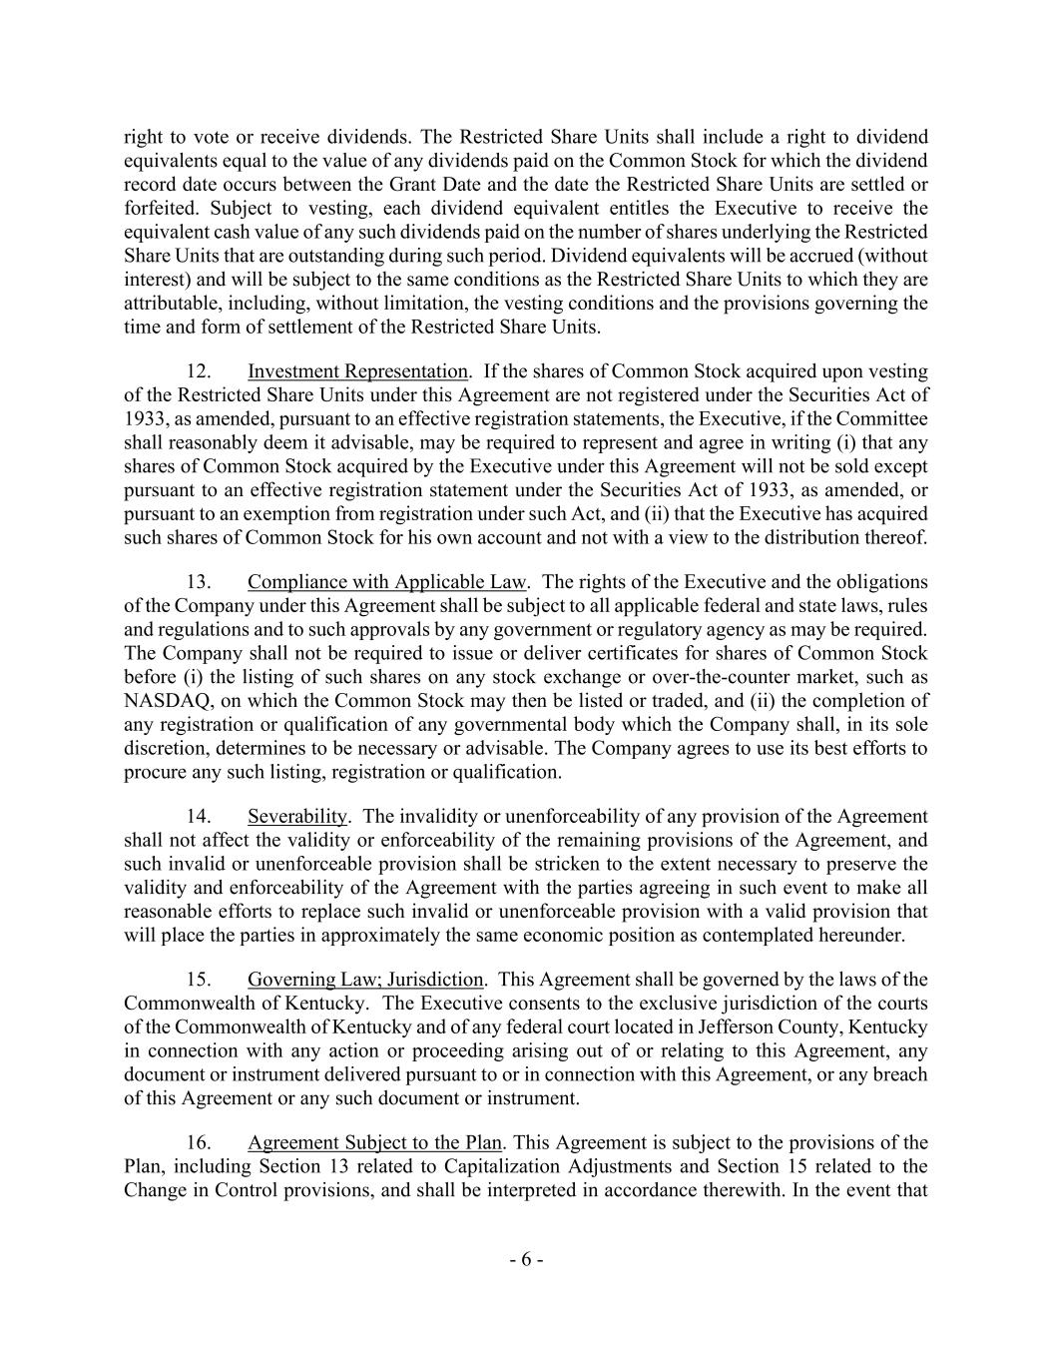
- 6 - right to vote or receive dividends. The Restricted Share Units shall include a right to dividend equivalents equal to the value of any dividends paid on the Common Stock for which the dividend record date occurs between the Grant Date and the date the Restricted Share Units are settled or forfeited. Subject to vesting, each dividend equivalent entitles the Executive to receive the equivalent cash value of any such dividends paid on the number of shares underlying the Restricted Share Units that are outstanding during such period. Dividend equivalents will be accrued (without interest) and will be subject to the same conditions as the Restricted Share Units to which they are attributable, including, without limitation, the vesting conditions and the provisions governing the time and form of settlement of the Restricted Share Units. 12. Investment Representation. If the shares of Common Stock acquired upon vesting of the Restricted Share Units under this Agreement are not registered under the Securities Act of 1933, as amended, pursuant to an effective registration statements, the Executive, if the Committee shall reasonably deem it advisable, may be required to represent and agree in writing (i) that any shares of Common Stock acquired by the Executive under this Agreement will not be sold except pursuant to an effective registration statement under the Securities Act of 1933, as amended, or pursuant to an exemption from registration under such Act, and (ii) that the Executive has acquired such shares of Common Stock for his own account and not with a view to the distribution thereof. 13. Compliance with Applicable Law. The rights of the Executive and the obligations of the Company under this Agreement shall be subject to all applicable federal and state laws, rules and regulations and to such approvals by any government or regulatory agency as may be required. The Company shall not be required to issue or deliver certificates for shares of Common Stock before (i) the listing of such shares on any stock exchange or over-the-counter market, such as NASDAQ, on which the Common Stock may then be listed or traded, and (ii) the completion of any registration or qualification of any governmental body which the Company shall, in its sole discretion, determines to be necessary or advisable. The Company agrees to use its best efforts to procure any such listing, registration or qualification. 14. Severability. The invalidity or unenforceability of any provision of the Agreement shall not affect the validity or enforceability of the remaining provisions of the Agreement, and such invalid or unenforceable provision shall be stricken to the extent necessary to preserve the validity and enforceability of the Agreement with the parties agreeing in such event to make all reasonable efforts to replace such invalid or unenforceable provision with a valid provision that will place the parties in approximately the same economic position as contemplated hereunder. 15. Governing Law; Jurisdiction. This Agreement shall be governed by the laws of the Commonwealth of Kentucky. The Executive consents to the exclusive jurisdiction of the courts of the Commonwealth of Kentucky and of any federal court located in Jefferson County, Kentucky in connection with any action or proceeding arising out of or relating to this Agreement, any document or instrument delivered pursuant to or in connection with this Agreement, or any breach of this Agreement or any such document or instrument. 16. Agreement Subject to the Plan. This Agreement is subject to the provisions of the Plan, including Section 13 related to Capitalization Adjustments and Section 15 related to the Change in Control provisions, and shall be interpreted in accordance therewith. In the event that

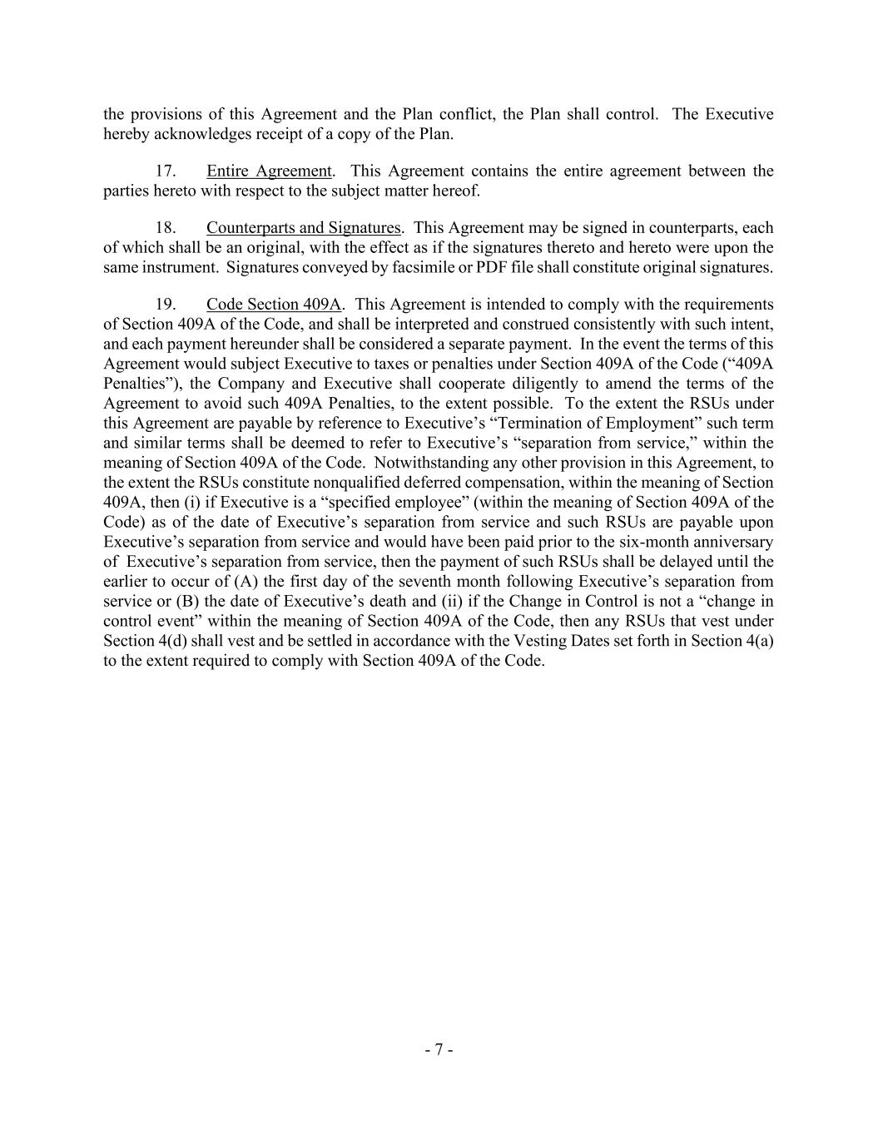
- 7 - the provisions of this Agreement and the Plan conflict, the Plan shall control. The Executive hereby acknowledges receipt of a copy of the Plan. 17. Entire Agreement. This Agreement contains the entire agreement between the parties hereto with respect to the subject matter hereof. 18. Counterparts and Signatures. This Agreement may be signed in counterparts, each of which shall be an original, with the effect as if the signatures thereto and hereto were upon the same instrument. Signatures conveyed by facsimile or PDF file shall constitute original signatures. 19. Code Section 409A. This Agreement is intended to comply with the requirements of Section 409A of the Code, and shall be interpreted and construed consistently with such intent, and each payment hereunder shall be considered a separate payment. In the event the terms of this Agreement would subject Executive to taxes or penalties under Section 409A of the Code (“409A Penalties”), the Company and Executive shall cooperate diligently to amend the terms of the Agreement to avoid such 409A Penalties, to the extent possible. To the extent the RSUs under this Agreement are payable by reference to Executive’s “Termination of Employment” such term and similar terms shall be deemed to refer to Executive’s “separation from service,” within the meaning of Section 409A of the Code. Notwithstanding any other provision in this Agreement, to the extent the RSUs constitute nonqualified deferred compensation, within the meaning of Section 409A, then (i) if Executive is a “specified employee” (within the meaning of Section 409A of the Code) as of the date of Executive’s separation from service and such RSUs are payable upon Executive’s separation from service and would have been paid prior to the six-month anniversary of Executive’s separation from service, then the payment of such RSUs shall be delayed until the earlier to occur of (A) the first day of the seventh month following Executive’s separation from service or (B) the date of Executive’s death and (ii) if the Change in Control is not a “change in control event” within the meaning of Section 409A of the Code, then any RSUs that vest under Section 4(d) shall vest and be settled in accordance with the Vesting Dates set forth in Section 4(a) to the extent required to comply with Section 409A of the Code.


IN WITNESS WHEREOF, the Company and the Executive have executed and delivered this Agreement as of the date first above written. EXECUTIVE CHURCHILL DOWNS INCORPORATED By: Name: Title:

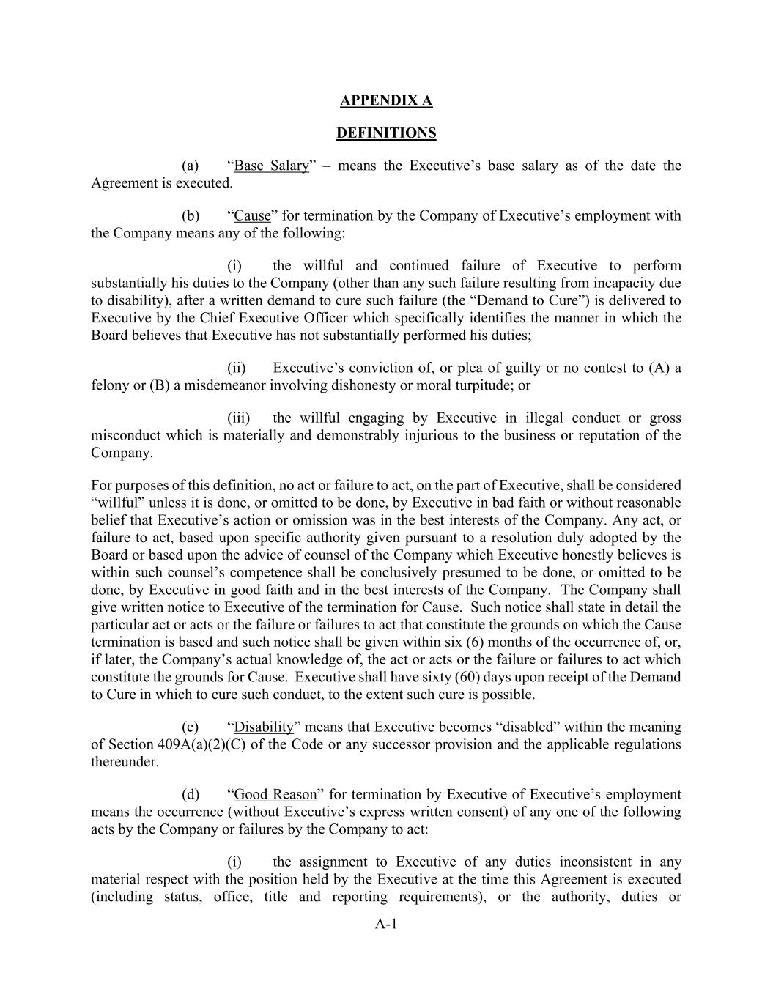
A-1 APPENDIX A DEFINITIONS (a) “Base Salary” – means the Executive’s base salary as of the date the Agreement is executed. (b) “Cause” for termination by the Company of Executive’s employment with the Company means any of the following: (i) the willful and continued failure of Executive to perform substantially his duties to the Company (other than any such failure resulting from incapacity due to disability), after a written demand to cure such failure (the “Demand to Cure”) is delivered to Executive by the Chief Executive Officer which specifically identifies the manner in which the Board believes that Executive has not substantially performed his duties; (ii) Executive’s conviction of, or plea of guilty or no contest to (A) a felony or (B) a misdemeanor involving dishonesty or moral turpitude; or (iii) the willful engaging by Executive in illegal conduct or gross misconduct which is materially and demonstrably injurious to the business or reputation of the Company. For purposes of this definition, no act or failure to act, on the part of Executive, shall be considered “willful” unless it is done, or omitted to be done, by Executive in bad faith or without reasonable belief that Executive’s action or omission was in the best interests of the Company. Any act, or failure to act, based upon specific authority given pursuant to a resolution duly adopted by the Board or based upon the advice of counsel of the Company which Executive honestly believes is within such counsel’s competence shall be conclusively presumed to be done, or omitted to be done, by Executive in good faith and in the best interests of the Company. The Company shall give written notice to Executive of the termination for Cause. Such notice shall state in detail the particular act or acts or the failure or failures to act that constitute the grounds on which the Cause termination is based and such notice shall be given within six (6) months of the occurrence of, or, if later, the Company’s actual knowledge of, the act or acts or the failure or failures to act which constitute the grounds for Cause. Executive shall have sixty (60) days upon receipt of the Demand to Cure in which to cure such conduct, to the extent such cure is possible. (c) “Disability” means that Executive becomes “disabled” within the meaning of Section 409A(a)(2)(C) of the Code or any successor provision and the applicable regulations thereunder. (d) “Good Reason” for termination by Executive of Executive’s employment means the occurrence (without Executive’s express written consent) of any one of the following acts by the Company or failures by the Company to act: (i) the assignment to Executive of any duties inconsistent in any material respect with the position held by the Executive at the time this Agreement is executed (including status, office, title and reporting requirements), or the authority, duties or

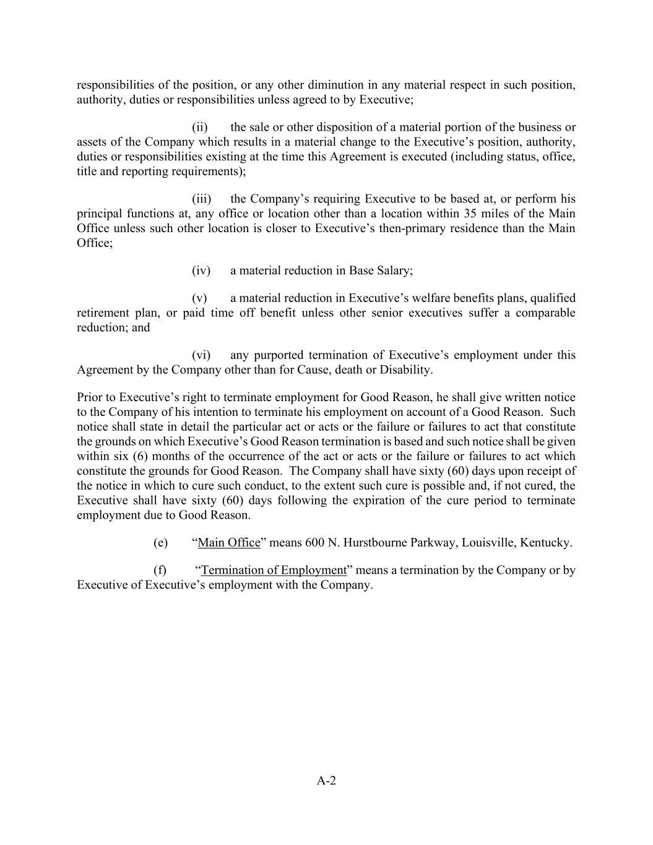
A-2 responsibilities of the position, or any other diminution in any material respect in such position, authority, duties or responsibilities unless agreed to by Executive; (ii) the sale or other disposition of a material portion of the business or assets of the Company which results in a material change to the Executive’s position, authority, duties or responsibilities existing at the time this Agreement is executed (including status, office, title and reporting requirements); (iii) the Company’s requiring Executive to be based at, or perform his principal functions at, any office or location other than a location within 35 miles of the Main Office unless such other location is closer to Executive’s then-primary residence than the Main Office; (iv) a material reduction in Base Salary; (v) a material reduction in Executive’s welfare benefits plans, qualified retirement plan, or paid time off benefit unless other senior executives suffer a comparable reduction; and (vi) any purported termination of Executive’s employment under this Agreement by the Company other than for Cause, death or Disability. Prior to Executive’s right to terminate employment for Good Reason, he shall give written notice to the Company of his intention to terminate his employment on account of a Good Reason. Such notice shall state in detail the particular act or acts or the failure or failures to act that constitute the grounds on which Executive’s Good Reason termination is based and such notice shall be given within six (6) months of the occurrence of the act or acts or the failure or failures to act which constitute the grounds for Good Reason. The Company shall have sixty (60) days upon receipt of the notice in which to cure such conduct, to the extent such cure is possible and, if not cured, the Executive shall have sixty (60) days following the expiration of the cure period to terminate employment due to Good Reason. (e) “Main Office” means 600 N. Hurstbourne Parkway, Louisville, Kentucky. (f) “Termination of Employment” means a termination by the Company or by Executive of Executive’s employment with the Company.

EXHIBIT 31(a)
CERTIFICATION OF CHIEF EXECUTIVE OFFICER
I, William C. Carstanjen, certify that:
1.I have reviewed this Quarterly Report on Form 10-Q of Churchill Downs Incorporated;
2.Based on my knowledge, this report does not contain any untrue statement of a material fact or omit to state a material fact necessary to make the statements made, in light of the circumstances under which such statements were made, not misleading with respect to the period covered by this report;
3.Based on my knowledge, the financial statements, and other financial information included in this report, fairly present in all material respects the financial condition, results of operations and cash flows of the registrant as of, and for, the periods presented in this report;
4.The registrant’s other certifying officer(s) and I are responsible for establishing and maintaining disclosure controls and procedures (as defined in Exchange Act Rules 13a-15(e) and 15d-15(e)) and internal control over financial reporting (as defined in Exchange Act Rules 13a-15(f) and 15d-15(f)) for the registrant and have:
a.Designed such disclosure controls and procedures, or caused such disclosure controls and procedures to be designed under our supervision, to ensure that material information relating to the registrant, including its consolidated subsidiaries, is made known to us by others within those entities, particularly during the period in which this report is being prepared;
b.Designed such internal control over financial reporting, or caused such internal control over financial reporting to be designed under our supervision, to provide reasonable assurance regarding the reliability of financial reporting and the preparation of financial statements for external purposes in accordance with generally accepted accounting principles;
c.Evaluated the effectiveness of the registrant’s disclosure controls and procedures and presented in this report our conclusions about the effectiveness of the disclosure controls and procedures, as of the end of the period covered by this report based on such evaluation; and
d.Disclosed in this report any change in the registrant’s internal control over financial reporting that occurred during the registrant’s most recent fiscal quarter (the registrant’s fourth fiscal quarter in the case of an annual report) that has materially affected, or is reasonably likely to materially affect, the registrant’s internal control over financial reporting; and
5.The registrant’s other certifying officer(s) and I have disclosed, based on our most recent evaluation of internal control over financial reporting, to the registrant’s auditors and the audit committee of the registrant’s board of directors (or persons performing the equivalent functions):
a.All significant deficiencies and material weaknesses in the design or operation of internal control over financial reporting which are reasonably likely to adversely affect the registrant’s ability to record, process, summarize and report financial information; and
b.Any fraud, whether or not material, that involves management or other employees who have a significant role in the registrant’s internal control over financial reporting.
Date: |  |  | April 22, 2026 |  |  |  |  |  | /s/ William C. Carstanjen
William C. Carstanjen
Chief Executive Officer
(Principal Executive Officer)

EXHIBIT 31(b)
CERTIFICATION OF PRINCIPAL FINANCIAL OFFICER
I, Marcia A. Dall, certify that:
1.I have reviewed this Quarterly Report on Form 10-Q of Churchill Downs Incorporated;
2.Based on my knowledge, this report does not contain any untrue statement of a material fact or omit to state a material fact necessary to make the statements made, in light of the circumstances under which such statements were made, not misleading with respect to the period covered by this report;
3.Based on my knowledge, the financial statements, and other financial information included in this report, fairly present in all material respects the financial condition, results of operations and cash flows of the registrant as of, and for, the periods presented in this report;
4.The registrant’s other certifying officer(s) and I are responsible for establishing and maintaining disclosure controls and procedures (as defined in Exchange Act Rules 13a-15(e) and 15d-15(e)) and internal control over financial reporting (as defined in Exchange Act Rules 13a-15(f) and 15d-15(f)) for the registrant and have:
a.Designed such disclosure controls and procedures, or caused such disclosure controls and procedures to be designed under our supervision, to ensure that material information relating to the registrant, including its consolidated subsidiaries, is made known to us by others within those entities, particularly during the period in which this report is being prepared;
b.Designed such internal control over financial reporting, or caused such internal control over financial reporting to be designed under our supervision, to provide reasonable assurance regarding the reliability of financial reporting and the preparation of financial statements for external purposes in accordance with generally accepted accounting principles;
c.Evaluated the effectiveness of the registrant’s disclosure controls and procedures and presented in this report our conclusions about the effectiveness of the disclosure controls and procedures, as of the end of the period covered by this report based on such evaluation; and
d.Disclosed in this report any change in the registrant’s internal control over financial reporting that occurred during the registrant’s most recent fiscal quarter (the registrant’s fourth fiscal quarter in the case of an annual report) that has materially affected, or is reasonably likely to materially affect, the registrant’s internal control over financial reporting; and
5.The registrant’s other certifying officer(s) and I have disclosed, based on our most recent evaluation of internal control over financial reporting, to the registrant’s auditors and the audit committee of the registrant’s board of directors (or persons performing the equivalent functions):
a.All significant deficiencies and material weaknesses in the design or operation of internal control over financial reporting which are reasonably likely to adversely affect the registrant’s ability to record, process, summarize and report financial information; and
b.Any fraud, whether or not material, that involves management or other employees who have a significant role in the registrant’s internal control over financial reporting.
Date: |  |  | April 22, 2026 |  |  |  |  |  | /s/ Marcia A. Dall
Marcia A. Dall
Executive Vice President and Chief Financial Officer
(Principal Financial & Accounting Officer)

EXHIBIT 32
Certification of Chief Executive Officer and Chief Financial Officer Pursuant to
18 U.S.C. Section 1350,
As Adopted Pursuant to
Section 906 of the Sarbanes-Oxley Act of 2002
In connection with the Quarterly Report on Form 10-Q of Churchill Downs Incorporated (the “Company”) for the year ended March 31, 2026, as filed with the Securities and Exchange Commission on the date hereof (the “Report”), William C. Carstanjen, as Chief Executive Officer (Principal Executive Officer) of the Company, and Marcia A. Dall, as Executive Vice President and Chief Financial Officer (Principal Financial & Accounting Officer) of the Company, each hereby certifies, pursuant to 18 U.S.C. § 1350, as adopted pursuant to § 906 of the Sarbanes-Oxley Act of 2002, to the best of his or her knowledge, that:
(1)The Report fully complies with the requirements of section 13(a) or 15(d) of the Securities Exchange Act of 1934, as amended; and
(2)The information contained in the Report fairly presents, in all material respects, the financial condition and results of operations of the Company.
/s/ William C. Carstanjen
William C. Carstanjen
Chief Executive Officer
(Principal Executive Officer)
April 22, 2026
/s/ Marcia A. Dall
Marcia A. Dall
Executive Vice President and Chief Financial Officer
(Principal Financial & Accounting Officer)
April 22, 2026
This certification is being furnished to the Securities and Exchange Commission as an exhibit to the Report and shall not be deemed filed by the Company for purposes of § 18 of the Securities Exchange Act of 1934, as amended.
A signed original of this written statement required by Section 906, or other document authenticating, acknowledging, or otherwise adopting the signature that appears in typed form within the electronic version of this written statement required by Section 906, has been provided to Churchill Downs Incorporated and will be retained by Churchill Downs Incorporated and furnished to the Securities and Exchange Commission or its staff upon request.

