UNITED STATES

SECURITIES AND EXCHANGE COMMISSION

WASHINGTON, D.C. 20549

FORM 10-Q

- QUARTERLY REPORT PURSUANT TO SECTION 13 OR 15(d) OF THE SECURITIES EXCHANGE ACT OF 1934

For the quarterly period ended September 30, 2024

OR

- TRANSITION REPORT PURSUANT TO SECTION 13 OR 15(d) OF THE SECURITIES EXCHANGE ACT OF 1934

 | For the transition period from |  | to
 | Commission file number 001-33998
Churchill Downs Incorporated
 | (Exact name of registrant as specified in its charter)
Kentucky |  |  | 61-0156015
(State or other jurisdiction of incorporation or organization) |  |  |  |  |  | (I.R.S. Employer Identification No.)
600 North Hurstbourne Parkway, Suite 400
Louisville, Kentucky |  |  | 40222
(Address of Principal Executive Offices) |  |  |  |  |  | (Zip Code)
 | (502) 636-4400
 | Registrant's telephone number, including area code
Securities registered pursuant to Section 12(b) of the Act:
Title of each class | Trading Symbol(s) |  |  |  |  | Name of each exchange on which registered
Common Stock, No Par Value | CHDN |  |  |  |  | The Nasdaq Global Select Market LLC

Indicate by check mark whether the registrant (1) has filed all reports required to be filed by Section 13 or 15(d) of the Securities Exchange Act of 1934 during the preceding 12 months (or for such shorter period that the registrant was required to file such reports), and (2) has been subject to such filing requirements for the past 90 days. Yes ☒ No ☐

Indicate by check mark whether the registrant has submitted electronically every Interactive Data File required to be submitted pursuant to Rule 405 of Regulation S-T (§232.405 of this chapter) during the preceding 12 months (or for such shorter period that the registrant was required to submit such files). Yes ☒ No ☐

Indicate by check mark whether the registrant is a large accelerated filer, an accelerated filer, a non-accelerated filer, a smaller reporting company, or an emerging growth company. See definitions of "large accelerated filer," "accelerated filer," "smaller reporting company," and "emerging growth company" in Rule 12b-2 of the Exchange Act.

Large accelerated filer | ☒ | Accelerated filer | ☐
Non-accelerated filer | ☐ | Smaller reporting company | ☐
 |  | Emerging growth company | ☐

If an emerging growth company, indicate by check mark if the registrant has elected not to use the extended transition period for complying with any new or revised financial accounting standards provided pursuant to Section 13(a) of the Exchange Act. ☐

Indicate by check mark whether the registrant is a shell company (as defined in Rule 12b-2 of the Exchange Act). Yes ☐ No ☒ The number of shares outstanding of registrant’s common stock at October 16, 2024 was 73,496,741 shares.

CHURCHILL DOWNS INCORPORATED

INDEX TO QUARTERLY REPORT ON FORM 10-Q

For the Quarter Ended September 30, 2024

 |  | Part I-FINANCIAL INFORMATION
Item 1. |  | Financial Statements (Unaudited)
 |  | Condensed Consolidated Statements of Comprehensive Income for the three and nine months ended September 30, 2024 and 2023 |  |  |  |  |  |  |  |  |  | 3
 |  | Condensed Consolidated Balance Sheets at September 30, 2024 and December 31, 2023 |  |  |  |  |  |  |  |  |  | 4
 |  | Condensed Consolidated Statements of Shareholders' Equity for the three and nine months ended September 30, 2024 and 2023 |  |  |  |  |  |  |  |  |  | 5
 |  | Condensed Consolidated Statements of Cash Flows for the nine months ended September 30, 2024 and 2023 |  |  |  |  |  |  |  |  |  | 7
 |  | Notes to Condensed Consolidated Financial Statements |  |  |  |  |  |  |  |  |  | 9
Item 2. |  | Management's Discussion and Analysis of Financial Condition and Results of Operations |  |  |  |  |  |  |  |  |  | 27
Item 3. |  | Quantitative and Qualitative Disclosures About Market Risk |  |  |  |  |  |  |  |  |  |  | 38
Item 4. |  | Controls and Procedures |  |  |  |  |  |  |  |  |  |  | 38

 |  |  | Part II-OTHER INFORMATION
Item 1. |  |  | Legal Proceedings |  |  |  |  |  |  |  |  |  |  | 40
Item 1A. |  |  | Risk Factors |  |  |  |  |  |  |  |  |  | 40
Item 2. |  |  | Unregistered Sales of Equity Securities and Use of Proceeds |  |  |  |  |  |  |  |  |  | 40
Item 3. |  |  | Defaults Upon Senior Securities |  |  |  |  |  |  |  |  |  |  | 40
Item 4. |  |  | Mine Safety Disclosures |  |  |  |  |  |  |  |  |  | 40
Item 5. |  |  | Other Information |  |  |  |  |  |  |  |  |  |  | 40
Item 6. |  |  | Exhibits |  |  |  |  |  |  |  |  |  |  | 41
 |  |  | Signatures |  |  |  |  |  |  |  |  |  | 42

FORM 10-Q FOR THE QUARTERLY PERIOD ENDED SEPTEMBER 30, 2024

2

PART I. | FINANCIAL INFORMATION
ITEM 1. | FINANCIAL STATEMENTS
 |  | CHURCHILL DOWNS INCORPORATED
 | CONDENSED CONSOLIDATED STATEMENTS OF COMPREHENSIVE INCOME
 |  |  |  | (Unaudited)
 |  |  |  | Three Months Ended September 30, |  |  |  |  |  | Nine Months Ended September 30,
(in millions, except per common share data) |  |  |  | 2024 |  |  | 2023 |  |  | 2024 |  |  | 2023
Net revenue:
Live and Historical Racing |  | $ |  | 247.5 |  | $ | 219.5 |  | $ | 957.3 |  | $ | 818.9
TwinSpires |  |  |  | 111.3 |  |  | 108.5 |  |  | 369.6 |  |  | 340.7
Gaming |  |  |  | 269.7 |  |  | 244.3 |  |  | 783.1 |  |  | 740.2
All Other |  |  |  | — |  |  | 0.2 |  |  | 0.1 |  |  | 0.7
Total net revenue |  |  |  | 628.5 |  |  | 572.5 |  |  | 2,110.1 |  |  | 1,900.5
Operating expense:
Live and Historical Racing |  |  |  | 171.3 |  |  | 158.2 |  |  | 549.9 |  |  | 505.7
TwinSpires |  |  |  | 72.3 |  |  | 73.4 |  |  | 229.5 |  |  | 219.8
Gaming |  |  |  | 194.8 |  |  | 175.6 |  |  | 561.7 |  |  | 528.3
All Other |  |  |  | 4.5 |  |  | 1.3 |  |  | 10.2 |  |  | 12.0
Selling, general and administrative expense |  |  |  | 59.8 |  |  | 50.2 |  |  | 172.0 |  |  | 150.6
Asset impairments |  |  |  | 3.9 |  |  | — |  |  | 3.9 |  |  | 24.5
Transaction expense, net |  |  |  | (4.0) |  |  | 1.5 |  |  | 0.7 |  |  | 1.8
Total operating expense |  |  |  | 502.6 |  |  | 460.2 |  |  | 1,527.9 |  |  | 1,442.7
Operating income |  |  |  | 125.9 |  |  | 112.3 |  |  | 582.2 |  |  | 457.8
Other (expense) income:
Interest expense, net |  |  |  | (73.1) |  |  | (67.9) |  |  | (217.0) |  |  | (197.8)
Equity in income of unconsolidated affiliates |  |  |  | 33.4 |  |  | 33.3 |  |  | 108.9 |  |  | 110.4
Gain on sale of Arlington |  |  |  | — |  |  | — |  |  | — |  |  | 114.0
Miscellaneous, net |  |  |  | (0.1) |  |  | 4.1 |  |  | 8.1 |  |  | 5.5
Total other (expense) income |  |  |  | (39.8) |  |  | (30.5) |  |  | (100.0) |  |  | 32.1
Income from operations before provision for income taxes |  |  |  | 86.1 |  |  | 81.8 |  |  | 482.2 |  |  | 489.9
Income tax provision |  |  |  | (19.9) |  |  | (20.8) |  |  | (125.4) |  |  | (130.2)
Net income |  |  |  | 66.2 |  |  | 61.0 |  |  | 356.8 |  |  | 359.7
Net income attributable to noncontrolling interest |  |  |  | 0.8 |  |  | — |  |  | 1.7 |  |  | —
Net income attributable to Churchill Downs Incorporated |  |  | $ | 65.4 |  | $ | 61.0 |  | $ | 355.1 |  | $ | 359.7
Net income attributable to Churchill Downs Incorporated per common share data:
Basic net income |  |  | $ | 0.87 |  | $ | 0.81 |  | $ | 4.78 |  | $ | 4.78
Diluted net income |  | $ |  | 0.86 |  | $ | 0.79 |  | $ | 4.73 |  | $ | 4.69
Weighted average shares outstanding:
Basic |  |  |  | 73.9 |  |  | 75.2 |  |  | 74.0 |  |  | 75.3
Diluted |  |  |  | 74.6 |  |  | 77.1 |  |  | 74.6 |  |  | 76.7

The accompanying notes are an integral part of the condensed consolidated financial statements.

FORM 10-Q FOR THE QUARTERLY PERIOD ENDED SEPTEMBER 30, 2024

3

CHURCHILL DOWNS INCORPORATED

CONDENSED CONSOLIDATED BALANCE SHEETS

(Unaudited)

(in millions) |  | September 30, 2024 |  |  | December 31, 2023
ASSETS
Current assets:
Cash and cash equivalents | $ | 152.7 |  | $ | 144.5
Restricted cash |  | 78.7 |  |  | 77.3
Accounts receivable, net |  | 93.2 |  |  | 106.9
Income taxes receivable |  | — |  |  | 12.6
Other current assets |  | 62.8 |  |  | 59.5
Total current assets |  | 387.4 |  |  | 400.8
Property and equipment, net |  | 2,805.5 |  |  | 2,561.2
Investment in and advances to unconsolidated affiliates |  | 650.2 |  |  | 655.9
Goodwill |  | 900.2 |  |  | 899.9
Other intangible assets, net |  | 2,411.7 |  |  | 2,418.4
Other assets |  | 17.5 |  |  | 19.3
Total assets | $ | 7,172.5 |  | $ | 6,955.5
LIABILITIES AND SHAREHOLDERS' EQUITY
Current liabilities:
Accounts payable | $ | 182.4 |  | $ | 158.5
Accrued expenses and other current liabilities |  | 430.1 |  |  | 426.8
Income taxes payable |  | 7.1 |  |  | —
Current deferred revenue |  | 26.8 |  |  | 73.2
Current maturities of long-term debt |  | 63.1 |  |  | 68.0
Dividends payable |  | 0.6 |  |  | 29.3
Total current liabilities |  | 710.1 |  |  | 755.8
Long-term debt, net of current maturities and loan origination fees |  | 1,695.7 |  |  | 1,697.1
Notes payable, net of debt issuance costs |  | 3,074.9 |  |  | 3,071.2
Non-current deferred revenue |  | 20.1 |  |  | 11.8
Deferred income taxes |  | 417.8 |  |  | 388.2
Other liabilities |  | 139.0 |  |  | 137.8
Total liabilities |  | 6,057.6 |  |  | 6,061.9
Commitments and contingencies
Redeemable noncontrolling interest |  | 17.9 |  |  | —
Shareholders' equity:
Preferred stock |  | — |  |  | —
Common stock |  | 1.7 |  |  | —
Retained earnings |  | 1,096.3 |  |  | 894.5
Accumulated other comprehensive loss |  | (1.0) |  |  | (0.9)
Total Churchill Downs Incorporated shareholders' equity |  | 1,097.0 |  |  | 893.6
Total liabilities and shareholders' equity | $ | 7,172.5 |  | $ | 6,955.5

The accompanying notes are an integral part of the condensed consolidated financial statements.

FORM 10-Q FOR THE QUARTERLY PERIOD ENDED SEPTEMBER 30, 2024

4

CHURCHILL DOWNS INCORPORATED

CONDENSED CONSOLIDATED STATEMENTS OF SHAREHOLDERS' EQUITY

(Unaudited)

 | Common Stock
 | Shares |  | Amount |  |  | Retained |  |  |  | Accumulated Other |  | Total Shareholders' Equity
(in millions) |  |  | Amount |  |  | Earnings |  |  |  | Comprehensive Loss
Balance, December 31, 2023 | 74.5 |  | $ | — |  | $ | 894.5 |  | $ | (0.9) |  | $ | 893.6
Net income attributable to Churchill Downs Incorporated |  |  |  |  |  |  | 80.4 |  |  |  |  |  | 80.4
Issuance of common stock | 0.3 |  |  |  |  |  |  |  |  |  |  |  | —
Repurchase of common stock | (1.2) |  |  | (7.2) |  |  | (138.5) |  |  |  |  |  | (145.7)
Taxes paid related to net share settlement of stock awards | (0.1) |  |  |  |  |  | (7.6) |  |  |  |  |  | (7.6)
Stock-based compensation |  |  |  | 7.2 |  |  |  |  |  |  |  |  | 7.2
Other |  |  |  |  |  |  | (1.0) |  |  |  |  |  | (1.0)
Balance, March 31, 2024 | 73.5 |  |  | — |  |  | 827.8 |  |  | (0.9) |  |  | 826.9
Net income attributable to Churchill Downs Incorporated |  |  |  |  |  |  | 209.3 |  |  |  |  |  | 209.3
Repurchase of common stock | (0.1) |  |  | (8.9) |  |  | (4.1) |  |  |  |  |  | (13.0)
Taxes paid related to net share settlement of stock awards |  |  |  |  |  |  | (0.2) |  |  |  |  |  | (0.2)
Stock-based compensation |  |  |  | 8.9 |  |  |  |  |  |  |  |  | 8.9
Other |  |  |  |  |  |  | (0.9) |  |  | (0.1) |  |  | (1.0)
Balance, June 30, 2024 | 73.4 |  |  | — |  |  | 1,031.9 |  |  | (1.0) |  |  | 1,030.9
Net income attributable to Churchill Downs Incorporated |  |  |  |  |  |  | 65.4 |  |  |  |  |  | 65.4
Issuance of common stock | 0.2 |  |  | 4.2 |  |  |  |  |  |  |  |  | 4.2
Repurchase of common stock | (0.1) |  |  | (9.0) |  |  |  |  |  |  |  |  | (9.0)
Taxes paid related to net share settlement of stock awards |  |  |  | (0.1) |  |  |  |  |  |  |  |  | (0.1)
Stock-based compensation |  |  |  | 7.1 |  |  |  |  |  |  |  |  | 7.1
Other |  |  |  | (0.5) |  |  | (1.0) |  |  |  |  |  | (1.5)
Balance, September 30, 2024 | 73.5 |  | $ | 1.7 |  | $ | 1,096.3 |  | $ | (1.0) |  | $ | 1,097.0

The accompanying notes are an integral part of the condensed consolidated financial statements.

FORM 10-Q FOR THE QUARTERLY PERIOD ENDED SEPTEMBER 30, 2024

5

CHURCHILL DOWNS INCORPORATED

CONDENSED CONSOLIDATED STATEMENTS OF SHAREHOLDERS' EQUITY

(Unaudited)

 | Common Stock
 | Shares |  | Amount |  |  | Retained |  |  |  | Accumulated Other |  | Total Shareholders' Equity
(in millions) |  |  | Amount |  |  | Earnings |  |  |  | Comprehensive Loss
Balance, December 31, 2022 | 74.8 |  | $ | — |  | $ | 552.4 |  | $ | (0.9) |  | $ | 551.5
Net income |  |  |  |  |  |  | 155.7 |  |  |  |  |  | 155.7
Issuance of common stock | 0.2 |  |  |  |  |  |  |  |  |  |  |  | —
Taxes paid related to net share settlement of stock awards | (0.1) |  |  | (8.6) |  |  | (2.7) |  |  |  |  |  | (11.3)
Stock-based compensation |  |  |  | 8.6 |  |  |  |  |  |  |  |  | 8.6
Other |  |  |  |  |  |  | (0.3) |  |  |  |  |  | (0.3)
Balance, March 31, 2023 | 74.9 |  |  | — |  |  | 705.1 |  |  | (0.9) |  |  | 704.2
Net income |  |  |  |  |  |  | 143.0 |  |  |  |  |  | 143.0
Taxes paid related to net share settlement of stock awards |  |  |  | (0.1) |  |  |  |  |  |  |  |  | (0.1)
Stock-based compensation |  |  |  | 8.1 |  |  |  |  |  |  |  |  | 8.1
Other |  |  |  |  |  |  | (1.4) |  |  |  |  |  | (1.4)
Balance, June 30, 2023 | 74.9 |  |  | 8.0 |  |  | 846.7 |  |  | (0.9) |  |  | 853.8
Net income |  |  |  |  |  |  | 61.0 |  |  |  |  |  | 61.0
Issuance of common stock |  |  |  | 3.1 |  |  |  |  |  |  |  |  | 3.1
Repurchase of common stock | (0.3) |  |  | (19.2) |  |  | (18.1) |  |  |  |  |  | (37.3)
Stock-based compensation |  |  |  | 8.1 |  |  |  |  |  |  |  |  | 8.1
Balance, September 30, 2023 | 74.6 |  | $ | — |  | $ | 889.6 |  | $ | (0.9) |  | $ | 888.7

The accompanying notes are an integral part of the condensed consolidated financial statements.

FORM 10-Q FOR THE QUARTERLY PERIOD ENDED SEPTEMBER 30, 2024

6

CHURCHILL DOWNS INCORPORATED

CONDENSED CONSOLIDATED STATEMENTS OF CASH FLOWS

(Unaudited)

 |  | Nine Months Ended September 30,
(in millions) |  | 2024 |  |  | 2023
Cash flows from operating activities:
Net income | $ | 356.8 |  | $ | 359.7
Adjustments to reconcile net income to net cash provided by operating activities:
Depreciation and amortization |  | 145.7 |  |  | 121.8
Distributions from unconsolidated affiliates |  | 113.8 |  |  | 126.6
Equity in income of unconsolidated affiliates |  | (108.9) |  |  | (110.4)
Stock-based compensation |  | 23.2 |  |  | 24.8
Deferred income taxes |  | 29.6 |  |  | 45.3
Asset impairments |  | 3.9 |  |  | 24.5
Amortization of operating lease assets |  | 4.1 |  |  | 4.8
Gain on sale of Arlington |  | — |  |  | (114.0)
Other |  | 9.1 |  |  | 6.5
Changes in operating assets and liabilities:
Income taxes |  | 17.1 |  |  | 6.0
Deferred revenue |  | (38.1) |  |  | (10.8)
Other assets and liabilities |  | 84.8 |  |  | 14.0
Net cash provided by operating activities |  | 641.1 |  |  | 498.8
Cash flows from investing activities:
Capital maintenance expenditures |  | (49.8) |  |  | (52.4)
Capital project expenditures |  | (367.8) |  |  | (445.7)
Acquisition of businesses, net of cash acquired |  | — |  |  | (241.3)
Proceeds from sale of Arlington |  | — |  |  | 195.7
Other |  | 1.8 |  |  | (5.8)
Net cash used in investing activities |  | (415.8) |  |  | (549.5)
Cash flows from financing activities:
Proceeds from borrowings under long-term debt obligations |  | 750.4 |  |  | 1,420.8
Repayments of borrowings under long-term debt obligations |  | (757.5) |  |  | (1,297.1)
Payment of dividends |  | (28.7) |  |  | (26.8)
Repurchase of common stock |  | (158.7) |  |  | (35.8)
Taxes paid related to net share settlement of stock awards |  | (10.6) |  |  | (13.2)
Debt issuance costs |  | (2.5) |  |  | (12.3)
Change in bank overdraft |  | (7.5) |  |  | 1.4
Other |  | (1.6) |  |  | 1.7
Net cash (used in) provided by financing activities |  | (216.7) |  |  | 38.7
Cash flows from discontinued operations:
Operating activities of discontinued operations |  | 1.0 |  |  | 0.5
Net increase (decrease) in cash, cash equivalents and restricted cash |  | 9.6 |  |  | (11.5)
Cash, cash equivalents and restricted cash, beginning of period |  | 221.8 |  |  | 204.7
Cash, cash equivalents and restricted cash, end of period | $ | 231.4 |  | $ | 193.2

The accompanying notes are an integral part of the condensed consolidated financial statements.

FORM 10-Q FOR THE QUARTERLY PERIOD ENDED SEPTEMBER 30, 2024

7

CHURCHILL DOWNS INCORPORATED

CONDENSED CONSOLIDATED STATEMENTS OF CASH FLOWS (Continued)

(Unaudited)

Nine Months Ended September 30,

(in millions) |  | 2024 |  |  | 2023
Supplemental disclosures of cash flow information:
Cash paid for interest | $ | 205.3 |  | $ | 180.5
Cash paid for income taxes |  | 81.8 |  |  | 78.9
Cash received from income tax refunds |  | 4.1 |  |  | 0.8
Schedule of non-cash operating, investing and financing activities:
Property and equipment additions included in accounts payable and accrued expenses | $ | 55.2 |  | $ | 52.0
Right-of-use assets obtained in exchange for lease obligations in operating leases |  | 4.2 |  |  | —
Right-of-use assets obtained in exchange for lease obligations in finance leases |  | 3.6 |  |  | 33.4
Repurchase of common stock included in accrued expense and other current liabilities |  | 9.0 |  |  | —
Deferred payments for acquisition of business included in other liabilities |  | 1.2 |  |  | 6.9

The accompanying notes are an integral part of the condensed consolidated financial statements.

FORM 10-Q FOR THE QUARTERLY PERIOD ENDED SEPTEMBER 30, 2024

8

Churchill Downs Incorporated

Notes to Condensed Consolidated Financial Statements

(Unaudited)

1. DESCRIPTION OF BUSINESS

Basis of Presentation

Churchill Downs Incorporated (the "Company" or "CDI") financial statements are presented in conformity with the requirements of this Quarterly Report on Form 10-Q and consequently do not include all of the disclosures normally required by U.S. generally accepted accounting principles ("GAAP") or those normally made in our Annual Report on Form 10-K. The December 31, 2023 Condensed Consolidated Balance Sheet data was derived from audited financial statements but does not include all disclosures required by GAAP.

The following information is unaudited. All per share amounts assume dilution unless otherwise noted. This report should be read in conjunction with our Annual Report on Form 10-K for the year ended December 31, 2023.

In the opinion of management, all adjustments necessary for a fair statement of this information have been made, and all such adjustments are of a normal, recurring nature.

In April 2024, the Company closed on the sale of 49% of the United Tote Company (“United Tote”), a wholly-owned subsidiary of CDI, to NYRA Content Management Solutions, LLC ("NYRA"), a subsidiary of the New York Racing Association, Inc. Refer to Note 11, Redeemable Noncontrolling Interest, for further information on the transaction.

We conduct our business through three reportable segments: Live and Historical Racing, TwinSpires, and Gaming. We aggregate our other businesses as well as certain corporate operations in All Other. We report net revenue and operating expense associated with these reportable segments in the accompanying Condensed Consolidated Statements of Comprehensive Income.

2. RECENT ACCOUNTING PRONOUNCEMENTS

Recent Accounting Pronouncements - effective in 2024 or thereafter

In October 2023, the Financial Accounting Standards Board ("FASB") issued Accounting Standards Update ("ASU") 2023-06, Disclosure Improvements: Codification Amendments in Response to the Securities and Exchange Commission’s ("SEC") Disclosure Update and Simplification Initiative, to amend certain disclosure and presentation requirements for a variety of topics within FASB's Accounting Standards Codification ("ASC"). These amendments align the requirements in the ASC regarding the removal of certain disclosure requirements set out in Regulation S-X and Regulation S-K, announced by the SEC. The effective date for each amended topic in the ASC is either the date on which the SEC’s removal of the related disclosure requirement from Regulation S-X or Regulation S-K becomes effective, or on June 30, 2027, if the SEC has not removed the requirements by that date. Early adoption is prohibited. The Company is currently evaluating the impact of this standard on the consolidated financial statements and related disclosures.

In November 2023, the FASB issued ASU 2023-07, Segment Reporting (Topic 280): Improvements to Reportable Segment Disclosures, which enhances the disclosures required for operating segments in the Company’s annual and interim consolidated financial statements. The amendments are effective for the Company in fiscal years beginning after December 15, 2023, and interim periods within fiscal years beginning after December 15, 2024. Early adoption of the amendment is permitted, including adoption in any interim periods for which financial statements have not been issued. The Company is currently evaluating the impact of this standard on the consolidated financial statements and related disclosures.

In December 2023, the FASB issued ASU 2023-09, Income Taxes (Topic 740): Improvements to Income Tax Disclosures. ASU 2023-09 is intended to enhance the transparency and decision usefulness of income tax disclosures. The amendments address investor requests for enhanced income tax information primarily through changes to the rate reconciliation and income taxes paid information. Early adoption is permitted. The amendments are expected to be applied prospectively to all annual periods beginning after December 15, 2024. The Company is currently evaluating the impact of this standard on the consolidated financial statements and related disclosures.

FORM 10-Q FOR THE QUARTERLY PERIOD ENDED SEPTEMBER 30, 2024

9

Churchill Downs Incorporated

Notes to Condensed Consolidated Financial Statements

(Unaudited)

3. ACQUISITIONS

Exacta Systems

On August 22, 2023, the Company completed its acquisition of Exacta Systems, LLC ("Exacta") for a purchase consideration of $248.2 million, net of cash acquired, which consisted of a $241.3 million cash payment and $6.9 million of deferred payments, which are payable over two years from acquisition (the "Exacta Transaction"). As of September 30, 2024, there were $1.2 million deferred payments remaining. Exacta is a leading provider of central determinate system technology in Historical Racing Machines ("HRMs") across the country. The Exacta Transaction enables the Company to realize significant synergies related to the Company’s HRM operations. Exacta operates within the Company’s TwinSpires segment and will continue to service its growing portfolio of third-party HRM operators in Kentucky, Wyoming, and New Hampshire and plans to expand its international presence.

Goodwill of $177.4 million related to the Exacta Transaction was recognized, of which $96.0 million was allocated to the Live and Historical Racing segment and $81.4 million was allocated to the TwinSpires segment. The goodwill related to the Exacta Transaction is deductible for tax purposes.

4. GOODWILL AND OTHER INTANGIBLE ASSETS
Goodwill, by segment, is composed of the following:
(in millions) | Live and Historical |  |  |  | TwinSpires |  | Gaming |  |  | All Other |  |  |  | Total
Balances as of December 31, 2023 | $ | 376.2 |  | $ | 233.4 |  | $ | 290.3 |  | $ | — |  | $ | 899.9
Adjustments |  | 0.1 |  |  | 0.2 |  |  | — |  |  | — |  |  | 0.3
Balances as of September 30, 2024 | $ | 376.3 |  | $ | 233.6 |  | $ | 290.3 |  | $ | — |  | $ | 900.2

We performed our annual goodwill impairment analysis as of April 1, 2024, and no adjustment to the carrying value of goodwill was required. We assessed goodwill for impairment by performing qualitative or quantitative analyses for each reporting unit. We concluded that the fair values of our reporting units exceeded their carrying values, and therefore no impairments were identified.

Other intangible assets are comprised of the following:

 |  |  |  |  | September 30, 2024 |  |  |  |  |  |  |  |  | December 31, 2023
 |  | Gross Carrying |  |  | Accumulated |  |  | Net Carrying |  |  | Gross Carrying |  |  | Accumulated |  |  | Net Carrying
(in millions) |  | Amount |  |  | Amortization |  |  | Amount |  |  | Amount |  |  | Amortization |  |  | Amount
Definite-lived intangible assets | $ | 96.0 |  | $ | (31.6) |  | $ | 64.4 |  | $ | 97.5 |  | $ | (26.4) |  | $ | 71.1
Indefinite-lived intangible assets |  |  |  |  |  |  |  | 2,347.3 |  |  |  |  |  |  |  |  | 2,347.3
Total |  |  |  |  |  |  | $ | 2,411.7 |  |  |  |  |  |  |  | $ | 2,418.4

In the second quarter of 2023, the Company recognized a $24.5 million non-cash impairment charge for the Presque Isle Downs and Casino ("Presque Isle") gaming rights and trademark. The Company continues to monitor the current economic conditions and the impacts on the results of operations of Presque Isle. Future economic conditions could have a negative impact on the estimates and assumptions utilized in our asset impairment assessments. These potential impacts could increase the risk of a future impairment of assets at Presque Isle.

We performed our annual indefinite-lived intangible assets impairment analysis as of April 1, 2024. We assessed our indefinite-lived intangible assets for impairment by performing qualitative or quantitative analyses for each asset. Based on the results of these analyses, no indefinite-lived intangible asset impairments were identified in connection with our annual impairment testing.

FORM 10-Q FOR THE QUARTERLY PERIOD ENDED SEPTEMBER 30, 2024

10

Churchill Downs Incorporated

Notes to Condensed Consolidated Financial Statements

(Unaudited)

5. INCOME TAXES

The Company’s effective income tax rate for the three months ended September 30, 2024 was higher than the U.S. federal statutory rate of 21.0% primarily resulting from state income taxes, non-deductible officer's compensation, and other non-deductible expense, partially offset by the excess tax benefit from the payment of restricted stock compensation and the tax benefit from the expiration of the statute of limitations for certain unrecognized tax benefits. The Company's effective income tax rate for the nine months ended September 30, 2024 was higher than the U.S. federal statutory rate of 21.0% primarily resulting from state income taxes and non-deductible officer's compensation.

The Company’s effective income tax rate for the three months ended September 30, 2023 was higher than the U.S. federal statutory rate of 21.0% primarily resulting from state income taxes. The Company’s effective income tax rate for the nine months ended September 30, 2023 was higher than the U.S. federal statutory rate of 21.0% primarily resulting from state income taxes and non-deductible officer’s compensation.

6. SHAREHOLDERS' EQUITY

Stock Repurchase Programs

On September 29, 2021, the Board of Directors of the Company approved a common stock repurchase program of up to $500.0 million (the "2021 Stock Repurchase Program"). The 2021 Stock Repurchase Program includes and is not in addition to any unspent amount remaining under the prior program authorization. Repurchases may be made at management’s discretion from time to time on the open market (either with or without a 10b5-1 plan) or through privately negotiated transactions. The repurchase program has no time limit and may be suspended or discontinued at any time.

We repurchased the following shares under the 2021 Stock Repurchase Program:

 |  |  | Three Months Ended September 30, |  |  |  |  |  |  |  | Nine Months Ended September 30,
(in millions, except share data) |  |  | 2024 |  |  |  | 2023 |  |  |  | 2024 |  |  |  | 2023
Repurchase Program |  | Shares |  | Aggregate |  | Shares |  | Aggregate |  | Shares |  | Aggregate |  | Shares |  | Aggregate
 |  | Shares |  | Purchase Price |  | Shares |  | Purchase Price |  | Shares |  | Purchase Price |  | Shares |  | Purchase Price
2021 Stock Repurchase Program |  | 67,139 | $ | 9.0 |  | 310,367 | $ | 37.3 |  | 345,834 | $ | 43.9 |  | 310,367 | $ | 37.3

We had approximately $170.9 million of repurchase authority remaining under the 2021 Stock Repurchase Program at September 30, 2024, based on trade date.

On January 2, 2024, the Company closed on an agreement, dated December 18, 2023, with an affiliate of The Duchossois Group ("TDG") to repurchase 1,000,000 shares of the Company’s common stock, for $123.75 per share in a privately negotiated transaction for an aggregate purchase price of $123.8 million. This represented a discount of 4.03% to the closing price on December 15, 2023 of $128.95. The repurchase of shares of common stock from TDG was approved by the Company's Board of Directors separately from and did not reduce the authorized amount remaining under any existing common stock repurchase programs. The repurchase of the shares was funded using available cash and borrowings under the Company’s senior secured credit facility.

Two for One Stock Split

Effective May 22, 2023, the Company's common stock was split two-for-one with a proportionate increase in the number of its authorized shares of common stock.

7. STOCK-BASED COMPENSATION PLANS

We have stock-based employee compensation plans with awards outstanding under the Churchill Downs Incorporated 2016 Omnibus Stock Incentive Plan (the "2016 Plan") and the Executive Long-Term Incentive Compensation Plan, which was adopted pursuant to the 2016 Plan. Our total stock-based compensation expense, which includes expenses related to restricted stock awards ("RSAs"), restricted stock unit awards ("RSUs"), performance share unit awards ("PSUs"), and stock options associated with our employee stock purchase plan was $7.1 million and $23.2 million for the three months and nine months ended September 30, 2024 and $8.1 million and $24.8 million for the three months and nine months ended September 30, 2023, respectively.

FORM 10-Q FOR THE QUARTERLY PERIOD ENDED SEPTEMBER 30, 2024

11

Churchill Downs Incorporated

Notes to Condensed Consolidated Financial Statements

(Unaudited)

During the nine months ended September 30, 2024, the Company awarded RSUs to employees, RSUs and PSUs to certain named executive officers ("NEOs"), and RSAs and RSUs to directors. The vesting criteria for the PSU awards granted in 2024 were based on a three-year service period with two performance conditions and a market condition related to relative total shareholder return ("TSR") consistent with prior year grants. The total compensation cost we will recognize under the PSUs is determined using the Monte Carlo valuation methodology, which factors in the value of the TSR market condition when determining the grant date fair value of the PSU. Compensation cost for each PSU is recognized during the performance and service period based on the probable achievement of the two performance criteria. The PSUs are converted into shares of our common stock at the time the PSU award value is finalized.

A summary of the RSAs, RSUs and PSUs granted during 2024 is presented below (units in thousands):

Grant Year |  | Award Type |  | Number of Units Awarded⁽¹⁾ |  | Vesting Terms
2024 |  | RSU |  | 144 |  | Vest equally over three service periods ending in 2026
2024 |  | PSU |  | 63 |  | Three-year performance and service period ending in 2026
2024 |  | RSA |  | 4 |  | One-year service period ending in 2025

- PSUs reflect the target number of units for the original PSU grant.

8. DEBT
The following table presents our total debt outstanding:
(in millions) |  | September 30, 2024 |  |  | December 31, 2023
Term Loan B-1 due 2028 | $ | 289.5 |  | $ | 291.8
Term Loan A due 2029 |  | 1,187.4 |  |  | 1,235.0
Revolver |  | 290.0 |  |  | 247.2
2027 Senior Notes |  | 600.0 |  |  | 600.0
2028 Senior Notes |  | 700.0 |  |  | 700.0
2030 Senior Notes |  | 1,200.0 |  |  | 1,200.0
2031 Senior Notes |  | 600.0 |  |  | 600.0
Total debt |  | 4,866.9 |  |  | 4,874.0
Current maturities of long-term debt |  | (63.1) |  |  | (68.0)
Unamortized premium and deferred finance charges |  | (33.2) |  |  | (37.7)
Total debt, net of current maturities and costs | $ | 4,770.6 |  | $ | 4,768.3

Credit Agreement

At September 30, 2024, the Company’s senior secured credit facility (as amended from time to time, the “Credit Agreement") consisted of a $1.2 billion revolving credit facility (the "Revolver"), $289.5 million senior secured term loan B-1 (the "Term Loan B-1"), $1.2 billion senior secured term loan A (the "Term Loan A"), and $100.0 million swing line commitment. On July 3, 2024, the Company closed an amendment of the Credit Agreement to (i) extend the maturity date of the Revolver and Term Loan A from 2027 to 2029 subject to an earlier “springing maturity” if certain indebtedness in respect of outstanding notes or other material indebtedness having a maturity date prior to July 3, 2029, is not refinanced or extended to a date after July 3, 2029, at least 91 days prior to such other debt’s stated maturity date, and (ii) amend certain other provisions of the Credit Agreement.

Term Loan B-1 bears interest at the Secured Overnight Financing Rate ("SOFR") plus 210 basis points and requires quarterly payments of 0.25% of the original $300.0 million balance. The Term Loan B-1 may be subject to additional mandatory prepayment from excess cash flow on an annual basis per the provisions of the Credit Agreement.

The Revolver and Term Loan A bear interest at SOFR plus 10 basis points, plus a variable applicable margin which is determined by the Company's net leverage ratio. As of September 30, 2024, that applicable margin was 150 basis points which was based on the pricing grid in the Credit Agreement. The Company had $902.4 million available borrowing capacity, after consideration of $7.6 million in outstanding letters of credit, under the Revolver as of September 30, 2024.

FORM 10-Q FOR THE QUARTERLY PERIOD ENDED SEPTEMBER 30, 2024

12

Churchill Downs Incorporated

Notes to Condensed Consolidated Financial Statements

(Unaudited)

The Company is required to pay a commitment fee on the unused portion of the Revolver as determined by a pricing grid based on the consolidated total net secured leverage ratio of the Company.

For the period ended September 30, 2024, the Company's commitment fee rate was 0.25%.

2027 Senior Notes

As of September 30, 2024, we had $600.0 million in aggregate principal amount of 5.500% senior unsecured notes that mature on April 1, 2027 (the "2027 Senior Notes"). The 2027 Senior Notes were issued at par in a private offering to qualified institutional buyers, with interest payable in arrears on April 1st and October 1st of each year, commencing on October 1st, 2019. The Company may redeem some or all of the 2027 Senior Notes at redemption prices set forth in the 2027 Indenture.

2028 Senior Notes

As of September 30, 2024, we had a total of $700.0 million in aggregate principal amount of 4.750% senior unsecured notes (the “2028 Senior Notes”) maturing on January 15, 2028. The 2028 Senior Notes consist of $500.0 million notes issued at par and $200.0 million notes issued at 103.25%. The 2028 Senior Notes were issued in a private offering to qualified institutional buyers, with interest payable in arrears on January 15th and July 15th of each year, commencing on July 15th, 2018. The 3.25% premium is being amortized through interest expense, net over the term of the notes. The Company may redeem some or all the 2028 Senior Notes at redemption prices set forth in the 2028 Indenture.

2030 Senior Notes

As of September 30, 2024, we had $1.2 billion in aggregate principal amount of 5.750% senior unsecured notes that mature on April 13, 2030 (the "2030 Senior Notes"). The 2030 Senior Notes were issued at par in a private offering to qualified institutional buyers, with interest payable in arrears on April 1st and October 1st of each year, commencing on October 1st, 2022. The Company may redeem some or all the 2030 Senior Notes at redemption prices set forth in the 2030 Indenture.

2031 Senior Notes

As of September 30, 2024, we had $600.0 million in aggregate principal amount of 6.750% senior unsecured notes that mature on April 25, 2031 (the "2031 Senior Notes"). The 2031 Senior Notes were issued at par in a private offering to qualified institutional buyers, with interest payable in arrears on May 1st and November 1st of each year, commencing on November 1st, 2023. The Company may redeem some or all of the 2031 Senior Notes at any time prior to April 25, 2025, at redemption prices set forth in the 2031 Offering Memorandum.

9. REVENUE FROM CONTRACTS WITH CUSTOMERS

Performance Obligations

As of September 30, 2024, our Live and Historical Racing segment had remaining performance obligations on contracts with a duration greater than one year relating to television rights, sponsorships, personal seat licenses, and admissions, with an aggregate transaction price of $262.3 million. The revenue we expect to recognize on these remaining performance obligations is $1.0 million for the remainder of 2024, $58.1 million in 2025, $57.1 million in 2026, and the remainder thereafter.

As of September 30, 2024, our remaining performance obligations on contracts with a duration greater than one year in segments other than Live and Historical Racing were not material.

Contract Assets and Contract Liabilities

As of September 30, 2024 and December 31, 2023, contract assets were not material.

As of September 30, 2024 and December 31, 2023, contract liabilities were $54.9 million and $92.3 million, respectively, which are included in current deferred revenue, non-current deferred revenue, and accrued expense in the accompanying Condensed Consolidated Balance Sheets. Contract liabilities primarily relate to the Live and Historical Racing segment and the decrease was primarily due to recognized deferred revenue related to the 150th Kentucky Derby. We recognized $1.1 million and $74.1 million of revenue during the three months and nine months ended September 30, 2024, respectively, which was included in the contract liabilities balance at December 31, 2023. We recognized $1.2 million and $43.6 million of revenue during the three months and nine months ended September 30, 2023, respectively, which was included in the contract liabilities balance at December 31, 2022.

Disaggregation of Revenue

The Company has included its disaggregated revenue disclosures as follows:

FORM 10-Q FOR THE QUARTERLY PERIOD ENDED SEPTEMBER 30, 2024

13

Churchill Downs Incorporated

Notes to Condensed Consolidated Financial Statements

(Unaudited)

- For the Live and Historical Racing segment, revenue is disaggregated between Churchill Downs Racetrack and historical racing properties given that Churchill Downs Racetrack revenue primarily revolves around live racing events while our other Live and Historical Racing properties' revenues primarily revolve around historical racing. This segment is also disaggregated by location given the geographic economic factors that affect the revenue of service offerings. Within the Live and Historical Racing segment, revenue is further disaggregated between live and simulcast racing, historical racing, racing event-related services, and other services.

- For the TwinSpires segment, revenue is disaggregated between live and simulcast racing, gaming, and other services.

- For the Gaming segment, revenue is disaggregated by location given the geographic economic factors that affect the revenue of Gaming service offerings. Within the Gaming segment, revenue is further disaggregated between live and simulcast racing, racing event-related services, gaming, and other services.

We believe that these disclosures depict how the amount, nature, timing, and uncertainty of cash flows are affected by economic factors. The tables below present net revenue from external customers and intercompany revenue from each of our segments:

FORM 10-Q FOR THE QUARTERLY PERIOD ENDED SEPTEMBER 30, 2024

14

Churchill Downs Incorporated

Notes to Condensed Consolidated Financial Statements

(Unaudited)

 |  | Three Months Ended September 30, |  |  |  |  |  | Nine Months Ended September 30,
(in millions) |  | 2024 |  |  | 2023 |  |  | 2024 |  |  | 2023
Net revenue from external customers:
Live and Historical Racing:
Churchill Downs Racetrack | $ | 11.7 |  | $ | 10.6 |  | $ | 242.8 |  | $ | 191.3
Louisville |  | 50.3 |  |  | 48.9 |  |  | 157.1 |  |  | 138.2
Northern Kentucky |  | 23.4 |  |  | 19.5 |  |  | 73.9 |  |  | 63.1
Southwestern Kentucky |  | 39.3 |  |  | 37.6 |  |  | 118.1 |  |  | 111.7
Western Kentucky |  | 9.8 |  |  | 11.6 |  |  | 22.7 |  |  | 25.8
Virginia |  | 110.0 |  |  | 88.1 |  |  | 333.1 |  |  | 280.4
New Hampshire |  | 3.0 |  |  | 3.2 |  |  | 9.6 |  |  | 8.4
Total Live and Historical Racing | $ | 247.5 |  | $ | 219.5 |  | $ | 957.3 |  | $ | 818.9
TwinSpires: | $ | 111.3 |  | $ | 108.5 |  | $ | 369.6 |  | $ | 340.7
Gaming:
Florida | $ | 23.8 |  | $ | 24.4 |  | $ | 76.4 |  | $ | 76.5
Iowa |  | 22.9 |  |  | 24.0 |  |  | 69.8 |  |  | 72.5
Indiana |  | 32.4 |  |  | — |  |  | 66.3 |  |  | —
Louisiana |  | 32.0 |  |  | 32.2 |  |  | 113.4 |  |  | 110.1
Maine |  | 27.7 |  |  | 30.9 |  |  | 81.3 |  |  | 88.1
Maryland |  | 31.5 |  |  | 32.0 |  |  | 79.3 |  |  | 82.9
Mississippi |  | 23.6 |  |  | 24.2 |  |  | 74.1 |  |  | 77.5
New York |  | 46.8 |  |  | 46.2 |  |  | 138.3 |  |  | 135.3
Pennsylvania |  | 29.0 |  |  | 30.4 |  |  | 84.2 |  |  | 97.3
Total Gaming |  | 269.7 |  |  | 244.3 |  |  | 783.1 |  |  | 740.2
All Other |  | — |  |  | 0.2 |  |  | 0.1 |  |  | 0.7
Net revenue from external customers | $ | 628.5 |  | $ | 572.5 |  | $ | 2,110.1 |  | $ | 1,900.5
Intercompany net revenues:
Live and Historical Racing | $ | 4.9 |  | $ | 6.0 |  | $ | 34.2 |  | $ | 30.4
TwinSpires |  | 7.4 |  |  | 3.9 |  |  | 23.1 |  |  | 7.1
Gaming |  | 0.6 |  |  | 0.6 |  |  | 4.8 |  |  | 4.2
All Other |  | 2.6 |  |  | — |  |  | 4.4 |  |  | —
Eliminations |  | (15.5) |  |  | (10.5) |  |  | (66.5) |  |  | (41.7)
Intercompany net revenue | $ | — |  | $ | — |  | $ | — |  | $ | —

FORM 10-Q FOR THE QUARTERLY PERIOD ENDED SEPTEMBER 30, 2024

15

Churchill Downs Incorporated

Notes to Condensed Consolidated Financial Statements

(Unaudited)

 |  |  |  |  |  | Three Months Ended September 30, 2024
 | Live and Historical |  |  |  | TwinSpires |  |  | Gaming |  |  | Total Segments |  | All Other |  |  |  | Total
(in millions) |  | Racing |  |  | TwinSpires |  |  |  |  |  |  |  | All Other |  |  |  | Total
Net revenue from external customers
Pari-mutuel:
Live and simulcast racing | $ | 15.2 |  | $ | 82.7 | $ |  | 5.0 |  | $ | 102.9 |  | $ | — |  | $ | 102.9
Historical racing^{(a)} |  | 205.9 |  |  | — |  |  | 9.3 |  |  | 215.2 |  |  | — |  |  | 215.2
Racing event-related services |  | 5.0 |  |  | — |  |  | 1.4 |  |  | 6.4 |  |  | — |  |  | 6.4
Gaming^{(a)} |  | 3.1 |  |  | 4.4 |  |  | 224.3 |  |  | 231.8 |  |  | — |  |  | 231.8
Other^{(a)} |  | 18.3 |  |  | 24.2 |  |  | 29.7 |  |  | 72.2 |  |  | — |  |  | 72.2
Total | $ | 247.5 |  | $ | 111.3 |  | $ | 269.7 |  | $ | 628.5 |  | $ | — |  | $ | 628.5

 |  |  |  |  |  | Three Months Ended September 30, 2023
 | Live and Historical |  |  |  | TwinSpires |  |  | Gaming |  |  | Total Segments |  |  | All Other |  |  | Total
(in millions) |  | Racing |  |  | TwinSpires |  |  |  |  |  |  |  |  |  |  |  | Total
Net revenue from external customers
Pari-mutuel:
Live and simulcast racing | $ | 16.0 |  | $ | 86.3 | $ |  | 5.1 |  | $ | 107.4 |  | $ | — |  | $ | 107.4
Historical racing^{(a)} |  | 179.9 |  |  | — |  |  | 7.5 |  |  | 187.4 |  |  | — |  |  | 187.4
Racing event-related services |  | 3.3 |  |  | — |  |  | 1.4 |  |  | 4.7 |  |  | — |  |  | 4.7
Gaming^{(a)} |  | 3.1 |  |  | 5.3 |  |  | 203.0 |  |  | 211.4 |  |  | — |  |  | 211.4
Other^{(a)} |  | 17.2 |  |  | 16.9 |  |  | 27.3 |  |  | 61.4 |  |  | 0.2 |  |  | 61.6
Total | $ | 219.5 |  | $ | 108.5 |  | $ | 244.3 |  | $ | 572.3 |  | $ | 0.2 |  | $ | 572.5

- Food and beverage, hotel, and other services furnished to customers for free as an inducement to wager or through the redemption of our customers' loyalty points are recorded at the estimated standalone selling prices in other revenue with a corresponding offset recorded as a reduction in historical racing pari-mutuel revenue for HRMs or gaming revenue for our casino properties. These amounts were $14.2 million for the three months ended September 30, 2024 and $13.3 million for the three months ended September 30, 2023.

FORM 10-Q FOR THE QUARTERLY PERIOD ENDED SEPTEMBER 30, 2024

16

Churchill Downs Incorporated

Notes to Condensed Consolidated Financial Statements

(Unaudited)

FORM 10-Q FOR THE QUARTERLY PERIOD ENDED SEPTEMBER 30, 2024

17

Churchill Downs Incorporated

Notes to Condensed Consolidated Financial Statements

(Unaudited)

 |  |  |  |  |  |  | Nine Months Ended September 30, 2024
 | Live and Historical |  |  |  | TwinSpires |  |  | Gaming |  |  | Total Segments |  |  | All Other |  |  | Total
(in millions) |  | Racing |  |  |  |  |  |  |  |  |  |  |  |  |  |  | Total
Net revenue from external customers
Pari-mutuel:
Live and simulcast racing | $ | 76.6 |  | $ | 277.9 |  | $ | 20.1 |  | $ | 374.6 |  | $ | — |  | $ | 374.6
Historical racing^{(a)} |  | 630.1 |  |  | — |  |  | 27.4 |  |  | 657.5 |  |  | — |  |  | 657.5
Racing event-related services |  | 182.1 |  |  | — |  |  | 5.0 |  |  | 187.1 |  |  | — |  |  | 187.1
Gaming^{(a)} |  | 9.5 |  |  | 14.4 |  |  | 645.5 |  |  | 669.4 |  |  | — |  |  | 669.4
Other^{(a)} |  | 59.0 |  |  | 77.3 |  |  | 85.1 |  |  | 221.4 |  |  | 0.1 |  |  | 221.5
Total | $ | 957.3 |  | $ | 369.6 |  | $ | 783.1 |  | $ | 2,110.0 |  | $ | 0.1 |  | $ | 2,110.1

 |  |  |  |  |  |  | Nine Months Ended September 30, 2023
 | Live and Historical |  |  |  | TwinSpires |  |  | Gaming |  |  | Total Segments |  |  | All Other |  |  | Total
millions) |  | Racing |  |  |  |  |  |  |  |  |  |  |  |  |  |  | Total
t revenue from external customers
ri-mutuel:
ive and simulcast racing | $ | 67.2 |  | $ | 283.2 |  | $ | 19.9 |  | $ | 370.3 |  | $ | — |  | $ | 370.3
istorical racing^{(a)} |  | 549.3 |  |  | — |  |  | 20.5 |  |  | 569.8 |  |  | — |  |  | 569.8
cing event-related services |  | 141.0 |  |  | — |  |  | 4.8 |  |  | 145.8 |  |  | — |  |  | 145.8
ming^{(a)} |  | 8.2 |  |  | 10.9 |  |  | 615.4 |  |  | 634.5 |  |  | — |  |  | 634.5
her^{(a)} |  | 53.2 |  |  | 46.6 |  |  | 79.6 |  |  | 179.4 |  |  | 0.7 |  |  | 180.1
otal | $ | 818.9 |  | $ | 340.7 |  | $ | 740.2 |  | $ | 1,899.8 |  | $ | 0.7 |  | $ | 1,900.5

- Food and beverage, hotel, and other services furnished to customers for free as an inducement to wager or through the redemption of our customers' loyalty points are recorded at the estimated standalone selling prices in other revenue with a corresponding offset recorded as a reduction in historical racing pari-mutuel revenue for HRMs or gaming revenue for our casino properties. These amounts were $41.7 million for the nine months ended September 30, 2024 and $37.8 million for the nine months ended September 30, 2023.

FORM 10-Q FOR THE QUARTERLY PERIOD ENDED SEPTEMBER 30, 2024

18

Churchill Downs Incorporated

Notes to Condensed Consolidated Financial Statements

(Unaudited)

10. SUPPLEMENTAL BALANCE SHEET INFORMATION

Accounts receivable, net

Accounts receivable is comprised of the following:

(in millions) |  |  | September 30, 2024 |  |  | December 31, 2023
Trade receivables | $ |  | 36.6 |  | $ | 42.6
Simulcast and online wagering receivables |  |  | 36.1 |  |  | 44.9
Other receivables |  |  | 27.0 |  |  | 24.4
 |  |  | 99.7 |  |  | 111.9
Allowance for credit losses |  |  | (6.5) |  |  | (5.0)
Total | $ |  | 93.2 |  | $ | 106.9
Accrued expenses and other current liabilities
Accrued expenses and other current liabilities consisted of the following:
(in millions) |  |  | September 30, 2024 |  |  | December 31, 2023
Account wagering deposits liability |  | $ | 61.4 |  | $ | 58.7
Accrued salaries and related benefits |  |  | 46.7 |  |  | 45.1
Purses payable |  |  | 34.3 |  |  | 35.2
Accrued interest |  |  | 75.6 |  |  | 49.4
Accrued fixed assets |  |  | 53.7 |  |  | 88.6
Accrued gaming liabilities |  |  | 34.4 |  |  | 29.5
Other |  |  | 124.0 |  |  | 120.3
Total |  | $ | 430.1 |  | $ | 426.8

11. REDEEMABLE NONCONTROLLING INTEREST

In April 2024, the Company closed on the sale of 49% of United Tote, a wholly-owned subsidiary of CDI, to NYRA. NYRA's interest includes certain embedded redemption features, such as a put right, that are not exclusively within the Company’s control. NYRA's interest is treated as redeemable noncontrolling interest and is presented outside of permanent equity on the Company’s Condensed Consolidated Balance Sheets.

The redeemable noncontrolling interest is initially accounted for at fair value and subsequently adjusted to the greater of the redemption value or the carrying value. Redeemable noncontrolling interest adjustments of carrying value to redemption value are reflected in retained earnings and are also included as an adjustment to income available to the Company’s shareholders in the calculation of earnings per share (See Note 15, Net Income Per Common Share Computations). The table below depicts changes in the Company’s redeemable noncontrolling interest balance.

(in millions)
Balance, December 31, 2023 | $ | —
Redeemable noncontrolling interest initial measurement |  | 14.4
Net income attributable to redeemable noncontrolling interest |  | 1.7
Redemption value adjustment |  | 1.8
Balance, September 30, 2024 | $ | 17.9

12. INVESTMENTS IN AND ADVANCES TO UNCONSOLIDATED AFFILIATES

Investments in and advances to unconsolidated affiliates as of September 30, 2024 and December 31, 2023 primarily consisted of interests in Rivers Casino Des Plaines ("Rivers Des Plaines") and Miami Valley Gaming and Racing ("MVG").

FORM 10-Q FOR THE QUARTERLY PERIOD ENDED SEPTEMBER 30, 2024

19

Churchill Downs Incorporated

Notes to Condensed Consolidated Financial Statements

(Unaudited)

Rivers Casino Des Plaines

The ownership of Rivers Des Plaines is comprised of the following: (1) the Company owns 61.3%, (2) High Plaines Gaming, LLC ("High Plaines"), an affiliate of Rush Street Gaming, LLC, owns 36.0%, and (3) Casino Investors, LLC owns 2.7%. Both the Company and High Plaines have participating rights over Rivers Des Plaines, and both must consent to certain operating, investing and financing decisions. As a result, we account for Rivers Des Plaines using the equity method. As of September 30, 2024, the net aggregate basis difference between the Company’s investment in Rivers Des Plaines and the amounts of the underlying equity in net assets was $832.9 million.

Our investment in Rivers Des Plaines was $537.9 million and $541.2 million as of September 30, 2024 and December 31, 2023, respectively. The Company received distributions from Rivers Des Plaines of $78.8 million and $93.1 million for the nine months ended September 30, 2024 and 2023, respectively.

Miami Valley Gaming and Racing

The Company owns a 50% interest in MVG and Delaware North Companies Gaming & Entertainment Inc. ("DNC") owns the remaining 50% interest in MVG. Since both the Company and DNC have participating rights over MVG, and both must consent to certain operating, investing and financing decisions, we account for MVG using the equity method.

Our investment in MVG was $112.3 million and $114.6 million as of September 30, 2024 and December 31, 2023, respectively. The Company received distributions from MVG of $35.0 million and $33.5 million for the nine months ended September 30, 2024 and 2023, respectively.

Summarized Financial Results for our Unconsolidated Affiliates

Summarized below are the financial results for our unconsolidated affiliates.

 | Three Months Ended September 30, |  |  |  |  |  |  |  | Nine Months Ended September 30,
(in millions) | 2024 |  |  | 2023 |  |  |  |  | 2024 |  |  |  | 2023
Net revenue | $ | 208.4 |  | $ | 208.9 |  |  | $ | 641.2 |  |  | $ | 648.2
Operating and SG&A expense |  | 132.2 |  |  | 135.1 |  |  |  | 399.3 |  |  |  | 407.3
Depreciation and amortization |  | 6.8 |  |  | 5.9 |  |  |  | 20.1 |  |  |  | 17.5
Total operating expense |  | 139.0 |  |  | 141.0 |  |  |  | 419.4 |  |  |  | 424.8
Operating income |  | 69.4 |  |  | 67.9 |  |  |  | 221.8 |  |  |  | 223.4
Interest and other, net |  | (11.1) |  |  | (11.1) |  |  |  | (33.5) |  |  |  | (32.7)
Net income | $ | 58.3 |  | $ | 56.8 |  |  | $ | 188.3 |  |  | $ | 190.7
(in millions) |  |  |  |  |  |  |  |  | September 30, 2024 |  |  |  | December 31, 2023
Assets
Current assets |  |  |  |  | $ |  |  |  | 93.9 |  |  | $ | 104.8
Property and equipment, net |  |  |  |  |  |  |  |  | 330.7 |  |  |  | 339.4
Other assets, net |  |  |  |  |  |  |  |  | 270.1 |  |  |  | 266.1
Total assets |  |  |  |  |  | $ |  |  | 694.7 |  |  | $ | 710.3
Liabilities and Members' Deficit
Current liabilities |  |  |  |  | $ |  |  |  | 105.6 |  |  | $ | 106.2
Long-term debt |  |  |  |  |  |  |  |  | 844.4 |  |  |  | 847.2
Other liabilities |  |  |  |  |  |  |  |  | 0.6 |  |  |  | 0.7
Members' deficit |  |  |  |  |  |  |  |  | (255.9) |  |  |  | (243.8)
Total liabilities and members' deficit |  |  |  |  |  | $ |  |  | 694.7 |  |  | $ | 710.3

13. FAIR VALUE OF ASSETS AND LIABILITIES

We endeavor to utilize the best available information in measuring fair value. Financial assets and liabilities are classified based on the lowest level of input that is significant to the fair value measurement. The following methods and assumptions are used to estimate the fair value of each class of financial instruments for which it is practicable to estimate.

FORM 10-Q FOR THE QUARTERLY PERIOD ENDED SEPTEMBER 30, 2024

20

Churchill Downs Incorporated

Notes to Condensed Consolidated Financial Statements

(Unaudited)

Restricted Cash

Our restricted cash accounts held in money market and interest-bearing accounts qualify for Level 1 in the fair value hierarchy, which includes unadjusted quoted market prices in active markets for identical assets.

Debt

The fair value of the Company’s 2031 Senior Notes, 2030 Senior Notes, 2028 Senior Notes, and 2027 Senior Notes are estimated based on unadjusted quoted prices for identical or similar liabilities in markets that are not active and as such are Level 2 measurements. The fair values of the Company's Term Loan B-1, Term Loan A, and Revolver under the Credit Agreement approximate the gross carrying value of the variable rate debt and as such are Level 2 measurements.

The carrying amounts and estimated fair values by input level of the Company's financial instruments are as follows:

 |  |  |  |  |  |  | September 30, 2024
(in millions) |  | Carrying Amount |  |  | Fair Value |  |  | Level 1 |  |  | Level 2 |  |  | Level 3
Financial assets:
Restricted cash | $ | 78.7 |  | $ | 78.7 |  | $ | 78.7 |  | $ | — $ |  |  | —
Financial liabilities:
Term Loan B-1 |  | 287.4 |  |  | 289.5 |  |  | — |  |  | 289.5 |  |  | —
Term Loan A |  | 1,181.4 |  |  | 1,187.4 |  |  | — |  |  | 1,187.4 |  |  | —
Revolver |  | 290.0 |  |  | 290.0 |  |  | — |  |  | 290.0 |  |  | —
2027 Senior Notes |  | 597.3 |  |  | 595.7 |  |  | — |  |  | 595.7 |  |  | —
2028 Senior Notes |  | 698.9 |  |  | 684.7 |  |  | — |  |  | 684.7 |  |  | —
2030 Senior Notes |  | 1,187.3 |  |  | 1,195.2 |  |  | — |  |  | 1,195.2 |  |  | —
2031 Senior Notes |  | 591.4 |  |  | 619.5 |  |  |  |  |  | 619.5

 |  |  |  |  |  |  |  | December 31, 2023
(in millions) |  | Carrying Amount |  |  | Fair Value |  |  | Level 1 |  |  | Level 2 |  |  | Level 3
Financial assets:
Restricted cash | $ | 77.3 |  | $ | 77.3 |  | $ | 77.3 |  | $ | — $ |  |  | —
Financial liabilities:
Term Loan B-1 |  | 289.2 |  |  | 291.8 |  |  | — |  |  | 291.8 |  |  | —
Term Loan A |  | 1,228.7 |  |  | 1,235.0 |  |  | — |  |  | 1,235.0 |  |  | —
Revolver |  | 247.2 |  |  | 247.2 |  |  | — |  |  | 247.2 |  |  | —
2027 Senior Notes |  | 596.5 |  |  | 591.8 |  |  | — |  |  | 591.8 |  |  | —
2028 Senior Notes |  | 698.7 |  |  | 668.6 |  |  | — |  |  | 668.6 |  |  | —
2030 Senior Notes |  | 1,185.6 |  |  | 1,171.5 |  |  | — |  |  | 1,171.5 |  |  | —
2031 Senior Notes |  | 590.4 |  |  | 611.2 |  |  | — |  |  | 611.2 |  |  | —

14. CONTINGENCIES

We are involved in litigation arising in the ordinary course of conducting business. We carry insurance for workers' compensation claims from our employees and general liability for claims from independent contractors, customers, and guests. We are self-insured up to an aggregate stop loss for our general liability and workers' compensation coverages.

We review all litigation on an ongoing basis when making accrual and disclosure decisions. For certain legal proceedings, we cannot reasonably estimate losses or a range of loss, if any, particularly for proceedings that are in the early stages of development or where the plaintiffs seek indeterminate damages. Various factors, including but not limited to, the outcome of potentially lengthy discovery and the resolution of important factual questions, may need to be determined before probability

FORM 10-Q FOR THE QUARTERLY PERIOD ENDED SEPTEMBER 30, 2024

21

Churchill Downs Incorporated

Notes to Condensed Consolidated Financial Statements

(Unaudited)

can be established or before a loss or range of loss can be reasonably estimated. In accordance with current accounting standards for loss contingencies and based upon information currently known to us, we establish reserves for litigation when it is probable that a loss associated with a claim or proceeding has been incurred and the amount of the loss or range of loss can be reasonably estimated. When no amount within the range of loss is a better estimate than any other amount, we accrue the minimum amount of the estimable loss. To the extent that such litigation against us may have an exposure to a loss in excess of the amount we have accrued, we believe that such excess would not be material to our consolidated financial condition, results of operations, or cash flows. Legal fees are expensed as incurred.

If the loss contingency in question is not both probable and reasonably estimable, we do not establish an accrual and the matter will continue to be monitored for any developments that would make the loss contingency both probable and reasonably estimable. In the event that a legal proceeding results in a substantial judgment against us, or settlement by us, there can be no assurance that any resulting liability or financial commitment would not have a material adverse impact on our business.

15. NET INCOME PER COMMON SHARE COMPUTATIONS

The following is a reconciliation of the numerator and denominator of the net income per common share computations:

 |  | Three Months Ended September 30, |  |  |  |  |  | Nine Months Ended September 30,
(in millions, except per share data) |  | 2024 |  |  | 2023 |  |  | 2024 |  |  | 2023
Numerator for basic and diluted net income per common share:
Net income attributable to Churchill Downs Incorporated | $ | 65.4 |  | $ | 61.0 |  | $ | 355.1 |  | $ | 359.7
Adjustments related to redeemable noncontrolling interest |  | (1.0) |  |  | — |  |  | (1.8) |  |  | —
Net income attributable to common shareholders | $ | 64.4 |  | $ | 61.0 |  | $ | 353.3 |  | $ | 359.7
Denominator for net income per common share:
Basic |  | 73.9 |  |  | 75.2 |  |  | 74.0 |  |  | 75.3
Plus dilutive effect of stock awards |  | 0.7 |  |  | 1.9 |  |  | 0.6 |  |  | 1.4
Diluted |  | 74.6 |  |  | 77.1 |  |  | 74.6 |  |  | 76.7
Net income per common share data:
Basic net income | $ | 0.87 |  | $ | 0.81 |  | $ | 4.78 |  | $ | 4.78
Diluted net income | $ | 0.86 |  | $ | 0.79 |  | $ | 4.73 |  | $ | 4.69

16. SEGMENT INFORMATION

We manage our operations through three reportable segments: Live and Historical Racing, TwinSpires, and Gaming. Our operating segments reflect the internal management reporting used by our chief operating decision maker to evaluate results of operations and to assess performance and allocate resources.

On September 7, 2023, the Company began operating retail sports betting at its racetracks and HRM facilities in Kentucky. In addition to retail sports betting, third-party service providers began operating online sports wagering in partnership with the Company’s racetracks on September 28, 2023. Our retail and online sports betting business is included in the TwinSpires segment.

Eliminations include the elimination of intersegment transactions. We utilize non-GAAP measures, including EBITDA (earnings before interest, taxes, depreciation and amortization) and Adjusted EBITDA. Our chief operating decision maker utilizes Adjusted EBITDA to evaluate segment performance, develop strategy, and allocate resources. Adjusted EBITDA includes the following adjustments:

Adjusted EBITDA includes our portion of EBITDA from our equity investments and the portion of EBITDA attributable to a noncontrolling interest.

FORM 10-Q FOR THE QUARTERLY PERIOD ENDED SEPTEMBER 30, 2024

22

Churchill Downs Incorporated

Notes to Condensed Consolidated Financial Statements

(Unaudited)

Adjusted EBITDA excludes:

- Transaction expense, net which includes:

– Acquisition, disposition, and property sale related charges;

– Other transaction expense, including legal, accounting, and other deal-related expense;

- Stock-based compensation expense;

- Asset impairments;

- Gain on property sales;

- Legal reserves;

- Pre-opening expense; and

- Other charges, recoveries, and expenses

As of December 31, 2021, our property in Arlington Heights, Illinois ("Arlington") ceased racing and simulcast operations and the property was sold on February 15, 2023 to the Chicago Bears.

Arlington's results and exit costs in 2023 are treated as an adjustment to EBITDA.

On June 26, 2023, the Company's management agreement for Lady Luck Casino Nemacolin ("Lady Luck") in Farmington, Pennsylvania expired and was not renewed. The Company completed the sale of substantially all its assets at Lady Luck for an immaterial amount.

We utilize the Adjusted EBITDA metric to provide a more accurate measure of our core operating results and enable management and investors to evaluate and compare from period to period our operating performance in a meaningful and consistent manner. Adjusted EBITDA should not be considered as an alternative to operating income as an indicator of performance, as an alternative to cash flows from operating activities as a measure of liquidity, or as an alternative to any other measure provided in accordance with GAAP. Our calculation of Adjusted EBITDA may be different from the calculation used by other companies and, therefore, comparability may be limited. For segment reporting, Adjusted EBITDA includes intercompany revenue and expense totals that are eliminated in the accompanying Condensed Consolidated Statements of Comprehensive Income.

The tables below present net revenue from external customers, Adjusted EBITDA by segment and reconciles comprehensive income to Adjusted EBITDA:

Net revenue by segment is comprised of the following:
 |  | Three Months Ended September 30, |  |  |  |  |  | Nine Months Ended September 30,
(in millions) |  | 2024 |  |  | 2023 |  |  | 2024 |  |  | 2023
Live and Historical Racing | $ | 247.5 |  | $ | 219.5 |  | $ | 957.3 |  | $ | 818.9
TwinSpires |  | 111.3 |  |  | 108.5 |  |  | 369.6 |  |  | 340.7
Gaming |  | 269.7 |  |  | 244.3 |  |  | 783.1 |  |  | 740.2
All Other |  | — |  |  | 0.2 |  |  | 0.1 |  |  | 0.7
Net Revenue | $ | 628.5 |  | $ | 572.5 |  | $ | 2,110.1 |  | $ | 1,900.5

FORM 10-Q FOR THE QUARTERLY PERIOD ENDED SEPTEMBER 30, 2024

23

Churchill Downs Incorporated

Notes to Condensed Consolidated Financial Statements

(Unaudited)

Adjusted EBITDA by segment is comprised of the following:
 |  | Three Months Ended September 30, 2024
(in millions) | Live and Historical Racing |  |  |  | TwinSpires |  |  | Gaming
Revenues | $ | 252.4 |  | $ | 118.7 |  | $ | 270.3
Gaming taxes and purses |  | (66.7) |  |  | (5.5) |  |  | (87.8)
Marketing and advertising |  | (9.3) |  |  | (1.4) |  |  | (9.5)
Salaries and benefits |  | (31.1) |  |  | (8.0) |  |  | (42.7)
Content expense |  | (1.7) |  |  | (45.9) |  |  | (2.3)
Selling, general and administrative expense |  | (9.4) |  |  | (4.2) |  |  | (11.9)
Maintenance, insurance and utilities |  | (12.8) |  |  | (1.1) |  |  | (11.7)
Property and other taxes |  | (1.9) |  |  | (0.1) |  |  | (4.0)
Other operating expense |  | (26.6) |  |  | (10.0) |  |  | (21.1)
Other income |  | 0.1 |  |  | — |  |  | 44.0
Adjusted EBITDA | $ | 93.0 |  | $ | 42.5 |  | $ | 123.3

 |  | Three Months Ended September 30, 2023
(in millions) | Live and Historical Racing |  |  |  | TwinSpires |  |  | Gaming
Revenues | $ | 225.5 |  | $ | 112.4 |  | $ | 244.9
Gaming taxes and purses |  | (62.0) |  |  | (5.8) |  |  | (81.4)
Marketing and advertising |  | (7.6) |  |  | (1.3) |  |  | (8.9)
Salaries and benefits |  | (27.9) |  |  | (7.0) |  |  | (35.2)
Content expense |  | (1.6) |  |  | (49.4) |  |  | (2.4)
Selling, general and administrative expense |  | (7.4) |  |  | (3.0) |  |  | (9.9)
Maintenance, insurance and utilities |  | (12.5) |  |  | (0.9) |  |  | (10.3)
Property and other taxes |  | (1.7) |  |  | (0.2) |  |  | (3.6)
Other operating expense |  | (24.8) |  |  | (10.9) |  |  | (18.2)
Other income |  | 0.9 |  |  | — |  |  | 47.3
Adjusted EBITDA | $ | 80.9 |  | $ | 33.9 |  | $ | 122.3

FORM 10-Q FOR THE QUARTERLY PERIOD ENDED SEPTEMBER 30, 2024

24

Churchill Downs Incorporated

Notes to Condensed Consolidated Financial Statements

(Unaudited)

 |  | Nine Months Ended September 30, 2024
(in millions) | Live and Historical Racing |  |  |  | TwinSpires |  |  | Gaming
Revenues | $ | 991.5 |  | $ | 392.7 |  | $ | 787.9
Gaming taxes and purses |  | (231.7) |  |  | (17.7) |  |  | (251.8)
Marketing and advertising |  | (31.1) |  |  | (7.5) |  |  | (26.5)
Salaries and benefits |  | (94.4) |  |  | (23.9) |  |  | (121.0)
Content expense |  | (5.1) |  |  | (163.2) |  |  | (6.7)
Selling, general and administrative expense |  | (26.7) |  |  | (13.0) |  |  | (33.9)
Maintenance, insurance and utilities |  | (34.6) |  |  | (3.1) |  |  | (32.4)
Property and other taxes |  | (6.4) |  |  | (0.2) |  |  | (10.7)
Other operating expense |  | (88.8) |  |  | (35.8) |  |  | (59.8)
Other income |  | 0.3 |  |  | — |  |  | 141.7
Adjusted EBITDA | $ | 473.0 |  | $ | 128.3 |  | $ | 386.8

 |  | Nine Months Ended September 30, 2023
(in millions) | Live and Historical Racing |  |  |  | TwinSpires |  |  | Gaming
Revenues | $ | 849.3 |  | $ | 347.8 |  | $ | 744.4
Gaming taxes and purses |  | (203.9) |  |  | (17.8) |  |  | (246.7)
Marketing and advertising |  | (27.9) |  |  | (8.0) |  |  | (26.5)
Salaries and benefits |  | (80.0) |  |  | (20.7) |  |  | (109.2)
Content expense |  | (5.1) |  |  | (161.1) |  |  | (6.9)
Selling, general and administrative expense |  | (23.4) |  |  | (8.1) |  |  | (32.4)
Maintenance, insurance and utilities |  | (31.9) |  |  | (2.6) |  |  | (29.7)
Property and other taxes |  | (4.4) |  |  | (0.3) |  |  | (9.9)
Other operating expense |  | (87.3) |  |  | (33.1) |  |  | (52.5)
Other income |  | 1.1 |  |  | 1.1 |  |  | 144.6
Adjusted EBITDA | $ | 386.5 |  | $ | 97.2 |  | $ | 375.2

FORM 10-Q FOR THE QUARTERLY PERIOD ENDED SEPTEMBER 30, 2024

25

Churchill Downs Incorporated

Notes to Condensed Consolidated Financial Statements

(Unaudited)

Adjusted EBITDA by segment is comprised of the following:

 |  | Three Months Ended September 30, |  |  |  |  |  | Nine Months Ended September 30,
(in millions) |  | 2024 |  |  | 2023 |  |  | 2024 |  |  | 2023
Reconciliation of Comprehensive Income to Adjusted EBITDA:
Net income attributable to Churchill Downs Incorporated | $ | 65.4 |  | $ | 61.0 |  | $ | 355.1 |  | $ | 359.7
Net income attributable to noncontrolling interest |  | 0.8 |  |  | — |  |  | 1.7 |  |  | —
Net income and comprehensive income |  | 66.2 |  |  | 61.0 |  |  | 356.8 |  |  | 359.7
Additions:
Depreciation and amortization |  | 49.6 |  |  | 42.1 |  |  | 145.7 |  |  | 121.8
Interest expense |  | 73.1 |  |  | 67.9 |  |  | 217.0 |  |  | 197.8
Income tax provision |  | 19.9 |  |  | 20.8 |  |  | 125.4 |  |  | 130.2
EBITDA | $ | 208.8 |  | $ | 191.8 |  | $ | 844.9 |  | $ | 809.5
Adjustments to EBITDA:
Stock-based compensation expense | $ | 7.1 |  | $ | 8.1 |  | $ | 23.2 |  | $ | 24.8
Pre-opening expense |  | 7.8 |  |  | 5.0 |  |  | 23.6 |  |  | 11.4
Arlington exit costs |  | — |  |  | 0.1 |  |  | — |  |  | 9.4
Other expenses, net |  | 1.0 |  |  | 0.7 |  |  | 1.3 |  |  | 7.6
Asset impairments |  | 3.9 |  |  | — |  |  | 3.9 |  |  | 24.5
Transaction expense, net |  | (4.0) |  |  | 1.5 |  |  | 0.7 |  |  | 1.8
Other income, expense:
Interest, depreciation and amortization expense related to equity
investments |  | 10.6 |  |  | 10.1 |  |  | 31.4 |  |  | 29.8
Rivers Des Plaines' legal reserves and transaction costs |  | — |  |  | — |  |  | 0.3 |  |  | —
Other charges and recoveries, net |  | 0.1 |  |  | 0.9 |  |  | (6.7) |  |  | —
Gain on sale of Arlington |  | — |  |  | — |  |  | — |  |  | (114.0)
Total adjustments to EBITDA |  | 26.5 |  |  | 26.4 |  |  | 77.7 |  |  | (4.7)
Adjusted EBITDA | $ | 235.3 |  | $ | 218.2 |  | $ | 922.6 |  | $ | 804.8
Adjusted EBITDA by segment:
Live and Historical Racing | $ | 93.0 |  | $ | 80.9 |  | $ | 473.0 |  | $ | 386.5
TwinSpires |  | 42.5 |  |  | 33.9 |  |  | 128.3 |  |  | 97.2
Gaming |  | 123.3 |  |  | 122.3 |  |  | 386.8 |  |  | 375.2
Total segment Adjusted EBITDA |  | 258.8 |  |  | 237.1 |  |  | 988.1 |  |  | 858.9
All Other |  | (23.5) |  |  | (18.9) |  |  | (65.5) |  |  | (54.1)
Total Adjusted EBITDA | $ | 235.3 |  | $ | 218.2 |  | $ | 922.6 |  | $ | 804.8

FORM 10-Q FOR THE QUARTERLY PERIOD ENDED SEPTEMBER 30, 2024

26

The table below presents total asset information for each of our segments:

(in millions) |  |  | September 30, 2024 |  |  |  |  | December 31, 2023
Total assets:
Live and Historical Racing | $ |  | 4,068.7 | $ |  |  |  | 3,872.9
TwinSpires |  |  | 465.6 |  |  |  |  | 473.9
Gaming |  |  | 1,931.4 |  |  |  |  | 1,920.9
Total segment assets |  |  | 6,465.7 |  |  |  |  | 6,267.7
All Other |  |  | 706.8 |  |  |  |  | 687.8
Total assets | $ |  | 7,172.5 |  |  |  | $ | 6,955.5
The table below presents total capital expenditures for each of our segments:
 |  |  | Nine Months Ended September 30,
(in millions) |  |  | 2024 |  |  |  |  | 2023
Capital expenditures:
Live and Historical Racing | $ |  | 287.7 | $ |  |  |  | 358.3
TwinSpires |  |  | 14.2 |  |  |  |  | 12.0
Gaming |  |  | 105.4 |  |  |  |  | 120.5
Total segment capital expenditures |  |  | 407.3 |  |  |  |  | 490.8
All Other |  |  | 10.3 |  |  |  |  | 7.3
Total capital expenditures |  | $ | 417.6 |  |  | $ |  | 498.1

17. SUBSEQUENT EVENTS

At its regularly scheduled meeting held on October 22, 2024, the Board of Directors of the Company declared an annual cash dividend on the Company's common stock of $0.409 per outstanding share, to be paid on January 3, 2025, to shareholders of record as of the close of business on December 6, 2024, with aggregate cash dividend paid to each shareholder rounded to the nearest whole cent.

FORM 10-Q FOR THE QUARTERLY PERIOD ENDED SEPTEMBER 30, 2024

27

ITEM 2. MANAGEMENT’S DISCUSSION AND ANALYSIS OF FINANCIAL CONDITION AND RESULTS OF OPERATIONS

This report contains various "forward-looking statements" within the meaning of the Private Securities Litigation Reform Act of 1995 (the "Act"), which provides certain "safe harbor" provisions for forward-looking statements. All forward-looking statements made in this report are made pursuant to the Act. The reader is cautioned that such forward-looking statements are based on information available at the time and / or management’s good faith belief with respect to future events and are subject to risks and uncertainties that could cause actual performance or results to differ materially from those expressed in the statements. Forward-looking statements speak only as of the date that the statement was made. We assume no obligation to update forward-looking information to reflect actual results, changes in assumptions or changes in other factors affecting forward-looking information. Forward-looking statements are typically identified by the use of terms such as “anticipate,” “believe,” “could,” “estimate,” “expect,” “intend,” “may,” “might,” “plan,” “predict,” “project,” “seek,” “should,” “will,” “scheduled”, and similar words or similar expressions (or negative versions of such words or expressions), although some forward-looking statements are expressed differently.

Although we believe that the expectations reflected in such forward-looking statements are reasonable, we can give no assurance that such expectations will prove to be correct. Important factors that could cause actual results to differ materially from expectations include the following:

- the occurrence of extraordinary events, such as terrorist attacks, public health threats, civil unrest, and inclement weather, including as a result of climate change;

- the effect of economic conditions on our consumers' confidence and discretionary spending or our access to credit, including the impact of inflation;

- additional or increased taxes and fees;

- the impact of any pandemics, epidemics, or outbreaks of infectious diseases, and related economic matters on our results of operations, financial conditions, and prospects;

- lack of confidence in the integrity of our core businesses or any deterioration in our reputation;

- loss of key or highly skilled personnel, as well as general disruptions in the general labor market;

- the impact of significant competition, and the expectation that competition levels will increase;

- changes in consumer preferences, attendance, wagering, and sponsorships;

- risks associated with equity investments, strategic alliances, and other third-party agreements;

- inability to respond to rapid technological changes in a timely manner;

- concentration and evolution of slot machine and historical racing machine ("HRM") manufacturing and other technology conditions that could impose additional costs;

- failure to enter into or maintain agreements with industry constituents, including horsemen and other racetracks;

- inability to successfully focus on market access and retail operations for our TwinSpires sports betting business and effectively compete;

- online security risk, including cyber-security breaches, or loss or misuse of our stored information as a result of a breach including customers’ personal information could lead to government enforcement actions or other litigation;

- reliance on our technology services and catastrophic events and system failures disrupting our operations;

- inability to identify, complete, or fully realize the benefits of, our proposed acquisitions, divestitures, development of new venues or the expansion of existing facilities on time, on budget, or as planned;

- difficulty in integrating recent or future acquisitions into our operations;

- cost overruns and other uncertainties associated with the development of new venues and the expansion of existing facilities;

- general risks related to real estate ownership and significant expenditures, including risks related to environmental liabilities;

- personal injury litigation related to injuries occurring at our racetracks;

FORM 10-Q FOR THE QUARTERLY PERIOD ENDED SEPTEMBER 30, 2024

28

- compliance with the Foreign Corrupt Practices Act or other similar laws and regulations, or applicable anti-money laundering regulations;

- payment-related risks, such as risk associated with fraudulent credit card or debit card use;

- work stoppages and labor problems;

- risks related to pending or future legal proceedings and other actions;

- highly regulated operations and changes in the regulatory environment could adversely affect our business;

- restrictions in our debt facilities limiting our flexibility to operate our business;

- failure to comply with the financial ratios and other covenants in our debt facilities and other indebtedness;

- increases to interest rates (due to inflation or otherwise);

- disruption in the credit markets or changes to our credit ratings may adversely affect our business;

- increase in our insurance costs, or inability to obtain similar insurance coverage in the future, and any inability to recover under our insurance policies for damages sustained at our properties in the event of inclement weather and casualty events; and

- other factors described under the heading “Risk Factors” in our most recent Annual Report on Form 10-K and in other filings we make with the Securities and Exchange Commission.

We do not undertake any obligation to update or revise any forward-looking statements, whether as a result of new information, future events or otherwise, except as required by law.

The following information is unaudited. Tabular dollars are in millions, except per share amounts. All per share amounts assume dilution unless otherwise noted. This report should be read in conjunction with our Annual Report on Form 10-K for the year ended December 31, 2023, including Part I - Item 1A, "Risk Factors" of our Form 10-K for a discussion regarding some of the reasons that actual results may be materially different from those we anticipate.

FORM 10-Q FOR THE QUARTERLY PERIOD ENDED SEPTEMBER 30, 2024

29

Our Business

Churchill Downs Incorporated ("CDI" or the "Company") has been creating extraordinary entertainment experiences for over 150 years, beginning with the Company’s most iconic and enduring asset, the Kentucky Derby. Headquartered in Louisville, Kentucky, CDI has expanded through the development of live and historical racing entertainment venues, the growth of the TwinSpires horse racing online wagering business, expanded pari-mutuel content and technology services to B2C platforms, and the operation and development of regional casino gaming properties.

We conduct our business through three reportable segments: Live and Historical Racing, TwinSpires, and Gaming. We aggregate our other businesses as well as certain corporate operations in All Other.

Key Indicators to Evaluate Business Results and Financial Condition

Our management monitors a variety of key indicators to evaluate our business results and financial condition. These indicators include changes in net revenue, operating expense, operating income, earnings per share, outstanding debt balance, operating cash flow, and capital spend.

Our consolidated financial statements have been prepared in conformity with U.S. generally accepted accounting principles ("GAAP"). We also use non-GAAP measures, including EBITDA (earnings before interest, taxes, depreciation and amortization) and Adjusted EBITDA. We believe that the use of Adjusted EBITDA as a key performance measure of results of operations enables management and investors to evaluate and compare from period to period our operating performance in a meaningful and consistent manner. Our chief operating decision maker utilizes Adjusted EBITDA to evaluate segment performance, develop strategy, and allocate resources. Adjusted EBITDA is a supplemental measure of our performance that is not required by, or presented in accordance with, GAAP. Adjusted EBITDA should not be considered as an alternative to, or more meaningful than, net income (as determined in accordance with GAAP) as a measure of our operating results.

Adjusted EBITDA is defined as earnings before interest, taxes, depreciation and amortization, adjusted for the following:

Adjusted EBITDA includes our portion of EBITDA from our equity investments and the portion of EBITDA attributable to a noncontrolling interest.

Adjusted EBITDA excludes:

- Transaction expense, net which includes:

– Acquisition, disposition, and property sale related charges;

– Other transaction expense, including legal, accounting and other deal-related expense;

- Stock-based compensation expense;

- Asset impairments;

- Gain on property sales;

- Legal reserves;

- Pre-opening expense; and

- Other charges, recoveries and expenses

As of December 31, 2021, our property in Arlington Heights, Illinois ("Arlington") ceased racing and simulcast operations and the property was sold on February 15, 2023 to the Chicago Bears.

Arlington's results and exit costs in 2023 are treated as an adjustment to EBITDA.

On June 26, 2023, the Company's management agreement for Lady Luck Casino Nemacolin ("Lady Luck") in Farmington, Pennsylvania expired and was not renewed. The Company completed the sale of substantially all its assets at Lady Luck for an immaterial amount.

For segment reporting, Adjusted EBITDA includes intercompany revenue and expense totals that are eliminated in the Condensed Consolidated Statements of Comprehensive Income. See the Reconciliation of Comprehensive Income to Adjusted EBITDA included in this section for additional information.

FORM 10-Q FOR THE QUARTERLY PERIOD ENDED SEPTEMBER 30, 2024

30

Governmental Regulations and Legislative Changes

We are subject to various federal, state, and international laws and regulations that affect our businesses. The ownership, operation, and management of our Live and Historical Racing, TwinSpires, and Gaming segments, as well as our other operations, are subject to regulation under the laws and regulations of each of the jurisdictions in which we operate. The ownership, operation, and management of our businesses and properties are also subject to legislative actions at both the federal and state level. The following update on our regulatory and legislative actions should be read in conjunction with our Annual Report on Form 10-K for the year ended December 31, 2023, including Part I - Item 1, "Business" for a discussion of regulatory and legislative changes.

Specific State Gaming Regulations

Louisiana

In Louisiana, the 2021 Historical Horse Racing Act (the "2021 HHR Act") allows off-track betting facilities ("OTBs") to have up to 50 HRMs. On October 25, 2022, a number of individual plaintiffs associated with video poker and truckstops, filed a lawsuit in the 19th Judicial District Court in East Baton Rouge, Louisiana against certain racetracks in Louisiana, including our Fair Grounds Racecourse and Slots property, alleging that the 2021 HHR Act is unconstitutional to the extent it purports to permit historical racing in a parish without a referendum. On June 8, 2023, plaintiffs filed a motion for summary judgment on the constitutional issues raised in their complaint and a hearing was conducted on September 11, 2023.

On February 23, 2024, the judge issued a ruling in favor of plaintiffs granting summary judgment stating that: (i) historical horseracing is a new form of gaming not specifically authorized by law prior to 1996; (ii) historical horseracing may not be conducted in any parish of the state unless voters approve it through referendum; and (iii) the 2021 HHR Act that authorized historical horseracing is unconstitutional. The summary judgment, which was certified as final for purposes of appeal, was entered on March 18, 2024, and the Company, along with other interested parties including the Louisiana Racing Commission, filed a joint motion for a suspensive appeal, which was entered on March 26, 2024. The suspensive appeal allows the continued operation of HHR during the pendency of the appeal before the Louisiana Supreme Court. The case was lodged in the Louisiana Supreme Court on August 7, 2024 and the Company, and other appellants, including the Louisiana Attorney General on behalf of the Louisiana Racing Commission, filed opening briefs on October 9, 2024. The Company intends to vigorously defend the constitutionality of the HHR Act.

As of September 30, 2024, the Company had approximately 500 HRMs in OTBs in Louisiana. If the 2021 HHR Act is determined to be unconstitutional it could have an adverse impact on our Louisiana HRM results which are reported in our Gaming segment.

Consolidated Financial Results

The following table reflects our net revenue, operating income, net income attributable to Churchill Downs Incorporated, Adjusted EBITDA, and certain other financial information:

 | Three Months Ended September 30, |  |  |  |  |  |  |  |  |  | Nine Months Ended September 30,
(in millions) | 2024 |  |  | 2023 |  |  |  | Change |  |  | 2024 |  | 2023 |  |  |  | Change
Net revenue | $ | 628.5 |  | $ | 572.5 |  | $ | 56.0 |  | $ | 2,110.1 |  | $ | 1,900.5 |  | $ | 209.6
Operating income |  | 125.9 |  |  | 112.3 |  |  | 13.6 |  |  | 582.2 |  |  | 457.8 |  |  | 124.4
Operating income margin |  | 20 % |  |  | 20 % |  |  |  |  |  | 28 % |  |  | 24 %
Net income attributable to Churchill
Downs Incorporated |  | 65.4 |  |  | 61.0 |  |  | 4.4 |  |  | 355.1 |  |  | 359.7 |  |  | (4.6)
Adjusted EBITDA |  | 235.3 |  |  | 218.2 |  |  | 17.1 |  |  | 922.6 |  |  | 804.8 |  |  | 117.8

Three Months Ended September 30, 2024, Compared to Three Months Ended September 30, 2023

- Net revenue increased $56.0 million driven by a $28.0 million increase from the Live and Historical Racing segment primarily due to the opening of the Rosie's Emporia property in September 2023 and growth at our other HRM properties, a $25.4 million increase from the Gaming segment primarily driven by the opening of the Terre Haute Casino Resort in April 2024, and a $2.8 million increase from the TwinSpires segment primarily due to Exacta. All Other net revenue decreased $0.2 million.

- Operating income increased $13.6 million driven by a $14.9 million increase from the Live and Historical Racing segment primarily due to the opening of the Rosie's Emporia property in September 2023 and growth at our other HRM properties, a $6.2 million increase from the Gaming segment primarily due to opening of the Terre Haute Casino

FORM 10-Q FOR THE QUARTERLY PERIOD ENDED SEPTEMBER 30, 2024

31

Resort in April 2024 that was partially offset by regional gaming softness and increased competition, a $5.5 million decrease in transaction costs primarily driven by the settlement of certain liabilities recorded at the time of the Company's acquisition of substantially all of the assets of Peninsula Pacific Entertainment LLC in 2022, and a $3.9 million increase in the TwinSpires segment primarily due to Exacta. Partially offsetting these increases to operating income was a $9.6 million increase in selling, general and administrative expenses, a $3.9 million write-off of HRMs in Virginia that are no longer in use, and a $3.4 million decrease in All Other operating income.

- Net income attributable to Churchill Downs Incorporated increased $4.4 million. The following impacted the comparability of the Company's net income for the three months ended September 30, 2024 compared to the three months ended September 30, 2023: a $3.0 million increase in after-tax non-cash impairment costs, partially offset by a $1.7 million after-tax net decrease in transaction, pre-open and other expenses, and a $0.6 million after-tax decrease of other items. Excluding these items, net income increased $5.1 million due to a $10.5 million after-tax increase primarily driven by the results of our operations, partially offset by a $5.4 million after-tax increase in interest expense associated primarily with higher outstanding debt balances.

- Adjusted EBITDA increased $17.1 million driven by a $12.1 million increase from the Live and Historical Racing segment primarily due to growth at our Virginia HRM properties, an $8.6 million increase from the TwinSpires segment primarily due to Exacta, and a $1.0 million increase from the Gaming segment driven by the opening of the Terre Haute Casino Resort in April 2024 that was partially offset by regional gaming softness and increased competition. These increases were partially offset by a decrease of All Other adjusted EBITDA of $4.6 million.

Nine Months Ended September 30, 2024, Compared to Nine Months Ended September 30, 2023

- Net revenue increased $209.6 million driven by a $138.4 million increase from the Live and Historical Racing segment primarily due to a record-breaking Derby Week at Churchill Downs Racetrack, the opening of the Rosie's Emporia property in September 2023 and growth at our other HRM properties, a $42.9 million increase from the Gaming segment primarily driven by the opening of the Terre Haute Casino Resort in April 2024, and a $28.9 million increase from the TwinSpires segment primarily due to Exacta. All Other net revenue decreased $0.6 million.

- Operating income increased $124.4 million driven by a $94.2 million increase from the Live and Historical Racing segment primarily due to a record-breaking Derby Week at Churchill Downs Racetrack, Exacta savings, the opening of the Rosie's Emporia property in September 2023, and growth at our other HRM properties, a $20.6 million increase attributable to a $24.5 million non-cash impairment of Presque Isle intangible assets in the second quarter of 2023 compared to a $3.9 million write-off of HRMs in Virginia that are no longer in use in the third quarter of 2024, a $19.2 million increase in the TwinSpires segment primarily due to Exacta, a $9.5 million increase from the Gaming segment primarily due to opening of the Terre Haute Casino Resort in April 2024, partially offset by inclement weather in January, regional gaming softness, and increased competition, a $1.2 million increase in All Other operating income, and a $1.1 million decrease in transaction costs. Partially offsetting these increases to operating income was a $21.4 million increase in selling, general and administrative expenses.

- Net income attributable to Churchill Downs Incorporated decreased $4.6 million. The following impacted the comparability of the Company's net income for the nine months ended September 30, 2024 compared to the nine months ended September 30, 2023: an $86.2 million after-tax gain on the sale of the Arlington property in the prior year, partially offset by a $15.7 million decrease in after-tax non-cash impairment costs, a $4.8 million after-tax increase of other recoveries, net related to non-recurring insurance claim recoveries, and a $3.2 million decrease of other items. Excluding these items, net income increased $57.9 million primarily due to a $72.0 million after-tax increase primarily driven by the results of our operations, partially offset by a $14.1 million after-tax increase in interest expense associated with higher outstanding debt balances and higher interest rates.

- Adjusted EBITDA increased $117.8 million driven by an $86.5 million increase from the Live and Historical Racing segment primarily due to a record-breaking Derby Week at Churchill Downs Racetrack and growth at our HRM properties, a $31.1 million increase from the TwinSpires segment primarily due to Exacta, and an $11.6 million increase from the Gaming segment driven by the opening of the Terre Haute Casino Resort in April 2024 that was partially offset by inclement weather in January 2024, regional gaming softness, and increased competition. These increases were partially offset by a decrease of All Other adjusted EBITDA of $11.4 million.

FORM 10-Q FOR THE QUARTERLY PERIOD ENDED SEPTEMBER 30, 2024

32

Revenue by Segment

The following table presents net revenue for our segments, including intercompany revenue:

 | Three Months Ended September 30, |  |  |  |  |  |  |  |  |  | Nine Months Ended September 30,
(in millions) | 2024 |  |  | 2023 |  |  |  | Change |  |  | 2024 |  |  | 2023 |  |  | Change
Live and Historical Racing | $ | 252.4 |  | $ | 225.5 |  | $ | 26.9 |  | $ | 991.5 |  | $ | 849.3 |  | $ | 142.2
TwinSpires |  | 118.7 |  |  | 112.4 |  |  | 6.3 |  |  | 392.7 |  |  | 347.8 |  |  | 44.9
Gaming |  | 270.3 |  |  | 244.9 |  |  | 25.4 |  |  | 787.9 |  |  | 744.4 |  |  | 43.5
All Other |  | 2.6 |  |  | 0.2 |  |  | 2.4 |  |  | 4.5 |  |  | 0.7 |  |  | 3.8
Eliminations |  | (15.5) |  |  | (10.5) |  |  | (5.0) |  |  | (66.5) |  |  | (41.7) |  |  | (24.8)
Net Revenue | $ | 628.5 |  | $ | 572.5 |  | $ | 56.0 |  | $ | 2,110.1 |  | $ | 1,900.5 |  | $ | 209.6

Three Months Ended September 30, 2024, Compared to Three Months Ended September 30, 2023

- Live and Historical Racing revenue increased $26.9 million due to a $21.6 million increase attributable to growth at our Virginia properties and the opening of the Rosie's Emporia property in September 2023, a $3.8 million increase attributable to growth at our Northern Kentucky properties, and a $1.5 million net increase at our other Live and Historical Racing properties.

- TwinSpires revenue increased $6.3 million due to a $9.6 million increase attributable to Exacta and a $1.3 million increase attributable to our online sports betting market access agreements and our retail sports betting business. These increases were partially offset by a $4.6 million decrease primarily attributable to a decline in TwinSpires Horse Racing handle due to market access and shifts in race days at other tracks.

- Gaming revenue increased $25.4 million due to a $32.5 million increase attributable to the opening of the Terre Haute Casino Resort in April 2024, partially offset by a $7.1 million decrease primarily due to regional gaming softness and increased competition.

- All Other revenue increased due to intercompany revenue related to the captive insurance company that was established in April 2024. All captive revenue is eliminated in consolidation.

Nine Months Ended September 30, 2024, Compared to Nine Months Ended September 30, 2023

- Live and Historical Racing revenue increased $142.2 million due to a $54.5 million increase at Churchill Downs Racetrack, which includes a $38.6 million increase due to a record-breaking Derby Week, a $52.5 million increase attributable to growth at our Virginia properties and the opening of the Rosie's Emporia property in September 2023, a $34.0 million increase attributable to growth at our Kentucky HRM properties, and a $1.2 million increase at our New Hampshire property.

- TwinSpires revenue increased $44.9 million due to a $38.6 million increase attributable to Exacta, a $5.5 million increase attributable to our online sports betting market access agreements and our retail sports betting business, and a $0.8 million increase attributable to TwinSpires Horse Racing.

- Gaming revenue increased $43.5 million due to a $66.3 million increase attributable to the opening of the Terre Haute Casino Resort in April 2024, partially offset by a $12.5 million decrease primarily due to inclement weather in January 2024, regional gaming softness, and increased competition, and a $10.3 million decrease due to our decision not to renew the management agreement at Lady Luck at the end of June 2023.

- All Other revenue increased due to intercompany revenue related to the captive insurance company that was established in April 2024. All captive revenue is eliminated in consolidation.

FORM 10-Q FOR THE QUARTERLY PERIOD ENDED SEPTEMBER 30, 2024

33

Consolidated Operating Expense

The following table is a summary of our consolidated operating expense:

 |  | Three Months Ended September 30, |  |  |  |  |  |  |  |  | Nine Months Ended September 30,
(in millions) |  | 2024 |  |  | 2023 |  |  | Change |  |  | 2024 |  |  | 2023 |  |  | Change
Gaming taxes and purses | $ | 160.1 |  | $ | 149.1 |  | $ | 11.0 |  | $ | 501.2 |  | $ | 468.7 |  | $ | 32.5
Salaries and benefits |  | 83.5 |  |  | 70.6 |  |  | 12.9 |  |  | 244.1 |  |  | 211.3 |  |  | 32.8
Content expense |  | 43.4 |  |  | 46.1 |  |  | (2.7) |  |  | 132.4 |  |  | 135.4 |  |  | (3.0)
Selling, general and administrative expense |  | 59.8 |  |  | 50.2 |  |  | 9.6 |  |  | 172.0 |  |  | 150.6 |  |  | 21.4
Depreciation and amortization |  | 49.6 |  |  | 42.1 |  |  | 7.5 |  |  | 145.7 |  |  | 121.8 |  |  | 23.9
Marketing and advertising |  | 21.9 |  |  | 18.0 |  |  | 3.9 |  |  | 68.6 |  |  | 62.4 |  |  | 6.2
Maintenance, insurance and utilities |  | 27.3 |  |  | 24.1 |  |  | 3.2 |  |  | 70.5 |  |  | 66.0 |  |  | 4.5
Property and other taxes |  | 6.3 |  |  | 5.6 |  |  | 0.7 |  |  | 17.9 |  |  | 21.1 |  |  | (3.2)
Transaction expense, net |  | (4.0) |  |  | 1.5 |  |  | (5.5) |  |  | 0.7 |  |  | 1.8 |  |  | (1.1)
Asset impairments |  | 3.9 |  |  | — |  |  | 3.9 |  |  | 3.9 |  |  | 24.5 |  |  | (20.6)
Other operating expense |  | 50.8 |  |  | 52.9 |  |  | (2.1) |  |  | 170.9 |  |  | 179.1 |  |  | (8.2)
Total expense | $ | 502.6 |  | $ | 460.2 |  | $ | 42.4 |  | $ | 1,527.9 |  | $ | 1,442.7 |  | $ | 85.2

Three and Nine Months Ended September 30, 2024, Compared to Three and Nine Months Ended September 30, 2023

Operating expenses increased $42.4 million and $85.2 million for the three and nine months ended September 30, 2024 compared to September 30, 2023 primarily due to the Exacta Transaction in August 2023, the opening of Rosie's Emporia in September 2023, Derby City Gaming Downtown in December 2023, and Terre Haute Casino Resort in Indiana on April 5, 2024 and the hotel on May 15, 2024, and The Rose Gaming Resort in Virginia. Transaction expenses, net for the three months ended September 30, 2024, includes the settlement of certain liabilities recorded at the time of the Company's acquisition of substantially all of the assets of Peninsula Pacific Entertainment LLC in 2022 which resulted in a reduction in transaction expenses of $5.1 million. Asset impairments for the nine months ended September 30, 2024 include a $3.9 million write-off in the third quarter of 2024 of HRMs in Virginia that are no longer in use. Asset impairments for the nine months ended September 30, 2024 include the $24.5 million non-cash impairment of Presque Isle intangible assets in the second quarter of 2023.

Adjusted EBITDA

We believe that the use of Adjusted EBITDA as a key performance measure of the results of operations enables management and investors to evaluate and compare from period to period our operating performance in a meaningful and consistent manner. Adjusted EBITDA is a supplemental measure of our performance that is not required by or presented in accordance with GAAP. Adjusted EBITDA should not be considered as an alternative to operating income as an indicator of performance, as an alternative to cash flows from operating activities as a measure of liquidity, or as an alternative to any other measure provided in accordance with GAAP.

 |  | Three Months Ended September 30, |  |  |  |  |  |  |  |  | Nine Months Ended September 30,
(in millions) |  | 2024 |  |  | 2023 |  |  | Change |  |  | 2024 |  | 2023 |  |  |  | Change
Live and Historical Racing | $ | 93.0 |  | $ | 80.9 |  | $ | 12.1 |  | $ | 473.0 |  | $ | 386.5 |  | $ | 86.5
TwinSpires |  | 42.5 |  |  | 33.9 |  |  | 8.6 |  |  | 128.3 |  |  | 97.2 |  |  | 31.1
Gaming |  | 123.3 |  |  | 122.3 |  |  | 1.0 |  |  | 386.8 |  |  | 375.2 |  |  | 11.6
Total Segment Adjusted EBITDA |  | 258.8 |  |  | 237.1 |  |  | 21.7 |  |  | 988.1 |  |  | 858.9 |  |  | 129.2
All Other |  | (23.5) |  |  | (18.9) |  |  | (4.6) |  |  | (65.5) |  |  | (54.1) |  |  | (11.4)
Total Adjusted EBITDA | $ | 235.3 |  | $ | 218.2 |  | $ | 17.1 |  | $ | 922.6 |  | $ | 804.8 |  | $ | 117.8

FORM 10-Q FOR THE QUARTERLY PERIOD ENDED SEPTEMBER 30, 2024

34

Three Months Ended September 30, 2024, Compared to Three Months Ended September 30, 2023

- Live and Historical Racing Adjusted EBITDA increased $12.1 million due to a $15.2 million increase attributable to growth at our Virginia properties, which includes $3.9 million related to Exacta savings, and a $3.2 million increase attributable primarily to growth at our Northern Kentucky and Southwestern Kentucky HRM properties. These increases were partially offset by a $4.1 million decrease attributable to our Louisville and Western Kentucky HRM properties, a $1.4 million decrease attributable to Churchill Downs Racetrack, and a $0.8 million decrease attributable to proceeds for business interruption insurance claims in the third quarter 2023 that did not reoccur.

- TwinSpires Adjusted EBITDA increased $8.6 million due to a $7.5 million increase attributable to Exacta and a $1.1 million increase primarily attributable to our online sports betting market access agreements and our retail sports betting business.

- Gaming Adjusted EBITDA increased $1.0 million due to a $12.4 million increase attributable to the opening of the Terre Haute Casino Resort in April 2024, partially offset by a $10.2 million decrease primarily due to regional gaming softness, increased competition, and higher labor and benefit expense, and a $1.2 million decrease attributable to proceeds for business interruption insurance claims in the third quarter 2023 that did not reoccur.

- All Other Adjusted EBITDA decreased $4.6 million driven primarily by increased corporate compensation related expenses and other corporate administrative expenses.

Nine Months Ended September 30, 2024, Compared to Nine Months Ended September 30, 2023

- Live and Historical Racing Adjusted EBITDA increased $86.5 million due to a $44.1 million increase attributable to growth at our Virginia properties, which includes $15.3 million related to Exacta savings, a $33.9 million increase at Churchill Downs Racetrack, which includes a $31.3 million increase due to a record-breaking Derby Week, and an $8.5 million increase from growth at our other HRM properties.

- TwinSpires Adjusted EBITDA increased $31.1 million due to a $27.0 million increase attributable to Exacta and a $4.9 million increase attributable to our online sports betting market access agreements and our retail sports betting business, partially offset by a $0.8 million decrease attributable to TwinSpires Horse Racing.

- Gaming Adjusted EBITDA increased $11.6 million due to a $33.1 million increase attributable to the opening of the Terre Haute Casino Resort in April 2024, partially offset by a $20.3 million decrease primarily due to inclement weather in January 2024, regional gaming softness, and increased competition, and a $1.2 million decrease attributable to proceeds for business interruption insurance claims in the third quarter 2023 that did not reoccur.

- All Other Adjusted EBITDA decreased $11.4 million driven primarily by increased corporate compensation related expenses and other corporate administrative expenses.

FORM 10-Q FOR THE QUARTERLY PERIOD ENDED SEPTEMBER 30, 2024

35

Reconciliation of Comprehensive Income to Adjusted EBITDA
 |  | Three Months Ended September 30, |  |  |  |  |  |  |  |  |  |  |  | Nine Months Ended September 30,
(in millions) |  | 2024 |  |  |  | 2023 |  | Change |  |  |  |  |  | 2024 |  |  |  |  | 2023 |  |  |  | Change
Net income attributable to Churchill Downs Incorporated | $ | 65.4 |  | $ |  | 61.0 |  | $ | 4.4 |  |  |  | $ | 355.1 |  |  | $ |  |  | 359.7 |  | $ | (4.6)
Net income attributable to noncontrolling interest |  | 0.8 |  |  |  | — |  |  | 0.8 |  |  |  |  | 1.7 |  |  |  |  |  | — |  |  | 1.7
Net income and comprehensive income |  | 66.2 |  |  |  | 61.0 |  |  | 5.2 |  |  |  |  | 356.8 |  |  |  |  |  | 359.7 |  |  | (2.9)
Additions:
Depreciation and amortization |  | 49.6 |  |  |  | 42.1 |  |  | 7.5 |  |  |  |  | 145.7 |  |  |  |  |  | 121.8 |  |  | 23.9
Interest expense |  | 73.1 |  |  |  | 67.9 |  |  | 5.2 |  |  |  |  | 217.0 |  |  |  |  |  | 197.8 |  |  | 19.2
Income tax provision |  | 19.9 |  |  |  | 20.8 |  |  | (0.9) |  |  |  |  | 125.4 |  |  |  |  |  | 130.2 |  |  | (4.8)
EBITDA | $ | 208.8 |  | $ |  | 191.8 |  | $ | 17.0 |  |  |  | $ | 844.9 |  |  | $ |  |  | 809.5 |  | $ | 35.4
Adjustments to EBITDA:
Stock-based compensation expense | $ | 7.1 |  | $ |  | 8.1 |  | $ | (1.0) |  |  |  | $ | 23.2 | $ |  |  |  |  | 24.8 |  | $ | (1.6)
Pre-opening expense |  | 7.8 |  |  |  | 5.0 |  |  | 2.8 |  |  |  |  | 23.6 |  |  |  |  |  | 11.4 |  |  | 12.2
Arlington exit costs |  | — |  |  |  | 0.1 |  |  | (0.1) |  |  |  |  | — |  |  |  |  |  | 9.4 |  |  | (9.4)
Other expense, net |  | 1.0 |  |  |  | 0.7 |  |  | 0.3 |  |  |  |  | 1.3 |  |  |  |  |  | 7.6 |  |  | (6.3)
Asset impairments |  | 3.9 |  |  |  | — |  |  | 3.9 |  |  |  |  | 3.9 |  |  |  |  |  | 24.5 |  |  | (20.6)
Transaction expense, net |  | (4.0) |  |  |  | 1.5 |  |  | (5.5) |  |  |  |  | 0.7 |  |  |  |  |  | 1.8 |  |  | (1.1)
Other income, expense: |  |  |  |  |  |  |  |  |  |  |  |  |  |  |  |  |  |  |  |  |  |  | —
Interest, depreciation and amortization expense related to
equity investments |  | 10.6 |  |  |  | 10.1 |  |  | 0.5 |  |  |  |  | 31.4 |  |  |  |  |  | 29.8 |  |  | 1.6
Rivers Des Plaines' legal reserves and transactions costs |  | — |  |  |  | — |  |  |  | — |  |  |  | 0.3 |  |  |  |  |  | — |  |  | 0.3
Other charges and recoveries, net |  | 0.1 |  |  |  | 0.9 |  |  | (0.8) |  |  |  |  | (6.7) |  |  |  |  |  | — |  |  | (6.7)
Gain on sale of Arlington |  | — |  |  |  | — |  |  |  | — |  |  |  | — |  |  |  |  |  | (114.0) |  |  | 114.0
Total adjustments to EBITDA |  | 26.5 |  |  |  | 26.4 |  |  | 0.1 |  |  |  |  | 77.7 |  |  |  |  |  | (4.7) |  |  | 82.4
Adjusted EBITDA | $ | 235.3 |  | $ |  | 218.2 |  | $ | 17.1 |  |  |  | $ | 922.6 |  |  | $ |  |  | 804.8 |  | $ | 117.8
Consolidated Balance Sheet
The following is a summary of our overall financial position:
(in millions) |  |  |  |  |  | September 30, 2024 |  |  |  |  |  |  |  | December 31, 2023 |  |  |  |  |  | Change
Total assets |  |  |  |  | $ |  |  | 7,172.5 |  |  | $ |  |  |  | 6,955.5 |  |  |  | $ |  |  |  | 217.0
Total liabilities |  |  |  |  |  |  |  | 6,057.6 |  |  |  |  |  |  | 6,061.9 |  |  |  |  |  |  |  | (4.3)
Total equity |  |  |  |  |  |  |  | 1,114.9 |  |  |  |  |  |  | 893.6 |  |  |  |  |  |  |  | 221.3

Significant items affecting the comparability of our Condensed Consolidated Balance Sheets include:

- Total assets increased $217.0 million driven by increased capital expenditures primarily at the Terre Haute Casino Resort, Churchill Downs Racetrack, Owensboro Racing and Gaming in Western Kentucky, and The Rose Gaming Resort in Virginia.

- Total liabilities decreased $4.3 million driven primarily by decreased deferred revenue due to the recognition of revenue related to the 150th Kentucky Derby and the payment of dividends, partially offset by increased accounts payables.

FORM 10-Q FOR THE QUARTERLY PERIOD ENDED SEPTEMBER 30, 2024

36

- Total equity increased $221.3 million driven by net income and the addition of a redeemable noncontrolling interest, partially offset by share repurchases.

Liquidity and Capital Resources

The following table is a summary of our liquidity and cash flows:

(in millions) | Nine Months Ended September 30,
Cash flows from: | 2024 |  |  | 2023 |  |  |  | Change
Operating activities | $ | 641.1 |  | $ | 498.8 |  | $ | 142.3
Investing activities |  | (415.8) |  |  | (549.5) |  |  | 133.7
Financing activities |  | (216.7) |  |  | 38.7 |  |  | (255.4)

Nine Months Ended September 30, 2024, Compared to the Nine Months Ended September 30, 2023

- Cash flows provided by operating activities increased $142.3 million driven primarily a decrease in cash used for working capital and an increase in operating income, partially offset by increased interest paid and decreased distributions from our unconsolidated affiliates in 2024. We anticipate that cash flows from operations and availability of borrowings under our credit facility over the next twelve months will be adequate to fund our business operations and capital expenditures.

- Cash flows used in investing activities decreased $133.7 million primarily driven by decreased funds used in acquisitions and capital expenditures in 2024, partially offset by proceeds from the Arlington sale received in 2023.

- Cash flows used in financing activities increased $255.4 million primarily driven by share repurchases in 2024 and decreased net proceeds from long-term debt in 2024 compared to 2023.

We have announced several project capital investments, including the following: Starting Gate Pavilion and Courtyard at Churchill Downs Racetrack, The Rose Gaming Resort in Northern Virginia, Owensboro Racing and Gaming in Western Kentucky, and a Calvert City HRM Venue in Southwestern Kentucky. We currently expect our project capital to be approximately $450.0 to $550.0 million in 2024, although this amount may vary significantly based on the timing of work completed, unanticipated delays, and timing of payments to third parties.

Common Stock Repurchase Program

On September 29, 2021, the Board of Directors of the Company approved a common stock repurchase program of up to $500.0 million (the "2021 Stock Repurchase Program"). The 2021 Stock Repurchase Program includes and is not in addition to the unspent amount remaining under the prior authorization. Repurchases may be made at management’s discretion from time to time on the open market (either with or without a 10b5-1 plan) or through privately negotiated transactions. The repurchase program has no time limit and may be suspended or discontinued at any time. During the third quarter of 2024, we repurchased 67,139 shares of the Company's common stock under the 2021 Stock Repurchase Program for a total cost of approximately $9.0 million. We had approximately $170.9 million of repurchase authority remaining under this program on September 30, 2024, based on trade date.

On January 2, 2024, the Company closed on an agreement, dated December 18, 2023, with an affiliate of The Duchossois Group ("TDG") to repurchase 1,000,000 shares of the Company’s common stock, for $123.75 per share in a privately negotiated transaction for an aggregate purchase price of $123.8 million. This represented a discount of 4.03% to the closing price on December 15, 2023 of $128.95. The repurchase of shares of common stock from TDG was approved by the Company's Board of Directors separately from and did not reduce the authorized amount remaining under the existing common stock repurchase program. The repurchase of the shares was funded using available cash and borrowings under the Company’s senior secured credit facility.

FORM 10-Q FOR THE QUARTERLY PERIOD ENDED SEPTEMBER 30, 2024

37

Credit Facilities and Indebtedness
The following table presents our debt outstanding:
(in millions) |  | September 30, 2024 |  |  | December 31, 2023 |  |  | Change
Revolver | $ | 290.0 |  | $ | 247.2 |  | $ | 42.8
Term Loan B-1 due 2028 |  | 289.5 |  |  | 291.8 |  |  | (2.3)
Term Loan A due 2029 |  | 1,187.4 |  |  | 1,235.0 |  |  | (47.6)
2027 Senior Notes |  | 600.0 |  |  | 600.0 |  |  | —
2028 Senior Notes |  | 700.0 |  |  | 700.0 |  |  | —
2030 Senior Notes |  | 1,200.0 |  |  | 1,200.0 |  |  | —
2031 Senior Notes |  | 600.0 |  |  | 600.0 |  |  | —
Total debt |  | 4,866.9 |  |  | 4,874.0 |  |  | (7.1)
Current maturities of long-term debt |  | (63.1) |  |  | (68.0) |  |  | 4.9
Total debt, net of current maturities |  | 4,803.8 |  |  | 4,806.0 |  |  | (2.2)
Issuance costs, net of premiums and discounts |  | (33.2) |  |  | (37.7) |  |  | 4.5
Net debt | $ | 4,770.6 |  | $ | 4,768.3 |  | $ | 2.3

Credit Agreement

At September 30, 2024, the Company’s senior secured credit facility (as amended from time to time, the “Credit Agreement") consisted of a $1.2 billion revolving credit facility (the "Revolver"), $289.5 million senior secured term loan B-1 (the "Term Loan B-1"), $1.2 billion senior secured term loan A (the "Term Loan A"), and $100.0 million swing line commitment. On July 3, 2024, the Company closed an amendment of the Credit Agreement to (i) extend the maturity date of the Revolver and Term Loan A from 2027 to 2029 and (ii) amend certain other provisions to the Credit Agreement.

Term Loan B-1 bears interest at the Secured Overnight Financing Rate ("SOFR") plus 210 basis points and requires quarterly payments of 0.25% of the original $300.0 million balance. The Term Loan B-1 may be subject to additional mandatory prepayment from excess cash flow on an annual basis per the provisions of the Credit Agreement.

The Revolver and Term Loan A bear interest at SOFR plus 10 basis points, plus a variable applicable margin which is determined by the Company's net leverage ratio. As of September 30, 2024, that applicable margin was 150 basis points which was based on the pricing grid in the Credit Agreement. The Company had $902.4 million available borrowing capacity, after consideration of $7.6 million in outstanding letters of credit, under the Revolver as of September 30, 2024.

The Company is required to pay a commitment fee on the unused portion of the Revolver as determined by a pricing grid based on the consolidated total net secured leverage ratio of the Company.

For the period ended September 30, 2024, the Company's commitment fee rate was 0.25%.

The estimated contractual payments, including interest, under the Credit Agreement for the next twelve months are estimated to be $178.5 million assuming no change in the weighted average borrowing rate of 6.5%, which was in place as of September 30, 2024. During the nine months ended September 30, 2024, we had repayments of principal and interest on the Credit Agreement of $858.2 million.

2027 Senior Notes

As of September 30, 2024, we had $600.0 million in aggregate principal amount of 5.500% senior unsecured notes that mature on April 1, 2027 (the "2027 Senior Notes"). The 2027 Senior Notes were issued at par in a private offering to qualified institutional buyers, with interest payable in arrears on April 1st and October 1st of each year, commencing on October 1st, 2019. The Company may redeem some or all of the 2027 Senior Notes at redemption prices set forth in the 2027 Indenture.

2028 Senior Notes

As of September 30, 2024, we had a total of $700.0 million in aggregate principal amount of 4.750% senior unsecured notes (the “2028 Senior Notes”) maturing on January 15, 2028. The 2028 Senior Notes consist of $500.0 million notes issued at par and $200.0 million notes issued at 103.25%. The 2028 Senior Notes were issued in a private offering to qualified institutional buyers, with interest payable in arrears on January 15th and July 15th of each year, commencing on July 15th, 2018. The 3.25% premium is being amortized through interest expense, net over the term of the notes. The Company may redeem some or all the 2028 Senior Notes at redemption prices set forth in the 2028 Indenture.

FORM 10-Q FOR THE QUARTERLY PERIOD ENDED SEPTEMBER 30, 2024

38

2030 Senior Notes

As of September 30, 2024, we had $1.2 billion in aggregate principal amount of 5.750% senior unsecured notes that mature on April 13, 2030 (the "2030 Senior Notes"). The 2030 Senior Notes were issued at par in a private offering to qualified institutional buyers, with interest payable in arrears on April 1st and October 1st of each year, commencing on October 1st, 2022. The Company may redeem some or all the 2030 Senior Notes at redemption prices set forth in the 2030 Indenture.

2031 Senior Notes

As of September 30, 2024, we had $600.0 million in aggregate principal amount of 6.750% senior unsecured notes that mature on April 25, 2031 (the "2031 Senior Notes"). The 2031 Senior Notes were issued at par in a private offering to qualified institutional buyers, with interest payable in arrears on May 1st and November 1st of each year, commencing on November 1st, 2023. The Company may redeem some or all of the 2031 Senior Notes at any time prior to April 25, 2025, at redemption prices set forth in the 2031 Offering Memorandum.

Leases

The Company leases certain real estate and other property. Most of our building and land leases have terms of 2 to 10 years and include one or more options to renew, with renewal terms that can extend the lease term from 1 to 5 years or more. Certain of our lease agreements include lease payments based on a percentage of net gaming revenue and others include rental payment adjustments periodically for inflation. As of September 30, 2024, minimum rent payable under operating leases was $26.9 million, with $6.0 million due in the next twelve months. As of September 30, 2024, minimum rent payable accounted for as financing obligations was $56.3 million, with $5.0 million due in the next twelve months.

Other Contractual Obligations

The Company has other contractual obligations with commitments of $12.4 million, $1.6 million of which is due within the next twelve months.

ITEM 3. QUANTITATIVE AND QUALITATIVE DISCLOSURES ABOUT MARKET RISK We are exposed to market risks arising from adverse changes in:
- general economic trends; and

- interest rate and credit risk.

General economic trends

Our business is sensitive to consumer confidence and reductions in consumers' discretionary spending, which may result from challenging economic conditions, inflation, unemployment levels and other changes in the economy. Demand for entertainment and leisure activities is sensitive to consumers’ disposable incomes, which can be adversely affected by economic conditions and unemployment levels. This could result in fewer patrons visiting our racetracks, HRM entertainment venues, online wagering sites, and gaming facilities, and/or may impact our customers’ ability to wager with the same frequency and to maintain wagering levels.

Interest rate and credit risk

Our primary exposure to market risk relates to changes in interest rates. On September 30, 2024, we had $1.8 billion outstanding under our Credit Agreement, which bears interest at SOFR based variable rates. We are exposed to market risk on variable rate debt due to potential adverse changes in these rates. Assuming the outstanding balance of the debt facility remains constant, a one-percentage point increase in the SOFR rate would reduce net income and cash flows from operating activities by $12.9 million.

ITEM 4. CONTROLS AND PROCEDURES

Evaluation of Disclosure Controls and Procedures

We maintain disclosure controls and procedures designed to ensure that information required to be disclosed in our reports that we file under the Securities Exchange Act of 1934, as amended, is recorded, processed, summarized, and reported within the time periods specified in the Securities and Exchange Commission rules and forms, and that such information is accumulated and communicated to our management, including our Chief Executive Officer and Chief Financial Officer, as appropriate, to allow timely decisions regarding required disclosures.

As required by the Securities and Exchange Commission Rule 13a-15(e), we carried out an evaluation, under the supervision and with the participation of management, including our Chief Executive Officer and Chief Financial Officer, of the

FORM 10-Q FOR THE QUARTERLY PERIOD ENDED SEPTEMBER 30, 2024

39

effectiveness of the design and operation of our disclosure controls and procedures as of September 30, 2024. Based upon the foregoing, our Chief Executive Officer and Chief Financial Officer concluded that our disclosure controls and procedures were effective.

Changes in Internal Control over Financial Reporting

There has been no change in our internal controls over financial reporting during our most recent fiscal quarter that has materially affected, or is reasonably likely to materially affect, our internal control over financial reporting. Our process for evaluating controls and procedures is continuous and encompasses constant improvement of the design and effectiveness of established controls and procedures.

FORM 10-Q FOR THE QUARTERLY PERIOD ENDED SEPTEMBER 30, 2024

40

PART II. OTHER INFORMATION

ITEM 1. LEGAL PROCEEDINGS

We are involved in ordinary routine litigation matters which are incidental to our business. Refer to Note 14, Contingencies, in the notes to our condensed consolidated financial statements, for further information.

ITEM 1A. RISK FACTORS

There have been no material changes to our risk factors previously disclosed in Part I, Item 1A of our Annual Report on Form 10-K for the year ended December 31, 2023.

ITEM 2. UNREGISTERED SALES OF EQUITY SECURITIES AND USE OF PROCEEDS

Issuer Purchases of Common Stock

The following table provides information with respect to shares of common stock that we repurchased during the quarter ended September 30, 2024:

 |  |  |  |  |  |  | Total Number of Shares |  |  | Approximate Dollar Value
 |  | Total Number of Shares |  |  | Average Price Paid Per |  | Purchased as Part of |  | of Shares That May Yet Be
Period |  |  |  |  |  |  | Publicly Announced Plans |  | Purchased Under the Plans
 |  | Purchased ⁽¹⁾⁽²⁾ |  |  | Share |  | or Programs ⁽¹⁾ |  | or Programs (in millions) ⁽¹⁾
July 2024 |  | — |  | $ | — |  | — |  | $ | 179.9
August 2024 |  | 978 |  |  | 137.72 |  | — |  |  | 179.9
September 2024 |  | 67,139 |  |  | 134.02 |  | 67,139 |  |  | 170.9
Total |  | 68,117 |  | $ | 134.07 |  | 67,139

- On September 29, 2021, the Board of Directors of the Company approved a common stock repurchase program of up to $500.0 million. The 2021 Stock Repurchase Program includes and is not in addition to the unspent amount remaining under the prior authorization. The repurchase program has no time limit and may be suspended or discontinued at any time.

- Includes shares withheld to pay taxes on the vesting of restricted stock and restricted stock units or to pay taxes on the exercise of stock options granted to employees.

ITEM 3. DEFAULTS UPON SENIOR SECURITIES

Not applicable.

ITEM 4. MINE SAFETY DISCLOSURES

Not applicable.

ITEM 5. OTHER INFORMATION

During the fiscal quarter ended September 30, 2024, none of the Company’s directors or executive officers adopted or terminated any contract, instruction or written plan for the purchase or sale of Company securities that was intended to satisfy the affirmative defense conditions of Rule 10b5-1 or any non-Rule 10b5-1 trading arrangement.

FORM 10-Q FOR THE QUARTERLY PERIOD ENDED SEPTEMBER 30, 2024

41

ITEM 6. |  |  | EXHIBITS
 | Number |  |  | Description |  | By reference to:
 | 10.01 |  |  | Second Amended and Restated Churchill Downs Incorporated 2000 Employee Stock
 |  |  |  | Purchase Plan (Effective, as Amended and Restated, August 1, 2024)
 | 31(a) |  |  | Certification of Chief Executive Officer Pursuant to Section 302 of the Sarbanes-Oxley
 |  |  |  | Act of 2002*
 | 31(b) |  |  | Certification of Principal Financial Officer Pursuant to Section 302 of the Sarbanes-Oxley
 |  |  |  | Act of 2002*

- Certification of Chief Executive Officer and Principal Financial Officer Pursuant to 18 U.S.C. Section 1350, As Adopted Pursuant to Section 906 of the Sarbanes-Oxley Act of 2002 (furnished pursuant to Rule 13a – 14(b))**

101.INS | XBRL Instance Document - the instance document does not appear in the Interactive Data
 | File because its XBRL tags are embedded within the Inline XBRL document
101.SCH | Inline XBRL Taxonomy Extension Schema Document*
101.CAL | Inline XBRL Taxonomy Extension Calculation Linkbase Document*
101.DEF | Inline XBRL Taxonomy Extension Definition Linkbase Document*
101.LAB | Inline XBRL Taxonomy Extension Label Linkbase Document*
101.PRE | Inline XBRL Taxonomy Extension Presentation Linkbase Document*

- Cover Page Interactive Data File (embedded as Inline XBRL and contained in Exhibit 101)

*filed herewith **furnished herewith

FORM 10-Q FOR THE QUARTERLY PERIOD ENDED SEPTEMBER 30, 2024

42

SIGNATURES

Pursuant to the requirements of the Securities Exchange Act of 1934, the registrant has duly caused this report to be signed on its behalf by the undersigned thereunto duly authorized.

 | CHURCHILL DOWNS INCORPORATED
October 23, 2024 | /s/ William C. Carstanjen
 | William C. Carstanjen
 | Chief Executive Officer
 | (Principal Executive Officer)
October 23, 2024 | /s/ Marcia A. Dall
 | Marcia A. Dall
 | Executive Vice President and Chief Financial Officer
 | (Principal Financial and Accounting Officer)



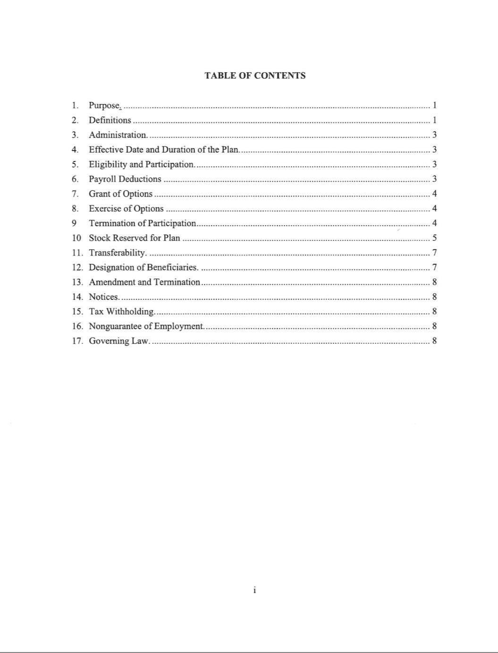

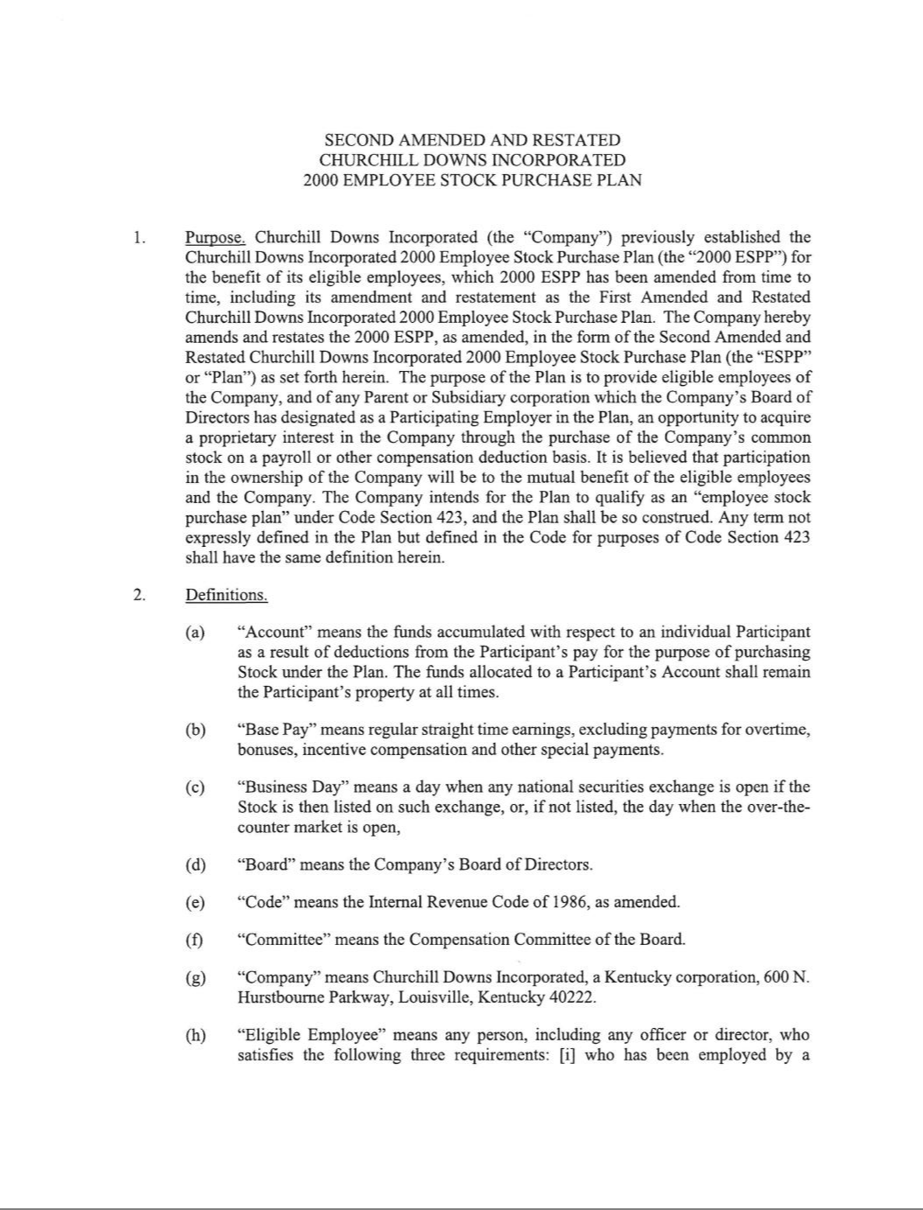

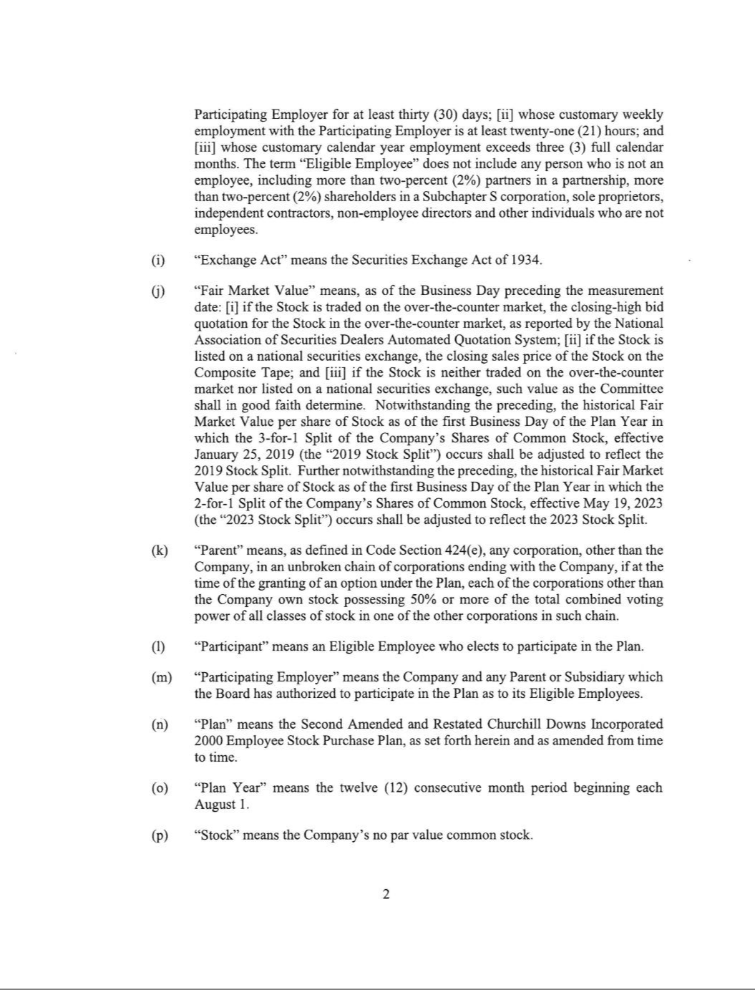

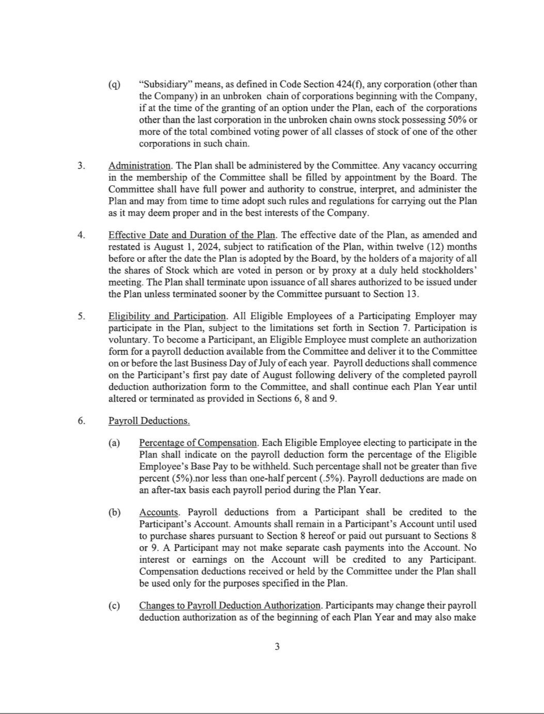

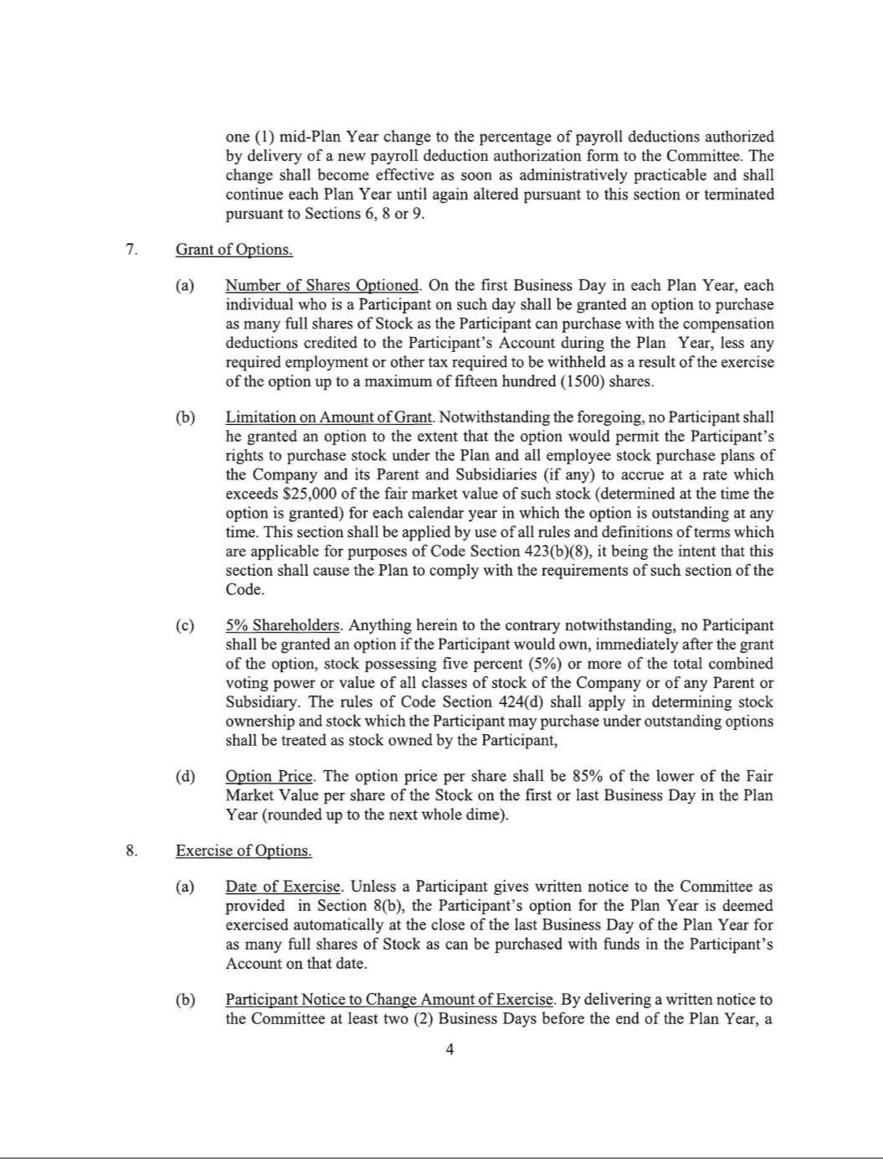

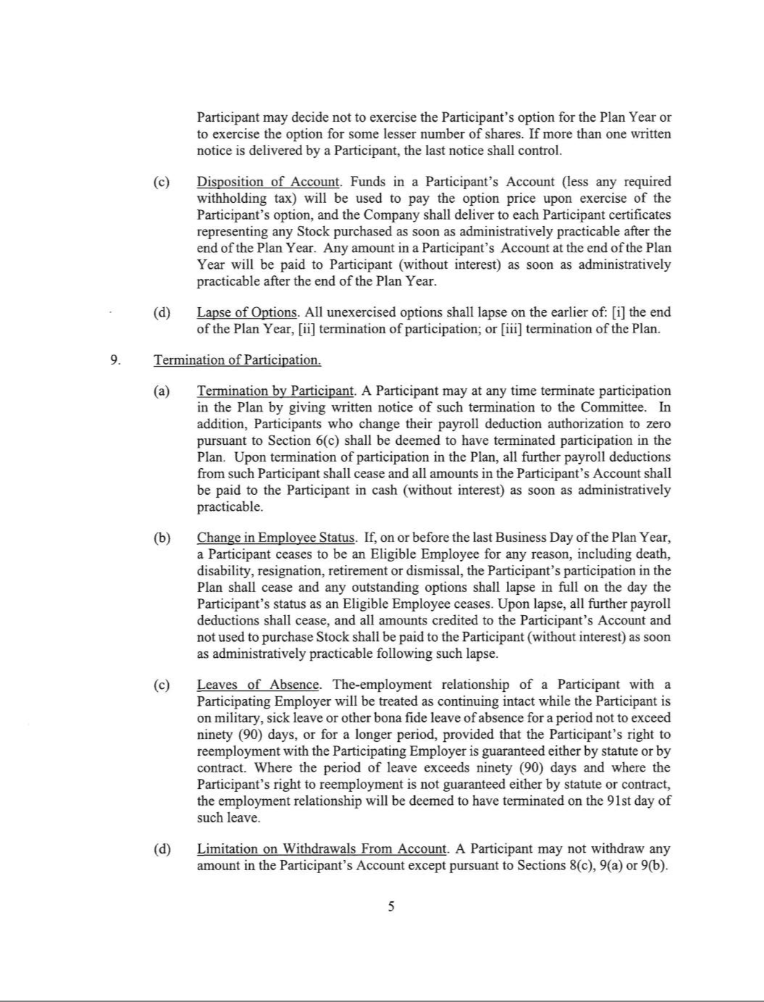

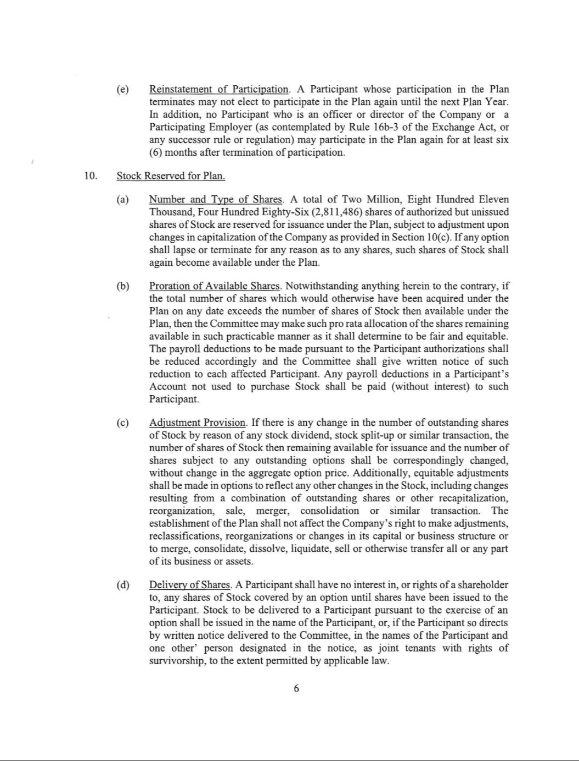

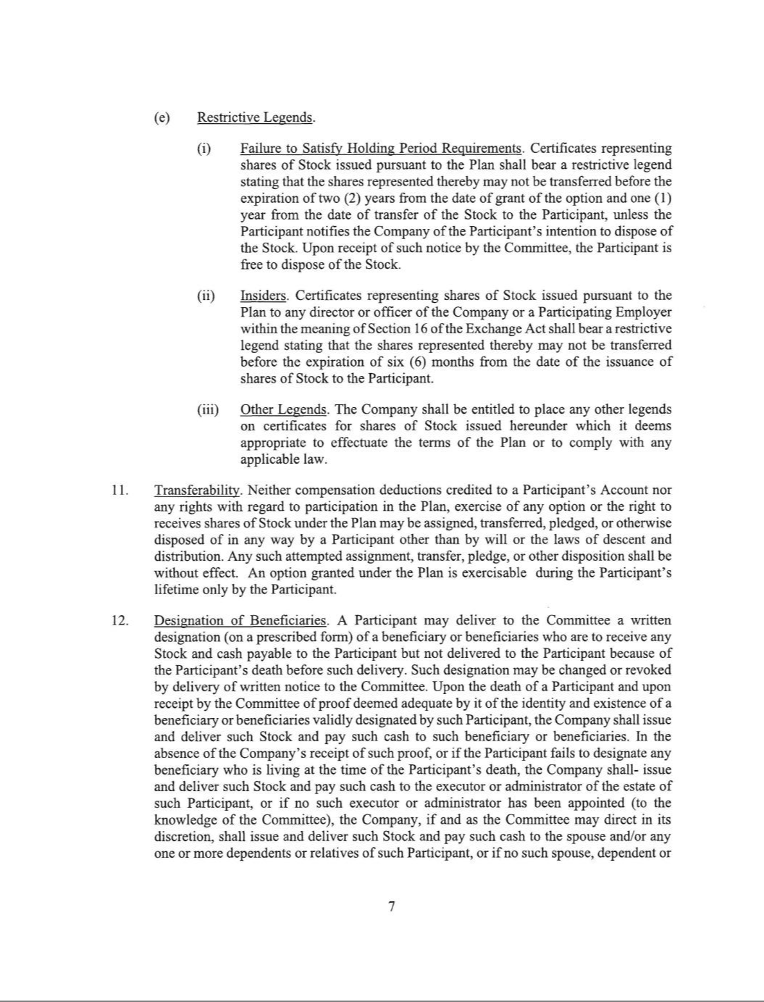

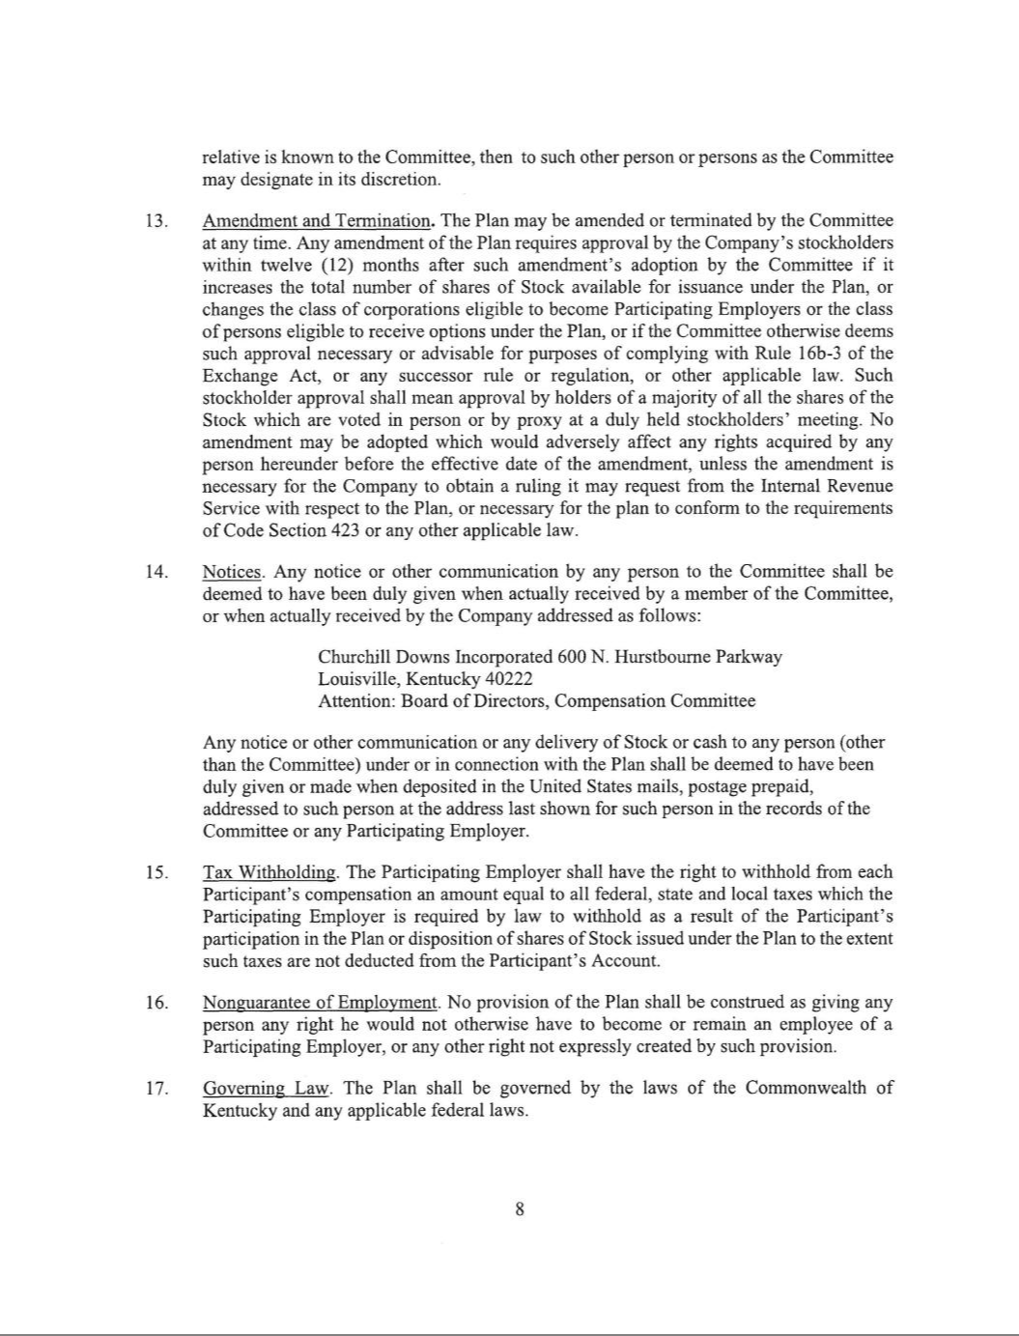

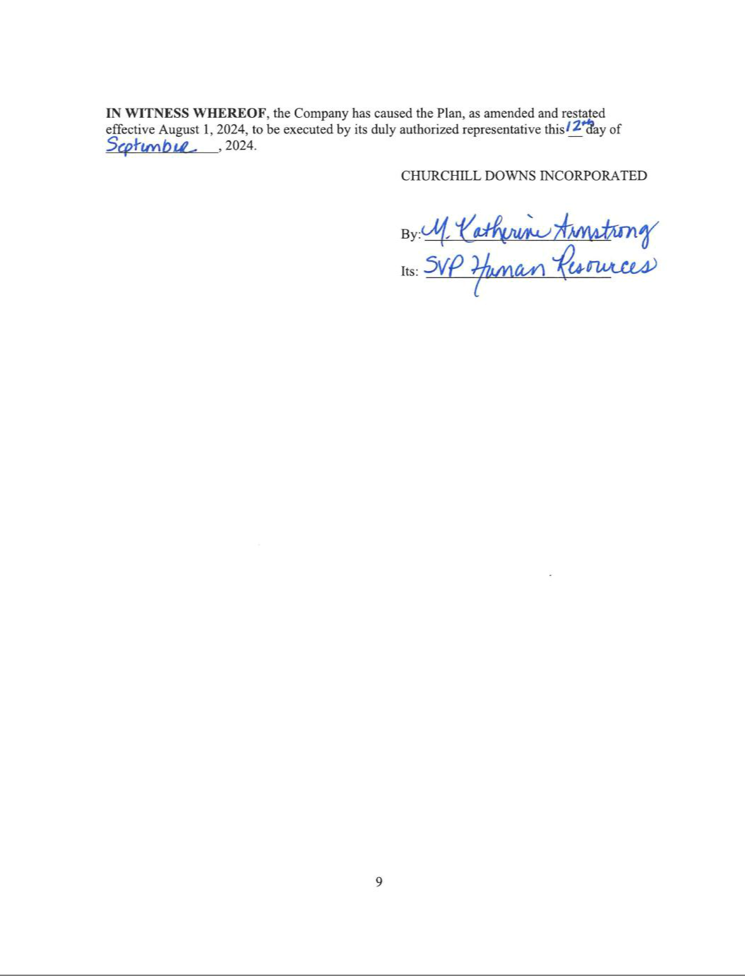

EXHIBIT 31(a)

CERTIFICATION OF CHIEF EXECUTIVE OFFICER

I, William C. Carstanjen, certify that:

- I have reviewed this Quarterly Report on Form 10-Q of Churchill Downs Incorporated;

- Based on my knowledge, this report does not contain any untrue statement of a material fact or omit to state a material fact necessary to make the statements made, in light of the circumstances under which such statements were made, not misleading with respect to the period covered by this report;

- Based on my knowledge, the financial statements, and other financial information included in this report, fairly present in all material respects the financial condition, results of operations and cash flows of the registrant as of, and for, the periods presented in this report;

- The registrant’s other certifying officer(s) and I are responsible for establishing and maintaining disclosure controls and procedures (as defined in Exchange Act Rules 13a-15(e) and 15d-15(e)) and internal control over financial reporting (as defined in Exchange Act Rules 13a-15(f) and 15d-15(f)) for the registrant and have:

  - Designed such disclosure controls and procedures, or caused such disclosure controls and procedures to be designed under our supervision, to ensure that material information relating to the registrant, including its consolidated subsidiaries, is made known to us by others within those entities, particularly during the period in which this report is being prepared;

  - Designed such internal control over financial reporting, or caused such internal control over financial reporting to be designed under our supervision, to provide reasonable assurance regarding the reliability of financial reporting and the preparation of financial statements for external purposes in accordance with generally accepted accounting principles;

  - Evaluated the effectiveness of the registrant’s disclosure controls and procedures and presented in this report our conclusions about the effectiveness of the disclosure controls and procedures, as of the end of the period covered by this report based on such evaluation; and

  - Disclosed in this report any change in the registrant’s internal control over financial reporting that occurred during the registrant’s most recent fiscal quarter (the registrant’s fourth fiscal quarter in the case of an annual report) that has materially affected, or is reasonably likely to materially affect, the registrant’s internal control over financial reporting; and

- The registrant’s other certifying officer(s) and I have disclosed, based on our most recent evaluation of internal control over financial reporting, to the registrant’s auditors and the audit committee of the registrant’s board of directors (or persons performing the equivalent functions):

  - All significant deficiencies and material weaknesses in the design or operation of internal control over financial reporting which are reasonably likely to adversely affect the registrant’s ability to record, process, summarize and report financial information; and

  - Any fraud, whether or not material, that involves management or other employees who have a significant role in the registrant’s internal control over financial reporting.

Date: October 23, 2024 /s/ William C. Carstanjen

William C. Carstanjen
Chief Executive Officer
(Principal Executive Officer)

EXHIBIT 31(b)

CERTIFICATION OF PRINCIPAL FINANCIAL OFFICER

I, Marcia A. Dall, certify that:

- I have reviewed this Quarterly Report on Form 10-Q of Churchill Downs Incorporated;

- Based on my knowledge, this report does not contain any untrue statement of a material fact or omit to state a material fact necessary to make the statements made, in light of the circumstances under which such statements were made, not misleading with respect to the period covered by this report;

- Based on my knowledge, the financial statements, and other financial information included in this report, fairly present in all material respects the financial condition, results of operations and cash flows of the registrant as of, and for, the periods presented in this report;

- The registrant’s other certifying officer(s) and I are responsible for establishing and maintaining disclosure controls and procedures (as defined in Exchange Act Rules 13a-15(e) and 15d-15(e)) and internal control over financial reporting (as defined in Exchange Act Rules 13a-15(f) and 15d-15(f)) for the registrant and have:

  - Designed such disclosure controls and procedures, or caused such disclosure controls and procedures to be designed under our supervision, to ensure that material information relating to the registrant, including its consolidated subsidiaries, is made known to us by others within those entities, particularly during the period in which this report is being prepared;

  - Designed such internal control over financial reporting, or caused such internal control over financial reporting to be designed under our supervision, to provide reasonable assurance regarding the reliability of financial reporting and the preparation of financial statements for external purposes in accordance with generally accepted accounting principles;

  - Evaluated the effectiveness of the registrant’s disclosure controls and procedures and presented in this report our conclusions about the effectiveness of the disclosure controls and procedures, as of the end of the period covered by this report based on such evaluation; and

  - Disclosed in this report any change in the registrant’s internal control over financial reporting that occurred during the registrant’s most recent fiscal quarter (the registrant’s fourth fiscal quarter in the case of an annual report) that has materially affected, or is reasonably likely to materially affect, the registrant’s internal control over financial reporting; and

- The registrant’s other certifying officer(s) and I have disclosed, based on our most recent evaluation of internal control over financial reporting, to the registrant’s auditors and the audit committee of the registrant’s board of directors (or persons performing the equivalent functions):

  - All significant deficiencies and material weaknesses in the design or operation of internal control over financial reporting which are reasonably likely to adversely affect the registrant’s ability to record, process, summarize and report financial information; and

  - Any fraud, whether or not material, that involves management or other employees who have a significant role in the registrant’s internal control over financial reporting.

Date: October 23, 2024 /s/ Marcia A. Dall

Marcia A. Dall
Executive Vice President and Chief Financial Officer
(Principal Financial & Accounting Officer)

EXHIBIT 32

Certification of Chief Executive Officer and Chief Financial Officer Pursuant to

18 U.S.C. Section 1350,

As Adopted Pursuant to

Section 906 of the Sarbanes-Oxley Act of 2002

In connection with the Quarterly Report on Form 10-Q of Churchill Downs Incorporated (the “Company”) for the quarterly period ended September 30, 2024, as filed with the Securities and Exchange Commission on the date hereof (the “Report”), William C. Carstanjen, as Chief Executive Officer (Principal Executive Officer) of the Company, and Marcia A. Dall, as Executive Vice President and Chief Financial Officer (Principal Financial & Accounting Officer) of the Company, each hereby certifies, pursuant to 18 U.S.C. § 1350, as adopted pursuant to § 906 of the Sarbanes-Oxley Act of 2002, to the best of his or her knowledge, that:

- The Report fully complies with the requirements of section 13(a) or 15(d) of the Securities Exchange Act of 1934, as amended; and

- The information contained in the Report fairly presents, in all material respects, the financial condition and results of operations of the Company.

/s/ William C. Carstanjen

William C. Carstanjen
Chief Executive Officer
(Principal Executive Officer)

October 23, 2024

/s/ Marcia A. Dall

Marcia A. Dall
Executive Vice President and Chief Financial Officer
(Principal Financial & Accounting Officer)

October 23, 2024

This certification is being furnished to the Securities and Exchange Commission as an exhibit to the Report and shall not be deemed filed by the Company for purposes of § 18 of the Securities Exchange Act of 1934, as amended.

A signed original of this written statement required by Section 906, or other document authenticating, acknowledging, or otherwise adopting the signature that appears in typed form within the electronic version of this written statement required by Section 906, has been provided to Churchill Downs Incorporated and will be retained by Churchill Downs Incorporated and furnished to the Securities and Exchange Commission or its staff upon request.

