UNITED STATES

SECURITIES AND EXCHANGE COMMISSION

WASHINGTON, D.C. 20549

FORM 10-K

- ANNUAL REPORT PURSUANT TO SECTION 13 OR 15(d) OF THE SECURITIES EXCHANGE ACT OF 1934

For the fiscal year ended December 31, 2024

OR

- TRANSITION REPORT PURSUANT TO SECTION 13 OR 15(d) OF THE SECURITIES EXCHANGE ACT OF 1934

For the transition period from to

Commission file number 001-33998

Churchill Downs Incorporated

 |  | (Exact name of registrant as specified in its charter)
Kentucky |  |  |  | 61-0156015
(State or other jurisdiction of incorporation or organization) |  |  |  |  | (IRS Employer Identification No.)
600 North Hurstbourne Parkway, Suite 400
Louisville, | Kentucky |  |  | 40222
(Address of principal executive offices) |  |  |  |  | (Zip Code)
 | (502) 636-4400
 |  | (Registrant’s telephone number, including area code)
Securities registered pursuant to Section 12(b) of the Act:
Common Stock, No Par Value |  | Trading Symbol(s) |  |  | The Nasdaq Stock Market LLC
(Title of each class registered) |  | CHDN |  |  | (Name of each exchange on which registered)
 |  | Securities registered pursuant to Section 12(g) of the Act:
 |  | None
 |  | (Title of class) | Yes ☒ No | ☐
Indicate by check mark if the registrant is a well-known seasoned issuer, as defined in Rule 405 of the Securities Act. |  |  | Yes ☒ No
Indicate by check mark if the registrant is not required to file reports pursuant to Section 13 or Section 15(d) of the Act. |  |  | Yes ☐ | No ☒

Indicate by check mark whether the registrant (1) has filed all reports required to be filed by Section 13 or 15(d) of the Securities Exchange Act of 1934 during the preceding 12 months (or for such shorter period that the registrant was required to file such reports), and (2) has been subject to such filing requirements for the past 90 days. Yes ☒ No ☐

Indicate by check mark whether the registrant has submitted electronically every Interactive Data File required to be submitted pursuant to Rule 405 of Regulation S-T (§ 232.405 of this chapter) during the preceding 12 months (or for such shorter period that the registrant was required to submit such files). Yes ☒ No ☐

Indicate by check mark whether the registrant is a large accelerated filer, an accelerated filer, a non-accelerated filer, a smaller reporting company, or an emerging growth company. See the definitions of "large accelerated filer," "accelerated filer," "smaller reporting company," and "emerging growth company" in Rule 12b-2 of the Exchange Act.

Large accelerated filer | ☒ | Accelerated filer | ☐
Non-accelerated filer | ☐ | Smaller reporting company | ☐
 |  | Emerging growth company | ☐

If an emerging growth company, indicate by check mark if the registrant has elected not to use the extended transition period for complying with any new or revised financial accounting standards provided pursuant to Section 13(a) of the Exchange Act. ☐

Indicate by a check mark whether the registrant has filed a report on and attestation to its management's assessment of the effectiveness of its internal control over financial reporting under Section 404(b) of the Sarbanes-Oxley Act (15 U.S.C. 7262(b)) by the registered public accounting firm that prepared or issued its audit report. ☒

If securities are registered pursuant to Section 12(b) of the Act, indicate by check mark whether the financial statements of the registrant included in the filing reflect the correction of an error to previously issued financial statements. ☐

Indicate by check mark whether any of those error corrections are restatements that required a recovery analysis of incentive-based compensation received by any of the registrant’s executive officers during the relevant recovery period pursuant to §240.10D-1(b). ☐

Indicate by check mark whether the Registrant is a shell company (as defined in Rule 12b-2 of the Exchange Act). Yes ☐ No ☒

As of February 12, 2025, 73,548,069 shares of the Registrant’s Common Stock were outstanding. As of June 30, 2024 (based upon the closing sale price for such date on the Nasdaq Stock Market), the aggregate market value of the shares held by non-affiliates of the Registrant was $9,764,280,136. For the purposes of this disclosure only, the registrant has assumed that its directors and executive officers (as defined in Rule 3b-7 under the Exchange Act) are the affiliates of the registrant.

Portions of the Registrant’s Proxy Statement for its Annual Meeting of Shareholders to be held on April 22, 2025 are incorporated by reference herein in response to Items 10, 11, 12, 13 and 14 of Part III of Form 10-K.

 |  |  |  |  |  |  |  |  |  |  |  |  |  |  |  |  |  |  |  |  |  |  |  |  | CHURCHILL DOWNS INCORPORATED
 |  |  |  |  |  |  |  |  |  |  |  |  |  |  |  |  |  |  |  |  |  |  |  | INDEX TO ANNUAL REPORT ON FORM 10-K
 |  |  |  |  |  |  |  |  |  |  |  |  |  |  |  |  |  |  |  |  |  |  |  |  | For the Year Ended December 31, 2024
 |  |  |  |  |  |  |  |  |  |  |  |  |  |  |  |  |  |  |  |  |  |  |  |  |  |  |  |  |  |  | Part I
 | Item 1. |  |  |  |  |  | Business |  |  |  |  |  |  |  |  |  |  |  |  |  |  |  |  |  |  |  |  |  |  |  |  |  |  |  |  |  |  |  | 4
 | Item 1A. |  |  |  |  |  | Risk Factors |  |  |  |  |  |  |  |  |  |  |  |  |  |  |  |  |  |  |  |  |  |  |  |  |  |  |  |  |  |  |  |  | 16
 | Item 1B. |  |  |  |  |  | Unresolved Staff Comments |  |  |  |  |  |  |  |  |  |  |  |  |  |  |  |  |  |  |  |  |  |  |  |  |  |  |  |  |  |  |  | 26
 | Item 1C. |  |  |  |  |  | Cybersecurity |  |  |  |  |  |  |  |  |  |  |  |  |  |  |  |  |  |  |  |  |  |  |  |  |  |  |  |  |  |  |  |  | 26
 | Item 2. |  |  |  |  |  | Properties |  |  |  |  |  |  |  |  |  |  |  |  |  |  |  |  |  |  |  |  |  |  |  |  |  |  |  |  |  |  |  |  | 27
 | Item 3. |  |  |  |  |  | Legal Proceedings |  |  |  |  |  |  |  |  |  |  |  |  |  |  |  |  |  |  |  |  |  |  |  |  |  |  |  |  |  |  |  |  | 28
 | Item 4. |  |  |  |  |  | Mine Safety Disclosures |  |  |  |  |  |  |  |  |  |  |  |  |  |  |  |  |  |  |  |  |  |  |  |  |  |  |  |  |  |  |  | 28
 |  |  |  |  |  |  |  |  |  |  |  |  |  |  |  |  |  |  |  |  |  |  |  |  |  |  |  |  |  | Part II
 | Item 5. |  |  |  |  |  | Market for Registrant’s Common Equity, Related Shareholder Matters and Issuer Purchases of Equity Securities |  |  |  |  |  |  |  |  |  |  |  |  |  |  |  |  |  |  |  |  |  |  |  |  |  |  |  |  |  |  |  | 29
 | Item 6. |  |  |  |  |  | Reserved |  |  |  |  |  |  |  |  |  |  |  |  |  |  |  |  |  |  |  |  |  |  |  |  |  |  |  |  |  |  |  |  | 30
 | Item 7. |  |  |  |  |  | Management’s Discussion and Analysis of Financial Condition and Results of Operations |  |  |  |  |  |  |  |  |  |  |  |  |  |  |  |  |  |  |  |  |  |  |  |  |  |  |  |  |  |  |  | 31
 | Item 7A. |  |  |  |  |  | Quantitative and Qualitative Disclosures About Market Risk |  |  |  |  |  |  |  |  |  |  |  |  |  |  |  |  |  |  |  |  |  |  |  |  |  |  |  |  |  |  |  | 45
 | Item 8. |  |  |  |  |  | Financial Statements and Supplementary Data |  |  |  |  |  |  |  |  |  |  |  |  |  |  |  |  |  |  |  |  |  |  |  |  |  |  |  |  |  |  |  |  | 46
 | Item 9. |  |  |  |  |  | Changes in and Disagreements with Accountants on Accounting and Financial Disclosure |  |  |  |  |  |  |  |  |  |  |  |  |  |  |  |  |  |  |  |  |  |  |  |  |  |  |  |  |  |  |  | 89
 | Item 9A. |  |  |  |  |  | Controls and Procedures |  |  |  |  |  |  |  |  |  |  |  |  |  |  |  |  |  |  |  |  |  |  |  |  |  |  |  |  |  |  |  |  | 89
 | Item 9B. |  |  |  |  |  | Other Information |  |  |  |  |  |  |  |  |  |  |  |  |  |  |  |  |  |  |  |  |  |  |  |  |  |  |  |  |  |  |  |  | 89
 | Item 9C. |  |  |  |  |  | Disclosure Regarding Foreign Jurisdictions that Prevent Inspections |  |  |  |  |  |  |  |  |  |  |  |  |  |  |  |  |  |  |  |  |  |  |  |  |  |  |  |  |  |  |  | 90
 |  |  |  |  |  |  |  |  |  |  |  |  |  |  |  |  |  |  |  |  |  |  |  |  |  |  |  |  | Part III
 | Item 10. |  |  |  |  |  | Directors, Executive Officers and Corporate Governance |  |  |  |  |  |  |  |  |  |  |  |  |  |  |  |  |  |  |  |  |  |  |  |  |  |  |  |  |  |  |  | 90
 | Item 11. |  |  |  |  |  | Executive Compensation |  |  |  |  |  |  |  |  |  |  |  |  |  |  |  |  |  |  |  |  |  |  |  |  |  |  |  |  |  |  |  | 90
 | Item 12. |  |  |  |  |  | Security Ownership of Certain Beneficial Owners and Management and Related Shareholder Matters |  |  |  |  |  |  |  |  |  |  |  |  |  |  |  |  |  |  |  |  |  |  |  |  |  |  |  |  |  |  |  | 90
 | Item 13. |  |  |  |  |  | Certain Relationships and Related Transactions, and Director Independence |  |  |  |  |  |  |  |  |  |  |  |  |  |  |  |  |  |  |  |  |  |  |  |  |  |  |  |  |  |  |  |  | 91
 | Item 14. |  |  |  |  |  | Principal Accountant Fees and Services |  |  |  |  |  |  |  |  |  |  |  |  |  |  |  |  |  |  |  |  |  |  |  |  |  |  |  |  |  |  |  | 91
 |  |  |  |  |  |  |  |  |  |  |  |  |  |  |  |  |  |  |  |  |  |  |  |  |  |  |  |  | Part IV
 | Item 15. |  |  |  |  |  | Exhibit and Financial Statement Schedule |  |  |  |  |  |  |  |  |  |  |  |  |  |  |  |  |  |  |  |  |  |  |  |  |  |  |  |  |  |  |  |  | 92
 |  |  |  |  |  |  | Exhibit Index |  |  |  |  |  |  |  |  |  |  |  |  |  |  |  |  |  |  |  |  |  |  |  |  |  |  |  |  |  |  |  |  | 93
 | Item 16. |  |  |  |  |  | Form 10-K Summary |  |  |  |  |  |  |  |  |  |  |  |  |  |  |  |  |  |  |  |  |  |  |  |  |  |  |  |  |  |  |  | 99
 |  |  |  |  |  |  | Signatures |  |  |  |  |  |  |  |  |  |  |  |  |  |  |  |  |  |  |  |  |  |  |  |  |  |  |  |  |  |  |  | 100
 |  |  |  |  |  |  | Schedule II—Valuation and Qualifying Accounts |  |  |  |  |  |  |  |  |  |  |  |  |  |  |  |  |  |  |  |  |  |  |  |  |  |  |  |  |  |  |  | 101
 |  |  |  |  |  |  |  |  |  |  |  |  |  |  |  |  |  |  |  |  |  |  |  | 2

Cautionary Statement Regarding Forward-Looking Information

This Annual Report on Form 10-K (“Report”) contains various "forward-looking statements" within the meaning of the “safe harbor” provisions of the Private Securities Litigation Reform Act of 1995. Forward-looking statements are typically identified by the use of terms such as “anticipate,” “believe,” “could,” “estimate,” “expect,” “intend,” “may,” “might,” “plan,” “predict,” “project,” “seek,” “should,” “will,” “scheduled,” and similar words or similar expressions (or negative versions of such words or expressions), although some forward-looking statements are expressed differently.

Although we believe that the expectations reflected in such forward-looking statements are reasonable, we can give no assurance that such expectations will prove to be correct. Important factors, that could cause actual results to differ materially from expectations include the following: the occurrence of extraordinary events, such as terrorist attacks, public health threats, civil unrest, and inclement weather, including as a result of climate change; the effect of economic conditions on our consumers' confidence and discretionary spending or our access to credit, including the impact of inflation; changes in, or new interpretations of, applicable tax laws or rulings that could result in additional tax liabilities; the impact of any pandemics, epidemics, or outbreaks of infectious diseases, and related economic matters on our results of operations, financial conditions and prospects; lack of confidence in the integrity of our core businesses or any deterioration in our reputation; negative shifts in public opinion regarding gambling that could result in increased regulation of, or new restrictions on, the gaming industry; loss of key or highly skilled personnel, as well as general disruptions in the general labor market; the impact of significant competition, and the expectation that competition levels will increase; changes in consumer preferences, attendance, wagering, and sponsorships; risks associated with equity investments, strategic alliances and other third-party agreements; inability to respond to rapid technological changes in a timely manner; concentration and evolution of slot machine and historical racing machine (HRM) manufacturing and other technology conditions that could impose additional costs; failure to enter into or maintain agreements with industry constituents, including horsemen and other racetracks; inability to successfully focus on market access and retail operations for our sports betting business and effectively compete; online security risk, including cyber-security breaches, or loss or misuse of our stored information as a result of a breach including customers’ personal information could lead to government enforcement actions or other litigation; costs of compliance with increasingly complex laws and regulations regarding data privacy and protection of personal information; reliance on our technology services and catastrophic events and system failures disrupting our operations; inability to identify, complete, or fully realize the benefits of our proposed acquisitions, divestitures, development of new venues or the expansion of existing facilities on time, on budget, or as planned; difficulty in integrating recent or future acquisitions into our operations; cost overruns and other uncertainties associated with the development of new venues and the expansion of existing facilities; general risks related to real estate ownership and significant expenditures, including risks related to environmental liabilities; personal injury litigation related to injuries occurring at our racetracks; compliance with the Foreign Corrupt Practices Act or other similar laws and regulations, or applicable anti-money laundering regulations; payment-related risks, such as risk associated with fraudulent credit card or debit card use; work stoppages and labor problems; risks related to pending or future legal proceedings and other actions; highly regulated operations and changes in the regulatory environment could adversely affect our business; restrictions in our debt facilities limiting our flexibility to operate our business; failure to comply with the financial ratios and other covenants in our debt facilities and other indebtedness; increases to interest rates (due to inflation or otherwise), disruption in the credit markets or changes to our credit ratings may adversely affect our business; increase in our insurance costs, or inability to obtain similar insurance coverage in the future, and any inability to recover under our insurance policies for damages sustained at our properties in the event of inclement weather and casualty events; and other factors described in Item 1A. Risk Factors, of this Report and in other filings we make with the Securities and Exchange Commission.

We do not undertake any obligation to update or revise any forward-looking statements, whether as a result of new information, future events or otherwise, except as required by law.

3

PART I

ITEM 1. BUSINESS

Overview

Churchill Downs Incorporated ("CDI" or the "Company") has been creating extraordinary entertainment experiences for over 150 years, beginning with the Company’s most iconic and enduring asset, the Kentucky Derby. Headquartered in Louisville, Kentucky, CDI has expanded through the acquisition, development, and operation of live and historical racing entertainment venues, the growth of the online wagering businesses, and the acquisition, development, and operation of regional casino gaming properties.

Business Segments

The Company manages its business through three reportable segments: Live and Historical Racing, Wagering Services and Solutions, and Gaming. The Wagering Services and Solutions segment was previously known as the TwinSpires segment. We aggregate our other businesses as well as certain corporate operations in All Other. We report net revenue and operating expense associated with these reportable segments and other information about these segments in Part II, Item 8. Financial Statements and Supplementary Data, contained within this Report. Further discussion of segment financial information, and our planned investments in segment properties, is set forth in Part II, Item 7. Management’s Discussion and Analysis of Financial Condition and Results of Operations contained within this Report.

Live and Historical Racing

The Live and Historical Racing segment includes live and historical pari-mutuel racing related revenue and expenses at Churchill Downs Racetrack and our historical racing properties in Kentucky, Virginia, and New Hampshire.

Our Live and Historical Racing properties earn commissions primarily from pari-mutuel wagering on live and historical races, simulcast fees earned from other wagering sites, fees from racing event-related services including admissions, personal seat licenses, sponsorships, television rights, other miscellaneous services, and revenue from food and beverage services.

Churchill Downs Racetrack

Churchill Downs Racetrack is in Louisville, Kentucky and is an internationally known thoroughbred racing operation best known as the home of our iconic flagship event, the Kentucky Derby. Thoroughbred racing has been conducted at Churchill Downs Racetrack since 1875. The Kentucky Derby is the longest continuously held annual sporting event in the U.S. and is the first race of the annual series of races for 3-year-old thoroughbreds known as the Triple Crown. The demographic profile of our guests, global television viewership, and long-running nature of this iconic event are attractive to sponsors and corporate partners, especially those with luxury and/or marquee brands.

Churchill Down Racetrack conducts approximately 80 live race days each year.

Churchill Downs Racetrack is located on 175 acres and has a one-mile dirt track, a 7/8-mile turf track, a stabling area, and a variety of areas, structures, and buildings that provide reserved seating for our patrons. Churchill Downs Racetrack has one of the largest 4K video boards in the world sitting 80 feet above the ground and measuring 171 feet wide by 90 feet tall. This video board provides views of the finish line and the entire race for on-track guests, including those in the infield and guests along the entire front side of the racetrack. The facility also has permanent lighting to accommodate night races. We have a saddling paddock and our stable area has barns sufficient to accommodate 1,400 horses and a 114-room dormitory for backside personnel. We have a state-of-the-art equine medical center and quarantine barns on the backside area of Churchill Downs Racetrack which reinforces our ongoing commitment to equine safety and supports our long-term international growth strategy. The Churchill Downs Racetrack facility also includes a simulcast wagering facility. We also own 83 acres of land at our auxiliary training facility, which is five miles from Churchill Downs Racetrack.

In 2002, we transferred title of the Churchill Downs Racetrack facility to the City of Louisville, Kentucky and entered into a 30-year lease for the facility as part of the financing of improvements to the Churchill Downs Racetrack facility. We can reacquire the facility at any time for $1.00 subject to the terms of the lease.

Since 2021, we have completed several major multi-year capital investments at Churchill Downs Racetrack: The Homestretch Club, the First Turn Experience, the Jockey Club Suites renovation, and the Paddock Project. These investments transformed key areas of Churchill Downs Racetrack that enhance the experience for our guests.

The Paddock Project was completed for the 150th running of the Kentucky Derby. The redesigned area improved the flow of guests throughout the paddock. The Paddock Project created a larger paddock walking ring for viewing the horses prior to the races, a new Paddock Club in the area on the first floor under the Twin Spires providing views of the paddock and views of the tunnel that the horses walk through, new hospitality and other amenities for guests in certain areas of the third floor clubhouse seats, and new terraces overlooking the paddock.

4

The Company is also investing up to $85 million to renovate the Starting Gate Pavilion and Courtyard to enhance the existing grandstand and provide improved amenities for the 151st Kentucky Derby in May 2025.

Historical Racing Properties

The following table summarizes key information regarding our current historical racing properties:

State | Property | City/ Location | Floor Space (Sq. ft.) | Historical Racing Machines | Retail Race & Sportsbook^{(a)}
 |  |  |  | ("HRMs") | Retail Race & Sportsbook^{(a)}
Kentucky | Derby City Gaming & Hotel | Louisville, Kentucky | 55,000 | 1,270 | ü
Kentucky | Derby City Gaming Downtown | Louisville, Kentucky | 43,000 | 450 | ü
Kentucky | Turfway Park | Northern Kentucky | 45,000 | 810 | ü
Kentucky | Newport | Northern Kentucky | 23,000 | 460 | ü
Kentucky | Oak Grove | Southwestern Kentucky | 180,000 | 1,240 | ü
Kentucky | Marshall Yards^{(b)} | Southwestern Kentucky | 9,000 | 250 | ü
Kentucky | Ellis Park | Western Kentucky | 40,000 | 300 | ü
Kentucky | Owensboro^{(c)} | Western Kentucky | 24,000 | 600 | ü
New Hampshire | Chasers^{(d)} | Salem, New Hampshire | 4,000 | (d) | N/A
Virginia | Colonial Downs / Rosie's | New Kent / Central Virginia | 127,000 | 490 | N/A
Virginia | Rosie's^{(e)} | Richmond / Central Virginia | 54,000 | 1,200 | N/A
Virginia | Roseshire^{(f)} | Henrico County / Central Virginia | 7,000 | 175 | N/A
Virginia | Rosie's | Dumfries / Northern Virginia | 19,000 | 150 | N/A
Virginia | The Rose | Dumfries / Northern Virginia | 58,000 | 1,650 | N/A
Virginia | Rosie's | Hampton / Southern Virginia | 38,000 | 700 | N/A
Virginia | Rosie's | Emporia / Southern Virginia | 22,000 | 150 | N/A
Virginia | Rosie's | Collinsville / Southern Virginia | 2,000 | 40 | N/A
Virginia | Rosie's | Vinton / Western Virginia | 15,000 | 470 | N/A
Total |  |  | 765,000 | 10,405

- The Company's retail sports betting business is included in the Wagering Services and Solutions segment.

- The Company plans to open Marshall Yards Racing & Gaming in the first quarter of 2026.

- The Company opened Owensboro Racing & Gaming in February 2025.

- The Company plans to build a new charitable gaming facility to accommodate HRMs and table games.

- The Company plans to expand Rosie's Richmond HRM venue to accommodate a total of 1,200 HRMs in the third quarter of 2025.

- The Company plans to open the Roseshire in Henrico County in the fourth quarter of 2025.

Kentucky

Louisville

Derby City Gaming & Hotel ("Derby City Gaming") opened in September 2018 in Louisville, Kentucky. Derby City Gaming is a state-of-the-art HRM facility located at the Churchill Downs Racetrack auxiliary training facility and has a center bar with large format televisions, two food venues, an open-air gaming patio, and retail sports betting.

Derby City Gaming was expanded in the second quarter of 2023. The expansion included a 123-room hotel, a VIP gaming area, a new sports bar, a stage for live entertainment, and an upscale-casual restaurant and bar.

5

Derby City Gaming Downtown ("DCG Downtown") opened in December 2023 in downtown Louisville, Kentucky. DCG Downtown has a gaming area, a main-level sports bar with a stage for live entertainment, retail sports betting, a premium bourbon bar, and an elegant wine lounge for guests, including locals, tourists, and convention attendees.

Northern Kentucky

Newport Racing & Gaming ("Newport") opened in October 2020 and is located within three miles of Cincinnati, Ohio. Newport is an HRM entertainment venue that includes a simulcast area, food and beverage offerings, and retail sports betting.

Turfway Park Racing & Gaming ("Turfway Park") opened in September 2022 in Northern Kentucky. Turfway Park is a state-of-the-art live thoroughbred racing and HRM entertainment venue with an event center, food and beverage offerings, and retail sports betting.

Southwestern Kentucky

Oak Grove Racing, Gaming & Hotel ("Oak Grove") opened in 2020 and is located approximately one-hour north of Nashville, Tennessee. Oak Grove is a premier state-of-the-art live harness racing and HRM entertainment venue with a 128-room hotel, a simulcast center, event center, an amphitheater, recreational vehicle park, equestrian center, and retail sports betting.

Marshall Yards Racing & Gaming ("Marshall Yards") is expected to open in the first quarter 2026 in Calvert City, Kentucky. The new state-of-the-art HRM entertainment venue will have 250 HRMs, a sports bar, retail sportsbook, and a simulcast center.

Western Kentucky

Ellis Park Racing & Gaming ("Ellis Park") was acquired by the Company in September 2022 and is located five miles from Evansville, Indiana. Ellis Park is a live thoroughbred racing and HRM entertainment venue with food and beverage offerings and retail sports betting.

Owensboro Racing & Gaming ("Owensboro") opened in February 2025 in Owensboro, Kentucky with 600 HRMs, a retail sportsbook, simulcast wagering, and multiple food and beverage offerings. Virginia

Colonial Downs Racetrack ("Colonial Downs") and six historical racing entertainment venues across Virginia were acquired by the Company in November 2022. Colonial Downs has a dirt track, the widest turf track oval in North America, a simulcast area, food and beverage offerings, and two off-track betting facilities ("OTBs"). Colonial Downs conducts approximately 30 live race days each year with plans to increase up to 50 live race days per year. The Company has also created the Virginia Derby to be held in March 2025 as a qualifying race to the Kentucky Derby.

Rosie's Emporia was opened in September 2023 in Emporia, Virginia with 150 HRMs and a restaurant and bar.

The Rose Gaming Resort ("The Rose") was opened in November 2024 in Dumfries, Virginia with a 102-room hotel, eight food and beverage options, and 1,650 HRMs.

Rosie’s Richmond is located in Richmond, Virginia and features 750 HRMs, a simulcast wagering area, food & beverage offerings, and a center bar. Rosie’s Richmond will be expanded by the third quarter of 2025 to add an additional 450 HRMs.

Rosie’s Hampton is located in Hampton, Virginia and features 700 HRMs, a simulcast wagering area, and a food & beverage outlet.

Roseshire in Henrico County is expected to open in the fourth quarter of 2025 as a state-of-the-art HRM entertainment venue in Henrico County, Virginia. Roseshire will open with 175 HRMs.

New Hampshire

Chasers Poker Room ("Chasers") was acquired in 2022 and is in Salem, New Hampshire. Chasers is a charitable gaming facility that offers poker and a variety of table games.

Wagering Services and Solutions

The Wagering Services and Solutions segment includes the revenue and expenses from pari-mutuel wagers through TwinSpires, our retail and online sports betting business, United Tote Company ("United Tote"), and Exacta Systems, LLC ("Exacta").

6

TwinSpires

TwinSpires is an advance deposit wagering ("ADW") business that operates the online horse racing wagering business for TwinSpires.com, BetAmerica.com, and other white-label platforms, facilitates high dollar wagering by certain customers, and provides the Bloodstock Research Information Services platform for horse racing statistical data. TwinSpires is one of the largest and most profitable legal online horse racing wagering platforms in the U.S. TwinSpires is headquartered in Louisville, Kentucky. TwinSpires accepts pari-mutuel wagers through ADW from customers residing in certain states who establish and fund an account from which these customers may place wagers via telephone, mobile applications, or through the Internet. This business is licensed as a multi-jurisdictional simulcasting and interactive wagering hub in the state of Oregon and holds licenses from various other states where applicable. This business also offers customers streaming video of live horse races, replays, and an assortment of racing and handicapping information. BetAmerica.com is an online wagering business licensed under TwinSpires that offers wagering on horse racing throughout the U.S. We also provide technology services to third parties, including FanDuel and DraftKings, and we earn commissions from white label ADW products and services. Under these arrangements, we typically provide an ADW platform and related operational services while the third party typically provides the brand, marketing, and limited customer functions.

Sports Betting

Our sports betting business includes the results of our retail sportsbooks at our wholly owned properties and online sports betting through third parties. We have executed strategic market access agreements with Bet365 in Pennsylvania, Golden Nugget in Indiana, and various market access partners in Kentucky. The Company also operates retail sports betting at certain of its racetracks and HRM and gaming facilities.

United Tote

United Tote manufactures and operates pari-mutuel wagering systems for racetracks, OTBs, and other pari-mutuel wagering businesses. United Tote provides totalisator services which accumulate wagers, calculate payoffs, and display wagering data to patrons who wager on horse races. United Tote has contracts to provide totalisator services to several third-party racetracks, OTBs, and other pari-mutuel wagering businesses and provides these services at our facilities.

In April 2024, the Company completed the sale of 49% of United Tote, a wholly owned subsidiary of CDI, to NYRA Content Management Solutions, LLC ("NYRA"), a subsidiary of the New York Racing Association, Inc.

Exacta

Exacta was acquired by the Company on August 22, 2023. Exacta is a leading provider of central determinant system technology in HRMs across the country. Exacta's system architecture supports multiple game vendors and virtually unlimited math modeling capabilities on a single central determinant system enabling Exacta to deliver a diverse gaming library to Company owned and third-party HRM entertainment venues in Virginia, Kentucky, Wyoming, New Hampshire, and is expanding internationally.

Gaming

The Gaming segment includes revenue and expenses for the casino properties and associated racetracks which support the casino license. The Gaming segment generates revenue and expenses from slot machines, table games, video lottery terminals ("VLTs"), video poker, HRMs, ancillary food and beverage services, hotel services, commission on pari-mutuel wagering, racing event-related services, and other miscellaneous operations. The following table summarizes key information regarding our gaming properties:

7

 | State |  |  |  | Property | Acres | Casino Space (Sq. ft.) | Slots and Video Lottery | Table Games | Hotel Rooms Retail Sportsbook^{(b)}
 |  |  |  |  |  |  |  | Terminals^{(a)} | Table Games
 | Wholly owned
 |  | Florida |  |  | Calder Casino | 54 | 106,000 | 1,070 | 6 | N/A | N/A
 |  | Indiana |  |  | Terre Haute Casino Resort | 48 | 36,000 | 1,040 | 36 | 122 | ü
 |  | Iowa |  |  | Hard Rock Iowa | 15 | 41,000 | 670 | 25 | 54 | ü
 |  | Louisiana |  |  | Fair Grounds Race Course and Slots and Video
 |  |  |  |  | Services LLC | 145 | 33,000 | 2,040 | N/A | N/A | ü
 |  | Maine |  |  | Oxford Casino and Hotel | 97 | 27,000 | 970 | 23 | 107 | N/A
 |  | Maryland |  |  | Ocean Downs Casino and Racetrack | 167 | 70,000 | 900 | 19 | N/A | ü
 |  | Mississippi |  |  | Harlow's Casino Resort and Spa | 85 | 33,000 | 660 | 13 | 105 | ü
 |  | Mississippi |  |  | Riverwalk Casino Hotel | 22 | 25,000 | 560 | 11 | 76 | ü
 |  | New York |  |  | del Lago Resort and Casino | 83 | 99,000 | 1,670 | 80 | 205 | ü
 |  | Pennsylvania |  |  | Presque Isle Downs and Casino | 270 | 61,000 | 1,540 | 34 | N/A | ü
 | Equity Investments
 |  | Illinois |  |  | Rivers Casino Des Plaines | 21 | 78,000 | 1,520 | 120 | N/A | ü
 |  | Ohio |  |  | Miami Valley Gaming and Racing | 120 | 190,000 | 2,220 | N/A | N/A | ü
 |  |  |  |  | Total |  | 799,000 | 14,860 | 367 | 669

- Includes HRMs and video poker machines at Fair Grounds Race Course and Slots and Video Services LLC.

- The Company's retail sports betting business at its wholly owned properties is included in the Wagering Services and Solutions segment. Wholly owned gaming properties

Florida

Calder Casino ("Calder") in Miami Gardens, Florida is located near Hard Rock Stadium, home of the Miami Dolphins. Calder offers two dining facilities and an entertainment venue. Calder is located on 54 acres of land, and the Company may sell 15-20 acres of this land in the future for retail development.

Indiana

The Terre Haute Casino Resort ("Terre Haute") gaming entertainment venue was opened in April 2024 and a luxury hotel was opened in May 2024 in Terre Haute, Indiana. Terre Haute has 1,040 slot machines, 36 table games, a state-of-the-art sportsbook, and offers regionally inspired food and beverage amenities.

Iowa

The Company acquired Hard Rock Hotel and Casino in Sioux City, Iowa ("Hard Rock Iowa") in November 2022, which is a gaming facility and hotel with food and beverage offerings, a retail sportsbook, and entertainment venues.

Louisiana

Fair Grounds Race Course & Slots ("Fair Grounds") is located in New Orleans, Louisiana. Fair Grounds is a gaming facility and racecourse with a bar, simulcast facility, dirt and turf track, and stabling area. Fair Grounds conducts approximately 80 live racing days each year. The facility includes clubhouse and grandstand seating for approximately 5,000 guests, a general admissions area, several dining facilities, and a retail sportsbook. The stable area consists of barns that can accommodate approximately 1,900 horses and living quarters for approximately 130 people. Fair Grounds also owns and operates 15 OTBs, 13 of which have over 500 HRMs. Video Services LLC ("VSI") is the owner and operator of video poker machines in 13 of those OTBs in Louisiana.

Maine

Oxford Casino and Hotel is located in Oxford, Maine and is a gaming facility with a hotel and a dining facility.

8

Maryland

Ocean Downs Casino and Racetrack ("Ocean Downs") is located in Berlin, Maryland. Ocean Downs is a gaming facility with several dining options, a retail sportsbook, and a racetrack that conducts approximately 45 live harness racing days each year.

Mississippi

Harlow’s Casino Resort and Spa is located in Greenville, Mississippi, and is a gaming facility and hotel with two dining facilities and a retail sportsbook.

Riverwalk Casino Hotel is located in Vicksburg, Mississippi, and is a gaming facility and hotel with two dining facilities and a retail sportsbook.

New York

Del Lago Resort and Casino ("del Lago") was acquired by the Company in November 2022 and is located in Waterloo, New York. Del Lago is a gaming facility and a hotel with several dining options and a retail sportsbook.

Pennsylvania

Presque Isle Downs and Casino ("Presque Isle") is located in Erie, Pennsylvania. Presque Isle is a gaming facility with three dining facilities, a retail sportsbook, an entertainment venue and thoroughbred racetrack that conducts approximately 80 live racing days each year.

Equity Investments

Illinois

The Company has a 61.3% equity ownership in Midwest Gaming Holdings, LLC ("Midwest Gaming"), the parent company of Rivers Casino Des Plaines ("Rivers Des Plaines"), located in Des Plaines, Illinois. Rivers Des Plaines is a gaming entertainment venue located on 21 acres and has seven dining facilities, an approximate 5,000 square-foot state-of-the-art BetRivers Sports Bar, and a 10,000 square-foot ballroom for private events and live entertainment.

Ohio

The Company has a 50% equity investment in Miami Valley Gaming and Racing ("MVG") located just north of Cincinnati, Ohio. MVG is a gaming entertainment venue with a harness racetrack, a racing simulcast center, multiple food and drink offerings, and a retail sportsbook.

All Other

We have aggregated our captive insurance company that was established in April 2024 as well as certain corporate operations in All Other to reconcile to consolidated results.

Corporate

Corporate includes miscellaneous and other revenue, compensation expense, professional fees, and other general and administrative expense not allocated to our segments.

Competition

Overview

We operate in a highly competitive industry with many participants, some of which have financial and other resources that are greater than ours. The industry faces competition from a variety of sources for discretionary consumer spending, including spectator sports, sports wagering, and other entertainment and gaming options. Our brick-and-mortar casinos compete with traditional and Native American casinos, VLTs, state-sponsored lotteries, and other forms of legalized gaming in the U.S. and other jurisdictions.

Legalized gambling is currently permitted in various forms in many states and Canada. Other jurisdictions could legalize gambling in the future, and established gaming jurisdictions could award additional gaming licenses or permit the expansion of existing gaming operations. If additional gaming opportunities become available near our racing or gaming operations, such gaming operations could have a material adverse impact on our business.

In May 2018, the United States Supreme Court struck down the 1992 Professional and Amateur Sports Protection Act, which had effectively banned sports wagering in most states. Removal of the ban gives states the authority to authorize sports wagering.

9

Live and Historical Racing

In 2024, approximately 31,000 thoroughbred horse races were conducted in the U.S., which was down 2.8% compared to 2023. As a racetrack operator, we compete for horses with other racetracks running live racing meets at or near the same time as our races. Our ability to compete is substantially dependent on the racing calendar, number of horses racing, and purse sizes. As a content provider, we compete for wagering dollars in the simulcast market with other racetracks conducting races at or near the same times as our races. In recent years, competition has increased as more states legalize gaming and allow slot machines at racetracks with mandatory purse contributions. Our HRM entertainment venues in Kentucky, Virginia, and New Hampshire compete with regional casinos in the area and other forms of legal and illegal gaming.

Wagering Services and Solutions

TwinSpires

TwinSpires competes with other ADW businesses for both customers and racing content, as well as brick-and-mortar racetracks, casinos, OTBs, and other forms of legal and illegal sports betting.

Sports Betting

Our sports betting business competes for customers with retail, mobile, and online offerings from commercial brick-and-mortar casinos and racetracks. We also compete with daily fantasy sports gaming companies that are expanding into mobile and online sports betting and iGaming, international sports betting businesses looking to expand into the U.S. market, and other forms of legal and illegal sports betting and iGaming operations.

Exacta

Exacta competes with HRM and other central determinant systems providers for casino and racino operators, players, and third-party game content providers.

Gaming

Our Gaming properties operate in highly competitive environments and primarily compete for customers with other casinos in the surrounding regional gaming markets. Our Gaming properties compete to a lesser extent with state-sponsored lotteries, off-track wagering, card parlors, online gambling, and other forms of legalized gaming in the U.S.

Human Capital

We believe our people are essential to our operations and fundamental to the long-term success of our Company. Our focus is on attracting innovative and collaborative team members who are eager to develop their skills within a dynamic and growing portfolio of businesses dedicated to delivering exceptional experiences for our guests.

Our People

As of December 31, 2024, we had approximately 8,870 team members, including 6,480 that are full-time. Our highest level of seasonal employment occurs in the second quarter, coinciding with the Kentucky Derby.

As of the same date, approximately 840 full-time team members were covered by 12 collective bargaining agreements. We have not experienced any material operational disruptions due to labor disputes.

Talent Acquisition, Development and Retention

We are committed to attracting, developing, and retaining top talent. Our approach emphasizes a clear purpose and strategy, setting ambitious goals, fostering accountability, continuously assessing and advancing talent, and driving a leadership-led culture of growth. We provide opportunities for team members to expand their expertise within their current roles while also encouraging skill development across different areas of the Company.

Talent reviews and succession planning are conducted regularly with our Chief Executive Officer and Board of Directors, with a focus on accelerating career development, strengthening leadership pipelines, and fostering a breadth of perspectives and experiences within our workforce.

Compensation, Benefits, Safety and Wellness

We strive to offer competitive salaries and wages while providing comprehensive health and retirement benefits to eligible team members. Our core health and welfare offerings are supplemented with targeted programs designed to manage or improve common health conditions, along with a variety of voluntary benefits and paid time-off programs.

10

Additionally, we provide innovative initiatives aimed at promoting physical, emotional, and financial well-being. The safety of our team members, customers, and community remains a top priority, and we have established safety programs across all our properties to ensure best practices are continuously identified and implemented.

Governmental Regulations and Potential Legislative Changes

We are subject to various federal, state, local, and international laws and regulations that affect our businesses. The ownership, operation, and management of our Live and Historical Racing, Wagering Services and Solutions, and Gaming segments are subject to regulation under the laws and regulations of each of the jurisdictions in which we operate. Our businesses and properties are also subject to legislative actions at both the federal and state level.

Live and Historical Racing Regulations

Horse racing is a highly regulated industry. In the U.S., interstate pari-mutuel wagering on horse racing is subject to the Interstate Horseracing Act of 1978, as amended in 2000 ("IHA"). Under the IHA, racetracks and ADWs can accept interstate off-track wagers if the racetracks and ADWs have approvals from (1) the host horse racetrack including a written agreement with the horsemen’s group, if applicable, (2) the host racing commission, and (3) the off-track racing commission. If these requirements are met, racetracks can commingle wagers from different racetracks and wagering facilities and broadcast horse racing events to other licensed establishments.

In the U.S., individual states regulate the operations of racetracks located within their respective jurisdictions with the intent to, among other things, protect the public from unfair and illegal gambling practices, generate tax revenue, license racetracks and operators and prevent organized crime from being involved in the industry. Although the specific form may vary, states that regulate horse racing generally do so through a horse racing commission or other gambling regulatory authority. In general, regulatory authorities perform background checks on all racetrack owners prior to granting the necessary operating licenses. Horse owners, trainers, jockeys, drivers, stewards, judges, and backside personnel are also subject to licensing by governmental authorities.

The total number of days on which each racetrack conducts live racing may fluctuate annually based on applications and approvals.

Louisiana

In Louisiana, the 2021 Historical Horse Racing Act (the "2021 HHR Act") allows off-track betting facilities ("OTBs") to have up to 50 HRMs. On October 25, 2022, a number of individual plaintiffs associated with video poker and truckstops, filed a lawsuit in the 19th Judicial District Court in East Baton Rouge, Louisiana against certain racetracks in Louisiana, including our Fair Grounds Race Course and Slots property, alleging that the 2021 HHR Act is unconstitutional to the extent it purports to permit historical racing in a parish without a referendum. On June 8, 2023, plaintiffs filed a motion for summary judgment on the constitutional issues raised in their complaint and a hearing was conducted on September 11, 2023.

On February 23, 2024, the judge issued a ruling in favor of plaintiffs granting summary judgment stating that: (i) historical horseracing is a new form of gaming not specifically authorized by law prior to 1996; (ii) historical horseracing may not be conducted in any parish of the state unless voters approve it through referendum; and (iii) the 2021 HHR Act that authorized historical horseracing is unconstitutional. The summary judgment, which was certified as final for purposes of appeal, was entered on March 18, 2024, and the Company, along with other interested parties including the Louisiana Racing Commission, filed a joint motion for a suspensive appeal, which was entered on March 26, 2024. The suspensive appeal allows the continued operation of HHR during the pendency of the appeal before the Louisiana Supreme Court. The case was lodged in the Louisiana Supreme Court on August 7, 2024 and the Company, and other appellants, including the Louisiana Attorney General on behalf of the Louisiana Racing Commission, filed opening briefs on October 9, 2024. Oral arguments occurred on January 27, 2025. The Company intends to vigorously defend the constitutionality of the HHR Act.

As of December 31, 2024, the Company had approximately 500 HRMs in OTBs in Louisiana. If the 2021 HHR Act is determined to be unconstitutional it could have an adverse impact on our Louisiana HRM results which are reported in our Gaming segment.

Wagering Services and Solutions Regulations and Potential Legislative Changes

TwinSpires is licensed in Oregon under a multi-jurisdictional simulcasting and interactive wagering totalisator hub license issued by the Oregon Racing Commission in accordance with Oregon law and the IHA. We also hold ADW licenses in certain other states where appropriate. Changes in the form of new legislation or regulatory activity at the state or federal level could adversely impact our mobile and online ADW business.

11

Sports Betting and iGaming Regulations and Potential Legislative Changes

In May 2018, the United States Supreme Court struck down the 1992 Professional and Amateur Sports Protection Act, which had effectively banned sports wagering in most states. Removal of the ban gave states the authority to authorize sports wagering. Sports betting has been authorized and is operational in thirty-eight states and the District of Columbia as of December 31, 2024. Each state has different structures for the number of allowable industry participants, license fees, taxes, and other operational requirements.

As of December 31, 2024, the Company is operational in ten states for retail sports betting.

Gaming Regulations and Potential Legislative Changes

The gaming industry is a highly regulated industry. In the U.S., gaming laws are generally designed to protect consumers and the viability and integrity of the industry. Gaming laws may also be designed to protect and maximize state and local revenue derived through taxes and licensing fees imposed on industry participants as well as to enhance economic development and tourism. To accomplish these public policy goals, gaming laws establish procedures to ensure that participants in the industry meet certain standards of character and fitness. Gaming laws require industry participants to:

- Ensure that unsuitable individuals and organizations have no role in gaming operations,

- Establish procedures designed to prevent cheating and fraudulent practices,

- Establish and maintain responsible accounting practices and procedures,

- Maintain effective controls over financial practices, including establishment of minimum procedures for internal fiscal affairs and the safeguarding of assets and revenue,

- Maintain systems for reliable record keeping,

- File periodic reports with gaming regulators,

- Ensure that contracts and financial transactions are commercially reasonable, reflect fair market value and are arms-length transactions,

- Establish programs to promote responsible gambling and inform patrons of the availability of help for problem gambling, and

- Enforce minimum age requirements.

A state regulatory environment is established by statute and administered by a regulatory agency with broad discretion to regulate the affairs of owners, managers, and persons with financial interests in gaming operations. Gaming authorities in the various jurisdictions in which we operate:

- Adopt rules and regulations under the implementing statutes,

- Interpret and enforce gaming laws,

- Impose disciplinary sanctions for violations, including fines and penalties,

- Review the character and fitness of participants in gaming operations and make determinations regarding suitability or qualification for licensure,

- Grant licenses for participation in gaming operations,

- Collect and review reports and information submitted by participants in gaming operations,

- Review and approve transactions, such as acquisitions or change-of-control transactions of gaming industry participants, securities offerings, and debt transactions engaged in by such participants, and

- Establish and collect fees and taxes.

Any change in the gaming laws or regulations of a jurisdiction could have a material adverse impact on our gaming operations.

Licensing and Suitability Determinations

Gaming laws require us, each of our subsidiaries engaged in gaming operations, certain of our directors, officers and employees, and in some cases, certain of our shareholders, to obtain licenses from gaming authorities. Licenses typically require a determination that the applicant qualifies or is suitable to hold the license. Gaming authorities have very broad discretion in determining whether an applicant qualifies for licensing or should be deemed suitable. Criteria used in determining whether to grant a license to conduct gaming operations, while varying between jurisdictions, generally include consideration of factors such as the good character, honesty, and integrity of the applicant; the financial stability, integrity, and responsibility of the

12

applicant, including whether the operation is adequately capitalized in the state and exhibits the ability to maintain adequate insurance levels; the quality of the applicant’s gaming facilities; the amount of revenue to be derived by the applicable state from the operation of the applicant’s gaming facility; the applicant’s practices with respect to minority hiring and training; and the effect on competition and general impact on the community.

In evaluating individual applicants, gaming authorities consider the individual’s business experience and reputation for good character, the individual’s criminal history, and the character of those with whom the individual associates.

Many gaming jurisdictions limit the number of licenses granted to operate gaming facilities within the state and some states limit the number of licenses granted to any one gaming operator. Licenses under gaming laws are generally not transferable without approval. Licenses in most of the jurisdictions in which we conduct gaming operations are granted for limited durations and require renewal from time to time. There can be no assurance that any of our licenses will be renewed. The failure to renew any of our licenses could have a material adverse impact on our gaming operations.

Gaming authorities may investigate any subsidiary engaged in gaming operations and may investigate any individual who has a material relationship to or material involvement with any of these entities to determine whether such individual is suitable or should be licensed as a business associate of a gaming licensee. Our officers, directors, and certain key employees must file applications with the gaming authorities and may be required to be licensed, qualify, or be found suitable in many jurisdictions. Gaming authorities may deny an application for licensing for any cause that they deem reasonable. Qualification and suitability determinations require submission of detailed personal and financial information followed by a thorough investigation. Changes in licensed positions must be reported to gaming authorities. Gaming authorities have the ability to deny a license, qualification, or finding of suitability and have jurisdiction to disapprove a change in a corporate position.

If one or more gaming authorities were to find that an officer, director, or key employee fails to qualify or is unsuitable for licensing or unsuitable to continue having a relationship with us, we would be required to sever all relationships with such person. Gaming authorities may also require us to terminate the employment of any person who refuses to file appropriate applications.

In many jurisdictions, certain of our shareholders may be required to undergo a suitability investigation similar to that described above. Many jurisdictions require any person who acquires beneficial ownership of more than a certain percentage of our voting securities, typically 5%, to report the acquisition to gaming authorities, and may be required to apply for qualification or a finding of suitability. Most gaming authorities, however, allow an "institutional investor" to apply for a waiver.

Any person who fails or refuses to apply for a finding of suitability or a license within the prescribed period after being advised it is required by gaming authorities may be denied a license or found unsuitable, as applicable. Any shareholder found unsuitable or denied a license and who holds, directly or indirectly, any beneficial ownership of our voting securities beyond such period of time as may be prescribed by the applicable gaming authorities may be guilty of a criminal offense. We may be subject to disciplinary action if, after we receive notice that a person is unsuitable to be a shareholder or to have any other relationship with us or any of our subsidiaries, we:

- pay that person any dividend or interest upon our voting securities,

- allow that person to exercise, directly or indirectly, any voting right conferred through securities held by that person,

- pay remuneration in any form to that person for services rendered or otherwise, or

- fail to pursue all lawful efforts to require such unsuitable person to relinquish voting securities including, if necessary, the immediate purchase of said voting securities for cash at fair market value.

Violations of Gaming Laws

If we violate applicable gaming laws, our gaming licenses could be limited, conditioned, suspended, or revoked by gaming authorities, and we and any other persons involved could be subject to substantial fines. A supervisor or conservator can be appointed by gaming authorities to operate our gaming properties, or in some jurisdictions, take title to our gaming assets in the jurisdiction, and under certain circumstances, income generated during such appointment could be forfeited to the applicable state or states. Violations of laws in one jurisdiction could result in disciplinary action in other jurisdictions. As a result, violations by us of applicable gaming laws could have a material adverse impact on our gaming operations.

Some jurisdictions prohibit certain types of political activity by a gaming licensee, officers, directors, and key employees. A violation of such a prohibition may subject the offender to criminal and/or disciplinary action.

Reporting and Record-Keeping Requirements

We are required periodically to submit detailed financial and operating reports and furnish any other information that gaming authorities may require. Under federal law, we are required to record and submit detailed reports of currency transactions

13

greater than $10,000 at our gaming facilities and racetracks as well as any suspicious activity that may occur at such facilities. Failure to comply with these requirements could result in fines or cessation of operations. We are required to maintain a current stock ledger that may be examined by gaming authorities at any time. If any securities are held in trust by an agent or by a nominee, the record holder may be required to disclose the identity of the beneficial owner to gaming authorities. A failure to make such disclosure may be grounds for finding the record holder unsuitable. Gaming authorities may require certificates for our securities to bear a legend indicating that the securities are subject to specified gaming laws.

Review and Approval of Transactions

Substantially all material loans, leases, sales of securities, and similar financing transactions must be reported to and in some cases approved by gaming authorities. We may not make a public offering of securities without the prior approval of certain gaming authorities. Changes in control through merger, consolidation, stock or asset acquisitions, management, or consulting agreements, or otherwise are subject to receipt of prior approval of gaming authorities. Entities seeking to acquire control of us or one of our subsidiaries must satisfy gaming authorities with respect to a variety of stringent standards prior to assuming control. Gaming authorities may also require controlling shareholders, officers, directors, and other persons having a material relationship or involvement with the entity proposing to acquire control, to be investigated and licensed as part of the approval process relating to the transaction.

License Fees and Gaming Taxes

We pay substantial license fees and taxes in many jurisdictions in connection with our gaming operations which are computed in various ways depending on the type of gambling or activity involved. Depending upon the particular fee or tax involved, these fees and taxes are payable with varying frequency. License fees and taxes are based upon such factors as a percentage of the gaming revenue received; the number of gambling devices and table games operated; or a one-time fee payable upon the initial receipt of license and fees in connection with the renewal of license. In some jurisdictions, casino tax rates are graduated such that the tax rates increase as gaming revenue increases. Tax rates are subject to change, sometimes with little notice, and such changes could have a material adverse impact on our gaming operations.

Operational Requirements

In most jurisdictions, we are subject to certain requirements and restrictions on how we must conduct our gaming operations. In certain states, we are required to give preference to local suppliers and include minority and women-owned businesses and organized labor in construction projects to the maximum extent practicable. We may be required to give employment preference to minorities, women, and in-state residents in certain jurisdictions. Our ability to conduct certain types of games, introduce new games or move existing games within our facilities may be restricted or subject to regulatory review and approval. Some of our operations are subject to restrictions on the number of gaming positions we may have, and the maximum wagers allowed to be placed by our customers.

Environmental Matters

We are subject to various federal, state, and local environmental laws and regulations that govern activities that may have adverse environmental effects, such as discharges to air and water, as well as the management and disposal of solid, animal, and hazardous wastes and exposure to hazardous materials. These laws and regulations, which are complex and subject to change, include the United States Environmental Protection Agency ("EPA") and state laws and regulations that address the impacts of manure and wastewater generated by Concentrated Animal Feeding Operations ("CAFO") on water quality, including, but not limited to, storm and sanitary water discharges. CAFO and other water discharge regulations include permit requirements and water quality discharge standards. Enforcement of these regulations has been receiving increased governmental attention. Compliance with these and other environmental laws can, in some circumstances, require significant capital expenditures. We may incur future costs under existing and new laws and regulations pertaining to storm water and wastewater management at our racetracks. Violations can result in significant penalties and, in some instances, interruption, or cessation of operations.

We also are subject to laws and regulations that create liability and cleanup responsibility for releases of hazardous substances into the environment. Under certain of these laws and regulations, a current or previous owner or operator of property may be liable for the costs of remediating hazardous substances or petroleum products on its property, without regard to whether the owner or operator knew of, or caused, the presence of the contaminants, and regardless of whether the practices that resulted in the contamination were legal at the time the contamination occurred. The presence of, or failure to remediate properly, such substances may materially adversely affect the ability to sell or rent such property or to borrow funds using such property as collateral. The owner of a property may be subject to claims by third parties based on damages and costs resulting from environmental contamination emanating from the property.

14

Marks and Intellectual Property

We hold numerous state and federal service mark registrations on specific names and designs in various categories including the entertainment business, apparel, paper goods, printed matter, housewares, and glass. We license the use of these service marks and derive revenue from such license agreements.

Available Information

Our Annual Reports on Form 10-K, Quarterly Reports on Form 10-Q, Current Reports on Form 8-K, proxy statements and other Securities and Exchange Commission ("SEC") filings, and any amendments to those reports and any other filings that we file with or furnish to the SEC under the Securities Exchange Act of 1934 are made available free of charge on our website (www.churchilldownsincorporated.com) as soon as reasonably practicable after we electronically file the materials with the SEC and are also available at the SEC’s website at www.sec.gov.

15

ITEM 1A. RISK FACTORS

Our operations and financial results are subject to various risks and uncertainties, including those described below, that could adversely affect our business, financial condition, results of operations, cash flows, and the trading price of our common stock.

Economic and External Risks

Our business could be adversely affected by the occurrence of extraordinary events, such as terrorist attacks, public health threats, and civil unrest

Our operating results depend, in large part, on revenues derived from customers visiting our casinos and racetracks, which is subject to the occurrence and threat of extraordinary events that may discourage attendance or expose us to substantial liability. Terrorist activity, including acts of domestic terrorism, civil unrest, or other actions that discourage attendance at other locations, or even the threat of such activity, including public concerns regarding air travel, military actions, safety, and additional national or local catastrophic incidents, could result in reduced attendance at Churchill Downs Racetrack and at our other locations. A major epidemic or pandemic, outbreak of a contagious equine disease, or the threat of such an event, could also adversely affect attendance and could impact the supply chain for our major construction projects resulting in higher costs and delays of the projects. For example, the COVID-19 global pandemic resulted in the temporary suspension of operations of all of our wholly owned gaming properties, certain wholly owned racing operations, and the two gaming properties related to our equity investments. While we are constantly evaluating our security precautions in an effort to ensure the safety of the public, no security measures can guarantee safety and there can be no assurances of avoiding potential liabilities.

Our business may be subject to fluctuations due to seasonality and inclement weather, including as a result of climate change, that could result in volatility and have an adverse effect on our operating results

Unfavorable weather conditions, including extremely high and low temperatures, heavy rains, high winds, storms, tornadoes, and hurricanes, have caused and may in the future cause events to be canceled and/or attendance to be lower, resulting in reduced wagering. Inclement weather conditions may deter or prevent customers from reaching the facilities, including our gaming and HRM venues. Climate change could have an impact on longer-term natural weather trends. Extreme weather events that are linked to rising temperatures, changing global weather patterns, sea, land, and air temperatures, as well as sea levels, rain, and snow could result in increased occurrence and severity of adverse weather events. Our operations are subject to reduced patronage, disruptions, or complete cessation of operations due to weather conditions, natural disasters, and other casualties. The occurrence or threat of any such extraordinary event at our locations, particularly at Churchill Downs Racetrack during Kentucky Derby and Oaks week, could have a material negative effect on our business and results of operations.

Our business is sensitive to economic conditions which may affect consumer confidence, consumers’ discretionary spending, or our access to credit in a manner that adversely impacts our operations

Economic trends can impact consumer confidence and consumers’ discretionary spending, including:

- Negative economic conditions and the persistence of elevated levels of unemployment can impact consumers’ disposable incomes and, therefore, impact the demand for entertainment and leisure activities.

- Inflationary periods negatively impact consumers' discretionary income and could reduce the amount of income previously used for gaming and entertainment.

- Declines in the residential real estate market, increases in individual tax rates and other factors that we cannot accurately predict may reduce the disposable income of our customers.

- Decreases in consumer discretionary spending could affect us even if such decreases occur in other markets. For example, reduced wagering levels, and profitability at racetracks from which we carry racing content could cause certain racetracks to cancel races or cease operations and therefore reduce the content we could provide to our customers.

Lower consumer confidence or reductions in consumers’ discretionary spending could result in fewer patrons spending money at our racetracks, our online wagering sites and gaming and wagering facilities, and reduced consumer spending overall.

Our access to and the cost of credit may be impacted to the extent global and U.S. credit markets are affected by downward economic trends. Economic trends can also impact the financial viability of other industry constituents, making collection of amounts owed to us uncertain. Our ability to respond to periods of economic contraction may be limited, as certain of our costs remain fixed or even increase when revenue declines.

16

Due to the nature of our business, we are subject to taxation in a number of jurisdictions and changes in, or new interpretations of, tax laws, tax rulings or their application by tax authorities could result in additional tax liabilities and could materially affect our financial condition and results of operations

We believe that the prospect of raising significant additional revenue through taxes and fees is one of the primary reasons that certain jurisdictions permit legalized gaming. As a result, gaming companies are typically subject to significant taxes and fees in addition to the normal federal, state, provincial, and local income taxes and such taxes and fees may be increased at any time. From time to time, legislators and officials have proposed changes in tax laws or in the administration of laws affecting the horse racing, online wagering, and casino industries. Many states and municipalities, including ones in which we operate, are currently experiencing budgetary pressures that may make it more likely they would seek to impose additional taxes and fees on our operations. We are subject to tax in multiple U.S. tax jurisdictions and judgment is required in determining our provision for income taxes, deferred tax assets or liabilities, and in evaluating our tax positions. It is not possible to determine the likelihood, extent or impact of any future changes in tax laws or fees, or changes in the administration of such laws; however, if enacted, such changes could have a material adverse impact on our business.

Strategic Risks

A lack of confidence in the integrity of our core businesses or any deterioration in our reputation could affect our ability to retain our customers and engage with new customers

Horse racing, pari-mutuel wagering, and casino gaming businesses depend on the public perception of integrity and fairness in their operations. To prevent cheating or erroneous payouts, necessary oversight processes must be in place to ensure that such activities cannot be manipulated. A lack or loss of confidence in the fairness of our industries could have a material adverse impact on our business.

Acts of fraud or cheating in our gaming businesses using counterfeit chips, covert schemes, and other tactics, possibly in collusion with our employees, may be attempted or committed by our gaming customers with the aim of increasing their winnings. Our gaming customers, visitors, and employees may also commit crimes such as theft to obtain chips not belonging to them. Despite our efforts to safeguard against this risk, we may not be successful in preventing or detecting such culpable behavior and schemes in a timely manner and the relevant insurance we have obtained may not be sufficient to cover our losses depending on the incident, which could result in losses to our gaming operations and generate negative publicity, both of which could have an adverse effect on our reputation, business, results of operations, and cash flows.

Other factors that could influence our reputation include the quality of the services we offer and public perception of our actions with regard to social issues such as diversity, human rights, and support for local communities. Broad access to social media makes it easy for anyone to provide public feedback that can influence perceptions of us or our properties. It may be difficult to control or effectively manage negative publicity, regardless of whether it is accurate. Negative events and publicity could quickly and materially damage perceptions of us, our properties, or our industries, which, in turn, could adversely impact our business, financial condition or results of operations through loss of customers, loss of business opportunities, lack of acceptance of our company to operate in host communities, employee retention, or recruiting difficulties or other difficulties.

An inability to attract and retain key and highly qualified and skilled personnel, as well as disruptions in the general labor market, could impact our ability to successfully develop, operate, and grow our business

We believe that our success depends in part on our ability to hire, develop, motivate, and retain highly qualified and skilled employees throughout our organization. If we do not successfully hire, develop, motivate, and retain highly qualified and skilled employees, it is likely that we could experience significant disruptions in our operations and our ability to successfully develop, operate, and grow our business could be impacted.

Competition for the type of talent we seek to hire continues to be a challenge in the geographic areas in which we operate. As a result, we may incur significant costs to attract and retain highly skilled employees. We may be unable to attract and retain the personnel necessary to sustain our business or support future growth.

Certain of our key employees are required to file applications with the gaming authorities in each of the jurisdictions in which we operate and are required to be licensed or found suitable by these gaming authorities. If the gaming authorities were to find a key employee unsuitable for licensing, we may be required to sever the employee relationship, or the gaming authorities may require us to terminate the employment of any person who refuses to file appropriate applications. Either result could significantly impact our operations.

We continue to experience a competitive labor market. Increased employee turnover, changes in the availability of our workers, or labor shortages in our supply chain could result in increased costs and impact our ability to fully staff our operations, which could negatively affect our financial condition, results of operations, or cash flows.

17

Our Company faces significant competition, and we expect competition levels to increase

We face an increasingly high degree of competition among a large number of participants operating from physical locations and/or through online or mobile platforms, including destination casinos, riverboat casinos; dockside casinos; land-based casinos; video lottery; iGaming; sports betting; gaming at taverns in certain states, such as Illinois; gaming at truck stops, gas stations, and other establishments in certain states, such as Louisiana, Pennsylvania, Virginia, and Kentucky; historical horse racing in Kentucky; sweepstakes and poker machines not located in casinos; fantasy sports; Native American gaming; and other forms of gaming in the U.S. Furthermore, competition from internet lotteries, sweepstakes, illegal slot machines and skill games, fantasy sports and internet, or mobile-based gaming platforms, which allow their customers to wager on a wide variety of sporting events and/or play Las Vegas-style casino games from home or in non-casino settings could divert customers from our properties and thus adversely affect our financial condition, results of operations, and cash flows. Currently, there are proposals that would legalize internet poker, sports betting, and other varieties of iGaming in a number of states. Expansion of land-based and iGaming in other jurisdictions (both regulated and unregulated) could further compete with our operations, which could have an adverse impact on our financial condition, results of operations, and cash flows.

Legalized gaming is currently permitted in various forms throughout the U.S. and on various lands taken into trust for the benefit of certain Native Americans in the U.S. and Canada. Other jurisdictions, including states adjacent to states in which we currently have properties, have recently legalized, implemented, and expanded gaming. Established gaming jurisdictions could award additional gaming licenses or permit the expansion or relocation of existing gaming operations. Voters and state legislatures may seek to supplement traditional tax revenue sources of state governments by authorizing or expanding gaming in the states that we operate in or the states that are adjacent to or near our existing properties. New, relocated, or expanded operations by other persons could increase competition for our operations and could have a material adverse impact on us.

Our operations also face competition from other leisure and entertainment activities.

Our Churchill Downs Racetrack and the Kentucky Derby may be adversely affected by changes in consumer preferences, attendance, wagering, and sponsorships

Our Churchill Downs Racetrack is dependent upon the number of people attending and wagering on live horse races. If interest in horse racing is lower in the future, it may have a negative impact on revenue and profitability in our Live and Historical Racing segment. In addition, accidents and adverse events that may occur at our racetrack and any reputational damage as a result may negatively impact attendance at our live horse races. If attendance at and wagering on live horse racing declines, it could have a material adverse impact on our business.

The number and level of sponsorships are important to the success of the Kentucky Derby. Our ability to retain sponsors, acquire new sponsors, and compete for sponsorships and advertising dollars could have a material adverse impact on our business.

We are subject to significant risks associated with our equity investments, strategic alliances, and other third-party agreements

We pursue certain license opportunities, development projects, and other strategic business opportunities through equity investments, joint ventures, license arrangements, and other alliances with third parties.

Our equity investments are governed by mutually established agreements that we entered into with our co-investors and therefore, we do not unilaterally control the applicable entity or other initiatives. The terms of the equity investments and the rights of our co-investors may preclude us from taking actions that we believe to be in the best interests of the Company. Disagreements with our co-investors could result in delays in project development, including construction delays, and ultimate failure of the project. Our co-investors also may not be able to provide capital to the applicable entity on the terms agreed to or at all, and the applicable entity may be unable to obtain external financing to finance their operations. Also, our ability to exit the equity investments may be subject to contractual and other limitations.

With any third-party arrangement, there is a risk that our partners’ economic, business, or legal interests or objectives may not be aligned with ours, leading to potential disagreements and/or failure of the applicable project or initiative. We are also subject to risks relating to our co-investors’ failure to satisfy contractual obligations, conflicts arising between us and any of our partners and changes in the ownership of any of our co-investors.

Any of these risks could have a material adverse impact on our business.

We may not be able to respond to rapid technological changes in a timely manner, which may cause customer dissatisfaction

Our Wagering Services and Solutions segment and gaming and historical racing properties are characterized by the rapid development of new technologies and the continuous introduction of new products. Our main technological advantage versus potential competitors is our software lead-time in the market and our experience in operating an Internet-based wagering network. It may be difficult to maintain our competitive technological position against current and potential competitors,

18

especially those with greater financial resources. The Company's competitors may adopt new technologies and technological advancements, such as using artificial intelligence and machine learning, to pursue new products, services and approaches more quickly, successfully, and effectively than the Company.

Our success depends upon new product development and technological advancements, including the development of new wagering platforms and features. While we expend resources on research and development and product enhancement, we may not be able to continue to improve and market our existing products or technologies or develop and market new products in a timely manner. Further technological developments from our competitors may cause our products or technologies to become obsolete or noncompetitive.

The concentration and evolution of the slot machine and HRM manufacturing industry or other technological conditions could impose additional costs on us

A significant amount of our revenue is attributable to slot, HRM, VLTs, and video poker machines operated by us at our properties, and there are a limited number of slot machine and HRM manufacturers servicing the industry. It is important for competitive reasons that we offer the most popular and up-to-date machine games with the latest technology to our guests. A substantial majority of the slot and HRM machines sold in the U.S. are manufactured by a few select companies. The prices of new machines may escalate and manufacturers could refuse to sell us machines featuring the most popular games, instead requiring participating lease arrangements to acquire the machines. Such agreements may be substantially more expensive over the long term than the cost of purchasing a new machine.

We rely on vendors that may use components produced in foreign countries. Restrictions on international trade, such as tariffs and other controls on imports or exports, could impact the pricing and availability of slot and HRM machines. Availability of the most popular games may also be limited by the manufacturer. If we are unable to maintain availability of the most popular games, it could impact our ability to attract and retain customers.

We rely on a variety of hardware and software products to maximize revenue and efficiency in our operations. Technology in the gaming industry is developing rapidly, and we may need to invest substantial amounts to acquire the most current gaming and hotel technology and equipment in order to remain competitive in the markets in which we operate. We rely on a limited number of vendors to provide video poker, slot, and HRM machines and any loss of equipment suppliers could impact our operations. Ensuring the successful implementation and maintenance of any new technology acquired is an additional risk.

Our operations in certain jurisdictions depend on agreements with industry constituents including horsemen and other racetracks, and the failure to enter into or maintain these agreements on terms acceptable to us could have a material adverse effect on our business, results of operations, and financial condition

Our operations in certain jurisdictions depend on agreements with third parties. If we are unable to renew these agreements on satisfactory terms as they expire, our business may be disrupted. For example, the Interstate Horseracing Act, as well as various state racing laws, require that we have written agreements with the horsemen at our racetracks in order to simulcast races, and, in some cases, conduct live racing. Certain industry groups negotiate these agreements on behalf of the horsemen (the "Horsemen’s Groups"). These agreements provide that we must receive the consent of the Horsemen’s Groups at the racetrack conducting live races before we may allow third parties to accept wagers on those races. We currently negotiate formal agreements with the applicable Horsemen’s Groups at our racetracks on an annual basis. The failure to maintain agreements with, or obtain consents from, the Horsemen's Groups on satisfactory terms or the refusal by a Horsemen’s Group to consent to third parties accepting wagers on our races or our accepting wagers on third-party races could have a material adverse impact on our business, as such failure will result in our inability to conduct live racing and export and import simulcasting.

From time to time, certain Horsemen’s Groups have withheld their consent to send or receive racing signals among racetracks. Failure to receive the consent of these Horsemen’s Groups for new and renewing simulcast agreements could have a material adverse impact on our business. We also have written agreements with certain Horsemen’s Groups with regards to the proceeds of gaming machines in certain states that may be required to operate such gaming.

We have agreements with other racetracks for the distribution of racing content through both the import of other racetracks’ signals for wagering at our properties and the export of our racing signal for wagering at other racetracks’ facilities, OTBs, and ADWs. From time to time, we may be unable to reach agreements on terms acceptable to us. As a result, we may be unable to distribute our racing content to other locations or to receive other racetracks’ racing content for wagering at our racetracks. The inability to distribute our racing content could have a material adverse impact on our business, results of operations, and financial condition.

We intend to focus on market access and our retail operations for our sports betting business and there can be no assurance that we will be able to compete effectively or that we will generate sufficient returns on our investment

During the second quarter of 2018, the U.S. Supreme Court overturned the federal ban on sports betting. Sports betting has been authorized and is operational in thirty-eight states and the District of Columbia as of December 31, 2024. Additional states may

19

legalize sports betting in the future. Each state has different structures for the number of allowable industry participants, license fees, taxes, and other operational requirements. The market for sports betting and online gaming is rapidly evolving and highly competitive with an increasing number of competitors. The success of our retail and online sportsbooks is dependent on several factors that are beyond our control, including:

- the timing of adoption of regulations authorizing betting and gaming activities,

- operating requirements and other restrictions,

- the number of allowable industry participants,

- the license fees and tax rates,

- our ability to gain market share in a newly developing market,

- the potential that the market does not develop as we anticipate,

- our ability to compete with new entrants in the market,

- changes in consumer demographics and public tastes and preferences, and

- the availability and popularity of other forms of entertainment.

There can be no assurance as to the returns that we will receive from sports betting business.

Operational Risks

Our business is subject to online security risk, including data privacy and cybersecurity breaches. Loss or misuse of our stored information as a result of such a breach, including customers’ personal information, could lead to government enforcement actions or other litigation, potential liability, or otherwise harm our business

We receive, process, store, and use personal information and other customer and employee data by maintaining and transmitting customers’ personal and financial information, credit card settlements, credit card funds transmissions, mailing lists, and reservations information. Our collection of such data is subject to extensive regulation by private groups, such as the payment card industry, as well as governmental authorities, including gaming authorities.

There are numerous federal, state, and local laws regarding privacy and the storing, sharing, use, processing, disclosure and protection of personal information and other data, and such privacy laws and regulations continue to evolve. Many states have passed laws requiring notification to customers when there is a security breach for personal data, such as the 2002 amendment to California’s Information Practices Act or requiring the adoption of minimum information security standards that are often vaguely defined and difficult to implement. California has adopted the California Consumer Privacy Act of 2018 (the "CCPA"), which went into effect on January 1, 2020, providing California consumers greater control of the information collected, stored, and sold, and other states are considering similar legislation. The CCPA provides a private right of action (in addition to statutory damages) for California residents whose sensitive personal information was breached as a result of a business’s violation of its duty to reasonably secure such information. The costs of compliance with these laws may increase as a result of changes in interpretation or changes in law. Any failure on our part to comply with these laws or our privacy policies may subject us to significant liabilities, including governmental enforcement actions or litigation.

We have experienced cyber attacks in the past. While these attacks have not had a significant impact on the Company to date, we may continue to experience cyber attacks, and such attacks could have an adverse impact on our business in the future. Our systems and processes that are designed to protect customer information and prevent data loss and other security breaches, including systems and processes designed to reduce the impact of a security breach at a third-party vendor or joint venture partner, may not be successful. Interruptions in our services or a breach of a customer’s secure data could cause current or potential users to believe that our systems are unreliable, which could permanently harm our reputation and brand. These interruptions could also increase the burden on our engineering staff, which, in turn, could delay our introduction of new features and services on our websites and in our casinos. Such incidents could give rise to remediation costs, monetary fines, and other penalties, which could be significant. We attempt to protect against this risk with our property and business interruption insurance, which covers damage or interruption of our systems, although there is no assurance that such insurance will be adequate to cover all potential losses.

Third parties we work with, such as vendors, may violate applicable laws or our privacy policies, and such violations may also put our customers’ information at risk and could in turn have an adverse impact on our business. We are also subject to payment card association rules and obligations under each association’s contracts with payment card processors. Under these rules and obligations, if information is compromised, we could be liable to payment card issuers for the associated expense and

20

penalties. If we fail to follow payment card industry security standards, even if no customer information is compromised, we could incur significant fines or experience a significant increase in payment card transaction costs.

Security breaches, computer malware, and computer hacking attacks have become more prevalent in our industry, and hackers and data thieves are increasingly sophisticated and operate large-scale and complex attacks. Many companies, including ours, have been the targets of such attacks. Moreover, the rapid evolution and increased adoption of artificial intelligence technologies may intensify our cybersecurity risks. Any security breach caused by hacking which involves efforts to gain unauthorized access to information or systems, or to cause intentional malfunctions or loss or corruption of data, software, hardware or other computer equipment, and the inadvertent transmission of computer viruses could harm our business. Because the techniques used to obtain unauthorized access, disable, or degrade service, or sabotage systems, change frequently and often are not recognized until launched against a target, we may be unable to anticipate these techniques or to implement adequate preventative measures. Though it is difficult to determine what harm may directly result from any specific interruption or breach, any failure to maintain performance, reliability, security, and availability of our network infrastructure to the satisfaction of our players may harm our reputation and our ability to retain existing players and attract new players.

The costs to eliminate or address the foregoing security threats and vulnerabilities before or after a cyber incident could be significant. Our remediation efforts may not be successful and could result in interruptions, delays, or cessation of service, and loss of existing or potential suppliers or customers. As threats related to cyber attacks develop and grow, we may also find it necessary to make further investments to protect our data and infrastructure, which may impact our results of operations. We have insurance coverage for protection against cyber attacks, which is designed to cover expenses around notification, credit monitoring, investigation, crisis management, public relations, and legal advice. This insurance coverage may not be sufficient to cover all possible claims, and we could suffer losses that could have a material adverse effect on our business.

Our operations rely heavily on technology services, and catastrophic events and system failures with respect to these technology services could cause a significant and continued disruption to our operations

We rely on information technology and other systems to manage our business. A disruption or failure in our technology systems or operations in the event of a cyber attack, major earthquake, weather event, terrorist attack, or other catastrophic event could interrupt our operations, damage our properties, and reduce the number of customers who visit our facilities in the affected areas. Security breaches could expose the Company to a risk of loss or misuse of our or our customers’ information, litigation, and potential liability. In addition, cyber incidents that impact the availability, reliability, speed, accuracy, or other proper functioning of our technology systems could impact our operations. A significant cyber incident, including system failure, security breach, disruption by malware or other damage could interrupt or delay our operations, result in a violation of applicable privacy and other laws, damage our reputation, subject us to litigation, cause a loss of customers or give rise to remediation costs, monetary fines, and other penalties, which could be significant.

Our online wagering, HRM and brick-and-mortar casino businesses depend upon our communications hardware and our computer hardware. Our systems also remain vulnerable to damage or interruption from floods, fires, power loss, telecommunication failures, terrorist cyber attacks, hardware or software error, computer viruses, computer denial-of-service attacks and similar events. Despite any precautions we may take, the occurrence of a natural disaster or other unanticipated problems could result in lengthy interruptions in our services. Any unscheduled interruption in the availability of our websites and our services could result in an immediate, and possibly substantial, loss of revenue.

We may not be able to identify and / or complete acquisitions, divestitures, development of new venues or the expansion of existing facilities on time, on budget or as planned We pursue acquisitions, divestitures, development of new venues, and expansion of existing facilities to grow our business.
We face challenges in identifying and completing acquisitions or divestiture opportunities or other development or expansion projects that fit with our strategic objectives. These projects require significant capital commitments and the incurrence of additional debt. These projects also have risks associated with managing and integrating the acquisition or expansion project.

Supply chain disruptions and inflationary pressure related to these projects could lead to delays and higher project costs. The acquisition or divestiture of businesses may be delayed by external factors beyond our control including federal, state, and local issues.

The impact of these risks may cause us not to realize the intended benefits of these capital investments which could have a material adverse impact on our business. We may experience difficulty in integrating recent or future acquisitions into our operations

We have completed acquisition transactions in the past, and we may pursue acquisitions from time to time in the future. The successful integration of newly acquired businesses into our operations has required and will continue to require the expenditure of substantial managerial, operating, financial, and other resources and may also lead to a diversion of our attention

21

from our ongoing business concerns. We may not be able to successfully integrate new businesses, manage the combined operations or realize projected revenue gains, cost savings, and synergies in connection with those acquisitions on the timetable contemplated, if at all. Management of the new business operations, especially those in new lines of business or different geographic areas, may require that we increase our managerial resources. The process of integrating new operations may also interrupt the activities of those businesses, which could have a material adverse impact on our business. The costs of integrating businesses we acquire could significantly impact our short-term operating results. These costs could include the following:

- restructuring charges associated with the acquisitions,

- non-recurring transaction costs, including accounting and legal fees, investment banking fees, and recognition of transaction-related costs or liabilities, and

- costs of imposing financial and management controls and operating, administrative and information systems.

We perform financial, operational, and legal diligence on the businesses we purchase; however, an unavoidable level of risk remains regarding the actual condition of these businesses and our ability to continue to operate these businesses successfully and integrate them into our existing operations. In any acquisition we make, we face risks that include the following:

- the risk that the acquired business may not further our business strategy or that we paid more than the business was worth,

- the risk that the financial performance of the acquired business declines or fails to meet our expectations from and after the date of acquisition,

- the potential adverse impact on our relationships with partner companies or third-party providers of technology or products,

- the possibility that we have acquired substantial undisclosed liabilities for which we may have no recourse against the sellers or third-party insurers,

- costs and complications in maintaining required regulatory approvals or obtaining further regulatory approvals necessary to implement the acquisition in accordance with our strategy,

- the risks of acquiring businesses and/or entering markets in which we have limited or no prior experience,

- the potential loss of key employees or customers,

- the possibility that we may be unable to retain or recruit employees with the necessary skills to manage the acquired businesses, and

- changes to legal and regulatory guidelines which may negatively affect acquisitions.

If we are unsuccessful in overcoming these risks, it could have a material adverse impact on our business.

The development of new venues and the expansion of existing facilities is costly and susceptible to delays, cost overruns, and other uncertainties

We may decide to develop, construct, and open hotels, casinos, other gaming venues, or racetracks in response to opportunities that may arise. For example, we've announced multiple major multi-year capital investments to transform key areas of Churchill Downs Racetrack, as well as other capital investments in new venues. Future development projects may require significant capital commitments and the incurrence of additional debt, which could have a material adverse impact on our business. In addition, we may not receive the intended benefits of such capital investments.

Ownership and development of our real estate requires significant expenditures and ownership of such properties is subject to risk, including risks related to environmental liabilities

We own extensive real estate holdings and make significant capital investments to grow our operations. All real estate investments are subject to risks including the following: general economic conditions, such as the availability and cost of financing; local and national real estate conditions, such as an oversupply of residential, office, retail, or warehousing space, or a reduction in demand for real estate in the area; governmental regulation, including taxation of property and environmental legislation; and the attractiveness of properties to potential purchasers or tenants. Significant expenditures, including property taxes, debt repayments, maintenance costs, insurance costs, and related charges, must be made throughout the period of ownership of real property. Such expenditures may negatively impact our operating results.

We are subject to a variety of federal, state, and local governmental laws and regulations relating to the use, storage, discharge, emission, and disposal of hazardous materials. Environmental laws and regulations could hold us responsible for the cost of cleaning up hazardous materials contaminating real property that we own or operate (or previously owned or operated) or properties at which we have disposed of hazardous materials, even if we did not cause the contamination. Some of our facilities

22

are subject to CAFO regulations. If we fail to comply with environmental laws or if contamination is discovered, a court or government agency could impose severe penalties or restrictions on our operations or assess us with the costs of taking remedial actions. Enforcement of such regulations have been receiving increased governmental attention and compliance with these and other environmental laws can, in some circumstances, require significant capital expenditures (including with respect to fines).

Horse racing is an inherently dangerous sport, and our racetracks are subject to personal injury litigation

Personal injuries and injuries to horses have occurred during races or workouts, and may continue to occur, which could subject us to negative publicity and / or litigation. Negative publicity may lead some customers to avoid the Company’s properties or could cause horse owners to avoid racing their horses at our racetracks. Any litigation resulting from injuries at our properties could be costly and time consuming and could divert our management and key personnel from our business operations. We buy insurance for all our racetracks; however, our coverage may not be sufficient for all losses. Due to the potential impact of negative publicity and inherent uncertainty related to the outcome of litigation, there can be no assurance that the resolution of any claim or proceeding would not have a material adverse effect on our results of operations, financial position or liquidity.

Any violation of the Foreign Corrupt Practices Act, other similar laws and regulations, or applicable anti-money laundering regulations could have a negative impact on us

We are subject to risks associated with doing business outside of the U.S., including exposure to complex foreign and U.S. regulations such as the Foreign Corrupt Practices Act (the "FCPA") and other anti-corruption laws which generally prohibit U.S. companies and their intermediaries from making improper payments to foreign officials for the purpose of obtaining or retaining business. Violations of the FCPA and other anti-corruption laws may result in severe criminal and civil sanctions and other penalties. It may be difficult to oversee the conduct of any contractors, third-party partners, representatives, or agents who are not our employees, potentially exposing us to greater risk from their actions. If our employees or agents fail to comply with applicable laws or company policies governing our international operations, we may face legal proceedings and actions which could result in civil penalties, administration actions, and criminal sanctions.

Any determination that we have violated any anti-corruption laws could have a material adverse impact on our business. We also deal with significant amounts of cash in our operations and are subject to various reporting and anti-money laundering regulations. Any violation of anti-money laundering laws or regulations by any of our properties could have a material adverse impact on our business.

We are subject to payment-related risks, such as risk associated with the fraudulent use of credit or debit cards which could have adverse effects on our business due to chargebacks from customers

We allow funding and payments to accounts using a variety of methods, including electronic funds transfer ("EFT") and credit and debit cards. As we continue to introduce new funding or payment options to our players, we may be subject to additional regulatory and compliance requirements. We also may be subject to the risk of fraudulent use of credit or debit cards, or other funding and/or payment options. For certain funding or payment options, including credit and debit cards, we may pay interchange and other fees which may increase over time and, therefore, raise operating costs and reduce profitability. We rely on third parties to provide payment-processing services and it could disrupt our business if these companies become unwilling or unable to provide these services to us. We are also subject to rules and requirements governing EFT which could change or be reinterpreted to make it difficult or impossible for us to comply. If we fail to comply with these rules or requirements, we may be subject to fines and higher transaction fees or possibly lose our ability to accept credit or debit cards, or other forms of payment from customers which could have a material adverse impact on our business.

Chargebacks occur when customers seek to void credit card or other payment transactions. Cardholders are intended to be able to reverse card transactions only if there has been unauthorized use of the card or the services contracted for have not been provided. In our business, customers occasionally seek to reverse online gaming and other wagering losses through chargebacks. Our control procedures to protect from chargebacks may not be sufficient to protect us from adverse effects on our business or results of operations.

Work stoppages and other labor problems could negatively impact our future plans and limit our operational flexibility

Some of our employees are represented by labor unions. A strike or other work stoppage at one of our properties could have an adverse impact on our business and results of operations. From time to time, we have also experienced attempts to unionize certain of our non-union employees. We may experience additional union activity in the future. Any such union organization efforts could cause disruptions in our business and result in significant costs.

23

Legal and Regulatory Risks

We face risks related to pending or future legal proceedings and other actions

From time to time, we are a party to various lawsuits and judicial and governmental actions. No assurance can be provided as to the outcome of these lawsuits and actions, which can be expensive and time consuming. We may not be successful in the defense or prosecution of these lawsuits or actions, which could result in settlements, costs, or damages that could have a material adverse impact on our business, financial condition, results of operations, and reputation. Such matters may include investigations or litigation from various parties, including vendors, customers, state, and federal agencies, stockholders, and employees relating to intellectual property, employment, consumer, personal injury, corporate governance, commercial, or other matters arising in the ordinary course of business.

We have also been subject to claims in cases concerning or similar to class action allegations. Plaintiffs in such lawsuits often seek recovery of very large or indeterminate amounts, and the magnitude of the potential loss and defense costs relating to such lawsuits may not be accurately estimated. We evaluate all the claims and proceedings involving us to assess the expected outcome, and where possible, we estimate the potential losses we may incur. In many cases, including class action matters, we may not be able to estimate the potential losses we will incur and/or our estimates may prove to be insufficient. These assessments are made by management based on the information available at the time made and require the use of a significant amount of judgment, and actual outcomes or losses may materially differ. Regardless of whether any claims against us are valid, or whether we are ultimately held liable, such litigation may be expensive to defend and may divert resources away from our operations and negatively impact earnings. We may not be able to obtain adequate insurance to protect us from these types of litigation matters or extraordinary business losses.

Our operations are highly regulated and changes in the regulatory environment could adversely affect our business

We conduct live and historical pari-mutuel wagering, online pari-mutuel wagering through ADWs, casino gaming, and sports betting operations, which are subject to extensive state and for some local regulation. These regulatory authorities have broad discretion, and may, for any reason set forth in the applicable legislation, rules, and regulations, limit, condition, suspend, fail to renew, or revoke a license or registration to conduct our operations or prevent another person from owning an equity interest in the Company.

There can be no assurance that we will be able to retain our existing governmental licenses, registrations, permits, or approvals necessary to operate our existing businesses or demonstrate suitability to obtain any licenses, registrations, permits, or approvals. The loss of a license in one jurisdiction could trigger the loss of a license or affect our eligibility for a license in another jurisdiction. As we expand our operations in our existing jurisdictions or to new areas, we may have to meet additional suitability requirements and obtain additional licenses, registrations, permits, and approvals from authorities in these jurisdictions. The approval process can be time-consuming and costly, and we cannot be sure that we will be successful.

Our Live and Historical Racing segment is subject to extensive state and local regulation, and we depend on continued state approval of legalized pari-mutuel wagering in states where we operate. Our wagering and racing (including HRM) facilities must meet the licensing requirements of various regulatory authorities. We may be unable to maintain our existing licenses. The failure to obtain such licenses in the future or the loss of or material change in our business licenses, registrations, permits, or approvals may materially limit the number of races we conduct or our racing (including HRM) operation.

Regulatory authorities also have input into important aspects of our operations, including hours of operation, location, or relocation of a facility, and numbers and types of HRMs. Regulators may also levy substantial fines against or seize our assets or the assets of our subsidiaries or the people involved in violating pari-mutuel laws or regulations. For example, individual plaintiffs associated with video poker and truck stops in Louisiana are challenging the constitutionality of the Louisiana 2021 HHR Act which may adversely impact Fair Ground’s historical racing operations.

TwinSpires accepts ADW wagers from customers of certain states who set up and fund accounts from which they may place wagers via telephone, mobile device, or through the Internet pursuant to the Interstate Horseracing Act and relevant licenses and consents. The online horse racing wagering business is heavily regulated, and laws governing ADW pari-mutuel wagering vary from state to state. State attorney generals, regulators, and other law enforcement officials may interpret state laws, federal laws, constitutional principles, and the related regulations in a different manner than we do.

Certain states have taken affirmative action and more may take action in the future to make advance deposit wagering unlawful or to limit the number of ADW licenses. We may not be successful in lobbying state legislatures or regulatory bodies to obtain or renew required legislation, licenses, registrations, permits, and approvals necessary to facilitate the operation or expansion of our online horse racing wagering business or in any legal challenge to the validity of any restrictions on ADW. Legal challenges and regulatory and legislative processes can be lengthy, costly, and uncertain.

Many states have considered and are considering interactive and Internet gaming legislation and regulations which may inhibit our ability to do business in such states or increase competition for online wagering. Anti-gaming conclusions and

24

recommendations of other governmental or quasi-governmental bodies could form the basis for new laws, regulations, and enforcement policies. The extensive regulation by both state and federal authorities of gaming activities also can be significantly affected by changes in the political climate and changes in economic and regulatory policies.

Any of these events could have a material adverse impact on our financial condition, results of operations, and cash flows.

Financial Risks

Our debt facilities contain restrictions that limit our flexibility in operating our business

Our debt facilities contain several covenants that impose significant operating and financial restrictions on our business, including restrictions on our ability to, among other things, take the following actions:

- incur additional debt or issue certain preferred shares,

- pay dividends on or make distributions in respect of our capital stock, repurchase common shares or make other restricted payments,

- make certain investments,

- sell certain assets or consolidate, merge, sell, or otherwise dispose of all or substantially all our assets,

- create liens on certain assets,

- enter into certain transactions with our affiliates, and

- designate our subsidiaries as unrestricted subsidiaries.

As a result of these covenants, we are limited in the manner in which we conduct our business, and we may be unable to engage in favorable business activities or finance future operations or capital needs.

Any failure to comply with the financial ratios and other covenants in our debt facilities and other indebtedness could have a material adverse impact on our business

Under our debt facilities, we are required to satisfy and maintain specified financial ratios. Our ability to meet those financial ratios can be affected by events beyond our control, and as a result, we may be unable to meet those ratios. A failure to comply with the financial ratios and other covenants contained in our debt facilities or our other indebtedness could result in an event of default which, if not cured or waived, could have a material adverse impact on our business and financial condition. In the event of any default under our debt facilities or our other indebtedness, the lenders thereunder:

- will not be required to lend any additional amounts to us,

- could elect to declare all borrowings outstanding, together with accrued and unpaid interest and fees, to be due and payable and could terminate all commitments to extend further credit, or

- could require us to apply all our available cash to repay these borrowings.

We have pledged a significant portion of our assets as collateral under our debt facilities. If any of these lenders accelerate the repayment of borrowings, we may not have sufficient assets to repay our indebtedness and our lenders could exercise their rights against the collateral we have granted them.

Increases to interest rates (due to inflation or otherwise), disruptions in the credit markets, or changes to our credit ratings may adversely affect our business.

While we currently generate significant cash flows from ongoing operations and have access to global credit markets through our various financing activities, interest rate increases, disruption in the credit markets, or changes to our credit ratings could negatively impact the availability or cost of funding.

During inflationary periods, interest rates have historically increased, which would have a direct effect on the interest expense of our borrowings. We are exposed to increases in interest rates on our variable-rate borrowings, which consist of borrowings under our credit facility and our term loans. Therefore, interest rate increases, due to inflation or otherwise, could, increase our interest expense under these variable-rate facilities in the short-term and increase our financing costs as we refinance our existing variable-rate and fixed-rate long-term borrowings in the long term, or we could incur additional interest expense related to the issuance of incremental debt. These increased costs could reduce our profitability, impair our ability to meet our debt obligations, negatively impact our ability to maintain compliance with the financial covenants in our Credit Agreement, or increase the cost of financing our acquisition, investment, and development activity.

Reduced access to credit or increased costs could adversely affect our liquidity and capital resources or significantly increase our cost of capital.

25

Our insurance costs may increase, we may not be able to obtain similar insurance coverage in the future, and the extent to which we can recover under our insurance policies for damages sustained at our operating properties in the event of inclement weather and casualty events, all could adversely affect our business

We renew our insurance policies on an annual basis. The cost of coverage may become so high that we may need to further reduce our policy limits or agree to certain additional exclusions from our coverage. If we are unable to obtain sufficient insurance coverage, we could be at risk for increased potential losses, which could be substantial. Our debt instruments and other material agreements require us to meet certain standards related to insurance coverage. If we are unable to obtain sufficient insurance coverage to satisfy these requirements, an event of default could result under these debt instruments or material agreements.

Portions of our business are difficult or impracticable to insure. After carefully weighing the costs, risks, and benefits of retaining versus insuring various risks, as well as the availability of certain types of insurance coverage, we may opt to retain certain risks not covered by our insurance policies. Retained risks are associated with deductible limits or self-insured retentions, partial self-insurance programs, and insurance policy coverage ceilings.

Flooding, blizzards, windstorms, earthquakes, hurricanes, or other weather conditions could adversely affect our casino and horse racing locations. We maintain insurance coverage that may cover certain costs that we incur as a result of some natural disasters, which coverage is subject to deductibles, exclusions, and limits on maximum benefits. We may not be able to fully collect, if at all, on any claims resulting from extreme weather conditions or other disasters. If any of our properties are damaged or if our operations are disrupted or face prolonged closure as a result of weather conditions in the future, or if weather conditions adversely impact general economic or other conditions in the areas in which our properties are located or from which we draw our patrons, the disruption could have a material adverse impact on our business.

We have "all risk" property insurance coverage for our operating properties which covers damage caused by a casualty loss (such as fire, natural disasters, acts of war, or terrorism). Our level of property insurance coverage, which is subject to policy maximum limits and certain exclusions, may not be adequate to cover all losses in the event of a major casualty. In addition, certain casualty events may not be covered at all under our policies. Therefore, certain acts could expose us to substantial uninsured losses. Any losses we incur that are not adequately covered by insurance may decrease our future operating income, require us to fund replacements or repairs for destroyed property and reduce the funds available for payment of our obligations.

ITEM 1B. UNRESOLVED STAFF COMMENTS

None.

ITEM 1C. CYBERSECURITY

We maintain a comprehensive process for detecting, assessing, and managing material risks from cybersecurity threats as part of our overall enterprise risk management system and processes. Our Chief Technology Officer (“CTO”) oversees our Chief Information Security Officer and a dedicated team of information security professionals who are responsible for our cybersecurity risk management program. Our CTO oversees our information security professionals’ efforts to prevent, detect, mitigate, and remediate cybersecurity and other emerging technology risks and incidents and the efforts for assessing and managing our material risks from cybersecurity threats. Our cybersecurity and risk management program includes technical security controls, policy enforcement mechanisms, monitoring systems, employee training, contractual arrangements, tools, and related services from third-party providers. Our CTO has over twenty years of extensive experience in information technology and security.

We use the National Institute of Standards and Technology Cybersecurity Framework ("NIST CSF") as a guide to help us identify, assess, and manage cybersecurity risks relevant to our business. This does not mean that we meet any particular technical standards, specifications, or requirements of the NIST CSF. We routinely engage consultants and other third parties to assist with our cybersecurity risk management, including third-party penetration tests of our various information technology environments. As part of our current due diligence review and contracting process with third-party vendors that may have access to our data or systems, we perform an information security review of the vendor’s program and require such contracts to include certain minimum-security safeguards and notification requirements, where applicable. We also carry cybersecurity insurance with coverage for costs associated with a cybersecurity incident.

We have an established incident response plan to address and guide our employees and management on our response to a cybersecurity incident. The Company has two management committees that assist with cybersecurity incidents and risk management. These committees consist of senior leadership and cross-functional members from across our organization. The Consumer Data Privacy Committee assists with identifying and managing consumer data privacy issues. The Cybersecurity Disclosure Committee (“CD Committee”) assists senior management in fulfilling their responsibilities for oversight of the accuracy and timeliness of disclosures made by the Company in response to cybersecurity incidents and vulnerabilities. In the

26

event a potentially significant cybersecurity incident is identified by our information security team, such incident is reported to the CD Committee to consider applicable disclosures, with the assistance of outside counsel as needed. In addition, senior leadership prepares an enterprise risk management report identifying and evaluating enterprise risks, including cybersecurity risks, which is regularly presented to the Audit Committee.

Our executive leadership team, along with oversight from the Audit Committee of the Board of Directors, are responsible for our overall enterprise risk management system and processes and regularly consider cybersecurity risks in the context of other material risks to the Company. The Audit Committee oversees the processes by which management assesses the Company’s exposure to cybersecurity risks and evaluates the guidelines and policies governing the Company’s monitoring, control, and minimization of such risks. Our CTO regularly reports to the Audit Committee regarding cybersecurity matters.

As of the date of this report, the Company is not aware of any cybersecurity risks that have, or are reasonably likely to, materially affect us, our business strategy, results of operation, or financial condition. Although we have invested in information security and monitor our systems on an ongoing basis, there can be no guarantee that such efforts will in the future prevent compromises to our information technology systems that could have a material adverse effect on our business. For additional information concerning cybersecurity risks we face, refer to Part I, Item 1A, Risk Factors.

ITEM 2. PROPERTIES

Live and Historical Racing

- Kentucky

  - Louisville

    - Churchill Downs Racetrack - we lease 158 acres under a 30-year lease that began in 2002 where we transferred title of the facility to the City of Louisville and retained the right to re-acquire the facility at any time for $1.00, subject to the terms of the lease as part of the financing of improvements to the facility.

    - Churchill Downs auxiliary training facility

    - Derby City Gaming & Hotel

    - Derby City Gaming Downtown

  - Southwestern Kentucky

    - Oak Grove Racing, Gaming & Hotel

    - Marshall Yards Racing & Gaming (Planned opening 1st quarter 2026)

  - Northern Kentucky

    - Turfway Park Racing & Gaming

    - Newport Racing & Gaming (leased)

  - Western Kentucky

    - Ellis Park Racing & Gaming

    - Owensboro Racing & Gaming

- Virginia

  - Central Virginia

    - Colonial Downs Racetrack & Rosie's in New Kent

    - Rosie’s in Richmond

    - Roseshire in Henrico County (Planned opening 4th quarter 2025)

    - Office space in Richmond (leased)

  - Northern Virginia

    - The Rose Gaming Resort in Dumfries

    - Rosie’s in Dumfries (leased)

  - Southern Virginia

    - Rosie's in Emporia

    - Rosie's in Collinsville (leased)

    - Rosie's in Hampton (leased)

  - Western Virginia - Rosie's in Vinton

- New Hampshire - Chasers Poker Room in Salem (leased)

27

Wagering Services and Solutions

- Kentucky

  - TwinSpires.com and Brisnet offices in Lexington (leased)

  - TwinSpires and United Tote offices in Louisville (leased)

- California - United Tote offices in San Diego (leased)

- Oregon - United Tote offices in Portland (leased)

- Florida - Exacta offices in Boynton Beach (leased)

- Texas - Exacta offices in Austin (leased)

Gaming

- Florida - Calder Casino in Miami Gardens

- Indiana - Terre Haute Casino Resort in Terre Haute

- Iowa - Hard Rock Hotel & Casino in Sioux City

- Louisiana - Fair Grounds Race Course & Slots and certain VSI properties in New Orleans (certain ones leased)

- Maine - Oxford Casino & Hotel in Oxford

- Maryland - Ocean Downs Casino & Racetrack in Ocean City

- Mississippi - Riverwalk Casino Hotel in Vicksburg

- Mississippi - Harlow's Casino Resort & Spa in Greenville (land leased)

- New York - del Lago Resort & Casino in Waterloo

- Pennsylvania - Presque Isle Downs & Casino in Erie

All Other

- Kentucky - Corporate headquarters in Louisville (leased)

ITEM 3.LEGAL PROCEEDINGS

We are involved in ordinary routine litigation matters which are incidental to our business. Refer to Note 19, Contingencies to the notes to consolidated financial statements included in Item 8.

Financial Statements and Supplementary Data of this Annual Report on Form 10-K, for further information.

ITEM 4. MINE SAFETY DISCLOSURES

Not applicable.

28

PART II

ITEM 5. MARKET FOR REGISTRANT’S COMMON EQUITY, RELATED SHAREHOLDER MATTERS AND ISSUER PURCHASES OF EQUITY SECURITIES

Market for Common Stock

The Company's common stock is traded on the Nasdaq Global Select Market under the symbol CHDN. As of February 12, 2025, there were approximately 2,020 shareholders of record.

Dividends

Since joining The Nasdaq Global Select Market in 1993, we have declared and paid cash dividends on an annual basis at the discretion of our Board of Directors. The payment and amount of future dividends will be determined by the Board of Directors and will depend upon, among other things, our operating results, financial condition, cash requirements and general business conditions at the time such payment is considered. We declared a dividend of $0.409 in October 2024, which was paid in January 2025, and we declared a dividend of $0.382 in October 2023, which was paid in January 2024.

Issuer Purchases of Common Stock

The following table provides information with respect to shares of common stock that we repurchased during the quarter ended December 31, 2024:

 |  |  |  |  |  |  | Total Number of Shares Purchased |  |  | Approximate Dollar Value of
 |  | Total Number of Shares |  |  |  |  |  |  |  | Shares That May Yet Be
Period |  |  |  |  | Average Price Paid Per Share |  | as Part of Publicly Announced |  |  | Purchased under the Plans or
 |  | Purchased⁽¹⁾⁽²⁾ |  |  |  |  | Plans or Programs |  |  | Programs (in millions) ⁽¹⁾
October 2024 |  | 111,416 |  | $ | 143.97 |  | — |  | $ | 170.9
November 2024 |  | — |  |  | — |  | — |  |  | 170.9
December 2024 |  | 186,325 |  |  | 132.99 |  | 160,466 |  |  | 149.6
Total |  | 297,741 |  | $ | 137.10 |  | 160,466

- On September 29, 2021, the Board of Directors of the Company approved a common stock repurchase program of up to $500.0 million. The 2021 Stock Repurchase Program includes and is not in addition to the unspent amount remaining under the prior authorization. For more information, refer to Note 9, Shareholders' Equity, to the notes to consolidated financial statements included in this Annual Report on Form 10-K.

- Includes shares withheld to pay taxes on the vesting of restricted stock and restricted stock units or to pay taxes on the exercise of stock options granted to employees.

Shareholder Return Performance Graph

The following performance graph and related information shall not be deemed "soliciting material" nor to be "filed" with the SEC, nor shall such information be incorporated by reference into any future filings under the Securities Act of 1933 or the Securities Exchange Act of 1934, each as amended, except to the extent we specifically incorporate it by reference into such filing.

29

The following graph depicts the cumulative total shareholder return, assuming reinvestment of dividends, for the periods indicated for our Common Stock compared to the Russell 1000 Index, S&P Midcap 400 Index, and the S&P 500 Index. We consider the Russell 1000 Index to be our most comparable peer group index.
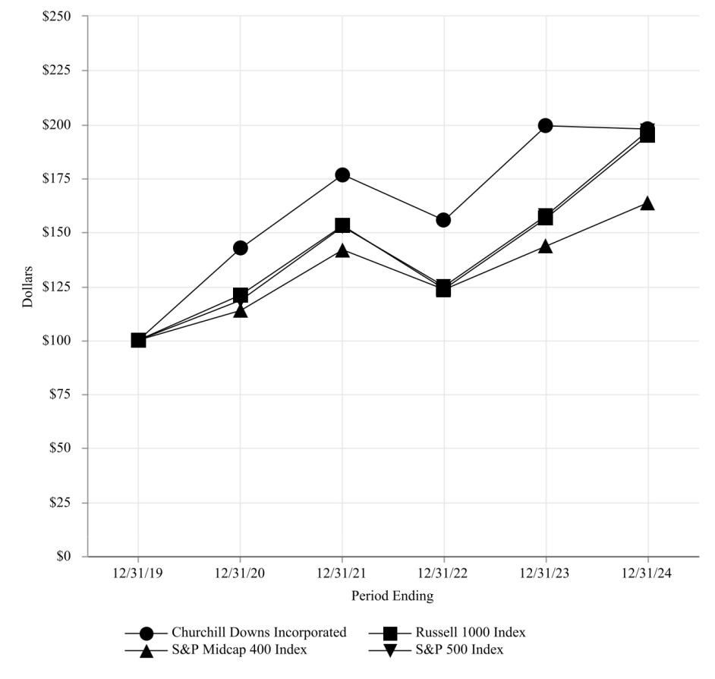

Churchill Downs Incorporated |  |  | 12/31/19 |  |  | 12/31/20 |  |  |  | 12/31/21 |  |  | 12/31/22 |  |  | 12/31/23 |  |  | 12/31/24
 |  | $ | 100.00 |  | $ | 142.44 |  |  | $ | 176.65 |  | $ | 155.52 |  | $ | 199.12 |  | $ | 197.63
Russell 1000 Index |  | $ | 100.00 |  | $ | 120.96 | $ |  |  | 152.96 |  | $ | 123.71 |  | $ | 156.53 |  | $ | 194.89
S&P Midcap 400 Index |  | $ | 100.00 |  | $ | 113.66 | $ |  |  | 141.80 |  | $ | 123.28 |  | $ | 143.54 |  | $ | 163.54
S&P 500 Index |  | $ | 100.00 |  | $ | 118.40 | $ |  |  | 152.39 |  | $ | 124.79 |  | $ | 157.59 |  | $ | 197.02
NOTE 1: Index Data: Copyright Russell Investments. Used with permission. All rights reserved.
NOTE 2: Index Data: Copyright Standard and Poor’s, Inc. Used with permission. All rights reserved.
ITEM 6. | [RESERVED]
 |  |  |  |  |  |  | 30

ITEM 7. MANAGEMENT’S DISCUSSION AND ANALYSIS OF FINANCIAL CONDITION AND RESULTS OF OPERATIONS

The following discussion and analysis of our consolidated financial condition and results of operations should be read in conjunction with our audited consolidated financial statements and related notes included in Part II, Item 8. Financial Statements and Supplementary Data. The following discussion provides an analysis of our results of operations and reasons for material changes therein for 2024 as compared to 2023. Discussion regarding our financial condition and results of operations for 2023 as compared to 2022 is included in Part II, Item 7 of our Annual Report on Form 10-K for the year ended December 31, 2023, filed with the SEC on February 21, 2024.

Our Business

Churchill Downs Incorporated ("CDI" or the "Company") has been creating extraordinary entertainment experiences for over 150 years, beginning with the Company’s most iconic and enduring asset, the Kentucky Derby. Headquartered in Louisville, Kentucky, CDI has expanded through the acquisition, development, and operation of live and historical racing entertainment venues, the growth of the online wagering businesses, and the acquisition, development, and operation of regional casino gaming properties.

2024 Transactions and Expansions

The Rose Gaming Resort Opening

In November 2024, the Company opened The Rose Gaming Resort approximately 30 miles south of Washington D.C. The Company invested approximately $460 million to construct The Rose Gaming Resort with a 102-room hotel, eight food and beverage options, and 1,650 historical racing machines ("HRMs"). The Rose Gaming Resort has the potential to be expanded to up to 1,800 HRMs.

Terre Haute Casino Resort Opening

In April 2024, the Company opened the Terre Haute Casino Resort in Terre Haute, Indiana. The Company invested approximately $290 million to develop the Terre Haute Casino Resort with a luxury hotel, 1,040 slot machines, 36 tables games, a state-of-the-art sportsbook, and regionally inspired food and beverage amenities.

NYRA Transaction

In April 2024, the Company closed on the sale of 49% of the United Tote Company (“United Tote”), a wholly owned subsidiary of CDI, to NYRA Content Management Solutions, LLC ("NYRA"), a subsidiary of the New York Racing Association, Inc.

2023 Transactions and Expansions

Derby City Gaming Downtown Opening

In December 2023, the Company opened Derby City Gaming Downtown in Louisville, Kentucky. The Company invested approximately $90 million to develop Derby City Gaming Downtown with a gaming area, a main-level sports bar with a stage for live entertainment, retail sports betting, a premium bourbon bar, and an elegant wine lounge for guests, including locals, tourists, and convention attendees.

Exacta Systems, LLC Acquisition

On August 22, 2023, the Company completed its acquisition of Exacta Systems, LLC ("Exacta Transaction"). Exacta Systems, LLC ("Exacta") is a leading provider of central determinant system technology in HRMs across the country. Exacta’s system architecture supports multiple game vendors and virtually unlimited math modeling capabilities on a single central determinant system enabling Exacta to deliver a diverse gaming library to Company owned and third-party HRM entertainment venues in Virginia, Kentucky, Wyoming, New Hampshire, and is expanding internationally.

Lady Luck Casino Nemacolin Agreement

In June 2023, the Company's management agreement for Lady Luck Casino Nemacolin ("Lady Luck") in Farmington, Pennsylvania expired and was not renewed. The Company completed the sale of substantially all its assets at Lady Luck for an immaterial amount.

Derby City Gaming & Hotel Expansion

In June 2023, the Company invested approximately $78 million to expand the Derby City Gaming facility in Louisville, Kentucky and build a five-story hotel with 123 rooms including amenities to better serve and attract guests. The expansion included a VIP gaming area, a new sports bar, a stage for live entertainment, and an upscale-casual restaurant and bar.

31

Arlington Sale

On February 15, 2023, the Company closed on the sale of the Arlington property in Arlington Heights, Illinois. We sold 326-acres to the Chicago Bears for $197.2 million. The net proceeds of $195.7 million were used to pay down the outstanding balance amount on our revolving credit facility that was drawn on to fund the acquisition of substantially all the assets of Peninsula Pacific Entertainment LLC.

Other Business Activities

Impairment

During the quarter ended June 30, 2023, the Company evaluated economic conditions subsequent to the date of our annual impairment assessment on April 1, 2023, including competition in the market and inflationary pressures, which increased during the second quarter of 2023, and impacted the performance and outlook of Presque Isle Downs and Casino ("Presque Isle"). As a result, the Company concluded that a trigger event for impairment testing occurred related to the Presque Isle gaming rights, trademark, and the reporting unit's goodwill at the end of the second quarter. Based on the trigger event, the Company evaluated and subsequently updated the projected cash flows and discount rate to reflect the economic environment at that time. As a result, the Company recognized a non-cash impairment charge of $24.5 million in the second quarter of 2023 for the Presque Isle gaming rights and trademark. For additional information, refer to Note 7, Asset Impairments to the notes to consolidated financial statements included in Item 8. Financial Statements and Supplementary Data of this Annual Report on Form 10-K.

Stock Split

Effective May 22, 2023, the Company's common stock was split two-for-one with a proportionate increase in the number of its authorized shares of common stock. For additional information, refer to Note 9, Shareholders' Equity to the notes to consolidated financial statements included in Item 8. Financial Statements and Supplementary Data of this Annual Report on Form 10-K.

Key Indicators to Evaluate Business Results and Financial Condition

Our management monitors a variety of key indicators to evaluate our business results and financial condition. These indicators include changes in net revenue, operating expense, operating income, earnings per share, outstanding debt balance, operating cash flow and capital spend.

Our consolidated financial statements have been prepared in conformity with U.S. generally accepted accounting principles ("GAAP"). We also use non-GAAP measures, including EBITDA (earnings before interest, taxes, depreciation and amortization) and Adjusted EBITDA. We believe that the use of Adjusted EBITDA as a key performance measure of results of operations enables management and investors to evaluate and compare from period to period our operating performance in a meaningful and consistent manner. Our chief operating decision maker utilizes Adjusted EBITDA to evaluate segment performance, develop strategy, and allocate resources. Adjusted EBITDA is a supplemental measure of our performance that is not required by, or presented in accordance with, GAAP. Adjusted EBITDA should not be considered as an alternative to, or more meaningful than, net income (as determined in accordance with GAAP) as a measure of our operating results.

Adjusted EBITDA is defined as earnings before interest, taxes, depreciation and amortization, adjusted for the following:

Adjusted EBITDA includes our portion of EBITDA from our equity investments and the portion of EBITDA attributable to a noncontrolling interest.

Adjusted EBITDA excludes:

- Transaction expense, net which includes:

– Acquisition, disposition, and property sale related charges;

– Other transaction expense, including legal, accounting and other deal-related expense;

- Stock-based compensation expense;

- Rivers Des Plaines' impact on our investments in unconsolidated affiliates from:

– Legal reserves and transaction costs;

- Asset impairments;

- Gain on property sales;

- Legal reserves;

32

- Pre-opening expense; and

- Other charges, recoveries and expenses

As of December 31, 2021, Arlington International Racecourse ("Arlington") ceased racing and simulcast operations and the property was sold on February 15, 2023 to the Chicago Bears. Arlington's results and exit costs in 2023 are treated as an adjustment.

On June 26, 2023, the Company's management agreement for Lady Luck in Farmington, Pennsylvania expired and was not renewed.

For segment reporting, Adjusted EBITDA includes intercompany revenue and expense totals that are eliminated in the Consolidated Statements of Comprehensive Income. See the Reconciliation of Net Income to Adjusted EBITDA included in this section for additional information.

Business Highlights

In 2024, we delivered strong performance while continuing the execution of several organic investments that we believe will provide long-term sustainable value creation. We delivered strong growth in net revenue, operating income, net income, and Adjusted EBITDA compared to fiscal year 2023:

- Net revenue was $2.7 billion, up $272.6 million or 11.1%;

- Net income was $426.8 million, up $9.5 million or 2.3%;

- Adjusted EBITDA was $1.2 billion, up $135.3 million, or 13.2%;

- Cash from operations was $771.7 million, up $166.4 million or 27.5%.

Live and Historical Racing Segment:

- Adjusted EBITDA was $574.6 million, up $99.2 million or 20.9% from fiscal year 2023.

- Churchill Downs Racetrack:

  - Churchill Downs Racetrack ran the 150th Kentucky Derby on the first Saturday of May, generating all-time record all-sources handle and all-time record Derby Week Adjusted EBITDA with nearly 157,000 fans gathered in person to watch the most exciting two minutes in sports.

  - We successfully completed the transformative Paddock Project prior to the 150th Kentucky Derby. This multi-year project fundamentally improves the entire venue for every guest and provides a foundation to further innovate for years to come.

  - We extended the agreement with NBC Sports to continue hosting the Kentucky Derby on NBC and Peacock through 2032.

  - We announced the Starting Gate Pavilion and Courtyard renovation to be open for the 151st Kentucky Derby.

- Kentucky HRMs:

  - Owensboro Racing & Gaming: Constructed a new HRM entertainment venue that opened in February 2025 in Owensboro, Kentucky.

  - Marshall Yards Racing & Gaming: Announced a new HRM entertainment venue near Paducah, Kentucky, that will open in the first quarter of 2026.

- Virginia HRMs:

  - The Rose Gaming Resort: Opened a world class entertainment resort in Dumfries, Virginia in November 2024 that includes 1,650 HRMs, eight bars and restaurants, and a hotel with over 100 rooms and event space.

  - Richmond Expansion: Announced plans to further expand the Richmond, Virginia HRM venue by 450 HRMs.

  - Roseshire Henrico County: Announced plans to open a new HRM entertainment venue in Henrico County, Virginia that will include 175 HRMs.

Wagering Services and Solutions Segment:

- Adjusted EBITDA was $165.6 million, up $33.5 million or 25.4% from fiscal year 2023.

- We expanded Exacta technology and product offerings to customers in new states and internationally.

33

- We monetized online sports betting market access in select states (Indiana, Kentucky, and Pennsylvania) with third parties.

Gaming Segment:

- Adjusted EBITDA was $506.9 million, up $18.3 million or 3.7% from fiscal year 2023.

- Terre Haute Casino Resort: Opened the Terre Haute Casino Resort in April 2024 and luxury 122-room hotel in May 2024 that includes over 1,000 slot machines, table games, a state-of-the-art retail sportsbook, a 400,000 square-foot entertainment venue, and several food and drink offerings.

All Other:

- We amended our senior secured credit agreement to extend the maturity date of our revolving credit facility and term loan A facility from 2027 to 2029 and to make certain other changes to our existing credit agreement.

- We repurchased $65.3 million of shares under our share repurchase program in 2024, based on trade date.

- We continued in our ESG efforts with the ongoing promotion of responsible gaming; initiatives at our properties to lessen energy and water usage, to decrease carbon emissions, and to responsibly manage waste; increasing investments in the communities in which we operate and supporting our teams through educational and leadership development; and increasing engagement with our shareholders.

The Company’s five-year total shareholder return for 2024 was 97.6% compared to 94.9% for the Russell 1000 and 97.0% for the S&P 500. The preceding shareholder return calculations assume dividends are reinvested.

We remain committed to delivering strong financial results and long-term sustainable growth. Our businesses generate strong cash flow, and we have a solid balance sheet that supports our organic growth as well as strategic acquisitions that we believe will create long-term value for our shareholders.

Our Operations

We manage our operations through three reportable segments: Live and Historical Racing, Wagering Services and Solutions, and Gaming.

Refer to Part I, Item 1. Business, of this Annual Report on Form 10-K for more information on our segments and a description of our competition and government regulations and potential legislative changes that affect our business.

Consolidated Financial Results

The following table reflects our net revenue, operating income, net income, Adjusted EBITDA, and certain other financial information:

 |  | Years Ended December 31,
(in millions) |  | 2024 |  |  | 2023 |  |  | Change
Net revenue | $ | 2,734.3 |  | $ | 2,461.7 |  | $ | 272.6
Operating income |  | 709.0 |  |  | 564.0 |  |  | 145.0
Operating income margin |  | 25.9 % |  |  | 22.9 %
Net income attributable to Churchill Down Incorporated | $ | 426.8 |  | $ | 417.3 | $ |  | 9.5
Adjusted EBITDA |  | 1,159.2 |  |  | 1,023.9 |  |  | 135.3

Year Ended December 31, 2024 Compared to the Year Ended December 31, 2023

- Net revenue increased $272.6 million driven by a $178.3 million increase from the Live and Historical Racing segment primarily from growth at our Virginia properties and the opening of the Rosie's Emporia HRM venue and The Rose Gaming Resort, a record-breaking Derby Week at Churchill Downs Racetrack, and growth at our other HRM venues, a $70.5 million increase from the Gaming segment primarily from the opening of the Terre Haute Casino Resort, and a $24.6 million increase from the Wagering Services and Solutions segment primarily from to our Exacta business. All Other net revenue decreased $0.8 million.

- Operating income increased $145.0 million driven by a $105.1 million increase from the Live and Historical Racing segment primarily from a record-breaking Derby Week at Churchill Downs Racetrack, lower fees related to the Exacta technology used in the Company's HRM operations, the opening of the Rosie's Emporia HRM venue and The Rose Gaming Resort, and growth at our other HRM venues, a $21.6 million increase from the Gaming segment primarily from the opening of the Terre Haute Casino Resort, partially offset by inclement weather in January 2024, regional

34

gaming softness, and increased competition, a $20.7 million increase from a reduction of non-cash impairment costs, a $16.9 million benefit to transaction expense primarily related to the settlement of certain liabilities recorded at the time of the Company's November 2022 acquisition of substantially all of the assets of Peninsula Pacific Entertainment LLC, and a $16.3 million increase in the Wagering Services and Solutions segment primarily from our Exacta business. Partially offsetting these increases to operating income was a $35.4 million increase in selling, general and administrative expenses and a $0.2 million decrease in All Other operating income.

- Net income attributable to Churchill Downs Incorporated increased $9.5 million. The following impacted comparability of the Company's net income for the year ended December 31, 2024 compared to the prior year: an $86.2 million after-tax gain on the sale of the Arlington property in the prior year, partially offset by a $15.7 million after-tax decrease in non-cash impairment costs, a $12.8 million after- tax decrease in transaction, pre-opening, and other expense primarily from the settlement of certain liabilities recorded at the time of the Company's November 2022 acquisition of substantially all of the assets of Peninsula Pacific Entertainment LLC, a $5.1 million after-tax increase of other charges and recoveries, net related to non-recurring insurance claim recoveries, and a $0.9 million after-tax decrease of all other charges. Excluding these items, net income increased $61.2 million primarily due to a $77.0 million after-tax increase primarily driven by the results of our operations and equity income from our unconsolidated affiliates, partially offset by a $15.8 million after-tax increase in interest expense associated with higher outstanding debt balances and higher interest rates.

- Adjusted EBITDA increased $135.3 million driven by a $99.2 million increase from the Live and Historical Racing segment primarily from a record-breaking Derby Week at Churchill Downs Racetrack and growth at our HRM venues, a $33.5 million increase from the Wagering Services and Solutions segment primarily due to our Exacta business, and an $18.3 million increase from the Gaming segment primarily from the opening of the Terre Haute Casino Resort in April 2024 that was partially offset by inclement weather in January 2024, regional gaming softness, and increased competition. These increases were partially offset by a decrease of All Other Adjusted EBITDA of $15.7 million.

Revenue by Segment

The following table presents net revenue for our segments, including intercompany revenues:

 |  | Years Ended December 31,
(in millions) |  | 2024 |  |  | 2023 |  |  | Change
Live and Historical Racing | $ | 1,267.0 |  | $ | 1,084.6 |  | $ | 182.4
Wagering Services and Solutions |  | 500.7 |  |  | 458.4 |  |  | 42.3
Gaming |  | 1,045.4 |  |  | 974.6 |  |  | 70.8
All Other |  | 6.6 |  |  | 0.9 |  |  | 5.7
Eliminations |  | (85.4) |  |  | (56.8) |  |  | (28.6)
Net Revenue | $ | 2,734.3 |  | $ | 2,461.7 |  | $ | 272.6

Year Ended December 31, 2024 Compared to the Year Ended December 31, 2023

- Live and Historical Racing revenue increased $182.4 million due to a $57.2 million increase at Churchill Downs Racetrack due to a record-breaking 150th Derby Week, a $25.9 million increase in Northern Virginia including the opening of The Rose Gaming Resort, a $17.2 million increase from the opening of the Rosie’s Emporia HRM venue in Southern Virginia in September 2023, a $39.5 million increase from our other Virginia HRM venues, a $41.5 million increase from our Kentucky HRM venues, and a $1.1 million increase from our New Hampshire venue.

- Wagering Services and Solutions revenue increased $42.3 million due to a $40.8 million increase from our Exacta business primarily from growth in our third party HRM business and from the growth of our Virginia HRM venues and a $2.0 million increase from our sports betting business, partially offset by a $0.5 million decrease from TwinSpires Horse Racing.

- Gaming revenue increased $70.8 million primarily due to a $96.6 million increase from the opening of the Terre Haute Casino Resort. This increase was partially offset by a $15.6 million decrease from our other wholly owned gaming properties primarily due to inclement weather in January 2024, regional gaming softness, and increased competition; and a $10.2 million decrease due to our decision not to renew the management agreement at Lady Luck at the end of June 2023.

- All Other revenue increased $5.7 million primarily due to intercompany revenue related to the captive insurance company that was established in April 2024. All captive revenue is eliminated in consolidation.

35

Consolidated Operating Expense

The following table is a summary of our consolidated operating expense:

 |  | Years Ended December 31,
(in millions) |  | 2024 |  |  | 2023 |  |  | Change
Taxes and purses | $ | 662.9 |  | $ | 613.4 |  | $ | 49.5
Content expense |  | 168.4 |  |  | 173.0 |  |  | (4.6)
Salaries and benefits |  | 330.1 |  |  | 285.3 |  |  | 44.8
Selling, general and administrative expense |  | 237.7 |  |  | 202.3 |  |  | 35.4
Depreciation and amortization |  | 199.1 |  |  | 169.0 |  |  | 30.1
Marketing and advertising expense |  | 90.7 |  |  | 83.4 |  |  | 7.3
Maintenance, insurance and utilities |  | 95.2 |  |  | 88.9 |  |  | 6.3
Property and other taxes |  | 23.0 |  |  | 26.4 |  |  | (3.4)
Asset impairments |  | 3.9 |  |  | 24.6 |  |  | (20.7)
Transaction (benefit) expense, net |  | (12.1) |  |  | 4.8 |  |  | (16.9)
Other operating expense |  | 226.4 |  |  | 226.6 |  |  | (0.2)
Total expense | $ | 2,025.3 |  | $ | 1,897.7 |  | $ | 127.6

Year Ended December 31, 2024 Compared to the Year Ended December 31, 2023

Operating expenses increased $127.6 million for the year ended December 31, 2024 compared to December 31, 2023 primarily due to the Exacta Transaction in August 2023, the opening of Rosie's Emporia in September 2023, Derby City Gaming Downtown in December 2023, Terre Haute Casino Resort in Indiana in April 2024, and The Rose Gaming Resort in Virginia in November 2024. Transaction (benefit) expense, net for the year ended December 31, 2024, includes the settlement of certain liabilities recorded at the time of the Company's November 2022 acquisition of substantially all of the assets of Peninsula Pacific Entertainment LLC which resulted in a benefit to transaction expense of $18.8 million. Asset impairments for the year ended December 31, 2024 include a $3.9 million write-off in the third quarter of 2024 of HRMs in Virginia that are no longer in use. Asset impairments for the year ended December 31, 2023 include the $24.5 million non-cash impairment of Presque Isle intangible assets in the second quarter of 2023.

Adjusted EBITDA by Segment

We believe that the use of Adjusted EBITDA as a key performance measure of the results of operations enables management and investors to evaluate and compare from period to period our operating performance in a meaningful and consistent manner. Adjusted EBITDA is a supplemental measure of our performance that is not required by or presented in accordance with GAAP. Adjusted EBITDA should not be considered as an alternative to, or more meaningful than, net income (as determined in accordance with GAAP) as a measure of our operating results.

 |  | Year Ended December 31,
(in millions) |  | 2024 |  |  | 2023 |  |  | Change
Live and Historical Racing | $ | 574.6 |  | $ | 475.4 |  | $ | 99.2
Wagering Services and Solutions |  | 165.6 |  |  | 132.1 |  |  | 33.5
Gaming |  | 506.9 |  |  | 488.6 |  |  | 18.3
Total segment Adjusted EBITDA |  | 1,247.1 |  |  | 1,096.1 |  |  | 151.0
All Other |  | (87.9) |  |  | (72.2) |  |  | (15.7)
Total Adjusted EBITDA | $ | 1,159.2 |  | $ | 1,023.9 |  | $ | 135.3

Year Ended December 31, 2024 Compared to the Year Ended December 31, 2023

- Live and Historical Racing Adjusted EBITDA increased $99.2 million due to a $32.6 million increase at Churchill Downs Racetrack due to a record-breaking 150th Derby Week, $9.7 million increase in Northern Virginia including the opening of The Rose Gaming Resort, a $7.1 million increase from the opening of the Rosie’s Emporia HRM venue in Southern Virginia in September 2023, a $38.3 million increase from our other Virginia HRM venues, and an $11.5 million increase primarily from our other Kentucky HRM venues.

36

- Wagering Services and Solutions Adjusted EBITDA increased $33.5 million due to a $29.2 million increase from our Exacta business because of increased fees from our Virginia HRM venues, a $2.2 million increase from a one-time reduction in accrued compensation expenses related to our Exacta business, and a $2.6 million increase primarily from our sports betting business, partially offset by a $0.5 million decrease from TwinSpires Horse Racing.

- Gaming Adjusted EBITDA increased $18.3 million primarily due to a $44.5 million increase from the opening of the Terre Haute Casino Resort and a $3.0 million increase from our equity investment in Miami Valley Gaming. These increases were partially offset by a $19.5 million decrease from our wholly owned gaming properties and an $8.5 million decrease from our equity investment in Rivers Des Plaines primarily due to inclement weather in January 2024, regional gaming softness, increased competition, and higher labor and benefit expense; and a $1.2 million decrease from proceeds for business interruption insurance claims in the third quarter 2023 that did not reoccur.

- All Other Adjusted EBITDA decreased $15.7 million driven primarily by increased corporate compensation related expenses and other corporate administrative expenses driven by enterprise growth.

37

Reconciliation of Net Income to Adjusted EBITDA
 |  | Years Ended December 31,
(in millions) |  | 2024 |  |  | 2023 |  |  | Change
Net income attributable to Churchill Downs Incorporated | $ | 426.8 |  | $ | 417.3 |  | $ | 9.5
Net income attributable to noncontrolling interest |  | 2.3 |  |  | — |  |  | 2.3
Net income |  | 429.1 |  |  | 417.3 |  |  | 11.8
Adjustments:
Depreciation and amortization |  | 199.1 |  |  | 169.0 |  |  | 30.1
Interest expense |  | 289.8 |  |  | 268.4 |  |  | 21.4
Income tax provision |  | 144.1 |  |  | 144.5 |  |  | (0.4)
Stock-based compensation expense |  | 36.1 |  |  | 32.9 |  |  | 3.2
Legal reserves |  | — |  |  | (1.2) |  |  | 1.2
Pre-opening expense |  | 29.6 |  |  | 18.6 |  |  | 11.0
Arlington exit costs |  | — |  |  | 9.4 |  |  | (9.4)
Other expense, net |  | 4.2 |  |  | 7.0 |  |  | (2.8)
Transaction (benefit) expense, net |  | (12.1) |  |  | 4.8 |  |  | (16.9)
Asset impairments |  | 3.9 |  |  | 24.6 |  |  | (20.7)
Other income, expense:
Interest, depreciation and amortization expense related to equity investments |  | 42.0 |  |  | 40.2 |  |  | 1.8
Rivers Des Plaines' legal reserves and transactions costs |  | 0.3 |  |  | — |  |  | 0.3
Other charges and recoveries, net |  | (6.9) |  |  | 2.4 |  |  | (9.3)
Gain on the sale of assets |  | — |  |  | (114.0) |  |  | 114.0
Total adjustments |  | 730.1 |  |  | 606.6 |  |  | 123.5
Adjusted EBITDA | $ | 1,159.2 |  | $ | 1,023.9 |  | $ | 135.3
Consolidated Balance Sheet
The following table is a summary of our overall financial position:
 |  | As of December 31,
(in billions) |  | 2024 |  |  | 2023 |  |  | Change
Total assets | $ | 7.3 |  | $ | 7.0 |  | $ | 0.3
Total liabilities |  | 6.2 |  |  | 6.1 |  |  | 0.1
Total shareholders’ equity |  | 1.1 |  |  | 0.9 |  |  | 0.2

- Total assets increased $0.3 billion driven by increased capital expenditures primarily at the Terre Haute Casino Resort, Churchill Downs Racetrack, Owensboro Racing and Gaming in Western Kentucky, and The Rose Gaming Resort in Northern Virginia.

- Total liabilities increased $0.1 billion driven primarily by increased borrowings on our revolver and increased deferred income taxes, partially offset by decreased accrued capital expenditures and decreased deferred revenue due to the recognition of revenue related to the 150th Kentucky Derby.

- Total shareholders’ equity increased $0.2 billion driven by net income and the addition of a redeemable noncontrolling interest, partially offset by share repurchases.

Liquidity and Capital Resources

Our primary sources of liquidity and capital resources have been and will continue to be cash flow from operations, borrowings under our credit facility, and proceeds from the issuance of debt securities. Our ongoing liquidity will depend on a number of factors, including available cash resources, cash flow from operations, acquisitions or equity investments, funding of construction for development projects, and our compliance with our covenants under our credit facility.

38

The following table is a summary of our liquidity and cash flows:
 |  | Year Ended December 31,
(in millions) |  | 2024 |  |  | 2023 |  |  | Change
Cash Flows from:
Operating activities | $ | 771.7 |  | $ | 605.3 | $ |  | 166.4
Investing activities |  | (545.2) |  |  | (718.0) |  |  | 172.8
Financing activities |  | (196.6) |  |  | 129.3 |  |  | (325.9)

Operating Cash Flow

Cash flows from operating activities increased $166.4 million driven by increased operating income and due to the change in working capital primarily related to an increase in short-term gaming and racing liabilities as a result of our Company’s growth and a decrease in accounts receivable primarily from the timing of collections. Partially offsetting these increases to cash from operating activities was increased interest paid and decreased distributions from our unconsolidated affiliates in 2024. We anticipate that cash flows from operations and availability of borrowings under our credit facility over the next twelve months will be adequate to fund our business operations and capital expenditures.

Investing Cash Flow

Cash flows used in investing activities decreased $172.8 million primarily driven by decreased funds used in acquisitions and capital expenditures in 2024, partially offset by proceeds from the Arlington sale received in 2023.

Financing Cash Flow

Cash flows from financing activities decreased $325.9 million primarily driven by decreased net proceeds from long-term debt in 2024 compared to 2023 and by increased share repurchases in 2024.

Capital Expenditures

Included in cash flows from investing activities are capital maintenance expenditures and capital project expenditures. Capital maintenance expenditures relate to the replacement of existing fixed assets with a useful life greater than one year that are obsolete, exhausted, or no longer cost effective to repair. Capital project expenditures represent fixed asset additions related to land or building improvements to new or existing assets or purchases of new (non-replacement) equipment or software related to specific projects deemed necessary expenditures.

We have spent $463.4 million in 2024 on project capital investments including: Churchill Downs Racetrack Paddock Project, the Terre Haute Casino Resort in Vigo County, Indiana, The Rose Gaming Resort in Northern Virginia, and Owensboro Racing & Gaming in Western Kentucky. We currently expect our project capital to be approximately $350 to $400 million in 2025, although this amount may vary significantly based on the timing of work completed, unanticipated delays, and timing of payments to third parties.

Common Stock Repurchase Program

On September 29, 2021, the Board of Directors of the Company approved a common stock repurchase program of up to $500.0 million ("2021 Stock Repurchase Program"). Repurchases may be made at management’s discretion from time to time on the open market (either with or without a 10b5-1 plan) or through privately negotiated transactions. The repurchase program has no time limit and may be suspended or discontinued at any time. We had $149.6 million of repurchase authority remaining under this program as of December 31, 2024.

Dividends

On October 22, 2024, the Company's Board of Directors approved an annual cash dividend on our common stock of $0.409 per outstanding share, which represented a 7% increase over the prior year. The dividend was payable on January 3, 2025 to shareholders of record as of the close of business on December 6, 2024. The 7% increase marked the fourteenth consecutive year that the Company has increased the dividend. The payment and amount of future dividends will be determined by the Board of Directors and will depend upon, among other things, our operating results, financial condition, cash requirements and general business conditions at the time such payment is considered.

39

Credit Facilities and Indebtedness
The following table presents our debt outstanding, bond premium and debt issuance costs:
 |  | As of December 31,
(in millions) |  | 2024 |  |  | 2023 |  |  | Change
Term Loan B-1 due 2028 | $ | 288.8 |  | $ | 291.8 |  | $ | (3.0)
Term Loan A due 2029 |  | 1,172.4 |  |  | 1,235.0 |  |  | (62.6)
Revolver |  | 377.5 |  |  | 247.2 |  |  | 130.3
2027 Senior Notes |  | 600.0 |  |  | 600.0 |  |  | —
2028 Senior Notes |  | 700.0 |  |  | 700.0 |  |  | —
2030 Senior Notes |  | 1,200.0 |  |  | 1,200.0 |  |  | —
2031 Senior Notes |  | 600.0 |  |  | 600.0 |  |  | —
Total debt |  | 4,938.7 |  |  | 4,874.0 |  |  | 64.7
Current maturities of long-term debt |  | (63.1) |  |  | (68.0) |  |  | 4.9
Total debt, net of current maturities |  | 4,875.6 |  |  | 4,806.0 |  |  | 69.6
Issuance cost and fees |  | (31.5) |  |  | (37.7) |  |  | 6.2
Total debt | $ | 4,844.1 |  | $ | 4,768.3 |  | $ | 75.8

Credit Agreement

At December 31, 2024, the Company’s senior secured credit facility (as amended from time to time, the “Credit Agreement") consisted of a $1.2 billion revolving credit facility (the "Revolver"), $288.8 million senior secured term loan B-1 due 2028 (the "Term Loan B-1"), $1.2 billion senior secured term loan A due 2029 (the "Term Loan A"), and $100.0 million swing line commitment. Certain amendments to the Credit Agreement entered into during 2023, 2024, and 2025 are described below.

On February 24, 2023, the Company closed an amendment of the Credit Agreement to increase the loans under the Term Loan A from $800.0 million to $1.3 billion and made certain other changes to the existing credit agreement. The Company used the net proceeds from the borrowings under the increased Term Loan A to repay outstanding loans under its Revolver, pay related transaction fees and expenses, and for general corporate purposes.

On July 3, 2024, the Company closed an amendment of the Credit Agreement to extend the maturity date of the Revolver and Term Loan A from 2027 to 2029 and amend certain other provisions of the Credit Agreement. The Company has $5.7 million of capitalized unamortized debt issuance costs associated with the Term Loan A which are being amortized as interest expense over the remainder of the term.

On February 14, 2025, the Company announced that it closed the seventh amendment of the Credit Agreement. The seventh amendment to the Credit Agreement (i) reduced the interest rate for the Term Loan B-1 from Secured Overnight Financing Rate ("SOFR") plus 200 basis points to SOFR plus 175 basis points, (ii) eliminates the 0.10% credit spread adjustment, and (iii) makes certain other amendments to the Credit Agreement.

The Term Loan B-1 requires quarterly payments of 0.25% of the original $300.0 million balance and may be subject to additional mandatory prepayment from excess cash flow on an annual basis per the provisions of the Credit Agreement.

The Revolver and Term Loan A bear interest at SOFR plus 10 basis points, plus a variable applicable margin which is determined by the Company's net leverage ratio. As of December 31, 2024, that applicable margin was 150 basis points which was based on the pricing grid in the Credit Agreement. The Company had $814.9 million available borrowing capacity, after consideration of $7.6 million in outstanding letters of credit, under the Revolver as of December 31, 2024.

The Company is required to pay a commitment fee on the unused portion of the Revolver as determined by a pricing grid based on the consolidated total net secured leverage ratio of the Company.

For the period ended December 31, 2024, the Company's commitment fee rate was 0.25%.

The Company completed the transition of its financing from London Interbank Offered Rate to SOFR during the second quarter of 2023. These transition activities did not have a material impact on the Company’s financial statements.

The Credit Agreement is collateralized by substantially all the wholly owned assets of the Company. The Credit Agreement contains certain customary affirmative and negative covenants, which include limitations on liens, investments, indebtedness, dispositions, mergers and acquisitions, the making of restricted payments, changes in the nature of business, changes in fiscal year, and transactions with affiliates. The Credit Agreement also contains financial covenants providing for the maintenance of a maximum consolidated secured net leverage ratio and maintenance of a minimum consolidated interest coverage ratio.

40

 | Actual as of
 | December 31, 2024 |  | Requirement
Interest coverage ratio | 3.9 to 1.0 |  | > 2.5 to 1.0
Consolidated total secured net leverage ratio | 1.3 to 1.0 |  | < 4.0 to 1.0

The Company was compliant with all applicable covenants on December 31, 2024.

2027 Senior Notes

On March 25, 2019, the Company completed an offering of $600.0 million in aggregate principal amount of 5.50% Senior Unsecured Notes that mature on April 1, 2027 (the "2027 Senior Notes") in a private offering to qualified institutional buyers pursuant to Rule 144A that is exempt from registration under the Securities Act of 1933, as amended (the "Securities Act"), and to certain non-U.S. persons in accordance with Regulation S under the Securities Act. The Company used the net proceeds from the offering to repay the then-outstanding balance on the Revolver. In connection with the offering, we capitalized $8.9 million of debt issuance costs which are being amortized as interest expense over the term of the 2027 Senior Notes.

The 2027 Senior Notes were issued at par, with interest payable on April 1st and October 1st of each year, commencing on October 1, 2019. The 2027 Senior Notes will vote as one class under the indenture governing the 2027 Senior Notes.

The Company may redeem some or all of the 2027 Senior Notes at redemption prices set forth in the 2027 Indenture.

2028 Senior Notes

On December 27, 2017, the Company completed an offering of $500.0 million in aggregate principal amount of 4.75% Senior Unsecured Notes that mature on January 15, 2028 (the "Existing 2028 Notes") in a private offering to qualified institutional buyers pursuant to Rule 144A that is exempt from registration under the Securities Act, and to certain non-U.S. persons in accordance with Regulation S under the Securities Act. The Existing 2028 Notes were issued at par, with interest payable on January 15th and July 15th of each year, commencing on July 15, 2018. The Company used the net proceeds from the offering to repay a portion of our $600.0 million 5.375% Senior Unsecured Notes due in 2021. In connection with the offering, we capitalized $7.7 million of debt issuance costs which are being amortized as interest expense over the term of the Existing 2028 Notes.

On March 17, 2021, the Company completed an offering of $200.0 million in aggregate principal amount of 4.75% Senior Unsecured Notes that mature on January 15, 2028 (the "Additional 2028 Notes") in a private offering to qualified institutional buyers pursuant to Rule 144A that is exempt from registration under the Securities Act, and to certain non-U.S. persons in accordance with Regulation S under the Securities Act. The Additional 2028 Notes were offered under the indenture dated as of December 27, 2017, governing the $500.0 million aggregate principal amount of 4.75% Senior Unsecured Notes due 2028 and form a part of the same series for purposes of the indenture. In connection with the offering, we capitalized $3.4 million of debt issuance costs which are being amortized as interest expense over the term of the Additional 2028 Notes. Upon completion of this offering, the aggregate principal amount outstanding of the Existing 2028 Notes, together with the Additional 2028 Notes (collectively, the "2028 Senior Notes"), is $700.0 million.

The Additional 2028 Notes were issued at 103.25% of the principal amount, plus interest deemed to have accrued from January 15, 2021, with interest payable on January 15th and July 15th of each year, commencing on July 15, 2021. The 2028 Senior Notes will vote as one class under the indenture governing the 2028 Senior Notes. The 3.25% premium is being amortized through interest expense, net over the term of the Additional 2028 Notes.

The Company may redeem some or all the 2028 Senior Notes at redemption prices set forth in the 2028 Indenture.

2030 Senior Notes

On April 13, 2022, a wholly owned subsidiary of the Company completed an offering of $1.2 billion in aggregate principal amount of 5.75% Senior Unsecured Notes that mature on April 13, 2030 (the "2030 Senior Notes") in a private offering to qualified institutional buyers pursuant to Rule 144A that was exempt from registration under the Securities Act, and to certain non-U.S. persons in accordance with Regulation S under the Securities Act. The offering of the 2030 Senior Notes was part of the financing utilized for the acquisition of substantially all of the assets of Peninsula Pacific Entertainment LLC. In connection with the offering, we capitalized $18.3 million of debt issuance costs which are being amortized as interest expense over the term of the 2030 Senior Notes.

The 2030 Senior Notes were issued at 100% of the principal amount, plus interest deemed to have accrued from April 13, 2022, with interest payable in arrears on April 1st and October 1st of each year, commencing on October 1, 2022. The 2030 Senior Notes will vote as one class under the indenture governing the 2030 Senior Notes.

41

The Issuer may redeem some of or all the 2030 Senior Notes at any time prior to April 1, 2025, at redemption prices set forth in the 2030 Offering Memorandum.

2031 Senior Notes

On April 25, 2023, the Company completed an offering of $600.0 million in aggregate principal amount of 6.75% senior unsecured notes that mature on April 25, 2031 (the "2031 Senior Notes") in a private offering to qualified institutional buyers pursuant to Rule 144A that is exempt from registration under the Securities Act, and to certain non-U.S. persons in accordance with Regulation S under the Securities Act. The Company used a portion of the net proceeds from the offering to repay indebtedness outstanding under its Term Loan B Facility due 2024, and to fund related transaction fees and expenses, working capital and other general corporate purposes. The Company recognized a loss on extinguishment on Term Loan B of $1.3 million, which is included in miscellaneous, net in the accompanying Consolidated Statements of Comprehensive Income. The Company capitalized $10.5 million of debt issuance costs associated with the 2031 Senior Notes which are being amortized as interest expense over the remainder of the 8-year term.

The 2031 Senior Notes were issued at 100% of the principal amount, plus interest deemed to have accrued from April 25, 2023, with interest payable in arrears on May 1st and November 1st of each year, commencing on November 1, 2023. The 2031 Senior Notes will vote as one class under the indenture governing the 2031 Senior Notes.

The Company may redeem some or all of the 2031 Senior Notes at any time prior to April 25, 2025, at redemption prices set forth in the 2031 Offering Memorandum.

Contractual Obligations

Our commitments to make future payments as of December 31, 2024, are estimated as follows:

(in millions) |  | 2025 |  |  | 2026-2027 |  |  | 2028-2029 |  |  | Thereafter |  |  | Total
Dividends | $ | 30.1 |  | $ | — |  | $ | — |  | $ | — |  | $ | 30.1
Revolver |  | — |  |  | — |  |  | 377.5 |  |  | — |  |  | 377.5
Interest on Revolver ⁽¹⁾ |  | 22.8 |  |  | 45.6 |  |  | 34.5 |  |  | — |  |  | 102.9
Term Loan B-1 |  | 3.0 |  |  | 6.0 |  |  | 279.8 |  |  | — |  |  | 288.8
Interest on Term Loan B-1 ⁽¹⁾ |  | 18.8 |  |  | 37.1 |  |  | 3.9 |  |  | — |  |  | 59.8
Term Loan A |  | 60.1 |  |  | 120.2 |  |  | 992.1 |  |  | — |  |  | 1,172.4
Interest on Term Loan A⁽¹⁾ |  | 69.5 |  |  | 128.1 |  |  | 86.9 |  |  | — |  |  | 284.5
2027 Senior Notes |  | — |  |  | 600.0 |  |  | — |  |  | — |  |  | 600.0
2028 Senior Notes |  | — |  |  | — |  |  | 700.0 |  |  | — |  |  | 700.0
2030 Senior Notes |  | — |  |  | — |  |  | — |  |  | 1,200.0 |  |  | 1,200.0
2031 Senior Notes |  | — |  |  | — |  |  | — |  |  | 600.0 |  |  | 600.0
Interest on 2027 Senior Notes |  | 33.0 |  |  | 49.5 |  |  | — |  |  | — |  |  | 82.5
Interest on 2028 Senior Notes |  | 33.3 |  |  | 66.5 |  |  | 16.6 |  |  | — |  |  | 116.4
Interest on 2030 Senior Notes |  | 69.0 |  |  | 138.0 |  |  | 138.0 |  |  | 34.5 |  |  | 379.5
Interest on 2031 Senior Notes |  | 40.5 |  |  | 81.0 |  |  | 81.0 |  |  | 60.8 |  |  | 263.3
Operating and Finance Leases |  | 11.0 |  |  | 19.4 |  |  | 14.5 |  |  | 30.2 |  |  | 75.1
All other |  | 1.6 |  |  | 3.0 |  |  | 2.8 |  |  | 5.0 |  |  | 12.4
Total | $ | 392.7 |  | $ | 1,294.4 |  | $ | 2,727.6 |  | $ | 1,930.5 |  | $ | 6,345.2

- Interest includes the estimated contractual payments under our Credit Facility assuming no change in the weighted average borrowing rate of 6.04%, which was the rate in place as of December 31, 2024.

As of December 31, 2024, we had approximately $3.2 million of unrecognized tax benefits.

Critical Accounting Policies and Estimates

Our significant accounting policies and recently adopted accounting policies are more fully described in Note 2, Significant Accounting Policies to the notes to consolidated financial statements included in Item 8. Financial Statements and Supplementary Data of this Annual Report on Form 10-K.

Our consolidated financial statements have been prepared in conformity with GAAP, which requires management to make estimates, judgments, and assumptions that we believe are reasonable based on our historical experience, contract terms,

42

observance of known trends in our Company and the industry as a whole and information available from other outside sources. Our estimates affect the reported amounts of assets and liabilities and related disclosures of contingent assets and liabilities at the date of the financial statements and the reported amounts of revenue and expense during the reporting period. Actual results may differ from those initial estimates.

Our critical accounting estimates relate to goodwill and certain indefinite-lived intangible assets.

Goodwill and certain intangible assets

Acquisition of certain identifiable intangible assets

In conjunction with the acquisition of a business, the Company records identifiable intangible assets acquired at their respective fair values as of the date of acquisition. Our indefinite-lived intangible assets primarily consist of gaming rights and trademarks. Certain of our gaming rights and trademarks are considered indefinite-lived intangible assets that do not require amortization based on our future expectations to operate our gaming facilities and use the trademarks indefinitely, and our historical experience in renewing these intangible assets at minimal cost with various state gaming commissions. Our definite-lived intangible assets primarily consist of technology and other assets.

We use various valuation methods to determine initial fair value of our intangible assets, including the Greenfield Method and relief-from-royalty method of the income approach, all of which use significant unobservable inputs, or Level 3 inputs, as defined by the fair value hierarchy. The use of these valuation methods requires us to make significant estimates and assumptions about future revenue and operating expenses, expected start-up costs, capital expenditures, royalty rate, and the discount rate. The fair values of gaming rights are generally determined using the Greenfield Method, which is an income approach methodology that calculates the present value based on a projected cash flow stream. This method assumes that the gaming rights provides the opportunity to develop a casino or historical racing facility in a specified region, and that the present value of the projected cash flows are a result of the realization of advantages contained in these rights. Under this methodology, the acquirer is expected to absorb all start-up costs, as well as incur all expenses pertaining to the acquisition and/or the creation of all tangible and intangible assets. The estimated future revenue and operating expenses, start-up costs of the acquired business, and the discount rate are the primary assumptions and estimates used in these valuations. The fair values of trademarks are generally determined using the relief-from-royalty method of the income approach, which estimates the fair value of the intangible asset by discounting the fair value of the hypothetical royalty payments a market participant would be willing to pay to enjoy the benefits of the trademarks. The estimated future revenue, royalty rate, and the discount rate are the primary assumptions and estimates used in these valuations. The fair value of technology assets are generally determined using the relief-from-royalty method of the income approach, which estimates the cost savings that accrue to the owner of the intangibles asset that would otherwise be payable as royalties or license fees on revenues earned through the use of the asset. The estimated future revenue, royalty rate, and discount rate are the primary assumptions and estimates used in the valuations. The discount rates used to discount expected future cash flows to present value are generally derived from the weighted average cost of capital analysis and adjusted for the size and/or risk of the asset. Changes in estimates or the application of alternative assumptions could produce significantly different results.

Assessments of goodwill and intangible assets

We perform our annual review for impairment of goodwill and indefinite-lived intangible assets on April 1st of each fiscal year, or more frequently if events or changes in circumstances indicate that it is more likely than not the asset is impaired. Adverse industry or economic trends, lower projections of profitability, or a sustained decline in our market capitalization, among other items, may be indications of potential impairment issues which are triggering events requiring the testing of an asset’s carrying value for recoverability.

Goodwill and indefinite-lived intangible assets are required to be tested annually or more frequently if events or changes in circumstances indicate that it is more likely than not that an asset is impaired. An entity may first assess qualitative factors to determine whether it is necessary to complete the impairment test using a more likely than not criteria. If an entity believes it is more likely than not that the fair value of a reporting unit is greater than the reporting unit's carrying value, including goodwill, the quantitative impairment test can be bypassed. Alternatively, an entity has an unconditional option to bypass the qualitative assessment and proceed directly to performing the quantitative impairment test. If a quantitative impairment test of goodwill is required, we generally determine the fair value under the market and income valuation approaches using inputs primarily related to discounted projected cash flows and price multiples of publicly traded comparable companies. If a quantitative impairment test of our indefinite-lived intangible assets is required, we generally determine the fair value using the Greenfield Method for gaming rights and relief-from-royalty method of the income approach for trademarks. Qualitative factors include macroeconomic conditions, industry and market conditions, cost factors, and overall financial performance, among others. These factors require significant judgments and estimates, and application of alternative assumptions could produce materially different results. Evaluations of possible impairment require us to estimate, among other factors, forecasts of future operating results, revenue growth, operating expense, tax rates, start-up costs, capital expenditures, depreciation, working capital,

43

discount rates, long-term growth rates, risk premiums, royalty rates, terminal values, and fair values of our reporting units and assets. The impairment tests for goodwill and indefinite-lived intangible assets are subject to uncertainties arising from such events as changes in competitive conditions, the current economic environment, material changes in growth rate assumptions that could positively or negatively impact anticipated future operating conditions and cash flows, changes in the discount rate, and the impact of strategic decisions. If any of these factors were to materially change, such change may require a reevaluation of our goodwill and indefinite-lived intangible assets. Changes in estimates or the application of alternative assumptions could produce significantly different results.

44

ITEM 7A. QUANTITATIVE AND QUALITATIVE DISCLOSURES ABOUT MARKET RISK

We are exposed to market risks arising from adverse changes in:

- general economic trends; and

- interest rate and credit risk.

General economic trends

Our business is sensitive to consumer confidence and reductions in consumers' discretionary spending, which may result from challenging economic conditions, interest rate fluctuations, unemployment levels and other changes in the economy. Demand for entertainment and leisure activities is sensitive to consumers’ disposable incomes, which can be adversely affected by economic conditions and unemployment levels. This could result in fewer patrons visiting our racetracks, HRM entertainment venues, online wagering sites, and gaming facilities, and/or may impact our customers’ ability to wager with the same frequency and to maintain wagering levels.

Interest rate and credit risk

Our primary exposure to market risk relates to changes in interest rates. On December 31, 2024, we had $1.8 billion outstanding under our Credit Agreement, which bears interest at SOFR based variable rates. We are exposed to market risk on variable rate debt due to potential adverse changes in these rates. Assuming the outstanding balance of the debt facility remains constant, a one-percentage point increase in the SOFR rate would reduce net income and cash flows from operating activities by $13.3 million.

45

ITEM 8. | FINANCIAL STATEMENTS AND SUPPLEMENTARY DATA
 | CHURCHILL DOWNS INCORPORATED
 | CONSOLIDATED STATEMENTS OF COMPREHENSIVE INCOME
 | for the years ended December 31,
(in millions, except per common share data) |  |  | 2024 |  |  | 2023 |  |  | 2022
Net revenue:
Live and Historical Racing |  | $ | 1,225.6 |  | $ | 1,047.3 |  | $ | 614.6
Wagering Services and Solutions |  |  | 469.5 |  |  | 444.9 |  |  | 436.4
Gaming |  |  | 1,039.1 |  |  | 968.6 |  |  | 755.9
All Other |  |  | 0.1 |  |  | 0.9 |  |  | 2.9
Total net revenue |  |  | 2,734.3 |  |  | 2,461.7 |  |  | 1,809.8
Operating expense:
Live and Historical Racing |  |  | 735.4 |  |  | 662.2 |  |  | 400.9
Wagering Services and Solutions |  |  | 296.5 |  |  | 288.2 |  |  | 293.6
Gaming |  |  | 748.9 |  |  | 700.0 |  |  | 537.9
All Other |  |  | 15.0 |  |  | 15.6 |  |  | 11.0
Selling, general and administrative expense |  |  | 237.7 |  |  | 202.3 |  |  | 164.2
Asset impairments |  |  | 3.9 |  |  | 24.6 |  |  | 38.3
Transaction (benefit) expense |  |  | (12.1) |  |  | 4.8 |  |  | 42.1
Total operating expense |  |  | 2,025.3 |  |  | 1,897.7 |  |  | 1,488.0
Operating income |  |  | 709.0 |  |  | 564.0 |  |  | 321.8
Other (expense) income:
Interest expense, net |  |  | (289.8) |  |  | (268.4) |  |  | (147.3)
Equity in income of unconsolidated affiliates |  |  | 144.9 |  |  | 146.3 |  |  | 152.7
Gain on the sale of assets |  |  | — |  |  | 114.0 |  |  | 274.6
Miscellaneous, net |  |  | 9.1 |  |  | 5.9 |  |  | 7.0
Total other (expense) income |  |  | (135.8) |  |  | (2.2) |  |  | 287.0
Income from operations before provision for income taxes |  |  | 573.2 |  |  | 561.8 |  |  | 608.8
Income tax provision |  |  | (144.1) |  |  | (144.5) |  |  | (169.4)
Net income |  |  | 429.1 |  |  | 417.3 |  |  | 439.4
Net income attributable to noncontrolling interest |  |  | 2.3 |  |  | — |  |  | —
Net income and comprehensive income attributable to Churchill Downs Incorporated |  | $ | 426.8 |  | $ | 417.3 |  | $ | 439.4
Net income attributable to Churchill Downs Incorporate per common share data:

Basic net income | $ | 5.73
Diluted net income | $ | 5.68
Weighted average shares outstanding:
Basic |  | 74.0
Diluted |  | 74.6

The accompanying notes are an integral part of the consolidated financial statements.

$ | 5.55 |  | $ | 5.79
$ | 5.49 |  | $ | 5.71
 | 75.2 |  |  | 75.9
 | 76.1 |  |  | 77.0

46

CHURCHILL DOWNS INCORPORATED

CONSOLIDATED BALANCE SHEETS

December 31,

(in millions) |  | 2024 |  |  | 2023
ASSETS
Current assets:
Cash and cash equivalents | $ | 175.5 |  | $ | 144.5
Restricted cash |  | 77.2 |  |  | 77.3
Accounts receivable, net |  | 98.7 |  |  | 106.9
Income taxes receivable |  | 14.5 |  |  | 12.6
Other current assets |  | 46.4 |  |  | 59.5
Total current assets |  | 412.3 |  |  | 400.8
Property and equipment, net |  | 2,874.9 |  |  | 2,561.2
Investment in and advances to unconsolidated affiliates |  | 661.2 |  |  | 655.9
Goodwill |  | 900.2 |  |  | 899.9
Other intangible assets, net |  | 2,409.0 |  |  | 2,418.4
Other assets |  | 18.3 |  |  | 19.3
Total assets | $ | 7,275.9 |  | $ | 6,955.5
LIABILITIES AND SHAREHOLDERS' EQUITY
Current liabilities:
Accounts payable | $ | 180.3 |  | $ | 158.5
Accrued expenses and other current liabilities |  | 402.0 |  |  | 426.8
Current deferred revenue |  | 52.9 |  |  | 73.2
Current maturities of long-term debt |  | 63.1 |  |  | 68.0
Dividends payable |  | 31.0 |  |  | 29.3
Total current liabilities |  | 729.3 |  |  | 755.8
Long-term debt (net of current maturities and loan origination fees of $7.7 in 2024 and $8.9 in 2023) |  | 1,767.9 |  |  | 1,697.1
Notes payable (net of debt issuance costs of $23.8 in 2024 and $28.8 in 2023) |  | 3,076.2 |  |  | 3,071.2
Non-current deferred revenue |  | 20.0 |  |  | 11.8
Deferred income taxes |  | 432.7 |  |  | 388.2
Other liabilities |  | 146.5 |  |  | 137.8
Total liabilities |  | 6,172.6 |  |  | 6,061.9
Commitments and contingencies
Redeemable noncontrolling interest |  | 19.7 |  |  | —
Shareholders' equity:
Preferred stock, no par value; 0.3 shares authorized; no shares issued or outstanding |  | — |  |  | —
Common stock, no par value; 300.0 shares authorized; 73.5 shares issued and outstanding December 31, 2024 and 74.5 shares at December 31, |  | — |  |  | —
2023 |  |  |  |  | —
Retained earnings |  | 1,084.6 |  |  | 894.5
Accumulated other comprehensive loss |  | (1.0) |  |  | (0.9)
Total shareholders' equity |  | 1,083.6 |  |  | 893.6
Total liabilities and shareholders' equity | $ | 7,275.9 |  | $ | 6,955.5

The accompanying notes are an integral part of the consolidated financial statements.

47

CHURCHILL DOWNS INCORPORATED

CONSOLIDATED STATEMENTS OF SHAREHOLDERS’ EQUITY

for the years ended December 31, 2024, 2023 and 2022

 | Common Stock |  |  |  |  |  | Retained |  |  | Accumulated Other |  |  | Total Shareholders'
 | Shares |  |  | Amount |  |  |  |  |  |  |  |  | Total Shareholders'
(in millions, except per common share data) |  |  |  |  |  |  | Earnings |  |  | Comprehensive Loss |  |  | Equity
Balance, December 31, 2021 | 76.2 |  | $ | — |  | $ | 307.7 |  | $ | (0.9) |  | $ | 306.8
Net income attributable to Churchill Downs Incorporated |  |  |  |  |  |  | 439.4 |  |  |  |  |  | 439.4
Issuance of common stock | 0.6 |  |  | 2.7 |  |  |  |  |  |  |  |  | 2.7
Repurchase of common stock | (1.8) |  |  | (34.5) |  |  | (141.0) |  |  |  |  |  | (175.5)
Taxes paid related to net share settlement of stock awards | (0.2) |  |  |  |  |  | (26.9) |  |  |  |  |  | (26.9)
Stock-based compensation |  |  |  | 31.8 |  |  |  |  |  |  |  |  | 31.8
Cash dividends ($0.357 per share) |  |  |  |  |  |  | (26.8) |  |  |  |  |  | (26.8)
Balance, December 31, 2022 | 74.8 |  |  | — |  |  | 552.4 |  |  | (0.9) |  |  | 551.5
Net income attributable to Churchill Downs Incorporated |  |  |  |  |  |  | 417.3 |  |  |  |  |  | 417.3
Issuance of common stock | 0.3 |  |  | 3.1 |  |  |  |  |  |  |  |  | 3.1
Repurchase of common stock | (0.5) |  |  | (36.0) |  |  | (19.3) |  |  |  |  |  | (55.3)
Taxes paid related to net share settlement of stock awards | (0.1) |  |  |  |  |  | (26.5) |  |  |  |  |  | (26.5)
Stock-based compensation |  |  |  | 32.9 |  |  |  |  |  |  |  |  | 32.9
Cash dividends ($0.382 per share) |  |  |  |  |  |  | (28.5) |  |  |  |  |  | (28.5)
Other |  |  |  |  |  |  | (0.9) |  |  |  |  |  | (0.9)
Balance, December 31, 2023 | 74.5 |  |  | — |  |  | 894.5 |  |  | (0.9) |  |  | 893.6
Net income attributable to Churchill Downs Incorporated |  |  |  |  |  |  | 426.8 |  |  |  |  |  | 426.8
Issuance of common stock | 0.7 |  |  | 4.2 |  |  |  |  |  |  |  |  | 4.2
Repurchase of common stock | (1.5) |  |  | (35.8) |  |  | (153.2) |  |  |  |  |  | (189.0)
Reclassification to liability awards |  |  |  |  |  |  | (20.9) |  |  |  |  |  | (20.9)
Taxes paid related to net share settlement of stock awards | (0.2) |  |  |  |  |  | (27.3) |  |  |  |  |  | (27.3)
Stock-based compensation |  |  |  | 32.0 |  |  |  |  |  |  |  |  | 32.0
Cash dividends ($0.409 per share) |  |  |  |  |  |  | (30.1) |  |  |  |  |  | (30.1)
Other |  |  |  | (0.4) |  |  | (5.2) |  |  | (0.1) |  |  | (5.7)
Balance, December 31, 2024 | 73.5 |  | $ | — |  | $ | 1,084.6 |  | $ | (1.0) |  | $ | 1,083.6

The accompanying notes are an integral part of the consolidated financial statements.

48

CHURCHILL DOWNS INCORPORATED

CONSOLIDATED STATEMENTS OF CASH FLOWS

for the years ended December 31,

(in millions) |  | 2024 |  |  | 2023 |  |  | 2022
Cash flows from operating activities:
Net income | $ | 429.1 |  | $ | 417.3 |  | $ | 439.4
Adjustments to reconcile net income to net cash provided by operating activities:
Depreciation and amortization |  | 199.1 |  |  | 169.0 |  |  | 113.7
Equity in income of unconsolidated affiliates |  | (144.9) |  |  | (146.3) |  |  | (152.7)
Distributions from unconsolidated affiliates |  | 138.7 |  |  | 155.1 |  |  | 156.9
Stock-based compensation |  | 36.1 |  |  | 32.9 |  |  | 31.8
Deferred income taxes |  | 44.5 |  |  | 47.4 |  |  | 108.7
Asset impairments |  | 3.9 |  |  | 24.6 |  |  | 38.3
Amortization of operating lease assets |  | 5.6 |  |  | 6.2 |  |  | 5.3
Gain on sale of assets |  | — |  |  | (114.0) |  |  | (274.6)
Other |  | 9.7 |  |  | 5.4 |  |  | 7.4
Changes in operating assets and liabilities, net of businesses acquired and dispositions:
Income taxes |  | (4.5) |  |  | (1.1) |  |  | 28.2
Deferred revenue |  | (12.1) |  |  | 34.2 |  |  | (12.7)
Other assets and liabilities |  | 66.5 |  |  | (25.4) |  |  | 21.1
Net cash provided by operating activities |  | 771.7 |  |  | 605.3 |  |  | 510.8
Cash flows from investing activities:
Capital maintenance expenditures |  | (83.6) |  |  | (77.7) |  |  | (50.2)
Capital project expenditures |  | (463.4) |  |  | (598.8) |  |  | (373.3)
Acquisition of businesses, net of cash acquired |  | — |  |  | (241.3) |  |  | (2,918.5)
Acquisition of gaming rights, net of cash acquired |  | — |  |  | — |  |  | (33.3)
Proceeds from sale of assets |  | — |  |  | 195.7 |  |  | 279.0
Other |  | 1.8 |  |  | 4.1 |  |  | (7.4)
Net cash used in investing activities |  | (545.2) |  |  | (718.0) |  |  | (3,103.7)
Cash flows from financing activities:
Proceeds from borrowings under long-term debt obligations |  | 965.5 |  |  | 1,771.1 |  |  | 2,862.4
Repayments of borrowings under long-term debt obligations |  | (900.8) |  |  | (1,536.0) |  |  | (205.4)
Payment of dividends |  | (29.2) |  |  | (27.1) |  |  | (26.0)
Repurchase of common stock |  | (186.0) |  |  | (55.9) |  |  | (174.9)
Taxes paid related to net share settlement of stock awards |  | (30.1) |  |  | (25.5) |  |  | (28.4)
Proceeds from pending equity transaction |  | — |  |  | 14.4 |  |  | —
Debt issuance costs |  | (2.6) |  |  | (13.0) |  |  | (27.3)
Change in bank overdraft |  | (10.9) |  |  | 2.0 |  |  | 13.3
Other |  | (2.5) |  |  | (0.7) |  |  | 2.3
Net cash (used in) provided by financing activities |  | (196.6) |  |  | 129.3 |  |  | 2,416.0
Cash flows from discontinued operations:
Operating cash flows of discontinued operations |  | 1.0 |  |  | 0.5 |  |  | 26.0
Net increase (decrease) in cash, cash equivalents and restricted cash |  | 30.9 |  |  | 17.1 |  |  | (150.9)
Cash, cash equivalents and restricted cash, beginning of year |  | 221.8 |  |  | 204.7 |  |  | 355.6
Cash, cash equivalents and restricted cash, end of year | $ | 252.7 |  | $ | 221.8 |  | $ | 204.7

The accompanying notes are an integral part of the consolidated financial statements.

49

CHURCHILL DOWNS INCORPORATED

CONSOLIDATED STATEMENTS OF CASH FLOWS (continued)

for the years ended December 31,

(in millions) |  | 2024 |  |  | 2023 |  |  | 2022
Supplemental disclosures of cash flow information:
Cash paid during the period for:
Interest | $ | 306.8 |  | $ | 283.6 |  | $ | 133.6
Cash paid for income taxes |  | 108.2 |  |  | 99.1 |  |  | 68.6
Cash received from income tax refunds |  | 5.2 |  |  | 0.9 |  |  | 61.6
Schedule of non-cash investing and financing activities:
Dividends payable | $ | 31.0 |  | $ | 29.3 |  | $ | 27.0
Deferred payment on gaming rights incurred during the period |  | — |  |  | — |  |  | 50.6
Deferred payments on the acquisition of business included in other liabilities |  | 1.2 |  |  | 4.9 |  |  | —
Property and equipment additions included in accounts payable and accrued expense and other current liabilities |  | 43.7 |  |  | 95.1 |  |  | 51.3

The accompanying notes are an integral part of the consolidated financial statements.

50

Churchill Downs Incorporated

Notes to Consolidated Financial Statements

1. DESCRIPTION OF BUSINESS

Churchill Downs Incorporated ("CDI" or the "Company") has been creating extraordinary entertainment experiences for over 150 years, beginning with the Company’s most iconic and enduring asset, the Kentucky Derby. Headquartered in Louisville, Kentucky, CDI has expanded through the acquisition, development, and operation of live and historical racing entertainment venues, the growth of the online wagering businesses, and the acquisition, development, and operation of regional casino gaming properties.

We own and operate 15 live and historical racing entertainment venues in three states, one of the largest online horse racing wagering platforms in the U.S., ten wholly owned casino gaming properties in nine states and 14 retail sportsbooks. We were organized as a Kentucky corporation in 1928, and our principal executive offices are located in Louisville, Kentucky.

2. SIGNIFICANT ACCOUNTING POLICIES

Principles of Consolidation

The accompanying consolidated financial statements include the accounts of the Company and subsidiaries. All intercompany balances and transactions have been eliminated in consolidation.

We consolidate all subsidiaries in which we have a controlling financial interest and variable interest entities ("VIEs") for which we or one of our consolidated subsidiaries is the primary beneficiary. We consolidate a VIE when we have both the power to direct the activities that most significantly impact the results of the VIE and the right to receive benefits or the obligation to absorb losses of the entity that could be potentially significant to the VIE.

Use of Estimates

Our financial statements have been prepared in conformity with U.S. generally accepted accounting principles ("GAAP"), which requires management to make estimates, judgments and assumptions that we believe are reasonable based on our historical experience, contract terms, observance of known trends in our Company and the industry as a whole and information available from other outside sources. Our estimates affect the reported amounts of assets and liabilities and related disclosures of contingent assets and liabilities at the date of the financial statements and the reported amounts of revenue and expense during the reporting period. Actual results may differ from those initial estimates.

Goodwill and Intangible Assets

Goodwill and indefinite-lived intangible assets are required to be tested annually or more frequently if events or changes in circumstances indicate that it is more likely than not that an asset is impaired. An entity may first assess qualitative factors to determine whether it is necessary to complete the impairment test using a more likely than not criteria. If an entity believes it is more likely than not that the fair value of a reporting unit is greater than the reporting unit's carrying value, including goodwill, the quantitative impairment test can be bypassed. Alternatively, an entity has an unconditional option to bypass the qualitative assessment and proceed directly to performing the quantitative impairment test. If a quantitative impairment test of goodwill is required, we generally determine the fair value under the market and income valuation approaches using inputs primarily related to discounted projected cash flows and price multiples of publicly traded comparable companies. If a quantitative impairment test of our indefinite-lived intangible assets is required, we generally determine the fair value using the Greenfield Method for gaming rights and relief-from-royalty method of the income approach for trademarks. The Greenfield Method is an income approach methodology that calculates the present value based on a projected cash flow stream. Qualitative factors include macroeconomic conditions, industry and market conditions, cost factors and overall financial performance, among others. These factors require judgments and estimates, and application of alternative assumptions could produce significantly different results. Evaluations of possible impairment require us to estimate, among other factors, forecasts of future operating results, revenue growth, operating expense, tax rates, start-up costs, capital expenditures, depreciation, working capital, discount rates, long-term growth rates, risk premiums, royalty rates, terminal values and fair market values of our reporting units and assets. The estimated future revenue and operating expenses, start-up costs, and discount rates are the primary assumptions and estimates in the valuation of gaming rights. Changes in estimates or the application of alternative assumptions could produce significantly different results.

We perform our annual review for impairment of goodwill and indefinite-lived intangible assets on April 1 of each fiscal year, or more frequently if events or changes in circumstances indicate that it is more likely than not the relevant asset is impaired. Adverse industry or economic trends, lower projections of profitability, or a sustained decline in our market capitalization, among other items, may be indications of potential impairment issues, which are triggering events requiring the testing of an asset’s carrying value for recoverability. Goodwill is allocated and evaluated for impairment at the reporting unit level, which is defined as an operating segment or one level below an operating segment, referred to as a component. We are required to aggregate the components of an operating segment into one reporting unit if they have similar economic characteristics.

51

Churchill Downs Incorporated

Notes to Consolidated Financial Statements

Our gaming rights and trademarks are considered indefinite-lived intangible assets that do not require amortization based on our future expectations to operate our gaming facilities and use the trademarks indefinitely and our historical experience in renewing these intangible assets at minimal cost with various state gaming commissions. The indefinite lived-intangible assets carrying value are tested annually, or more frequently, if indicators of impairment exist, by comparing the fair value of the recorded assets to the associated carrying amount. If the carrying amount of the gaming rights and trademark intangible assets exceed fair value, an impairment loss is recognized.

Other definite-lived intangible assets, consisting primarily of customer relationships and technology assets, are amortized over periods from seven to 15 years. Amortization expense related to the definite-lived intangible assets is provided on a straight-line basis, as it approximates the economic benefit over the estimated useful lives of the assets. With respect to definite-lived intangible assets, we periodically evaluate whether events and circumstances have occurred that may affect the estimated useful life or the recoverability of the remaining balance of such assets. If such events or circumstances indicate that the carrying amount of these assets may not be recoverable, we would estimate the future cash flows expected to result from the use of the assets and their eventual disposition. If the sum of the expected future cash flows were less than the carrying amount of the assets, we would recognize an impairment charge to reduce such assets to their fair value.

Property and Equipment

We review the carrying value of our property and equipment to be held and used in our operations whenever events or changes in circumstances indicate that the carrying value of an asset may not be recoverable from estimated future undiscounted cash flows expected to result from the asset's use and eventual disposition. Adverse industry or economic trends, lower projections of profitability, or a significant adverse change in legal factors or in the business climate, among other items, may be indications of potential impairment issues. If the undiscounted cash flows exceed the carrying value, no impairment is indicated. If the undiscounted cash flows do not exceed the carrying value, an impairment is recorded based on the fair value of the asset.

Depreciation is calculated using the straight-line method over the estimated useful lives of the related assets as follows: 10 to 40 years for grandstands and buildings, two to 10 years for equipment, two to 10 years for furniture and fixtures and 10 to 20 years for tracks and other improvements.

Our capital maintenance expenditures relate to the replacement of existing fixed assets with a useful life greater than one year that are obsolete, exhausted, or no longer cost effective to repair. Our capital project expenditures represent fixed asset additions related to land or building improvements to new or existing assets or purchases of new (non-replacement) equipment or software related to specific projects deemed necessary expenditures.

Revenue Recognition

We generate revenue from pari-mutuel wagering transactions with customers related to live races, simulcast races, and historical races as well as simulcast host fees earned from other wagering sites. Our racetracks that host live races also generate revenue through sponsorships, admissions (including luxury suites), personal seat licenses ("PSLs"), television rights, concessions, programs and parking. Concessions, programs, and parking revenue is recognized once the good or service is delivered.

Our live racetracks' revenue and income are influenced by our racing calendar. Similarly, TwinSpires advance deposit wagering ("ADW") and United Tote revenue and income is influenced by racing calendars. Therefore, revenue and operating results for any interim quarter are not generally indicative of the revenue and operating results for the year and may not be comparable with results for the corresponding period of the previous year. We historically have had fewer live racing days during the first quarter of each year, and the majority of our live racing revenue occurs during the second quarter with the running of the Kentucky Oaks and Kentucky Derby.

For live races we present at our racetracks, we recognize revenue on wagers we accept from customers at our racetrack ("on-track revenue") and revenue we earn from exporting our live racing signals to other racetracks, off-track betting facilities ("OTBs"), and ADW providers ("export revenue"). For simulcast races we display at our racetracks, OTBs, and TwinSpires' platforms, we recognize revenue we earn from providing a wagering service to our customers on these imported live races ("import revenue"). TwinSpires import revenue is generated through ADW which consists of patrons wagering through an advance deposit account. Each wagering contract for on-track revenue, and import revenue contains a single performance obligation and our export revenue contracts contain a series of distinct services that form a single performance obligation. The transaction price for on-track revenue and import revenue is fixed based on the established commission rate we are entitled to retain. The transaction price for export revenue is variable based on the simulcast host fee we charge our customers for exporting our signal. We may provide cash incentives in conjunction with wagering transactions we accept from TwinSpires' customers. These cash incentives represent consideration payable to a customer and therefore are treated as a reduction of the transaction price for the wagering transaction. Our export revenue contracts generally have a duration of one year or less. These arrangements are licenses of intellectual property containing a usage-based royalty. As a result, we have elected to use

52

Churchill Downs Incorporated

Notes to Consolidated Financial Statements

the practical expedient to omit disclosure related to remaining performance obligations for our export revenue contracts. We recognize on-track revenue, export revenue, and import revenue once the live race event is made official by the relevant racing regulatory body.

We recognize revenue we earn from providing a wagering service to our customers on historical races at our historical racing machine ("HRM") facilities. The transaction price for HRM revenue is based on the established commission rate we are entitled to retain for each wager on the HRM. We recognize HRM revenue once the historical race has been completed on the HRM, net of the liability to the pool.

We evaluate our on-track revenue, export revenue, import revenue, and HRM revenue contracts in order to determine whether we are acting as the principal or as the agent when providing services, which we consider in determining if revenue should be reported gross or net. An entity is a principal if it controls the specified service before that service is transferred to a customer.

The revenue we recognize for on-track revenue, import revenue, and HRM revenue is the commission we are entitled to retain for providing a wagering service to our customers. For these arrangements, we are the principal as we control the wagering service; therefore, any charges, including any applicable simulcast fees, we incur for delivering the wagering service are presented as operating expenses.

For export revenue, our customer is the third-party wagering site such as a racetrack, OTB, or ADW provider. Therefore, the revenue we recognize for export revenue is the simulcast host fee we earn for exporting our racing signal to the third-party wagering site.

Our admission contracts are either for a single live racing event day or multiple days. Our PSLs, sponsorships, and television rights contracts generally relate to multiple live racing event days. Multiple day admission, PSLs, sponsorships, and television rights contracts contain a distinct series of services that form single performance obligations. Sponsorship contracts generally include performance obligations related to admissions and advertising rights at our racetracks. Television rights contracts contain a performance obligation related to the rights to distribute certain live racing events on media platforms. The transaction prices for our admissions, PSLs, sponsorships, and television rights contracts are fixed. We allocate the transaction price to our sponsorship contract performance obligations based on the estimated relative standalone selling price of each distinct service.

The revenue we recognize for admissions to a live racing event day is recognized once the related event is complete. For admissions, PSLs, sponsorships, and television rights contracts that relate to multiple live racing event days, we recognize revenue over time using an output method of each completed live racing event day as our measure of progress. Each completed live racing event day corresponds with the transfer of the relevant service to a customer and therefore is considered a faithful depiction of our efforts to satisfy the promises in these contracts. This output method results in measuring the value transferred to date to the customer relative to the remaining services promised under the contracts. Certain premium live racing event days such as the Kentucky Derby and Oaks result in a higher value of revenue allocated relative to other live racing event days due to, among other things, the quality of thoroughbreds racing, higher levels of on-track attendance, national broadcast audience, local and national media coverage, and overall entertainment value of the event. While these performance obligations are satisfied over time, the timing of when this revenue is recognized is directly associated with the occurrence of our live racing events, which is when the majority of our revenues recognized at a point in time are also recognized.

Timing of revenue recognition may differ from the timing of invoicing to customers for our long-term contracts for racing event-related services. We generally invoice customers prior to delivery of services for our admissions, PSLs, sponsorships, and television rights contracts. We recognize a receivable and a contract liability at the time we have an unconditional right to receive payment. When cash is received in advance of delivering services under our contracts, we defer revenue and recognize it in accordance with our policies for that type of contract. In situations where the timing of revenue recognition differs from the timing of invoicing, we have determined our contracts do not include a significant financing component. The primary purpose of our invoicing terms is to allow our customers to secure the right to the specific services provided under our contracts, not to receive financing from our customers.

Gaming revenue primarily consists of gaming transactions. Other operating revenue, such as food and beverage or hotel revenue, is recognized once delivery of the product or service has occurred.

The transaction price for gaming transactions is the difference between gaming wins and losses. Gaming wager revenue is recognized when the wager settles.

The majority of our HRM facilities and gaming properties offer loyalty programs that enable customers to earn loyalty points based on their play. HRM and gaming transactions involve two performance obligations for those customers earning loyalty points under the Company’s loyalty programs and a single performance obligation for customers who do not participate in the program. Loyalty points are primarily redeemable for free wagering activities and food and beverage. For purposes of allocating the transaction price in an HRM and gaming transaction between the wagering performance obligation and the

53

Churchill Downs Incorporated

Notes to Consolidated Financial Statements

obligation associated with the loyalty points earned, the Company allocates an amount to the loyalty point contract liability based on the stand-alone selling price of the points earned, which is determined by the value of a loyalty point that can be redeemed for wagering activities or food and beverage. For gaming transactions, an amount of the transaction price allocated to the gaming performance obligation using the residual approach as the stand-alone price for wagers is highly variable and no set established price exists for such wagers. For HRM transactions, the amount of the transaction price allocated to the HRM performance obligation is the commission rate we are entitled to retain. The loyalty point contract liability amount is deferred and recognized as revenue when the customer redeems the points for a wagering transaction or food and beverage, and such goods or services are delivered to the customer.

Income Taxes

We use estimates and judgments for financial reporting to determine our current tax liability and deferred taxes. In accordance with the liability method of accounting for income taxes, we recognize the amount of taxes payable or refundable for the current year and deferred tax assets and liabilities for the future tax consequences of events that have been recognized in the consolidated financial statements or tax returns.

Adjustments to deferred taxes are determined based upon the changes in differences between the book basis and tax basis of our assets and liabilities and measured using enacted tax rates we estimate will be applicable when these differences are expected to reverse. Changes in current tax laws, enacted tax rates or the estimated level of taxable income or non-deductible expense could change the valuation of deferred tax assets and liabilities and affect the overall effective tax rate and tax provision.

When tax returns are filed, it is highly certain that some positions taken will be sustained upon examination by the taxing authorities, while others are subject to uncertainty about the merits of the position taken or the amount of the position that will be ultimately sustained. The benefit of a tax position is recognized in the financial statements in the period during which, based on all available evidence, management believes it is more likely than not that the position will be sustained upon examination, including the resolution of appeals or litigation processes, if any. Tax positions taken are not offset or aggregated with other positions. Tax positions that meet the more-likely-than-not recognition threshold are measured as the largest amount of tax benefit that is more than 50 percent likely of being realized upon settlement with the applicable taxing authority. The portion of the benefits associated with the tax positions taken that exceeds the amount measured as described above is reflected as a liability for unrecognized tax benefits in the accompanying Consolidated Balance Sheets, along with any associated interest and penalties that would be payable to the taxing authorities upon examination.

Cash and Cash Equivalents

We consider investments with original maturities of three months or less that are readily convertible to cash to be cash equivalents. We have, from time to time, cash in the bank in excess of federally insured limits. Under our cash management system, checks issued but not yet presented to banks that would result in negative bank balances when presented are classified as a current liability in the accompanying Consolidated Balance Sheets.

Restricted Cash and Account Wagering Deposit Liabilities

Restricted cash includes deposits collected from our TwinSpires' customers. Other amounts included in restricted cash represent amounts due to horsemen for purses, stakes and awards that are paid in accordance with the terms of our contractual agreements or statutory requirements.

The Company’s insurance captive, which was established in April 2024, maintains cash reserves to cover insurable claims. Insurance captive cash reserves totaled $8.3 million as of December 31, 2024.

Allowance for Credit Losses

We maintain an allowance for doubtful accounts for current expected credit losses on our financial assets measured at amortized cost which are primarily included in accounts receivable, net in the accompanying Consolidated Balance Sheets. The Company evaluates current expected credit losses on a collective (pool) basis when similar risk characteristics exist. Write-offs are recognized when the Company concludes that all or a portion of a financial asset is no longer collectible. Any subsequent recovery is recognized when it occurs.

Internal Use Software

Internal use software costs for our Wagering Services and Solutions' segment software are capitalized in property and equipment, net in the accompanying Consolidated Balance Sheets, in accordance with accounting guidance governing computer software developed or obtained for internal use. Once the software is placed in operation, we amortize the capitalized software over the software's estimated economic useful life, which is generally three years. We capitalized internal use software of approximately $18.4 million in 2024, $13.2 million in 2023, and $11.2 million in 2022. We incurred amortization expense of approximately $13.0 million in 2024, $11.2 million in 2023, and $10.7 million in 2022, for projects which had been placed in service.

54

Churchill Downs Incorporated

Notes to Consolidated Financial Statements

Fair Value of Assets and Liabilities

We adhere to a hierarchy for ranking the quality and reliability of the information used to determine fair values. Assets and liabilities that are carried at fair value are classified and disclosed in one of the following three categories: Level 1: Unadjusted quoted market prices in active markets for identical assets or liabilities; Level 2: Unadjusted quoted prices in active markets for similar assets or liabilities, unadjusted quoted prices for identical or similar assets or liabilities in markets that are not active, or inputs other than quoted prices that are observable for the asset or liability; and Level 3: Unobservable inputs for the asset or liability. We endeavor to utilize the best available information in measuring fair value. Financial assets and liabilities are classified based on the lowest level of input that is significant to the fair value measurement.

Investments in and Advances to Unconsolidated Affiliates

We have investments in unconsolidated affiliates accounted for under the equity method. Under the equity method, carrying value is adjusted for our share of the investees' income and losses, amortization of certain basis differences as well as capital contributions to and distributions from these companies. We use the cumulative earnings approach to present distributions received from equity method investees. Distributions in excess of equity method income are recognized as a return of investment and recorded as investing cash inflows in the accompanying Consolidated Statements of Cash Flows. We classify income and losses as well as gains and impairments related to our investments in unconsolidated affiliates as a component of other income (expense) in the accompanying Consolidated Statements of Comprehensive Income.

We evaluate our investments in unconsolidated affiliates for impairment whenever events or changes in circumstances indicate that the carrying value of the investment may have experienced an "other-than-temporary" decline in value. If such conditions exist, we compare the estimated fair value of the investment to the investment's carrying value to determine if an impairment is indicated and determine whether the impairment is "other-than-temporary" based on an assessment of all relevant factors, including consideration of our intent and ability to retain our investment until the recovery of the unrealized loss. We estimate fair value using a discounted cash flow analysis based on estimated future results of the investee.

Business Combinations

We account for acquisitions of businesses in accordance with ASC 805, Business Combinations. We initially allocate the purchase price of an acquisition to the assets acquired and liabilities assumed based on their estimated fair values, with any excess of consideration transferred recorded as goodwill. The results of operations of acquisitions are included in the consolidated financial statements from their respective dates of acquisition. Costs incurred to complete the business combination are not considered part of consideration and are expensed as incurred. Refer to Note 3, Acquisitions and Dispositions, for further information.

Leases

We determine if an arrangement is a lease at inception and categorize as either operating or finance based on the criteria of ASC 842. An arrangement contains a lease when the arrangement conveys the right to control the use of an identified asset over the lease term. Operating and finance leases are included in property and equipment, net; accrued expense and other current liabilities; and other liabilities in the accompanying Consolidated Balance Sheets. We generally do not separate lease and non-lease components for our lease contracts. We do not apply the right-of-use assets ("ROUA") and leases liability recognition requirements to short-term leases.

Lease liabilities are recognized based on the present value of the future minimum lease payments over the lease term at the commencement date. These leases do not provide an implicit rate, so therefore we use our incremental borrowing rate based on the information available at the commencement date in determining the present value of future lease payments. ROUAs are recognized at the lease commencement date at the value of the lease liability, adjusted for any lease payments made prior to commencement and exclude lease incentives and initial direct costs incurred. The lease terms include all non-cancelable periods and may include options to extend or terminate the lease when it is reasonably certain that we will exercise that option. Lease expense for minimum lease payments is recognized on a straight-line basis over the lease term for operating leases. Interest expense on the finance lease liabilities is recorded separately using the interest method.

We do not have any material leases where we are the lessor.

Debt Issuance Costs and Loan Origination Fees

Debt issuance costs and loan origination fees associated with our term debt, Revolver (as defined in Note 11, Debt), and notes payable are amortized as interest expense over the term of each respective financial instrument. Debt issuance costs and loan origination fees associated with our term debt and notes payable are presented as a direct deduction from the carrying amount of the related liability. Debt issuance costs and loan origination fees associated with our revolver are presented as an asset.

55

Churchill Downs Incorporated

Notes to Consolidated Financial Statements

Casino and Pari-mutuel Taxes

We recognize casino and pari-mutuel tax expense based on the statutory requirements of the federal, state, and local jurisdictions in which we conduct business. All of our casino taxes and the majority of our pari-mutuel taxes are gross receipts taxes levied on the gaming entity. We recognize these taxes as Live and Historical Racing, Wagering Services and Solutions, Gaming, and All Other operating expenses in our Consolidated Statements of Comprehensive Income. In certain jurisdictions governing our pari-mutuel contracts with customers, there are specific pari-mutuel taxes that are assessed on winning wagers from our customers, which we collect and remit to the government. These taxes are presented on a net basis.

Purse Expense

We recognize purse expense based on the statutorily or contractually determined amount that is required to be paid out in the form of purses to the qualifying finishers of horse races run at our racetracks in the period in which wagering occurs. We incur a liability for all unpaid purses that will be paid out on a future live race event.

Self-insurance Accruals

We are self-insured up to certain limits for costs associated with general liability, workers’ compensation and certain employee health coverage costs, and we purchase insurance for claims that exceed our self-insurance retention or deductible levels. We record self-insurance reserves that include accruals of estimated settlements for known claims ("Case Reserves"), as well as accruals of third-party actuarial estimates for claims incurred but not yet reported ("IBNR"). Case Reserves represent estimated liabilities for unpaid losses, based on a claims administrator's estimates of future payments on individual reported claims, including allocated loss adjustment expense, which generally include claims settlement costs such as legal fees. IBNR includes the provision for unreported claims, changes in case reserves and future payments on reopened claims.

Key variables and assumptions include, but are not limited to, loss development factors and trend factors such as changes in workers' compensation laws, medical care costs and wages. These loss development factors and trend factors are developed using our actual historical losses. It is possible that reasonable alternative selections would produce different reserve estimates.

Advertising and Marketing

We expense the costs of general advertising, marketing and associated promotional expenditures at the time the costs are incurred. We incurred advertising and marketing expense of approximately $90.7 million in 2024, $83.4 million in 2023, and $52.9 million in 2022 in our accompanying Consolidated Statements of Comprehensive Income.

Stock-Based Compensation

All stock-based payments to employees and directors, including grants of performance share units ("PSU"), restricted stock, and restricted stock units are recognized as compensation expense over the service period based on the fair value on the date of grant. For awards that have a graded vesting schedule, we recognize expense on a straight-line basis for each separately vesting portion of the award. We recognize forfeitures of awards as incurred.

The total compensation cost recognized for PSU awards is determined using the Monte Carlo valuation methodology, which factors in the achievement of the market criteria. Compensation cost for PSUs is recognized during the three-year performance and service period based on the probable achievement of the performance criteria. Compensation cost for equity-classified awards is recorded based on the grant date fair value of the award over the vesting period. Compensation cost for liability-classified awards is determined on a quarterly basis. Changes in market value of the liability-classified awards are recorded as adjustments to stock-based compensation expense over the vesting period.

Computation of Net Income per Common Share

Net income per common share is presented for both basic earnings per common share ("Basic EPS") and diluted earnings per common share ("Diluted EPS"). Basic EPS is based upon the weighted average number of common shares outstanding, excluding unvested stock awards, during the period plus vested common stock equivalents that have not yet been converted to common shares. Diluted EPS is based upon the weighted average number of shares used to calculate Basic EPS and potentially dilutive common shares outstanding during the period. Potentially dilutive common shares result from applying the treasury stock method to unvested stock awards.

Common Stock Share Repurchases

From time-to-time, we repurchase shares of our common stock under share repurchase programs and privately negotiated transactions authorized by our Board of Directors. Share repurchases constitute authorized but unissued shares under the Kentucky laws under which we are incorporated. Our common stock has no par or stated value. We record the full value of share repurchases, upon the trade date, against common stock on our Consolidated Balance Sheets except when to do so would result in a negative balance in such common stock account. In such instances, we record the cost of any further share repurchases as a reduction to retained earnings. Due to the large number of shares of our common stock repurchased over the

56

Churchill Downs Incorporated

Notes to Consolidated Financial Statements

past several years, our common stock balance will frequently be zero at the end of any given reporting period. Refer to Note 9, Shareholders' Equity, for additional information on our share repurchases.

Insurance Recoveries

The Company maintains insurance policies that provide coverage for property damages and business interruption. Losses due to physical damages are recognized during the accounting period in which the loss occurs, while the amount of monetary assets to be received from the insurance policy is recognized when receipt of insurance recoveries is probable. Losses, which are reduced by the related probable insurance recoveries, are recorded as operating expenses on the accompanying Consolidated Statements of Comprehensive Income. Anticipated proceeds in excess of recognized losses would be considered a gain contingency and recognized when the contingency related to the insurance claim has been resolved.

Recent Accounting Pronouncements - Adopted in 2024

In November 2023, the Financial Accounting Standards Board ("FASB") issued Accounting Standards Update ("ASU") 2023-07, Segment Reporting (Topic 280): Improvements to Reportable Segment Disclosures, which enhances the disclosures required for operating segments in the Company’s annual and interim consolidated financial statements. The amendments were effective for the Company in fiscal years beginning after December 15, 2023, and will be effective for the interim periods within fiscal years beginning after December 15, 2024. The adoption of this ASU did not have a material impact on our business. Refer to Note 21, Segment Information for applicable reportable segment disclosures required by this guidance.

Recent Accounting Pronouncements - Effective in 2025 or thereafter

In October 2023, the FASB issued ASU 2023-06, Disclosure Improvements: Codification Amendments in Response to the Securities and Exchange Commission’s ("SEC") Disclosure Update and Simplification Initiative, to amend certain disclosure and presentation requirements for a variety of topics within FASB's Accounting Standards Codification ("ASC"). These amendments align the requirements in the ASC regarding the removal of certain disclosure requirements set out in Regulation S-X and Regulation S-K, announced by the SEC. The effective date for each amended topic in the ASC is either the date on which the SEC’s removal of the related disclosure requirement from Regulation S-X or Regulation S-K becomes effective, or on June 30, 2027, if the SEC has not removed the requirements by that date. Early adoption is prohibited. The Company is currently evaluating the impact of this standard on the consolidated financial statements and related disclosures.

In December 2023, the FASB issued ASU 2023-09, Income Taxes (Topic 740): Improvements to Income Tax Disclosures. ASU 2023-09 is intended to enhance the transparency and decision usefulness of income tax disclosures. The amendments address investor requests for enhanced income tax information primarily through changes to the rate reconciliation and income taxes paid information. Early adoption is permitted. The amendments are expected to be applied prospectively to all annual periods beginning after December 15, 2024. The Company is currently evaluating the impact of this standard on the consolidated financial statements and related disclosures.

In November 2024, FASB issued ASU 2024-03, Income Statement—Reporting Comprehensive Income—Expense Disaggregation Disclosures (Subtopic 220-40): Disaggregation of Income Statement Expenses. Under ASU 2024-03, a public entity would be required to disclose information about purchases of inventory, employee compensation, depreciation, intangible asset amortization, and depletion for each income statement line item that contains those expenses. This standard is effective for annual reporting periods beginning after December 15, 2026 and interim reporting periods beginning after December 15, 2027. Early adoption is permitted. The Company is currently assessing the impact of this standard on the consolidated financial statements and related disclosures.

3. ACQUISITIONS & DISPOSITIONS

Exacta Systems

On August 22, 2023, the Company completed its acquisition of Exacta for purchase consideration of $248.2 million, net of cash acquired, consisting of a $241.3 million cash payment and $6.9 million of deferred payments, which is payable over two years (the "Exacta Transaction"). As of December 31, 2024, there were $1.2 million deferred payments remaining. Exacta is a leading provider of central determinant system technology in HRMs across the country. The Exacta Transaction enables the Company to realize significant synergies related to the Company’s HRM operations. Exacta operates within the Company’s Wagering Services and Solutions segment and will continue to service its growing portfolio of third-party HRM operators in several states and is expanding its international presence.

The following table summarizes the fair value of the assets acquired and liabilities assumed, net of cash acquired of $1.8 million, as of August 22, 2023:

57

(in millions)

Accounts receivable

Other current assets

Property and equipment

Goodwill

Other intangible assets

Other assets

Total assets acquired

Accounts payable

Accrued expenses and other current liabilities

Other liabilities assumed

Total liabilities assumed

Net assets acquired (net of cash)

The fair value of the intangible assets consists of the following:

Churchill Downs Incorporated

Notes to Consolidated Financial Statements

 | Total
$ | 9.0
 | 3.0
 | 9.0
 | 177.4
 | 54.3
 | 0.9
$ | 253.6
 | 2.7
 | 2.1
 | 0.6
$ | 5.4
$ | 248.2

(in millions)

Technology asset

Customer relationships

Trademark

Other

Total intangible assets

 | Fair Value Recognized
$ | 23.9
 | 21.3
 | 8.7
 | 0.4
$ | 54.3

Estimated Useful Life

7.0 years

15.0 years

10.0 years

5.0 years

Goodwill of $177.4 million related to the Exacta Transaction was recognized, of which $96.0 million was allocated to the Live and Historical Racing segment and $81.4 million was allocated to the Wagering Services and Solutions segment. The goodwill related to the Exacta Transaction is deductible for tax purposes.

P2E Transaction

On November 1, 2022, the Company completed the acquisition of substantially all the assets of Peninsula Pacific Entertainment LLC (the "P2E Transaction") for a purchase consideration of $2,835.9 million, net of cash acquired. The Peninsula Pacific Entertainment LLC ("P2E") assets acquired included Colonial Downs and six HRM entertainment venues in Virginia, del Lago in New York, and Hard Rock Sioux City in Iowa, as well as the development rights for Dumfries and Emporia HRM facilities in Virginia, and up to five additional HRM entertainment venues in Virginia.

The following table summarizes the fair value of the assets acquired and liabilities assumed, net of cash acquired of $126.4 million, as of November 1, 2022:

58

 | Churchill Downs Incorporated
 | Notes to Consolidated Financial Statements
(in millions) |  |  | Total
Accounts receivable |  | $ | 9.8
Other current assets |  |  | 7.2
Property and equipment |  |  | 611.2
Goodwill |  |  | 347.8
Other intangible assets |  |  | 1,941.5
Deferred taxes |  |  | 20.8
Other assets |  |  | 16.0
Total assets acquired |  | $ | 2,954.3
Accounts payable |  |  | 4.0
Accrued expenses and other current liabilities |  |  | 96.9
Other liabilities assumed |  |  | 17.5
Total liabilities assumed |  | $ | 118.4
Net assets acquired (net of cash) |  | $ | 2,835.9
The fair value of the intangible assets consists of the following:
(in millions) |  |  | Fair Value Recognized
Gaming rights |  | $ | 1,865.6
Trademark |  |  | 75.9
Total intangible assets |  | $ | 1,941.5

The gaming rights intangible assets were assigned an indefinite useful life based on the Company's expected use of the assets and determination that no legal, regulatory, contractual, competitive, economic, or other factors limit the useful life of the gaming rights. The trademarks were assigned an indefinite useful life based on the Company’s intention to keep the trademarks for an indefinite period of time.

Goodwill of $347.8 million was recognized due to the expected contribution of P2E to the Company's overall business strategy. The goodwill was assigned to the Gaming segment in the amount of $129.1 million and to the Live and Historical Racing segment in the amount of $218.7 million and is mostly deductible for tax purposes.

For the period November 1, 2022 through December 31, 2022, the operations of the properties acquired as part of the P2E Transaction, including the associated retail sportsbooks, generated net revenue of $109.7 million and net income of $42.9 million.

The following unaudited pro forma consolidated financial information for the Company has been prepared assuming the P2E Transaction had occurred as of January 1, 2021. The unaudited pro forma financial information is not necessarily indicative of either future results of operations or results of operations that might have been achieved had the acquisition been consummated as of January 1, 2021.

(in millions) |  | Year Ended December 31, 2022
Net revenue | $ | 2,348.7
Net income | $ | 535.4

Ellis Park

On September 26, 2022, the Company completed the Ellis Park Transaction for total consideration of $79.0 million in cash, plus $3.5 million in working capital and other purchase price adjustments. The fair values of the assets acquired and liabilities assumed, net of cash acquired of $1.4 million, are as follows: property and equipment of $19.3 million, indefinite-lived gaming rights of $47.4 million, indefinite-lived trademark of $3.6 million, goodwill of $9.2 million, and net working capital of $1.6 million.

59

Churchill Downs Incorporated

Notes to Consolidated Financial Statements

Chasers Poker Room

On September 2, 2022, the Company completed the Chasers Transaction which was treated as an asset acquisition because substantially all the value of the gross assets acquired was concentrated in the gaming rights. The Company made an initial payment at closing and recorded a liability for the remaining payments due on a future date. In conjunction with the acquisition, the Company recorded an $82.2 million gaming rights intangible asset which represented its fair value at the date of acquisition.

Valuation Techniques

For these transactions any current assets and current liabilities were valued at the existing carrying values, as these items are short term in nature and represent management's estimated fair value of the respective items.

Property and equipment acquired primarily relates to land, buildings, equipment, and furniture and fixtures. The fair value of the land was determined using the market approach and the fair values of the remaining property and equipment were primarily determined using the cost replacement method which is based on replacement or reproduction costs of the assets.

The fair value of gaming rights was determined using the Greenfield Method, which is an income approach methodology that calculates the present value of the overall business enterprise based on a projected cash flow stream. This method assumes that the gaming rights intangible assets provide the opportunity to develop a casino or historical racing facility in a specified region, and that the present value of the projected cash flows are a result of the realization of advantages contained in these rights. Under this methodology, the acquirer is expected to absorb all start-up costs, as well as incur all expenses pertaining to the acquisition and/or the creation of all tangible and intangible assets. The estimated future revenue and operating expenses, start-up costs, and discount rates were the primary assumptions and estimates in the valuation of the gaming rights. The gaming rights intangible assets were assigned an indefinite useful life based on the Company's expected use of the assets and determination that no legal, regulatory, contractual, competitive, economic, or other factors limit the useful life of the gaming rights.

Trademark intangible assets were valued using the relief-from-royalty method of the income approach, which estimates the fair value of the intangible assets by discounting the fair value of the hypothetical royalty payments a market participant would be willing to pay to enjoy the benefits of the assets. The estimated future revenue, royalty rates, and discount rates were the primary assumptions and estimates in the valuation of the trademarks.

The Company has not included other disclosures regarding the Exacta, Chasers, or Ellis Park Transactions as these transactions are immaterial to our business.

Lady Luck Casino Nemacolin

On June 26, 2023, the Company's management agreement for Lady Luck Casino Nemacolin ("Lady Luck") in Farmington, Pennsylvania expired and was not renewed. The Company completed the sale of substantially all its assets at Lady Luck for an immaterial amount.

Arlington

On February 15, 2023, we closed on the sale of the Arlington property in Arlington Heights, Illinois, to the Chicago Bears for $197.2 million. We received net proceeds of $195.7 million for the 326-acres and recognized a gain of $114.0 million on the sale, which is included in other (expense) income in the accompanying Consolidated Statements of Comprehensive Income.

The Company executed a forward like-kind exchange transaction by purchasing certain property as part of the P2E Transaction for $197.2 million, which qualified as an Internal Revenue Code §1031 transaction. An exchange accommodation titleholder ("EAT"), a type of variable interest entity, was used to facilitate this reverse like-kind exchange. The Company determined that it is the primary beneficiary of the EAT, thus the property held by the EAT has been consolidated and recorded in property and equipment, net on the Consolidated Balance Sheets.

Calder Land Sale

On June 17, 2022, the Company closed on the sale of 115.7 acres of land near Calder Casino ("Calder") for $291.0 million or approximately $2.5 million per acre to Link Logistics Real Estate, a Blackstone portfolio company. The Company received cash proceeds of $279.0 million which was net of $12.0 million of transaction costs. We recognized a gain of $274.6 million on the sale of the land, which is included in other (expense) income in the accompanying Consolidated Statements of Comprehensive Income. The gain consisted of cash proceeds of $279.0 million offset by the carrying value of the assets sold of $4.4 million.

60

Churchill Downs Incorporated

Notes to Consolidated Financial Statements

The proceeds were held by a qualifying intermediary in an interest-bearing account until they were utilized to purchase property as part of the P2E Transaction and to invest in other replacement properties that qualify as Internal Revenue Code §1031 transactions to defer the federal income tax on the gain on the Calder land sale. The Company completed one reverse like-kind exchange in June 2022 involving our $9.9 million investment in real property for the Derby City Gaming Downtown facility in Louisville, Kentucky, and one reverse like-kind exchange in December 2022 involving our $24.9 million investment in real property for the Terre Haute Casino Resort in Vigo County, Indiana. The remaining proceeds were used to execute a forward like-kind exchange with the P2E Transaction to purchase real property associated with del Lago in November 2022.

4. PROPERTY AND EQUIPMENT

Property and equipment, net is comprised of the following:

 |  | December 31,
(in millions) |  | 2024 |  |  | 2023
Grandstands and buildings | $ | 2,258.0 |  | $ | 1,460.6
Equipment |  | 847.5 |  |  | 685.2
Tracks and other improvements |  | 411.1 |  |  | 369.2
Land |  | 164.3 |  |  | 162.9
Furniture and fixtures |  | 199.3 |  |  | 180.4
Construction in progress |  | 140.3 |  |  | 668.5
 |  | 4,020.5 |  |  | 3,526.8
Accumulated depreciation |  | (1,168.6) |  |  | (988.4)
Subtotal |  | 2,851.9 |  |  | 2,538.4
Operating lease right-of-use assets |  | 23.0 |  |  | 22.8
Total | $ | 2,874.9 |  | $ | 2,561.2

Depreciation expense was $188.0 million in 2024, $161.8 million in 2023 and $109.0 million in 2022 and is classified in operating expense in the accompanying Consolidated Statements of Comprehensive Income.

5. GOODWILL

Goodwill, by segment, is comprised of the following:

 | Live and Historical |  |  |  | Wagering Services |  |  | Gaming |  |  | All Other |  |  | Total
(in millions) |  |  |  |  | and Solutions |  |  |  |  |  |  |  |  | Total
Balance, December 31, 2022 | $ | 280.3 |  | $ | 152.2 |  | $ | 290.3 |  | $ | 1.0 |  | $ | 723.8
Additions |  | 95.9 |  |  | 81.2 |  |  | — |  |  | — |  |  | 177.1
Adjustments |  | — |  |  | — |  |  | — |  |  | (1.0) |  |  | (1.0)
Balance, December 31, 2023 |  | 376.2 |  |  | 233.4 |  |  | 290.3 |  |  | — |  |  | 899.9
Adjustments |  | 0.1 |  |  | 0.2 |  |  | — |  |  | — |  |  | 0.3
Balance, December 31, 2024 | $ | 376.3 |  | $ | 233.6 |  | $ | 290.3 |  | $ | — |  | $ | 900.2

In 2023, we established goodwill related to the Exacta Transaction. The final amount of goodwill was $177.4 million. The goodwill was assigned to the Live and Historical Racing segment in the amount of $96.0 million and to the Wagering Services and Solutions segment in the amount of $81.4 million.

We performed our annual goodwill impairment analysis as of April 1, 2024. We assessed goodwill for impairment by performing qualitative or quantitative analyses for each reporting unit. Based on the results of these analyses, no goodwill impairments were identified in connection with our annual impairment testing.

61

Churchill Downs Incorporated

Notes to Consolidated Financial Statements

6. OTHER INTANGIBLE ASSETS

Other intangible assets, net is comprised of the following:

 |  |  |  | December 31, 2024 |  |  |  |  |  |  |  |  | December 31, 2023
 | Gross |  |  |  | Accumulated |  |  | Net |  | Gross |  |  |  | Accumulated |  |  | Net
(in millions) | Carrying |  |  |  |  |  |  | Carrying |  | Carrying |  |  |  |  |  |  | Carrying
(in millions) | Amount |  |  |  | Amortization |  |  | Amount |  | Amount |  |  |  | Amortization |  |  | Amount
Definite-lived intangible assets:
Customer relationships | $ | 25.9 |  | $ | (6.4) |  | $ | 19.5 | $ |  | 26.0 |  | $ | (3.9) |  | $ | 22.1
Technology asset |  | 23.9 |  |  | (4.6) |  |  | 19.3 |  |  | 23.9 |  |  | (2.0) |  |  | 21.9
Gaming licenses |  | 6.4 |  |  | (4.7) |  |  | 1.7 |  |  | 6.9 |  |  | (3.2) |  |  | 3.7
Other |  | 39.7 |  |  | (18.5) |  |  | 21.2 |  |  | 40.7 |  |  | (17.3) |  |  | 23.4
 | $ | 95.9 |  | $ | (34.2) |  | $ | 61.7 |  | $ | 97.5 |  | $ | (26.4) |  | $ | 71.1
Indefinite-lived intangible assets:
Trademarks |  |  |  |  |  |  |  | 121.5 |  |  |  |  |  |  |  |  | 121.5
Gaming rights |  |  |  |  |  |  |  | 2,225.8 |  |  |  |  |  |  |  |  | 2,225.8
Total |  |  |  |  |  |  | $ | 2,409.0 |  |  |  |  |  |  |  | $ | 2,418.4

Indefinite-lived intangible assets consist primarily of trademarks and state gaming rights in Indiana, Iowa, Kentucky, Louisiana, Maine, Maryland, Mississippi, New Hampshire, New York, and Virginia.

Amortization expense for definite-lived intangible assets was $11.1 million in 2024, $7.2 million in 2023, and $4.7 million in 2022, and is classified in operating expense in the accompanying Consolidated Statements of Comprehensive Income.

Refer to Note 7, Asset Impairments, for information regarding intangible asset impairments recognized during 2023.

We performed our annual indefinite-lived intangible assets impairment analysis as of April 1, 2024, which included an assessment of qualitative and quantitative factors to determine whether it is more likely than not that the fair values of the indefinite-lived intangible assets are less than the carrying amount. We concluded that the fair values of our indefinite-lived intangible assets exceeded their carrying value.

Future estimated aggregate amortization expense on existing definite-lived intangible assets for each of the next five fiscal years is as follows (in millions):

Years Ended December 31, |  |  | Estimated Amortization
 |  |  | Expense
2025 |  | $ | 8.1
2026 |  |  | 7.7
2027 |  |  | 7.4
2028 |  |  | 7.3
2029 |  |  | 7.2

62

Churchill Downs Incorporated

Notes to Consolidated Financial Statements

7. ASSET IMPAIRMENTS

Presque Isle Impairments

During the quarter ended December 31, 2022, the Company concluded that a trigger event for impairment testing occurred related to the Presque Isle Downs and Casino ("Presque Isle") gaming rights, trademark, and the reporting unit's goodwill due to the impact and uncertainty of negative economic trends ("2022 Trigger Event"). Factors considered in this evaluation included, among other things, the amount of the fair value over carrying value from the annual impairment testing performed as of April 1, 2022, changes in carrying values, changes in discount rates, and the impact of negative economic trends on cash flows.

Based on the 2022 Trigger Event, the Company updated the discount rate to reflect the increased uncertainty of the cash flows and updated the projected cash flow stream. As a result, the Company recognized a $33.4 million non-cash impairment charge in the fourth quarter of 2022 for the Presque Isle gaming rights and trademark, which are included in the Gaming segment.

We performed our annual goodwill and indefinite-lived intangible assets impairment analysis for Presque Isle as of April 1, 2023. Based on the results of this analysis, no impairments for Presque Isle were identified. Subsequent to the annual test, we continued to evaluate economic conditions, including competition in the market and inflationary pressures, which increased during the second quarter of 2023, and impacted the performance and outlook of Presque Isle. As a result, the Company concluded that a trigger event for impairment testing occurred related to the Presque Isle gaming rights, trademark, and the reporting unit's goodwill at the end of the second quarter ("2023 Trigger Event").

Based on the 2023 Trigger Event, the Company evaluated and subsequently updated the projected cash flows and discount rate to reflect the economic environment at that time. As a result, the Company recognized a $24.5 million non-cash impairment charge in the second quarter of 2023 for the Presque Isle gaming rights and trademark.

The fair value of the Presque Isle gaming rights was determined using the Greenfield Method, an income approach methodology that calculates the present value based on a projected cash flow stream. The fair value of the trademark was determined by using the relief-from-royalty method of the income approach.

The fair value of the Presque Isle reporting unit's goodwill was determined under the market and income valuation approaches using inputs primarily related to discounted projected cash flows and price multiples of publicly traded comparable companies.

In accordance with ASC 350, Intangibles - Goodwill and Other, the Company performed the impairment testing of the Presque Isle gaming rights and trademark prior to testing Presque Isle goodwill. Based on the trigger events described above, the Company updated the discount rate to reflect the increased uncertainty of the cash flows and updated the project cash flow stream. As a result, the Company did not recognize any impairment for Presque Isle goodwill because the fair value exceeded the carrying value.

The Company continues to monitor the competitive environment and the impacts on the results of Presque Isle's operations. Future economic conditions and increased competition could have a negative impact on the estimates and assumptions utilized in our asset impairment assessments. These potential impacts could increase the risk of a future impairment of assets at Presque Isle.

Other Impairments

On February 24, 2022, the Company announced plans to exit the direct online Sports and Casino business. During the quarter ended March 31, 2022, the Company evaluated whether this planned exit would indicate it is more likely than not that any of the Company’s intangible assets, long-lived assets, current assets, or property and equipment were impaired. Based on the evaluation, the Company concluded that a trigger event for impairment testing occurred related to certain Wagering Services and Solutions assets. As a result, the Company recorded a $4.9 million non-cash impairment charge related to certain assets in the Wagering Services and Solutions segment.

In the third quarter of 2024, we recorded a $3.9 million write-off of HRMs in Virginia that are no longer in use.

63

Churchill Downs Incorporated

Notes to Consolidated Financial Statements

8. INCOME TAXES

Components of the provision for income taxes are as follows:

 |  |  |  | Years Ended December 31,
(in millions) |  | 2024 |  |  | 2023 |  |  | 2022
Current provision:
Federal | $ | 75.2 |  | $ | 74.4 |  | $ | 41.0
State and local |  | 24.4 |  |  | 22.8 |  |  | 19.7
Foreign |  | — |  |  | (0.1) |  |  | —
Deferred provision: |  | 99.6 |  |  | 97.1 |  |  | 60.7
Federal |  | 44.2 |  |  | 42.5 |  |  | 79.9
State and local |  | 0.3 |  |  | 4.9 |  |  | 28.8
Income tax provision |  | 44.5 |  |  | 47.4 |  |  | 108.7
Income tax provision | $ | 144.1 |  | $ | 144.5 |  | $ | 169.4
Income from operations before provision for income taxes were as follows:
 |  |  |  | Years Ended December 31,
(in millions) |  | 2024 |  |  | 2023 |  |  | 2022
Domestic | $ | 573.2 |  | $ | 561.8 |  | $ | 608.9
Foreign |  | — |  |  | — |  |  | (0.1)
Income from operations before provision for income taxes | $ | 573.2 |  | $ | 561.8 |  | $ | 608.8

Our income tax provision is different from the amount computed by applying the federal statutory income tax rate to income from operations before taxes as follows:

 |  |  |  | Years Ended December 31,
(in millions) |  | 2024 |  |  | 2023 |  |  | 2022
Federal statutory tax on earnings before income taxes | $ | 120.3 |  | $ | 117.9 |  | $ | 127.9
State income taxes, net of federal income tax benefit |  | 20.3 |  |  | 21.6 |  |  | 32.6
Non-deductible officer's compensation |  | 7.5 |  |  | 6.1 |  |  | 7.6
Other |  | (4.0) |  |  | (1.1) |  |  | 1.3
Income tax provision | $ | 144.1 |  | $ | 144.5 |  | $ | 169.4

64

Churchill Downs Incorporated

Notes to Consolidated Financial Statements

Components of our deferred tax assets and liabilities were as follows:

 |  | December 31,
(in millions) |  | 2024 |  |  | 2023
Deferred tax assets:
§ 163(j) interest expense limitation carryforward | $ | 91.2 |  | $ | 55.0
Lease liabilities |  | 17.2 |  |  | 16.5
Net operating losses and credits carryforward |  | 8.6 |  |  | 6.5
Deferred liabilities |  | 10.1 |  |  | 8.1
Deferred compensation plans |  | 9.3 |  |  | 7.9
Deferred income |  | 3.5 |  |  | 3.3
Deferred tax assets |  | 139.9 |  |  | 97.3
Valuation allowance |  | (4.6) |  |  | (4.6)
Net deferred tax asset |  | 135.3 |  |  | 92.7
Deferred tax liabilities:
Property and equipment in excess of tax basis |  | 220.8 |  |  | 195.1
Equity investments in excess of tax basis |  | 157.3 |  |  | 148.0
Intangible assets in excess of tax basis |  | 169.0 |  |  | 116.9
Right-of-use assets |  | 16.1 |  |  | 15.9
Other |  | 4.8 |  |  | 5.0
Deferred tax liabilities |  | 568.0 |  |  | 480.9
Net deferred tax liability | $ | (432.7) |  | $ | (388.2)

As of December 31, 2024, we had U.S. state and foreign net operating losses with tax values of $8.0 million and $0.5 million, respectively. We have recorded a valuation allowance of $4.6 million due to the fact that it is unlikely that we will generate income in certain state and foreign jurisdictions which is necessary to utilize the deferred tax assets. We also had U.S. state tax credits with a tax value of $2.2 million that do not expire which we expect to fully utilize.

The Internal Revenue Service's most recent audit was completed for tax year 2012. Tax years 2021 and after are open to examination. As of December 31, 2024, we had approximately $3.2 million of total gross unrecognized tax benefits, excluding interest of $0.4 million. If the total gross unrecognized tax benefits were recognized, there would be a $3.0 million effect to the annual effective tax rate. We anticipate a decrease in our unrecognized tax positions of approximately $0.2 million during the next twelve months primarily due to expected settlements with tax authorities and the expiration of statutes of limitation.

A reconciliation of the beginning and ending amount of unrecognized tax benefits is as follows:

(in millions) |  | 2024 |  |  | 2023 |  |  | 2022
Balance as of January 1 | $ | 4.8 |  | $ | 6.4 |  | $ | 3.9
Additions for tax positions related to the current year |  | 0.3 |  |  | 0.2 |  |  | 0.1
Additions for tax positions of prior years |  | — |  |  | 0.3 |  |  | 2.9
Reductions for tax positions of prior years |  | (1.9) |  |  | (2.1) |  |  | (0.5)
Balance as of December 31 | $ | 3.2 |  | $ | 4.8 |  | $ | 6.4

9. SHAREHOLDERS' EQUITY

Stock Repurchase Programs

On September 29, 2021, the Board of Directors of the Company approved a common stock repurchase program of up to $500.0 million ("2021 Stock Repurchase Program"). Repurchases may be made at management’s discretion from time to time on the open market (either with or without a 10b5-1 plan) or through privately negotiated transactions. The repurchase program has no time limit and may be suspended or discontinued at any time. We had $149.6 million of repurchase authority remaining under this program on December 31, 2024.

65

Churchill Downs Incorporated

Notes to Consolidated Financial Statements

We repurchased the following shares under the 2021 Stock Repurchase Programs:

 |  |  |  |  |  | For the year ending December 31,
(in millions, except share data) |  | 2024 |  |  |  | 2023 |  |  |  | 2022
Repurchase Program |  | Shares | Aggregate Purchase |  |  | Shares | Aggregate Purchase |  |  | Shares | Aggregate Purchase
 |  | Shares |  | Price |  | Shares |  | Price |  | Shares |  | Price
2021 Stock Repurchase Program |  | 506,300 | $ | 65.3 |  | 461,761 | $ | 55.3 |  | 1,747,844 | $ | 175.5
Total |  | 506,300 | $ | 65.3 |  | 461,761 | $ | 55.3 |  | 1,747,844 | $ | 175.5

Stock Split

On April 25, 2023, the Company’s Board of Directors approved a two-for-one Stock Split and an amendment to the Company’s Articles of Incorporation to increase the number of shares of common stock the Company is authorized to issue from 150,000,000 shares, no par value, to 300,000,000 shares, no par value. This amendment to the Company’s Articles of Incorporation became effective on May 19, 2023 and our common stock began trading at the split-adjusted price on May 22, 2023. All share and per-share amounts in the Company’s consolidated financial statements and related notes have been retroactively adjusted to reflect the effects of the Stock Split.

The Duchossois Group ("TDG") Share Repurchase

On December 18, 2023, the Company entered into an agreement (the “2023 Stock Repurchase Agreement”) with an affiliate of TDG to repurchase 1,000,000 shares of the Company’s common stock, for $123.75 per share in a privately negotiated transaction, for an aggregate purchase price of $123.8 million. The repurchase of the shares of Company's common stock pursuant to the 2023 Stock Repurchase Agreement closed on January 2, 2024, and contained customary representations, warranties, and covenants of the parties. The repurchase of shares of common stock from TDG pursuant to the 2023 Stock Repurchase Agreement was approved by the Company's Board of Directors separately from, and did not reduce the authorized amount remaining under, the existing common stock repurchase program. The repurchase of the shares was funded using available cash and borrowings under the Company's senior secured credit facility.

10. STOCK-BASED COMPENSATION PLANS

Our total stock based compensation expense, which includes expense related to restricted stock awards, restricted stock unit awards, performance share unit awards, and stock options associated with our employee stock purchase plan, was $36.1 million in 2024, $32.9 million in 2023, and $31.8 million in 2022. We recorded a tax benefit related to stock-based compensation expense of $2.8 million in 2024, $2.3 million in 2023, and $1.6 million in 2022. Our stock-based employee compensation plans are described below.

2016 Omnibus Stock Incentive Plan

We have a stock-based employee compensation plan with awards outstanding under the Churchill Downs Incorporated 2016 Omnibus Stock Incentive Plan (the "2016 Plan") and Executive Long-Term Incentive Compensation Plan, which was adopted pursuant to the 2016 Plan. The 2016 Plan is intended to advance our long-term success by encouraging stock ownership among key employees and the Board of Directors. Awards may be in the form of stock options, stock appreciation rights, restricted stock awards ("RSA"), restricted stock units ("RSU"), performance share units ("PSU"), performance units, or performance cash. The 2016 Plan has a minimum vesting period of one year for awards granted.

Restricted Stock, Restricted Stock Units, and Performance Share Units

The 2016 Plan permits the award of RSAs, RSUs, or PSUs to directors and key employees responsible for the management, growth and protection of our business.

RSUs granted to employees under the 2016 Plan generally vest either in full upon three years from the date of grant or on a pro rata basis over a three-year term. RSUs granted to employees are converted into shares of our common stock at vesting. The RSAs and RSUs granted to directors under the 2016 Plan generally vest in full upon one year from the date of grant. RSAs are legally issued common stock at the time of grant, with certain restrictions placed on them. RSUs granted to directors are converted into shares of our common stock at the time of the director's retirement. The fair value of RSAs and RSUs that vest solely based on continued service under the Plan is determined by the product of the number of shares granted and the grant date market price of our common stock.

66

Churchill Downs Incorporated

Notes to Consolidated Financial Statements

PSUs granted to key executives have performance periods ranging from two to three years and vest depending on the Company’s achievement of predetermined targets related to both performance and market criteria. All PSUs awards are converted into shares of our common stock or settled in cash at the time the award value is finalized.

During the year ended December 31, 2024, the Company modified certain PSU awards to allow for settlement in the form of either cash or stock. The modification required the awards to be recorded as liability-classified awards. Compensation expense related to modified stock-based awards is based on the fair value for those awards as of the modification date with any remaining incremental stock-based compensation expense recognized ratably over the remaining requisite service period. As a result of the modification, the Company recorded stock-based compensation expense of $4.1 million during the year ended December 31, 2024. At December 31, 2024, the Company had $25.0 million recorded as liability-classified awards, which is included in accrued expense and other liabilities in the accompanying Consolidated Balance Sheets.

A summary of the 2024 RSA's, RSU's, and PSUs granted to certain executives, employees, and the Board of Directors is presented below (shares/units in thousands):

Grant Year |  | Award Type |  | Number of Units |  | Vesting Terms
 |  |  |  | Awarded⁽¹⁾ |  | Vesting Terms
2024 |  | PSU |  | 63 |  | Three-year performance and service period ending in 2026
2024 |  | RSU |  | 138 |  | Vest equally over three service periods ending in 2026
2024 |  | RSU |  | 6 |  | One year service period ending in 2025
2024 |  | RSA |  | 4 |  | One year service period ending in 2025

- PSUs presented are based on the target number of units for the original PSU grant.

Activity for our RSAs, RSUs, and PSUs is presented below (shares/units in thousands):

 | PSUs |  |  |  |  | RSAs and RSUs |  |  |  |  | Total
 |  |  |  | Weighted |  |  |  |  | Weighted |  |  |  |  | Weighted
 | Number of |  |  | Average |  | Number of |  |  | Average |  | Number of |  |  | Average
 | Number of |  |  | Grant Date |  | Number of |  |  | Grant Date |  | Number of |  |  | Grant Date
(in thousands, except grant date values) | Shares / Units |  |  | Fair Value |  | Shares / Units |  |  | Fair Value |  | Shares / Units |  |  | Fair Value
Balance, December 31, 2021 | 958 |  | $ | 41.50 |  | 358 |  | $ | 67.51 |  | 1,316 |  | $ | 45.14
Granted | 68 | $ |  | 110.13 |  | 134 | $ |  | 111.08 |  | 202 | $ |  | 110.76
Performance adjustment⁽¹⁾ | 94 | $ |  | 91.23 |  | — | $ |  | — |  | 94 | $ |  | 91.23
Vested | (368) | $ |  | 57.66 |  | (183) | $ |  | 79.45 |  | (551) | $ |  | 64.83
Forfeited | (11) | $ |  | 106.90 |  | (12) | $ |  | 102.36 |  | (23) | $ |  | 104.41
Balance, December 31, 2022 | 741 | $ |  | 45.04 |  | 297 | $ |  | 80.09 |  | 1,038 | $ |  | 55.07
Granted | 62 | $ |  | 134.12 |  | 142 | $ |  | 124.89 |  | 204 | $ |  | 127.69
Performance adjustment⁽¹⁾ | 49 | $ |  | 127.15 |  | — | $ |  | — |  | 49 | $ |  | 127.15
Vested | (305) | $ |  | 62.10 |  | (164) | $ |  | 90.10 |  | (469) | $ |  | 71.91
Forfeited | — | $ |  | — |  | (7) | $ |  | 99.74 |  | (7) | $ |  | 99.74
Balance, December 31, 2023 | 547 | $ |  | 99.64 |  | 268 | $ |  | 69.60 |  | 815 | $ |  | 139.72
Granted | 63 | $ |  | 115.22 |  | 148 | $ |  | 123.37 |  | 211 | $ |  | 120.93
Performance adjustment⁽¹⁾ | 68 | $ |  | 110.12 |  | — | $ |  | — |  | 68 | $ |  | 110.13
Vested | (343) | $ |  | 68.11 |  | (163) | $ |  | 99.51 |  | (506) | $ |  | 78.25
Forfeited | — | $ |  | — |  | (12) | $ |  | 122.46 |  | (12) | $ |  | 122.46
Balance, December 31, 2024 | 335 | $ |  | 60.83 |  | 241 | $ |  | 110.48 |  | 576 | $ |  | 81.58

- Adjustment to number of target units awarded for PSUs based on achievement of underlying performance goals. 67

Churchill Downs Incorporated

Notes to Consolidated Financial Statements

The fair value of shares and units vested was $69.7 million in 2024, $55.0 million in 2023, and $56.9 million in 2022.

A summary of total unrecognized stock-based compensation expense related to RSAs, RSUs, and PSUs (based on current performance estimates), on December 31, 2024, is presented below:

 |  | December 31, 2024 |  | Weighted Average Remaining
(in millions, except years) |  | December 31, 2024 |  | Vesting Period (Years)
Unrecognized expense:
RSU & RSA | $ | 9.6 | 1.84
PSU |  | 1.1 | 1.35
Total | $ | 10.7 | 1.79

Employee Stock Purchase Plan

Under the Employee Stock Purchase Plan (the "ESP Plan"), we are authorized to sell, pursuant to short-term stock options, shares of our common stock to our full-time and qualifying part-time employees at a discount from our common stock’s fair market value. The ESP Plan operates on the basis of recurring, consecutive one-year periods. Each period commences on August 1 and ends on the following July 31. Compensation expense related to the ESP Plan was not material for any year included in our accompanying Consolidated Statements of Comprehensive Income.

11. DEBT
The following table presents our total debt outstanding:
(in millions) |  | December 31, 2024 |  |  | December 31, 2023
Term Loan B-1 due 2028 | $ | 288.8 |  | $ | 291.8
Term Loan A due 2029 |  | 1,172.4 |  |  | 1,235.0
Revolver |  | 377.5 |  |  | 247.2
2027 Senior Notes |  | 600.0 |  |  | 600.0
2028 Senior Notes |  | 700.0 |  |  | 700.0
2030 Senior Notes |  | 1,200.0 |  |  | 1,200.0
2031 Senior Notes |  | 600.0 |  |  | 600.0
Total debt |  | 4,938.7 |  |  | 4,874.0
Current maturities of long-term debt |  | (63.1) |  |  | (68.0)
Unamortized premium and deferred finance charges |  | (31.5) |  |  | (37.7)
Total debt, net of current maturities and costs | $ | 4,844.1 |  | $ | 4,768.3

Credit Agreement

At December 31, 2024, the Company’s senior secured credit facility (as amended from time to time, the “Credit Agreement") consisted of a $1.2 billion revolving credit facility (the "Revolver"), $288.8 million senior secured term loan B-1 due 2028 (the "Term Loan B-1"), $1.2 billion senior secured term loan A due 2029 (the "Term Loan A"), and $100.0 million swing line commitment. Certain amendments to the Credit Agreement entered into during 2023, 2024, and 2025 are described below.

On February 24, 2023, the Company closed an amendment of the Credit Agreement to increase the loans under the Term Loan A from $800.0 million to $1.3 billion and made certain other changes to the existing credit agreement. The Company used the net proceeds from the borrowings under the increased Term Loan A to repay outstanding loans under its Revolver, pay related transaction fees and expenses, and for general corporate purposes.

On July 3, 2024, the Company closed an amendment of the Credit Agreement to (i) extend the maturity date of the Revolver and Term Loan A from 2027 to 2029 subject to an earlier "springing maturity" if certain indebtedness in respect of outstanding notes or other material indebtedness having a maturity date prior to July 3, 2029, is not refinanced or extended to a date after July 3, 2029, at least 91 days prior to such other debt's stated maturity date, and (ii) amend certain other provisions of the Credit Agreement. The Company has $5.7 million of capitalized unamortized debt issuance costs associated with the Term Loan A which are being amortized as interest expense over the remainder of the term.

68

Churchill Downs Incorporated

Notes to Consolidated Financial Statements

On February 14, 2025, the Company announced that it closed the seventh amendment of the Credit Agreement. The seventh amendment to the Credit Agreement (i) reduced the interest rate for the Term Loan B-1 from Secured Overnight Financing Rate ("SOFR") plus 200 basis points to SOFR plus 175 basis points, (ii) eliminates the 0.10% credit spread adjustment, and (iii) makes certain other amendments to the Credit Agreement.

The Term Loan B-1 requires quarterly payments of 0.25% of the original $300.0 million balance and may be subject to additional mandatory prepayment from excess cash flow on an annual basis per the provisions of the Credit Agreement.

The Revolver and Term Loan A bear interest at SOFR plus 10 basis points, plus a variable applicable margin which is determined by the Company's net leverage ratio. As of December 31, 2024, that applicable margin was 150 basis points which was based on the pricing grid in the Credit Agreement. The Company had $814.9 million available borrowing capacity, after consideration of $7.6 million in outstanding letters of credit, under the Revolver as of December 31, 2024.

The Company is required to pay a commitment fee on the unused portion of the Revolver as determined by a pricing grid based on the consolidated total net secured leverage ratio of the Company.

For the period ended December 31, 2024, the Company's commitment fee rate was 0.25%.

The Company completed the transition of its financing from London Interbank Offered Rate to SOFR during the second quarter of 2023. These transition activities did not have a material impact on the Company’s financial statements.

The Credit Agreement is collateralized by substantially all the wholly owned assets of the Company. The Credit Agreement contains certain customary affirmative and negative covenants, which include limitations on liens, investments, indebtedness, dispositions, mergers and acquisitions, the making of restricted payments, changes in the nature of business, changes in fiscal year, and transactions with affiliates. The Credit Agreement also contains financial covenants providing for the maintenance of a maximum consolidated secured net leverage ratio and maintenance of a minimum consolidated interest coverage ratio.

 | Actual as of
 | December 31, 2024 |  | Requirement
Interest coverage ratio | 3.9 to 1.0 |  | > 2.5 to 1.0
Consolidated total secured net leverage ratio | 1.3 to 1.0 |  | < 4.0 to 1.0

The Company was compliant with all applicable covenants on December 31, 2024.

2027 Senior Notes

On March 25, 2019, the Company completed an offering of $600.0 million in aggregate principal amount of 5.50% Senior Unsecured Notes that mature on April 1, 2027 (the "2027 Senior Notes") in a private offering to qualified institutional buyers pursuant to Rule 144A that is exempt from registration under the Securities Act of 1933, as amended (the "Securities Act"), and to certain non-U.S. persons in accordance with Regulation S under the Securities Act. The Company used the net proceeds from the offering to repay the then-outstanding balance on the Revolver portion of our Credit Agreement. In connection with the offering, we capitalized $8.9 million of debt issuance costs which are being amortized as interest expense over the term of the 2027 Senior Notes.

The 2027 Senior Notes were issued at par, with interest payable on April 1st and October 1st of each year, commencing on October 1, 2019. The 2027 Senior Notes will vote as one class under the indenture governing the 2027 Senior Notes.

The Company may redeem some or all of the 2027 Senior Notes at redemption prices set forth in the 2027 Indenture.

2028 Senior Notes

On December 27, 2017, the Company completed an offering of $500.0 million in aggregate principal amount of 4.75% Senior Unsecured Notes that mature on January 15, 2028 (the "Existing 2028 Notes") in a private offering to qualified institutional buyers pursuant to Rule 144A that is exempt from registration under the Securities Act, and to certain non-U.S. persons in accordance with Regulation S under the Securities Act. The Existing 2028 Notes were issued at par, with interest payable on January 15th and July 15th of each year, commencing on July 15, 2018. The Company used the net proceeds from the offering to repay a portion of our $600.0 million 5.375% Senior Unsecured Notes due in 2021. In connection with the offering, we capitalized $7.7 million of debt issuance costs which are being amortized as interest expense over the term of the Existing 2028 Notes.

69

Churchill Downs Incorporated

Notes to Consolidated Financial Statements

On March 17, 2021, the Company completed an offering of $200.0 million in aggregate principal amount of 4.75% Senior Unsecured Notes that mature on January 15, 2028 (the "Additional 2028 Notes") in a private offering to qualified institutional buyers pursuant to Rule 144A that is exempt from registration under the Securities Act, and to certain non-U.S. persons in accordance with Regulation S under the Securities Act. The Additional 2028 Notes were offered under the indenture dated as of December 27, 2017, governing the $500.0 million aggregate principal amount of 4.75% Senior Unsecured Notes due 2028 and form a part of the same series for purposes of the indenture. In connection with the offering, we capitalized $3.4 million of debt issuance costs which are being amortized as interest expense over the term of the Additional 2028 Notes. Upon completion of this offering, the aggregate principal amount outstanding of the Existing 2028 Notes, together with the Additional 2028 Notes (collectively, the "2028 Senior Notes"), is $700.0 million.

The Additional 2028 Notes were issued at 103.25% of the principal amount, plus interest deemed to have accrued from January 15, 2021, with interest payable on January 15th and July 15th of each year, commencing on July 15, 2021. The 2028 Senior Notes will vote as one class under the indenture governing the 2028 Senior Notes. The 3.25% premium is being amortized through interest expense, net over the term of the Additional 2028 Notes.

The Company may redeem some or all the 2028 Senior Notes at redemption prices set forth in the 2028 Indenture.

2030 Senior Notes

On April 13, 2022, a wholly owned subsidiary of the Company completed an offering of $1.2 billion in aggregate principal amount of 5.75% Senior Unsecured Notes that mature on April 13, 2030 (the "2030 Senior Notes") in a private offering to qualified institutional buyers pursuant to Rule 144A that was exempt from registration under the Securities Act, and to certain non-U.S. persons in accordance with Regulation S under the Securities Act. The offering of the 2030 Senior Notes was part of the financing utilized for the P2E Transaction. In connection with the offering, we capitalized $18.3 million of debt issuance costs which are being amortized as interest expense over the term of the 2030 Senior Notes.

The 2030 Senior Notes were issued at 100% of the principal amount, plus interest deemed to have accrued from April 13, 2022, with interest payable in arrears on April 1st and October 1st of each year, commencing on October 1, 2022. The 2030 Senior Notes will vote as one class under the indenture governing the 2030 Senior Notes.

The Issuer may redeem some of or all the 2030 Senior Notes at any time prior to April 1, 2025, at redemption prices set forth in the 2030 Offering Memorandum.

70

Churchill Downs Incorporated

Notes to Consolidated Financial Statements

2031 Senior Notes

On April 25, 2023, the Company completed an offering of $600.0 million in aggregate principal amount of 6.75% senior unsecured notes that mature on April 25, 2031 (the "2031 Senior Notes") in a private offering to qualified institutional buyers pursuant to Rule 144A that is exempt from registration under the Securities Act, and to certain non-U.S. persons in accordance with Regulation S under the Securities Act. The Company used a portion of the net proceeds from the offering to repay indebtedness outstanding under its Term Loan B Facility due 2024 and to fund related transaction fees and expenses, working capital, and other general corporate purposes. The Company recognized a loss on extinguishment on Term Loan B of $1.3 million, which is included in miscellaneous, net in the accompanying Consolidated Statements of Comprehensive Income. The Company capitalized $10.5 million of debt issuance costs associated with the 2031 Senior Notes which are being amortized as interest expense over the remainder of the 8-year term.

The 2031 Senior Notes were issued at 100% of the principal amount, plus interest deemed to have accrued from April 25, 2023, with interest payable in arrears on May 1st and November 1st of each year, commencing on November 1, 2023. The 2031 Senior Notes will vote as one class under the indenture governing the 2031 Senior Notes.

The Company may redeem some or all of the 2031 Senior Notes at any time prior to April 25, 2025, at redemption prices set forth in the 2031 Offering Memorandum.

Future aggregate maturities of total debt are as follows (in millions):

 | Years Ended December 31,
2025 | $ |  | 63.1
2026 |  |  | 63.1
2027 |  |  | 663.1
2028 |  |  | 1,039.9
2029 |  |  | 1,309.5
Thereafter |  |  | 1,800.0
Total |  | $ | 4,938.7

12. REVENUE FROM CONTRACTS WITH CUSTOMERS

Performance Obligations

As of December 31, 2024, our Live and Historical Racing segment had remaining performance obligations on contracts with a duration greater than one year relating to television rights, sponsorships, personal seat licenses, and admissions, with an aggregate transaction price of $271.0 million. The revenue we expect to recognize on these remaining performance obligations is $59.7 million in 2025, $58.3 million in 2026, $45.5 million in 2027, and the remainder thereafter.

As of December 31, 2024, our remaining performance obligations on contracts with a duration greater than one year in segments other than Live and Historical Racing were not material.

Contract Assets and Contract Liabilities

Contract assets were not material as of December 31, 2024 and 2023.

Contract liabilities were $81.5 million as of December 31, 2024 and $92.3 million as of December 31, 2023. Contract liabilities are included in current deferred revenue, non-current deferred revenue, and accrued expense and other current liabilities in the accompanying Consolidated Balance Sheets. Contract liabilities primarily relate to our Live and Historical Racing segment. The decrease in contract liabilities from December 31, 2023 to December 31, 2024 was primarily due to decreased advanced ticket sales in the deferred revenue balance at December 31, 2024. We recognized $76.1 million of revenue during the year ended December 31, 2024 that was included in the contract liabilities balance on December 31, 2023. We recognized $39.4 million of revenue during the year ended December 31, 2023 that was included in the contract liabilities balance on December 31, 2022.

Disaggregation of Revenue

The Company has included its disaggregated revenue disclosures as follows:

- For the Live and Historical Racing segment, revenue is disaggregated between Churchill Downs Racetrack and historical racing properties given that our racing facilities revenues primarily revolve around live racing events while

71

Churchill Downs Incorporated

Notes to Consolidated Financial Statements

our historical racing properties revenues primarily revolve around historical racing. This segment is also disaggregated by location given the geographic economic factors that affect the revenue of service offerings. Within the Live and Historical racing segment, revenue is further disaggregated between live and simulcast racing, historical racing, racing event-related services, and other services.

- For the Wagering Services and Solutions segment, revenue is disaggregated between live and simulcast racing, gaming, and other services.

- For the Gaming segment, revenue is disaggregated by location given the geographic economic factors that affect the revenue of Gaming service offerings. Within the Gaming segment, revenue is further disaggregated between live and simulcast racing, racing event-related services, gaming, and other services.

We believe that these disclosures depict how the amount, nature, timing, and uncertainty of cash flows are affected by economic factors. The tables below present net revenue from external customers and intercompany revenue from each of our segments:

 |  |  |  | Years Ended December 31,
(in millions) |  |  | 2024 |  |  | 2023 |  |  |  | 2022
Net revenue from external customers:
Live and Historical Racing:
Churchill Downs Racetrack | $ |  | 259.5 | $ |  | 205.8 |  |  | $ | 196.8
Louisville |  |  | 209.1 |  |  | 189.0 |  |  |  | 169.9
Northern Kentucky |  |  | 98.9 |  |  | 85.8 |  |  |  | 46.1
Southwestern Kentucky |  |  | 158.3 |  |  | 147.8 |  |  |  | 131.4
Western Kentucky |  |  | 28.8 |  |  | 31.8 |  |  |  | 4.5
Virginia |  |  | 458.2 |  |  | 375.4 |  |  |  | 62.4
New Hampshire |  |  | 12.8 |  |  | 11.7 |  |  |  | 3.5
Total Live and Historical Racing |  | $ | 1,225.6 |  | $ | 1,047.3 |  |  | $ | 614.6
Wagering Services and Solutions: | $ |  | 469.5 | $ |  | 444.9 |  |  | $ | 436.4
Gaming:
Florida | $ |  | 100.2 | $ |  | 100.7 |  |  | $ | 106.2
Iowa |  |  | 93.3 |  |  | 96.0 |  |  |  | 15.6
Indiana |  |  | 96.6 |  |  | — |  |  |  | —
Louisiana |  |  | 150.2 |  |  | 145.6 |  |  |  | 140.8
Maine |  |  | 106.0 |  |  | 114.1 |  |  |  | 114.4
Maryland |  |  | 101.8 |  |  | 106.9 |  |  |  | 105.3
Mississippi |  |  | 98.7 |  |  | 100.9 |  |  |  | 101.8
New York |  |  | 183.0 |  |  | 180.5 |  |  |  | 30.9
Pennsylvania |  |  | 109.3 |  |  | 123.9 |  |  |  | 140.9
Total Gaming |  | $ | 1,039.1 |  | $ | 968.6 |  |  | $ | 755.9
All Other |  |  | 0.1 |  |  | 0.9 |  |  |  | 2.9
Net revenue from external customers |  | $ | 2,734.3 |  | $ | 2,461.7 |  |  | $ | 1,809.8
Intercompany net revenues:
Live and Historical Racing | $ |  | 41.4 | $ |  | 37.3 |  |  | $ | 31.8
Wagering Services and Solutions |  |  | 31.2 |  |  | 13.5 |  |  |  | 5.2
Gaming |  |  | 6.3 |  |  | 6.0 |  |  |  | 5.9
All Other |  |  | 6.5 |  |  | — |  |  |  | 0.4
Eliminations |  |  | (85.4) |  |  | (56.8) |  |  |  | (43.3)
Intercompany net revenue |  | $ | — |  | $ | — |  |  | $ | —
 | 72

Churchill Downs Incorporated

Notes to Consolidated Financial Statements

 |  |  |  |  |  |  |  | Year Ended December 31, 2024
 | Live and Historical |  |  | Wagering Services |  |  |  | Gaming |  |  | Total Segments |  |  | All Other |  |  | Total
(in millions) |  | Racing |  |  | and Solutions |  |  |  |  |  |  |  |  |  |  |  | Total
Net revenue from external customers
Pari-mutuel:
Live and simulcast racing | $ | 91.3 |  | $ | 352.2 |  | $ | 26.4 |  | $ | 469.9 |  | $ | — |  | $ | 469.9
Historical racing^{(a)} |  | 854.9 |  |  | — |  |  | 37.0 |  |  | 891.9 |  |  | — |  |  | 891.9
Racing event-related services |  | 188.0 |  |  | — |  |  | 6.6 |  |  | 194.6 |  |  | — |  |  | 194.6
Gaming^{(a)} |  | 12.6 |  |  | 17.3 |  |  | 856.0 |  |  | 885.9 |  |  | — |  |  | 885.9
Other^{(a)} |  | 78.8 |  |  | 100.0 |  |  | 113.1 |  |  | 291.9 |  |  | 0.1 |  |  | 292.0
Total | $ | 1,225.6 |  | $ | 469.5 |  | $ | 1,039.1 |  | $ | 2,734.2 |  | $ | 0.1 |  | $ | 2,734.3

 |  |  |  |  |  |  |  | Year Ended December 31, 2023
 |  | Live and |  | Wagering Services |  |  |  | Gaming |  |  | Total Segments |  |  | All Other |  |  | Total
(in millions) | Historical Racing |  |  |  | and Solutions |  |  |  |  |  |  |  |  |  |  |  | Total
Net revenue from external customers
Pari-mutuel:
Live and simulcast racing | $ | 81.9 |  | $ | 359.7 |  | $ | 26.6 |  | $ | 468.2 |  | $ | — |  | $ | 468.2
Historical racing^{(a)} |  | 739.1 |  |  | — |  |  | 28.6 |  |  | 767.7 |  |  | — |  |  | 767.7
Racing event-related services |  | 145.9 |  |  | — |  |  | 6.4 |  |  | 152.3 |  |  | — |  |  | 152.3
Gaming^{(a)} |  | 11.4 |  |  | 17.3 |  |  | 803.5 |  |  | 832.2 |  |  | — |  |  | 832.2
Other^{(a)} |  | 69.0 |  |  | 67.9 |  |  | 103.5 |  |  | 240.4 |  |  | 0.9 |  |  | 241.3
Total | $ | 1,047.3 |  | $ | 444.9 |  | $ | 968.6 |  | $ | 2,460.8 |  | $ | 0.9 |  | $ | 2,461.7

 |  |  |  |  |  |  |  | Year Ended December 31, 2022
 | Live and Historical |  |  | Wagering Services |  |  |  | Gaming |  |  | Total Segments |  |  | All Other |  |  | Total
(in millions) |  | Racing |  |  | and Solutions |  |  |  |  |  |  |  |  |  |  |  | Total
Net revenue from external customers
Pari-mutuel:
Live and simulcast racing | $ | 66.8 |  | $ | 367.4 |  | $ | 28.1 |  | $ | 462.3 |  | $ | — |  | $ | 462.3
Historical racing^{(a)} |  | 374.1 |  |  | — |  |  | 9.8 |  |  | 383.9 |  |  | — |  |  | 383.9
Racing event-related services |  | 129.8 |  |  | — |  |  | 1.8 |  |  | 131.6 |  |  | — |  |  | 131.6
Gaming^{(a)} |  | 3.5 |  |  | 28.2 |  |  | 647.4 |  |  | 679.1 |  |  | — |  |  | 679.1
Other^{(a)} |  | 40.4 |  |  | 40.8 |  |  | 68.8 |  |  | 150.0 |  |  | 2.9 |  |  | 152.9
Total | $ | 614.6 |  | $ | 436.4 |  | $ | 755.9 |  | $ | 1,806.9 |  | $ | 2.9 |  | $ | 1,809.8

- Food and beverage, hotel, and other services furnished to customers for free as an inducement to wager or through the redemption of our customers' loyalty points are recorded at the estimated standalone selling prices in Other revenue with a corresponding offset recorded as a reduction in historical racing pari-mutuel revenue for HRMs or gaming revenue for our casino properties. These amounts were $56.0 million in 2024, $50.9 million in 2023, and $33.9 million in 2022.

73

Churchill Downs Incorporated

Notes to Consolidated Financial Statements

13. SUPPLEMENTAL BALANCE SHEET INFORMATION

Accounts receivable, net

Accounts receivable is comprised of the following:

 |  | December 31,
(in millions) |  | 2024 |  |  | 2023
Trade receivables | $ | 37.3 |  | $ | 42.6
Simulcast and online wagering receivables |  | 40.2 |  |  | 44.9
Other receivables |  | 26.1 |  |  | 24.4
 |  | 103.6 |  |  | 111.9
Allowance for credit losses |  | (4.9) |  |  | (5.0)
Total | $ | 98.7 |  | $ | 106.9
We recognized credit loss expense of $2.8 million in 2024, $2.9 million in 2023 and $2.3 million in 2022.
Other current assets
 |  | December 31,
(in millions) |  | 2024 |  |  | 2023
Inventory | $ | 11.6 |  | $ | 17.2
Prepaid technology costs |  | 6.4 |  |  | 7.7
Prepaid insurance and taxes |  | 7.7 |  |  | 7.4
Other prepaid costs |  | 16.0 |  |  | 18.3
Insurance deposits and other |  | 4.7 |  |  | 8.9
Total | $ | 46.4 |  | $ | 59.5
Accrued expenses and other current liabilities
Accrued expenses and other current liabilities consisted of the following:
 |  | December 31,
(in millions) |  | 2024 |  |  | 2023
Account wagering deposits liability | $ | 63.1 |  | $ | 58.7
Accrued salaries and related benefits |  | 57.7 |  |  | 45.1
Purses payable |  | 35.4 |  |  | 35.2
Accrued interest |  | 48.2 |  |  | 49.4
Accrued fixed assets |  | 42.7 |  |  | 88.6
Accrued gaming liabilities |  | 35.3 |  |  | 29.5
Accrued insurance |  | 13.1 |  |  | 12.8
Accrued property taxes |  | 9.7 |  |  | 8.5
Current lease liabilities |  | 8.7 |  |  | 7.8
Other |  | 88.1 |  |  | 91.2
Total | $ | 402.0 |  | $ | 426.8

14. REDEEMABLE NONCONTROLLING INTEREST

In April 2024, the Company closed on the sale of 49% of United Tote, a wholly owned subsidiary of CDI, to NYRA Content Management Solutions, LLC ("NYRA"), a subsidiary of the New York Racing Association, Inc. NYRA's interest includes certain embedded redemption features, such as a put right, that are not exclusively within the Company’s control. NYRA's interest is treated as redeemable noncontrolling interest and is presented outside of permanent equity on the Company’s Condensed Consolidated Balance Sheets.

74

Churchill Downs Incorporated

Notes to Consolidated Financial Statements

The redeemable noncontrolling interest is initially accounted for at fair value and subsequently adjusted to the greater of the redemption value or the carrying value. Redeemable noncontrolling interest adjustments of carrying value to redemption value are reflected in retained earnings and are also included as an adjustment to income available to the Company’s shareholders in the calculation of earnings per share (See Note 20, Net Income Per Common Share Computations). The table below depicts changes in the Company’s redeemable noncontrolling interest balance.

(in millions)
Balance, December 31, 2023 | $ | —
Redeemable noncontrolling interest initial measurement |  | 14.4
Net income attributable to redeemable noncontrolling interest |  | 2.3
Redemption value adjustment |  | 3.0
Balance, December 31, 2024 | $ | 19.7

15. INVESTMENTS IN AND ADVANCES TO UNCONSOLIDATED AFFILIATES

Investments in and advances to unconsolidated affiliates as of December 31, 2024 and 2023 primarily consisted of interests in Rivers Casino Des Plaines ("Rivers Des Plaines") and Miami Valley Gaming and Racing ("MVG").

Rivers Des Plaines

The ownership of Rivers Des Plaines is comprised of the following: (1) the Company owns 61.3% interest in Midwest Gaming Holdings, LLC ("Midwest Gaming"), the parent company of Rivers Des Plaines, (2) High Plaines Gaming, LLC ("High Plaines"), an affiliate of Rush Street Gaming, LLC owns of 36.0% of Midwest Gaming, and (3) Casino Investors, LLC own 2.7% of Midwest Gaming. Both the Company and High Plaines have participating rights over Rivers Des Plaines, and both must consent to certain operating, investing, and financing decisions. As a result, we account for Rivers Des Plaines using the equity method.

The Company’s investment in Midwest Gaming is presented at our initial cost of investment plus the Company's accumulated proportional share of income or loss, including depreciation/accretion of the difference in the historical basis of the Company’s contribution, less any distributions it has received. Following the point at which the Company gained 61.3% interest in Midwest Gaming, the carrying value of the Company's investment was $835.0 million higher than the Company’s underlying equity in the net assets of Midwest Gaming. This equity method basis difference was comprised of $853.7 million related to goodwill and indefinite-lived intangible assets, $(13.7) million related to non-depreciable land, $(9.5) million related to buildings that will be accreted into income over a weighted average useful life of 35.3 years, and $4.5 million related to personal property that will be depreciated over a weighted average useful life of 3.7 years. As of December 31, 2024, the net aggregate basis difference between the Company’s investment in Midwest Gaming and the amounts of the underlying equity in net assets was $832.9 million.

We also recognized a $103.2 million deferred tax liability and a corresponding increase in our investment in unconsolidated affiliates related to an entity we acquired in conjunction with our acquisition of the Clairvest ownership stake in Midwest Gaming.

Our investment in Rivers Des Plaines was $547.1 million as of December 31, 2024 and $541.2 million as of December 31, 2023. The Company received distributions from Rivers Des Plaines of $92.2 million in 2024, $111.1 million in 2023 and $123.8 million in 2022.

Miami Valley Gaming

The Company owns 50% interest in MVG and Delaware North Companies Gaming & Entertainment Inc. ("DNC") owns the remaining 50% interest. Since both we and DNC have participating rights over MVG, and both must consent to certain operating, investing and financing decisions, we account for MVG using the equity method.

Our investment in MVG was $114.1 million as of December 31, 2024 and $114.6 million as of December 31, 2023. The Company received distributions from MVG of $46.5 million in 2024, $44.0 million in 2023 and $33.0 million in 2022.

75

Churchill Downs Incorporated

Notes to Consolidated Financial Statements

Summarized Financial Results for our Unconsolidated Affiliates

The financial results for our unconsolidated affiliates are summarized below. The summarized income statement information for 2024 and 2023 and summarized balance sheet information as of December 31, 2024 and 2023 includes the following equity investments: MVG and Rivers Des Plaines.

 |  |  |  |  |  | December 31,
(in millions) |  |  |  |  |  | 2024 |  |  |  |  | 2023
Assets
Current assets |  | $ |  |  |  | 100.5 |  | $ |  |  | 104.8
Property and equipment, net |  |  |  |  |  | 325.6 |  |  |  |  | 339.4
Other assets, net |  |  |  |  |  | 267.5 |  |  |  |  | 266.1
Total assets |  |  | $ |  |  | 693.6 |  | $ |  |  | 710.3
Liabilities and Members' Deficit
Current liabilities |  | $ |  |  |  | 89.9 |  | $ |  |  | 106.2
Long-term debt |  |  |  |  |  | 839.8 |  |  |  |  | 847.2
Other liabilities |  |  |  |  |  | 1.7 |  |  |  |  | 0.7
Members' deficit |  |  |  |  |  | (237.8) |  |  |  |  | (243.8)
Total liabilities and members' deficit |  |  | $ |  |  | 693.6 |  | $ |  |  | 710.3
 |  |  |  |  | Years Ended December 31,
(in millions) |  | 2024 |  |  |  | 2023 |  |  |  |  | 2022
Net revenue | $ | 851.5 |  |  | $ | 864.8 |  |  |  | $ | 825.5
Operating and SG&A expense |  | 528.5 |  |  |  | 534.0 |  |  |  |  | 509.1
Depreciation and amortization |  | 27.0 |  |  |  | 23.8 |  |  |  |  | 25.8
Operating income |  | 296.0 |  |  |  | 307.0 |  |  |  |  | 290.6
Interest and other expense, net |  | (44.2) |  |  |  | (43.9) |  |  |  |  | (24.8)
Net income | $ | 251.8 |  |  | $ | 263.1 |  |  |  | $ | 265.8

16. LEASES

Our operating leases with terms greater than one year are primarily related to buildings and land. Our operating leases with terms less than one year are primarily related to equipment. Most of our building and land leases have terms of 2 to 10 years and include one or more options to renew, with renewal terms that can extend the lease term from 1 to 5 years or more. Certain of our lease agreements include lease payments based on a percentage of net gaming revenue and others include rental payment adjustments periodically for inflation. The estimated discount rate for each of our leases is determined based on adjustments made to our secured debt borrowing rate.

The components of total lease cost were as follows:

 |  | Years Ended December 31,
(in millions) |  | 2024 |  |  | 2023
Short-term lease cost ^{(a) (b)} | $ | 21.0 |  | $ | 16.4
Operating lease cost ^{(b)} |  | 9.5 |  |  | 7.4
Finance lease interest expense |  | 2.3 |  |  | 1.6
Finance lease amortization expense ^{(b)} |  | 4.2 |  |  | 3.5
Total lease cost | $ | 37.0 |  | $ | 28.9

- Includes leases with terms of one year or less.

- Includes variable lease costs, which were not material.

76

Churchill Downs Incorporated

Notes to Consolidated Financial Statements

Supplemental cash flow information related to leases are as follows:

(in millions)

Cash paid for amounts included in the measurement of lease liabilities

Operating cash flows from operating leases

Operating cash flows from finance leases

Financing cash flows from finance leases

ROUAs obtained in exchange for lease obligations

Operating leases

Finance leases

Other information related to operating leases was as follows:

Years Ended December 31,

 | 2024 |  |  | 2023
$ | 6.5 |  | $ | 6.3
 | 2.1 |  |  | 1.4
 | 2.6 |  |  | 1.7
$ | 6.0 |  | $ | 1.9
 | 3.6 |  |  | 33.4

December 31,

Weighted Average Remaining Lease Term | 2024 |  | 2023
Operating leases | 5.7 years |  | 5.7 years
Finance leases | 10.4 years |  | 11.8 years
Weighted Average Discount Rate
Operating leases | 4.6 % |  | 4.3 %
Finance leases | 4.9 % |  | 4.8 %

As of December 31, 2024, the future undiscounted cash flows associated with the Company's operating and financing lease liabilities were as follows:

(in millions)
Years Ended December 31, |  | Operating Leases |  |  | Finance Leases
2025 | $ | 6.4 |  | $ | 4.6
2026 |  | 5.7 |  |  | 4.7
2027 |  | 4.2 |  |  | 4.8
2028 |  | 2.9 |  |  | 4.8
2029 |  | 1.9 |  |  | 4.9
Thereafter |  | 6.0 |  |  | 24.2
Total future minimum lease payments |  | 27.1 |  |  | 48.0
Less: Imputed interest |  | 3.6 |  |  | 5.3
Present value of lease liabilities | $ | 23.5 |  | $ | 42.7
Reported lease liabilities as of December 31, 2024
Accrued expense and other current liabilities (current maturities of leases) | $ | 5.6 |  | $ | 3.1
Other liabilities (non-current maturities of leases) |  | 17.9 |  |  | 39.6
Present value of lease liabilities | $ | 23.5 |  | $ | 42.7

77

Churchill Downs Incorporated

Notes to Consolidated Financial Statements

17. BOARD OF DIRECTOR AND EMPLOYEE BENEFIT PLANS

Board of Directors and Officers Retirement Plan

Under the 2005 Deferred Compensation Plan (the "Deferred Plan"), members of our Board of Directors may elect to invest the deferred director fee compensation into our common stock within the Deferred Plan. Investments in our common stock are credited as hypothetical shares of common stock based on the market price of the stock at the time the compensation was earned. Upon the end of the director's service, common stock shares or the cash value is issued to the director based upon their elections.

Prior to December 13, 2019, we provided eligible executives the opportunity to defer the receipt of base and bonus compensation to a future date and included a Company matching contribution on base compensation with certain limits through the Deferred Plan. On December 13, 2019, the Compensation Committee elected to freeze the Deferred Plan for eligible executives after the 2019 plan year.

On December 13, 2019, the Compensation Committee adopted the Churchill Downs Incorporated Restricted Stock Unit Deferral Plan, effective January 1, 2020 (the "RSU Deferral Plan"). The Compensation Committee adopted an Amended and Restated Churchill Downs Incorporated Equity Award Deferral Plan, effective December 31, 2024 (the "Equity Award Deferral Plan") to amend the RSU Deferral Plan. Under the Equity Award Deferral Plan, certain individual employees who are management or highly compensated employees of the Company may elect to defer settlement of RSUs, PSUs, and other share based awards granted pursuant to the 2016 Plan.

Other Retirement Plans

We have a profit-sharing plan for all employees with three months or more of service who are not otherwise participating in an associated profit-sharing plan. We match contributions made by employees up to 3% of the employee’s annual compensation and match at 50% any contributions made by the employee up to an additional 2% of compensation with certain limits. We may also contribute a discretionary amount determined annually by the Board of Directors as well as a year-end discretionary match not to exceed 4% of compensation. Our cash contribution to the plan was $6.5 million in 2024, $5.1 million in 2023, and $4.3 million in 2022.

18. FAIR VALUE OF ASSETS AND LIABILITIES

We endeavor to utilize the best available information in measuring fair value. Financial assets and liabilities are classified based on the lowest level of input that is significant to the fair value measurement.

The following methods and assumptions are used to estimate the fair value of each class of financial instruments for which it is practicable to estimate:

Restricted Cash

Our restricted cash accounts that are held in interest-bearing accounts qualify for Level 1 in the fair value hierarchy, which includes unadjusted quoted market prices in active markets for identical assets.

Debt

The fair value of the Company’s 2031 Senior Notes, 2030 Senior Notes, 2028 Senior Notes, and 2027 Senior Notes are estimated based on unadjusted quoted prices for identical or similar liabilities in markets that are not active and as such are Level 2 measurements. The fair values of the Company's Term Loan B-1, Term Loan A, and Revolver under the Credit Agreement approximate the gross carrying value of the variable rate debt and as such are Level 2 measurements.

78

Churchill Downs Incorporated

Notes to Consolidated Financial Statements

The carrying amounts and estimated fair values by input level of the Company's financial instruments are as follows:
 |  |  |  |  |  |  |  | December 31, 2024
(in millions) |  | Carrying Amount |  |  | Fair Value |  |  | Level 1 |  |  | Level 2 |  |  | Level 3
Financial assets:
Restricted cash | $ | 77.2 |  | $ | 77.2 |  | $ | 77.2 |  | $ | — $ |  |  | —
Financial liabilities:
Term Loan B-1 |  | 286.8 |  |  | 288.8 |  |  | — |  |  | 288.8 |  |  | —
Term Loan A |  | 1,166.7 |  |  | 1,172.4 |  |  | — |  |  | 1,172.4 |  |  | —
Revolver |  | 377.5 |  |  | 377.5 |  |  | — |  |  | 377.5 |  |  | —
2027 Senior Notes |  | 597.6 |  |  | 593.2 |  |  | — |  |  | 593.2 |  |  | —
2028 Senior Notes |  | 699.0 |  |  | 675.2 |  |  | — |  |  | 675.2 |  |  | —
2030 Senior Notes |  | 1,187.9 |  |  | 1,172.6 |  |  | — |  |  | 1,172.6 |  |  | —
2031 Senior Notes |  | 591.7 |  |  | 605.2 |  |  | — |  |  | 605.2 |  |  | —

 |  |  |  |  |  |  |  | December 31, 2023
(in millions) |  | Carrying Amount |  |  | Fair Value |  |  | Level 1 |  |  | Level 2 |  |  | Level 3
Financial assets:
Restricted cash | $ | 77.3 |  | $ | 77.3 |  | $ | 77.3 |  | $ | — $ |  |  | —
Financial liabilities:
Term Loan B-1 |  | 289.2 |  |  | 291.8 |  |  | — |  |  | 291.8 |  |  | —
Term Loan A |  | 1,228.7 |  |  | 1,235.0 |  |  | — |  |  | 1,235.0 |  |  | —
Revolver |  | 247.2 |  |  | 247.2 |  |  | — |  |  | 247.2 |  |  | —
2027 Senior Notes |  | 596.5 |  |  | 591.8 |  |  | — |  |  | 591.8 |  |  | —
2028 Senior Notes |  | 698.7 |  |  | 668.6 |  |  | — |  |  | 668.6 |  |  | —
2030 Senior Notes |  | 1,185.6 |  |  | 1,171.5 |  |  | — |  |  | 1,171.5 |  |  | —
2031 Senior Notes |  | 590.4 |  |  | 611.2 |  |  | — |  |  | 611.2 |  |  | —

19. CONTINGENCIES

We are involved in litigation arising in the ordinary course of conducting business. We carry insurance for workers' compensation claims from our employees and general liability for claims from independent contractors, customers, and guests. We are self-insured up to an aggregate stop loss for our general liability and workers' compensation coverages.

We review all litigation on an ongoing basis when making accrual and disclosure decisions. For certain legal proceedings, we cannot reasonably estimate losses or a range of loss, if any, particularly for proceedings that are in the early stages of development or where the plaintiffs seek indeterminate damages. Various factors, including but not limited to, the outcome of potentially lengthy discovery and the resolution of important factual questions, may need to be determined before probability can be established or before a loss or range of loss can be reasonably estimated. In accordance with current accounting standards for loss contingencies and based upon information currently known to us, we establish reserves for litigation when it is probable that a loss associated with a claim or proceeding has been incurred and the amount of the loss or range of loss can be reasonably estimated. When no amount within the range of loss is a better estimate than any other amount, we accrue the minimum amount of the estimable loss. To the extent that such litigation against us may have an exposure to a loss in excess of the amount we have accrued, we believe that such excess would not be material to our consolidated financial condition, results of operations, or cash flows. Legal fees are expensed as incurred.

If the loss contingency in question is not both probable and reasonably estimable, we do not establish an accrual and the matter will continue to be monitored for any developments that would make the loss contingency both probable and reasonably estimable. In the event that a legal proceeding results in a substantial judgment against, or settlement by us, there can be no assurance that any resulting liability or financial commitment would not have a material adverse impact on our business.

79

Churchill Downs Incorporated

Notes to Consolidated Financial Statements

20. NET INCOME PER COMMON SHARE COMPUTATIONS

The following is a reconciliation of the numerator and denominator of the net income per common share computations:

 |  |  |  | Years Ended December 31,
(in millions, except per share data) |  | 2024 |  |  | 2023 |  |  | 2022
Numerator for basic net income per common share:
Net income attributable to Churchill Downs Incorporated | $ | 426.8 |  | $ | 417.3 |  | $ | 439.4
Adjustments related to redeemable noncontrolling interest |  | 3.0 |  |  | — |  |  | —
Net income attributable to common shareholders | $ | 423.8 |  | $ | 417.3 |  | $ | 439.4
Denominator for net income per common share:
Basic |  | 74.0 |  |  | 75.2 |  |  | 75.9
Plus dilutive effect of stock awards |  | 0.6 |  |  | 0.9 |  |  | 1.1
Diluted |  | 74.6 |  |  | 76.1 |  |  | 77.0
Net income per common share data:
Basic net income | $ | 5.73 |  | $ | 5.55 |  | $ | 5.79
Diluted net income
Diluted net income | $ | 5.68 |  | $ | 5.49 |  | $ | 5.71

All share and per-share amounts have been retroactively adjusted to reflect the effects of the Stock Split. Refer to Note 9, Shareholders' Equity for further information on the Stock Split.

21. SEGMENT INFORMATION

We manage our operations through three reportable segments: Live and Historical Racing, Wagering Services and Solutions, and Gaming. Our operating segments reflect the internal management reporting used by our chief operating decision maker, Chief Executive Officer, to evaluate results of operations and to assess performance and allocate resources.

- Live and Historical Racing

The Live and Historical Racing segment includes live and historical pari-mutuel racing related revenue and expenses at Churchill Downs Racetrack and our historical racing properties in Kentucky, Virginia, and New Hampshire.

Our Live and Historical Racing properties earn commissions primarily from pari-mutuel wagering on live and historical races; simulcast fees earned from other wagering sites, fees from racing event-related services including admissions, personal seat licenses, sponsorships, television rights, and other miscellaneous services, and revenue from food and beverage services.

- Wagering Services and Solutions

The Wagering Services and Solutions segment includes the revenue and expenses for TwinSpires Horse Racing, our sports betting business, United Tote, and Exacta.

TwinSpires Horse Racing operates the online horse racing wagering business for TwinSpires.com, BetAmerica.com, and other white-label platforms; facilitates high dollar wagering by international customers; and provides the Bloodstock Research Information Services platform for horse racing statistical data.

Our sports betting business includes the results of our retail sportsbooks at our wholly owned gaming properties, our retail sportsbooks in Kentucky, and our monetized online sports wagering licenses in Pennsylvania and Kentucky. The retail and online sportsbooks, if applicable, related to Rivers Des Plaines and MVG are included in the Gaming segment.

80

Churchill Downs Incorporated

Notes to Consolidated Financial Statements

United Tote manufactures and operates pari-mutuel wagering systems for racetracks, OTBs and other pari-mutuel wagering businesses. United Tote provides totalisator services which accumulate wagers, calculate payoffs and displays wagering data to patrons who wager on horse races. United Tote has contracts to provide totalisator services to third-party racetracks, OTBs and other pari-mutuel wagering businesses and also provides these services at our facilities.

Exacta is a leading provider of central determinant system technology in HRMs across the country. Exacta's system architecture supports multiple game vendors and virtually unlimited math modeling capabilities on a single system enabling Exacta to deliver a diverse gaming library to Company owned and third-party HRM entertainment venues in several states.

- Gaming

The Gaming segment includes revenue and expenses for the wholly owned casino properties and associated racetrack facilities which support the casino license in Florida, Indiana, Iowa, Louisiana, Maine, Maryland, Mississippi, New York, and Pennsylvania. The Gaming segment also includes our share of our equity investments in Illinois and Ohio.

The Gaming segment generates revenue and expenses from slot machines, table games, VLTs, video poker, HRMs, ancillary food and beverage services, hotel services, commission on pari-mutuel wagering, racing event-related services, and other miscellaneous operations.

On June 26, 2023, the Company's management agreement for Lady Luck expired and was not renewed. The Company completed the sale of substantially all its assets at Lady Luck for an immaterial amount.

We have aggregated Arlington as well as certain corporate operations, and other immaterial joint ventures in All Other to reconcile to consolidated results.

Eliminations include the elimination of intersegment transactions. We utilize non-GAAP measures, including EBITDA (earnings before interest, taxes, depreciation and amortization) and Adjusted EBITDA. Our chief operating decision maker utilizes Adjusted EBITDA to evaluate segment performance, develop strategy and allocate resources. Adjusted EBITDA includes the following adjustments:

Adjusted EBITDA includes our portion of EBITDA from our equity investments.

Adjusted EBITDA excludes:

- Transaction expense, net which includes:

– Acquisition, disposition, and property sale related charges;

– Direct online Sports and Casino business exit costs; and

– Other transaction expense, including legal, accounting, and other deal-related expense;

- Stock-based compensation expense;

- Rivers Des Plaines' impact on our investments in unconsolidated affiliates from:

– The impact of changes in fair value of interest rate swaps; and

– Legal reserves and transaction costs;

- Asset impairments;

- Gain on property sales;

- Legal reserves;

- Pre-opening expense; and

- Other charges, recoveries, and expenses

As of December 31, 2021, Arlington ceased racing and simulcast operations. On February 15, 2023, the Company closed on the sale of the property to the Chicago Bears. Arlington's results and exit costs in 2022 and 2023 are treated as an adjustment.

81

Churchill Downs Incorporated

Notes to Consolidated Financial Statements

The tables below present net revenue from external customers, intercompany revenue from each of our segments, Adjusted EBITDA by segment, and reconciliation of net income to Adjusted EBITDA. Refer to Note 12, Revenue from Contracts with Customers to see intercompany revenues by segment.

Net revenue from external customers by segment is comprised of the following:

 |  |  |  |  | Years Ended December 31,
(in millions) |  |  | 2024 |  |  | 2023 |  |  | 2022
Live and Historical Racing |  | $ | 1,225.6 |  | $ | 1,047.3 |  | $ | 614.6
Wagering Services and Solutions |  |  | 469.5 |  |  | 444.9 |  |  | 436.4
Gaming |  |  | 1,039.1 |  |  | 968.6 |  |  | 755.9
All Other |  |  | 0.1 |  |  | 0.9 |  |  | 2.9
Net Revenue |  | $ | 2,734.3 |  | $ | 2,461.7 |  | $ | 1,809.8
 | 82

Churchill Downs Incorporated

Notes to Consolidated Financial Statements

Adjusted EBITDA by segment is comprised of the following:
 |  |  |  | Year Ended December 31, 2024
 |  | Live and Historical Racing |  |  |  | Wagering Services and |  |  | Gaming
(in millions) |  |  |  |  |  | Solutions |  |  | Gaming
Revenue |  | $ | 1,267.0 |  | $ | 500.7 |  | $ | 1,045.4
Pari-mutuel taxes and purses |  |  | (300.0) |  |  | (19.7) |  |  | (43.5)
Gaming taxes |  |  | (5.7) |  |  | (2.4) |  |  | (291.6)
Marketing and advertising |  |  | (42.1) |  |  | (8.9) |  |  | (35.4)
Salaries and benefits |  |  | (127.0) |  |  | (32.8) |  |  | (164.6)
Content expense |  |  | (6.4) |  |  | (205.8) |  |  | (8.5)
Selling, general and administrative expense |  |  | (40.1) |  |  | (15.5) |  |  | (46.1)
Maintenance, insurance and utilities |  |  | (46.5) |  |  | (4.2) |  |  | (42.1)
Gaming equipment rental and technology costs |  |  | (41.6) |  |  | (3.5) |  |  | (15.4)
Food and beverage costs |  |  | (12.9) |  |  | — |  |  | (16.7)
Other operating expense⁽¹⁾ |  |  | (70.6) |  |  | (42.6) |  |  | (62.9)
Equity in income of unconsolidated affiliates |  |  | — |  |  | — |  |  | 186.4
Other income |  |  | 0.5 |  |  | 0.3 |  |  | 1.9
Adjusted EBITDA |  | $ | 574.6 |  | $ | 165.6 |  | $ | 506.9
 |  |  |  | Year Ended December 31, 2023
 |  | Live and Historical Racing |  |  |  | Wagering Services and |  |  | Gaming
(in millions) |  |  |  |  |  | Solutions |  |  | Gaming
Revenue |  | $ | 1,084.6 |  | $ | 458.4 |  | $ | 974.6
Pari-mutuel taxes and purses |  |  | (262.5) |  |  | (19.9) |  |  | (39.2)
Gaming taxes |  |  | (5.2) |  |  | (2.7) |  |  | (283.6)
Marketing and advertising |  |  | (37.6) |  |  | (9.8) |  |  | (35.4)
Salaries and benefits |  |  | (107.0) |  |  | (29.3) |  |  | (146.0)
Content expense |  |  | (6.5) |  |  | (205.1) |  |  | (8.8)
Selling, general and administrative expense |  |  | (31.9) |  |  | (12.4) |  |  | (42.7)
Maintenance, insurance and utilities |  |  | (43.2) |  |  | (3.8) |  |  | (40.0)
Gaming equipment rental and technology costs |  |  | (48.7) |  |  | (3.7) |  |  | (15.6)
Food and beverage costs |  |  | (11.3) |  |  | — |  |  | (14.9)
Other operating expense⁽¹⁾ |  |  | (56.6) |  |  | (40.6) |  |  | (53.2)
Equity in income of unconsolidated affiliates |  |  | — |  |  | — |  |  | 191.6
Other income |  |  | 1.3 |  |  | 1.0 |  |  | 1.8
Adjusted EBITDA |  | $ | 475.4 |  | $ | 132.1 |  | $ | 488.6
 | 83

Churchill Downs Incorporated

Notes to Consolidated Financial Statements

 |  |  | Year Ended December 31, 2022
 | Live and Historical Racing |  |  |  | Wagering Services and |  |  | Gaming
(in millions) |  |  |  |  | Solutions |  |  | Gaming
Revenue | $ | 646.4 |  | $ | 441.6 |  | $ | 761.8
Pari-mutuel taxes and purses |  | (167.1) |  |  | (18.7) |  |  | (36.4)
Gaming taxes |  | (1.5) |  |  | (8.3) |  |  | (241.7)
Marketing and advertising |  | (19.8) |  |  | (13.0) |  |  | (18.9)
Salaries and benefits |  | (63.4) |  |  | (26.8) |  |  | (102.7)
Content expense |  | (3.4) |  |  | (203.3) |  |  | (8.3)
Selling, general and administrative expense |  | (18.6) |  |  | (9.7) |  |  | (31.3)
Maintenance, insurance and utilities |  | (24.3) |  |  | (3.0) |  |  | (31.1)
Gaming equipment rental and technology costs |  | (18.6) |  |  | (3.4) |  |  | (11.8)
Food and beverage costs |  | (6.0) |  |  | — |  |  | (10.0)
Other operating expense⁽¹⁾ |  | (36.6) |  |  | (41.4) |  |  | (38.6)
Equity in income of unconsolidated affiliates |  | — |  |  | — |  |  | 184.5
Other income |  | 0.4 |  |  | 0.1 |  |  | 6.4
Adjusted EBITDA | $ | 287.5 |  | $ | 114.1 |  | $ | 421.9

- Other operating expense primarily includes supplies, regulatory licenses and fees, property taxes, and third-party service fees and costs.

84

Churchill Downs Incorporated

Notes to Consolidated Financial Statements

Years Ended December 31,

(in millions) |  | 2024 |  |  | 2023 |  |  | 2022
Reconciliation of Net Income to Adjusted EBITDA:
Net income attributable to Churchill Downs Incorporated | $ | 426.8 |  | $ | 417.3 |  | $ | 439.4
Net income attributable to noncontrolling interest |  | 2.3 |  |  | — |  |  | —
Net income |  | 429.1 |  |  | 417.3 |  |  | 439.4
Adjustments:
Depreciation and amortization |  | 199.1 |  |  | 169.0 |  |  | 113.7
Interest expense |  | 289.8 |  |  | 268.4 |  |  | 147.3
Income tax provision |  | 144.1 |  |  | 144.5 |  |  | 169.4
Stock-based compensation expense |  | 36.1 |  |  | 32.9 |  |  | 31.8
Legal reserves |  | — |  |  | (1.2) |  |  | 3.8
Pre-opening expenses |  | 29.6 |  |  | 18.6 |  |  | 13.2
Arlington exit costs |  | — |  |  | 9.4 |  |  | 5.7
Other expense, net |  | 4.2 |  |  | 7.0 |  |  | 1.7
Transaction (benefit) expense, net |  | (12.1) |  |  | 4.8 |  |  | 42.1
Asset impairments |  | 3.9 |  |  | 24.6 |  |  | 38.3
Other income, expense:
Interest, depreciation and amortization expense related to equity investments |  | 42.0 |  |  | 40.2 |  |  | 42.8
Changes in fair value of Rivers Des Plaines' interest rate swaps |  | — |  |  | — |  |  | (12.6)
Rivers Des Plaines' legal reserves and transactions costs |  | 0.3 |  |  | — |  |  | 0.6
Other charges and recoveries, net |  | (6.9) |  |  | 2.4 |  |  | 1.0
Gain on sale of assets |  | — |  |  | (114.0) |  |  | (274.6)
Total adjustments |  | 730.1 |  |  | 606.6 |  |  | 324.2
Adjusted EBITDA | $ | 1,159.2 |  | $ | 1,023.9 |  | $ | 763.6
Adjusted EBITDA by segment:
Live and Historical Racing | $ | 574.6 |  | $ | 475.4 |  | $ | 287.5
Wagering Services and Solutions |  | 165.6 |  |  | 132.1 |  |  | 114.1
Gaming |  | 506.9 |  |  | 488.6 |  |  | 421.9
Total segment Adjusted EBITDA |  | 1,247.1 |  |  | 1,096.1 |  |  | 823.5
All Other |  | (87.9) |  |  | (72.2) |  |  | (59.9)
Total Adjusted EBITDA | $ | 1,159.2 |  | $ | 1,023.9 |  | $ | 763.6

85

Churchill Downs Incorporated

Notes to Consolidated Financial Statements

The table below presents total asset information for each of our segments:

December 31,

(in millions) |  |  |  |  |  | 2024 |  |  |  | 2023
Total assets:
Live and Historical Racing |  |  | $ |  |  | 4,143.3 |  |  | $ | 3,872.9
Wagering Services and Solutions |  |  |  |  |  | 460.6 |  |  |  | 473.9
Gaming |  |  |  |  |  | 1,953.7 |  |  |  | 1,920.9
Total segment assets |  |  |  |  |  | 6,557.6 |  |  |  | 6,267.7
All Other |  |  |  |  |  | 718.3 |  |  |  | 687.8
 |  |  |  |  | $ | 7,275.9 |  |  | $ | 6,955.5
The table below presents total capital expenditures for each of our segments:
 |  |  | Years Ended December 31,
(in millions) |  | 2024 |  |  |  | 2023 |  |  |  | 2022
Capital expenditures:
Live and Historical Racing | $ | 385.4 | $ |  |  | 461.1 |  |  | $ | 307.0
Wagering Services and Solutions |  | 19.0 |  |  |  | 14.6 |  |  |  | 87.6
Gaming |  | 130.0 |  |  |  | 188.1 |  |  |  | 11.8
Total segment capital expenditures |  | 534.4 |  |  |  | 663.8 |  |  |  | 406.4
All Other |  | 12.6 |  |  |  | 12.7 |  |  |  | 17.1
Total capital expenditures | $ | 547.0 |  |  | $ | 676.5 |  |  | $ | 423.5

22. RELATED PARTY TRANSACTIONS

Directors and employees may from time to time own or have interests in horses racing at our racetracks. All such races are conducted under the regulations of each state’s respective regulatory agency, as applicable, and no director or employee receives any extra or special benefit with regard to having his or her horses selected to run in races or in connection with the actual running of races. There is no material financial statement impact attributable to directors or employees who may have interests in horses racing at our racetracks.

In the ordinary course of business, we may enter into transactions with certain of our officers and directors for the sale of personal seat licenses, suite accommodations, and tickets for our live racing events. We believe that each such transaction has been on terms no less favorable for us than could have been obtained in a transaction with a third party, and no officer or director received any extra or special benefit in connection with such transactions.

Stock Repurchase Agreement

On December 18, 2023, the Company entered into the 2023 Stock Repurchase Agreement with an affiliate of TDG to repurchase 1,000,000 shares of the Company’s common stock, for $123.75 per share representing a discount of 4.03% to the closing price on December 15, 2023 of $128.95 for an aggregate purchase price of $123.8 million. The repurchase of the shares of Company's common stock pursuant to the 2023 Stock Repurchase Agreement closed on January 2, 2024, and contains customary representations, warranties, and covenants of the parties. The repurchase of shares of common stock from TDG pursuant to the 2023 Stock Repurchase Agreement was approved by the Company's Board of Directors separately from, and did not reduce the authorized amount remaining under, the existing common stock repurchase program. The repurchase of the shares was funded using available cash and borrowings under the Company’s senior secured credit facility.

23. SUBSEQUENT EVENTS

On February 14, 2025, the Company closed an amendment of the Credit Agreement. Refer to Note 11, Debt for further information.

86

Report of Independent Registered Public Accounting Firm

To the Board of Directors and Shareholders of Churchill Downs Incorporated

Opinions on the Financial Statements and Internal Control over Financial Reporting

We have audited the accompanying consolidated balance sheets of Churchill Downs Incorporated and its subsidiaries (the "Company") as of December 31, 2024 and 2023, and the related consolidated statements of comprehensive income, of shareholders' equity and of cash flows for each of the three years in the period ended December 31, 2024, including the related notes and schedule of valuation and qualifying accounts for each of the three years in the period ended December 31, 2024 appearing under Item 15(a)(2) (collectively referred to as the "consolidated financial statements"). We also have audited the Company's internal control over financial reporting as of December 31, 2024, based on criteria established in Internal Control - Integrated Framework (2013) issued by the Committee of Sponsoring Organizations of the Treadway Commission (COSO).

In our opinion, the consolidated financial statements referred to above present fairly, in all material respects, the financial position of the Company as of December 31, 2024 and 2023, and the results of its operations and its cash flows for each of the three years in the period ended December 31, 2024 in conformity with accounting principles generally accepted in the United States of America. Also in our opinion, the Company maintained, in all material respects, effective internal control over financial reporting as of December 31, 2024, based on criteria established in Internal Control - Integrated Framework (2013) issued by the COSO.

Basis for Opinions

The Company's management is responsible for these consolidated financial statements, for maintaining effective internal control over financial reporting, and for its assessment of the effectiveness of internal control over financial reporting, included in Management’s Report on Internal Control over Financial Reporting appearing under Item 9A. Our responsibility is to express opinions on the Company’s consolidated financial statements and on the Company's internal control over financial reporting based on our audits. We are a public accounting firm registered with the Public Company Accounting Oversight Board (United States) (PCAOB) and are required to be independent with respect to the Company in accordance with the U.S. federal securities laws and the applicable rules and regulations of the Securities and Exchange Commission and the PCAOB.

We conducted our audits in accordance with the standards of the PCAOB. Those standards require that we plan and perform the audits to obtain reasonable assurance about whether the consolidated financial statements are free of material misstatement, whether due to error or fraud, and whether effective internal control over financial reporting was maintained in all material respects.

Our audits of the consolidated financial statements included performing procedures to assess the risks of material misstatement of the consolidated financial statements, whether due to error or fraud, and performing procedures that respond to those risks. Such procedures included examining, on a test basis, evidence regarding the amounts and disclosures in the consolidated financial statements. Our audits also included evaluating the accounting principles used and significant estimates made by management, as well as evaluating the overall presentation of the consolidated financial statements. Our audit of internal control over financial reporting included obtaining an understanding of internal control over financial reporting, assessing the risk that a material weakness exists, and testing and evaluating the design and operating effectiveness of internal control based on the assessed risk. Our audits also included performing such other procedures as we considered necessary in the circumstances. We believe that our audits provide a reasonable basis for our opinions.

Definition and Limitations of Internal Control over Financial Reporting

A company’s internal control over financial reporting is a process designed to provide reasonable assurance regarding the reliability of financial reporting and the preparation of financial statements for external purposes in accordance with generally accepted accounting principles. A company’s internal control over financial reporting includes those policies and procedures that (i) pertain to the maintenance of records that, in reasonable detail, accurately and fairly reflect the transactions and dispositions of the assets of the company; (ii) provide reasonable assurance that transactions are recorded as necessary to permit preparation of financial statements in accordance with generally accepted accounting principles, and that receipts and expenditures of the company are being made only in accordance with authorizations of management and directors of the company; and (iii) provide reasonable assurance regarding prevention or timely detection of unauthorized acquisition, use, or disposition of the company’s assets that could have a material effect on the financial statements.

Because of its inherent limitations, internal control over financial reporting may not prevent or detect misstatements. Also, projections of any evaluation of effectiveness to future periods are subject to the risk that controls may become inadequate because of changes in conditions, or that the degree of compliance with the policies or procedures may deteriorate.

87

Critical Audit Matters

The critical audit matter communicated below is a matter arising from the current period audit of the consolidated financial statements that was communicated or required to be communicated to the audit committee and that (i) relates to accounts or disclosures that are material to the consolidated financial statements and (ii) involved our especially challenging, subjective, or complex judgments. The communication of critical audit matters does not alter in any way our opinion on the consolidated financial statements, taken as a whole, and we are not, by communicating the critical audit matter below, providing a separate opinion on the critical audit matter or on the accounts or disclosures to which it relates.

Indefinite-Lived Intangible Asset Annual Impairment Assessment – Virginia Gaming Rights Intangible Asset

As described in Notes 2 and 6 to the consolidated financial statements, the Company’s indefinite-lived gaming rights intangible assets balance was $2,225.8 million as of December 31, 2024, of which a majority relates to the Virginia gaming rights intangible asset. Management performs an annual review for impairment of indefinite-lived intangible assets on April 1 of each fiscal year, or more frequently if events or circumstances indicate that it is more likely than not the relevant asset may be impaired. If the carrying amount of the gaming rights intangible asset exceeds fair value, an impairment loss is recognized. Management generally determines the fair value of gaming rights using the Greenfield Method. The estimated future revenue and operating expenses, start-up costs, and discount rates are the primary assumptions and estimates in the valuation of the gaming rights.

The principal considerations for our determination that performing procedures relating to the indefinite-lived intangible asset annual impairment assessment of the Virginia gaming rights intangible asset is a critical audit matter are (i) the significant judgment by management when developing the fair value estimate of the Virginia gaming rights intangible asset; (ii) a high degree of auditor judgment, subjectivity, and effort in performing procedures and evaluating management’s significant assumptions related to estimated future revenue and discount rate; and (iii) the audit effort involved the use of professionals with specialized skill and knowledge.

Addressing the matter involved performing procedures and evaluating audit evidence in connection with forming our overall opinion on the consolidated financial statements. These procedures included testing the effectiveness of controls relating to management’s indefinite-lived intangible asset impairment assessment, including controls over the valuation of the Virginia

gaming rights intangible asset. These procedures also included, among others, (i) testing management’s process for developing the fair value estimate of the Virginia gaming rights intangible asset; (ii) evaluating the appropriateness of the Greenfield Method used by management; (iii) testing the completeness and accuracy of the underlying data used in the
Greenfield Method; and (iv) evaluating the reasonableness of the estimated future revenue and discount rate assumptions used by management. Evaluating the reasonableness of the estimated future revenue assumption involved considering (i) the current and past performance of the Virginia properties; (ii) the consistency with economic and industry forecasts; and (iii) whether the assumption was consistent with evidence obtained in other areas of the audit. Professionals with specialized skill and knowledge were used to assist in evaluating (i) the appropriateness of the Greenfield Method and (ii) the reasonableness of the discount rate assumption.

/s/ PricewaterhouseCoopers LLP

Louisville, Kentucky

February 19, 2025

We have served as the Company’s auditor since 1990.

88

ITEM 9. CHANGES IN AND DISAGREEMENTS WITH ACCOUNTANTS ON ACCOUNTING AND FINANCIAL DISCLOSURE

None.

ITEM 9A. CONTROLS AND PROCEDURES

Evaluation of Disclosure Controls and Procedures

We maintain disclosure controls and procedures designed to ensure that information required to be disclosed in our reports that we filed or submitted under the Securities Exchange Act of 1934, as amended, is recorded, processed, summarized, and reported within the time periods specified in the Securities and Exchange Commission rules and forms, and that such information is accumulated and communicated to our management, including our Chief Executive Officer and Chief Financial Officer, as appropriate, to allow timely decisions regarding required disclosures.

As required by the Securities and Exchange Commission Rule 13a-15(e), we carried out an evaluation, under the supervision and with the participation of management, including our Chief Executive Officer and Chief Financial Officer, of the effectiveness of the design and operation of our disclosure controls and procedures as of December 31, 2024. Based upon the foregoing, our Chief Executive Officer and Chief Financial Officer concluded that our disclosure controls and procedures were effective.

Changes in Internal Control over Financial Reporting

There has been no change in our internal controls over financial reporting during our most recent fiscal quarter that has materially affected, or is reasonably likely to materially affect, our internal control over financial reporting. Our process for evaluating controls and procedures is continuous and encompasses constant improvement of the design and effectiveness of established controls and procedures.

Management’s Report on Internal Control over Financial Reporting

Management is responsible for establishing and maintaining adequate internal control over financial reporting of Churchill Downs Incorporated, as defined in Rules 13a-15(f) or 15d-15(f) under the Securities Exchange Act of 1934, as amended. Under the supervision and with the participation of our management, including our Chief Executive Officer and Chief Financial Officer, we conducted an evaluation of the effectiveness of Churchill Downs Incorporated's internal control over financial reporting based upon the framework in the Integrated Control-Integrated Framework (2013) issued by the Committee of Sponsoring Organizations of the Treadway Commission.

Based upon our evaluation under the framework in the Internal Control-Integrated Framework (2013) management has concluded that Churchill Downs Incorporated's internal control over financial reporting was effective as of December 31, 2024.

/s/ William C. Carstanjen |  | /s/ Marcia A. Dall |  | /s/ Jon E. Rauch
William C. Carstanjen |  | Marcia A. Dall |  | Jon E. Rauch
Chief Executive Officer |  | Executive Vice President and |  | Vice President and
February 19, 2025 |  | Chief Financial Officer |  | Chief Accounting Officer
 |  | February 19, 2025 |  | February 19, 2025

The effectiveness of the Company's internal control over financial reporting as of December 31, 2024 has been audited by PricewaterhouseCoopers LLP, an independent registered public accounting firm, as stated in their report which appears herein.

ITEM 9B. OTHER INFORMATION

On December 2, 2024, the Company’s Chief Operating Officer, William E. Mudd, adopted a trading plan intended to satisfy the conditions under Rule 10b5-1(c) of the Exchange Act. Mr. Mudd’s plan is for the sale of up to 101,379 shares of the Company’s common stock. The plan will terminate on the earlier of the date all shares under the plan are sold or July 30, 2025. None of the Company's other directors or executive officers adopted or terminated any contract, instruction or written plan for the purchase or sale of Company securities that was intended to satisfy the affirmative defense conditions of Rule 10b5-1 or any non-Rule 10b5-1 trading arrangement during the fiscal quarter ended December 31, 2024.

89

Item 9C. DISCLOSURE REGARDING FOREIGN JURISDICTIONS THAT PREVENT INSPECTIONS

Not applicable.

PART III

ITEM 10. DIRECTORS, EXECUTIVE OFFICERS AND CORPORATE GOVERNANCE

The information with respect to our directors and audit committee is incorporated by reference to the definitive proxy statement on Schedule 14A to be filed with the Securities and Exchange Commission no later than 120 days after December 31, 2024.

We have adopted a Code of Conduct that applies to all directors, employees, and officers, including our Chief Executive Officer, Chief Financial Officer and principal financial officers. This Code of Conduct is available on our corporate website, www.churchilldownsincorporated.com, under the "Corporate Governance" subheading of the "Investors" heading and is also available to shareholders upon request.

The Company has adopted an insider trading policy governing the purchase and sale and other disposition of Company securities by our directors, officers and employees. The Company believes this policy is reasonably designed to promote compliance with insider trading laws, rules and regulations, and Nasdaq listing standards. It is also our policy that the Company will not trade in company securities in violation of applicable securities laws or stock exchange listing standards.

Information about our Executive Officers
 |  |  | Age as of
Name |  |  | 2/19/2025
William C. Carstanjen |  |  | 56
William E. Mudd |  |  | 53

Principal Occupation for the Past Five Years
and Position with Churchill Downs Incorporated

Chief Executive Officer since August 2014; President and Chief Operating Officer from March 2011 to August 2014.

President and Chief Operating Officer since October 2015; President and Chief Financial Officer from August 2014 to October 2015; Executive Vice President and Chief Financial Officer from October 2007 to August 2014.

Marcia A. Dall | 61 | Executive Vice President and Chief Financial Officer since October 2015; Executive Vice President and Chief Financial Officer of
 |  | Erie Insurance Group and Erie Indemnity Company, a public corporation (Nasdaq: ERIE), from March 2009 through October 2015.
Bradley K. Blackwell | 53 | Senior Vice President, General Counsel and Secretary since March 2017; Vice President, Operations from February 2015 to March
 |  | 2017; Vice President, Legal from April 2011 to February 2015; Vice President, Legal and Regulatory Affairs for TwinSpires from
 |  | January 2007 to May 2011; Corporate Counsel from April 2005 to December 2007.
Maureen Adams | 61 | Senior Vice President of Gaming Operations since February 2022; Vice President of Gaming Operations from July 2019 to February
 |  | 2022; President and General Manager of Calder Casino from August 2013 to July 2019.

ITEM 11. EXECUTIVE COMPENSATION

The information required by this item with respect to executive compensation is incorporated by reference to the definitive proxy statement on Schedule 14(a) to be filed with the Securities and Exchange Commission no later than 120 days after December 31, 2024; provided, that the Compensation Committee Report will not be deemed to be "filed" with this Report.

ITEM 12. SECURITY OWNERSHIP OF CERTAIN BENEFICIAL OWNERS AND MANAGEMENT AND RELATED SHAREHOLDER MATTERS

The information required by this item with respect to security ownership of certain beneficial owners and management and related shareholder matters is with respect to securities authorized for issuance under equity compensation plans incorporated by reference to the definitive proxy statement on Schedule 14A to be filed with the Securities and Exchange Commission no later than 120 days after December 31, 2024.

90

ITEM 13. CERTAIN RELATIONSHIPS AND RELATED TRANSACTIONS, AND DIRECTOR INDEPENDENCE

The information required by this item with respect to transactions with related persons and director independence matters is incorporated by reference to the definitive proxy statement on Schedule 14A to be filed with the Securities and Exchange Commission no later than 120 days after December 31, 2024.

ITEM 14. PRINCIPAL ACCOUNTING FEES AND SERVICES

The information required by this Item with respect to principal accounting fees and services is incorporated by reference to the definitive proxy statement on Schedule 14A to be filed with the Securities and Exchange Commission no later than 120 days after December 31, 2024.

91

PART IV

ITEM 15. EXHIBITS, FINANCIAL STATEMENT SCHEDULE

Pages

- (1) Consolidated Financial Statements
 |  | The following financial statements of Churchill Downs Incorporated for the years ended 2024, 2023 and 2022 are included in Part II, Item 8:
 |  |  | Consolidated Statements of Comprehensive Income |  |  |  |  |  |  |  |  | 46
 |  |  | Consolidated Balance Sheets |  |  |  |  |  |  |  |  | 47
 |  |  | Consolidated Statements of Shareholders’ Equity |  |  |  |  |  |  |  |  | 48
 |  |  | Consolidated Statements of Cash Flows |  |  |  |  |  |  |  |  | 49
 |  |  | Notes to Consolidated Financial Statements |  |  |  |  |  |  |  |  | 51
 |  |  | Report of Independent Registered Public Accounting Firm (PCAOB ID 238) |  |  |  |  |  |  |  |  | 87
 | (2) Schedule II—Valuation and Qualifying Accounts |  |  |  |  |  |  |  |  |  |  | 101
 |  | All other schedules are omitted because they are not applicable, not significant or not required, or because the required information is included in the consolidated
 |  | financial statements or notes thereto.
 | (3) For the list of required exhibits, see exhibit index. |  |  |  |  |  |  |  |  |  |  | 93
(b) |  | Exhibits |  |  |  |  |  |  |  |  |  | 93
 |  |  | See exhibit index.

- All financial statements and schedules except those items listed under Items 15(a)(1) and (2) above are omitted because they are not applicable or not required, or because the required information is included in the consolidated financial statements or notes thereto.

92

 |  |  |  | EXHIBIT INDEX
Numbers |  | Description
2.1 |  | Purchase Agreement, dated as of February 18, 2022, by and between Peninsula Pacific
 |  | Entertainment Intermediate Holdings LLC and Churchill Downs Incorporated
2.2 |  | Amendment No. 1 to Purchase Agreement, dated as of September 2, 2022, by and between
 |  | Peninsula Pacific Entertainment Intermediate Holdings LLC and Churchill Downs
 |  | Incorporation
3.1 |  | Articles of Amendment to the Amended and Restated Articles of Incorporation of Churchill
 |  | Downs Incorporated effective as of the close of business on May 19, 2023
3.2 |  | Amended and Restated Articles of Incorporation of Churchill Downs Incorporated, as amended
 |  | and restated on January 25, 2019
3.3 |  | Amended and Restated Bylaws of Churchill Downs Incorporated, as amended October 25,
 |  | 2022
4.1 |  | Rights Agreement, dated as of March 19, 2008 by and between Churchill Downs Incorporated
 |  | and National City Bank
4.2 |  | Indenture, dated as of December 27, 2017, by and among Churchill Downs Incorporated, the
 |  | guarantors party thereto and U.S. Bank National Association
4.3 |  | Indenture, dated as of March 25, 2019, by and among Churchill Downs Incorporated, the
 |  | guarantors party thereto and U.S. Bank National Association
4.4 |  | Second Supplemental Indenture, dated as of March 17, 2021, by and among Churchill Downs
 |  | Incorporated, the guarantors party thereto and U.S. Bank National Association
4.5 |  | Indenture, dated April 13, 2022, by and between CDI Escrow Issuer, Inc. and U.S. Bank
 |  | National Association as trustee
4.6 |  | Registration Rights Agreement, dated as of December 27, 2017, by and among Churchill
 |  | Downs Incorporated, the guarantors party thereto and J.P. Morgan Securities LLC
4.7 |  | Registration Rights Agreement, dated as of March 25, 2019, by and among Churchill Downs
 |  | Incorporated, the guarantors party thereto and J.P. Morgan Securities, LLC
4.8 |  | Registration Rights Agreement, dated as of March 17, 2021, by and among Churchill Downs
 |  | Incorporated, the guarantors party thereto and J.P. Morgan Securities LLC
4.9 |  | Registration Rights Agreement, dated April 13, 2022, by and between CDI Escrow Issuer, Inc.
 |  | and J.P. Morgan Securities LLC, as representative of the initial purchasers
4.10 |  | Description of the Registrant’s Securities Registered Pursuant to Section 12 of the Securities
 |  | Exchange Act of 1934
4.11 |  | Indenture dated as of April 25, 2023 among, CDI, the Guarantors and U.S. Bank Trust
 |  | Company, National Association, as trustee
4.12 |  | Registration Rights Agreement dated April 25, 2023 by and among CDI, the Guarantors (stated
 |  | therein) and J.P. Morgan Securities, LLC, as representative of the initial purchasers
 |  | 93

By Reference To

Exhibit 2.1 to Current Report on Form 8-K filed February 22, 2022

Exhibit 2.1 to Current Report on Form 8-K filed September 6, 2022

Exhibit 3.1 to Current Report on Form 8-K filed on April 25, 2023

Exhibit 3.2 to Current Report on Form 8-K filed January 17, 2019

Exhibit 3.1 to Current Report on Form 8-K filed October 25, 2022

Exhibit 4.1 to Current Report on Form 8-K filed March 17, 2008

Exhibit 4.1 to Current Report on Form 8-K filed December 27, 2017

Exhibit 4.1 to Current Report on Form 8-K filed March 26, 2019

Exhibit 4.1 to Current Report on Form 8-K filed March 18, 2021

Exhibit 4.1 to Current Report on Form 8-K filed April 14, 2022

Exhibit 4.2 to Current Report on Form 8-K filed December 27, 2017

Exhibit 4.2 to Current Report on Form 8-K filed March 26, 2019

Exhibit 4.2 to Current Report on Form 8-K filed March 18, 2021

Exhibit 4.2 to Current Report on Form 8-K filed April 14, 2022

Exhibit 4(f) to Annual Report on Form 10-K for the fiscal year ended December 31, 2020 filed February 24, 2021

Exhibit 4.1 to Current Report on Form 8-K filed on April 25, 2023

Exhibit 4.2 to Current Report on Form 8-K filed on April 25, 2023

Numbers |  | Description |  | By Reference To
4.13 |  | First Supplemental Indenture relating to Churchill Downs Incorporated’s 5.50% Senior |  | Exhibit 4.3 to Quarterly Report on Form 10-Q filed on July 26, 2023
 |  | Unsecured Notes due 2027, dated as of March 19, 2021, by and among Churchill Downs
 |  | Incorporated, the Guarantors (stated therein) and U.S. Bank National Association
4.14 |  | Second Supplemental Indenture relating to Churchill Downs Incorporated’s 5.50% Senior |  | Exhibit 4.4 to Quarterly Report on Form 10-Q filed on July 26, 2023
 |  | Unsecured Notes due 2027, dated as of October 5, 2022, by and among Churchill Downs
 |  | Incorporated, the Guarantors (stated therein) and U.S. Bank National Association
4.15 |  | Third Supplemental Indenture relating to Churchill Downs Incorporated’s 5.50% Senior |  | Exhibit 4.5 to Quarterly Report on Form 10-Q filed on July 26, 2023
 |  | Unsecured Notes due 2027, dated as of October 26, 2022, by and among Churchill Downs
 |  | Incorporated, the Guarantors (stated therein) and U.S. Bank National Association
4.16 |  | Fourth Supplemental Indenture relating to Churchill Downs Incorporated’s 5.50% Senior |  | Exhibit 4.6 to Quarterly Report on Form 10-Q filed on July 26, 2023
 |  | Unsecured Notes due 2027, dated as of November 1, 2022, by and among Churchill Downs
 |  | Incorporated, the Guarantors (stated therein) and U.S. Bank National Association
4.17 |  | Fifth Supplemental Indenture relating to Churchill Downs Incorporated’s 5.50% Senior |  | Exhibit 4.7 to Quarterly Report on Form 10-Q filed on July 26, 2023
 |  | Unsecured Notes due 2027, dated as of May 1, 2023, by and among Churchill Downs
 |  | Incorporated, the Guarantors (stated therein) and U.S. Bank National Association
4.18 |  | First Supplemental Indenture relating to Churchill Downs Incorporated’s 4.75% Senior |  | Exhibit 4.8 to Quarterly Report on Form 10-Q filed on July 26, 2023
 |  | Unsecured Notes due 2028, dated as of December 12, 2018, by and among Churchill Downs
 |  | Incorporated, the Guarantors (stated therein) and U.S. Bank National Association
4.19 |  | Second Supplemental Indenture relating to Churchill Downs Incorporated’s 4.75% Senior |  | Exhibit 4.9 to Quarterly Report on Form 10-Q filed on July 26, 2023
 |  | Unsecured Notes due 2028, dated as of March 17, 2021, by and among Churchill Downs
 |  | Incorporated, the Guarantors (stated therein) and U.S. Bank National Association
4.20 |  | Third Supplemental Indenture relating to Churchill Downs Incorporated’s 4.75% Senior |  | Exhibit 4.10 to Quarterly Report on Form 10-Q filed on July 26, 2023
 |  | Unsecured Notes due 2028, dated May 19, 2021, by and among Churchill Downs Incorporated,
 |  | the Guarantors (stated therein) and U.S. Bank National Association
4.21 |  | Fourth Supplemental Indenture relating to Churchill Downs Incorporated’s 4.75% Senior |  | Exhibit 4.11 to Quarterly Report on Form 10-Q filed on July 26, 2023
 |  | Unsecured Notes due 2028, dated as of October 5, 2022, by and among Churchill Downs
 |  | Incorporated, the Guarantors (stated therein) and U.S. Bank Trust Company National
 |  | Association
4.22 |  | Fifth Supplemental Indenture relating to Churchill Downs Incorporated’s 4.75% Senior |  | Exhibit 4.12 to Quarterly Report on Form 10-Q filed on July 26, 2023
 |  | Unsecured Notes due 2028, dated as of October 26, 2022, by and among Churchill Downs
 |  | Incorporated, the Guarantors (stated therein) and U.S. Bank Trust Company National
 |  | Association
4.23 |  | Sixth Supplemental Indenture relating to Churchill Downs Incorporated’s 4.75% Senior |  | Exhibit 4.13 to Quarterly Report on Form 10-Q filed on July 26, 2023
 |  | Unsecured Notes due 2028, dated as of November 1, 2022, by and among Churchill Downs
Incorporated, the Guarantors (stated therein) and U.S. Bank Trust Company National
Association

94

Numbers |  | Description
4.24 |  | Seventh Supplemental Indenture relating to Churchill Downs Incorporated’s 4.75% Senior
 |  | Unsecured Notes due 2028, dated as of May 1, 2023, by and among Churchill Downs
 |  | Incorporated, the Guarantors (stated therein) and U.S. Bank Trust Company National
 |  | Association
4.25 |  | First Supplemental Indenture relating to Churchill Downs Incorporated’s 5.750% Senior
 |  | Unsecured Notes due 2030, dated as of November 1, 2022, by and among Churchill Downs
 |  | Incorporated, the Guarantors (stated therein) and U.S. Bank Trust Company National
 |  | Association
4.26 |  | Second Supplemental Indenture relating to Churchill Downs Incorporated’s 5.750% Senior
 |  | Unsecured Notes due 2030, dated as of November 1, 2022, by and among Churchill Downs
 |  | Incorporated, the Guarantors (stated therein) and U.S. Bank Trust Company National
 |  | Association
4.27 |  | Third Supplemental Indenture relating to Churchill Downs Incorporated’s 5.750% Senior
 |  | Unsecured Notes due 2030, dated as of May 1, 2023, by and among Churchill Downs
 |  | Incorporated, the Guarantors (stated therein) and U.S. Bank Trust Company National
 |  | Association
4.28 |  | First Supplemental Indenture relating to Churchill Downs Incorporated’s 6.750% Senior
 |  | Unsecured Notes due 2031, dated as of May 1, 2023, by and among Churchill Downs
 |  | Incorporated, the Guarantors (stated therein) and U.S. Bank Trust Company National
 |  | Association
10.1 |  | Churchill Downs Incorporated Amended and Restated Supplemental Benefit Plan effective
 |  | December 1, 1998†
10.2 |  | Churchill Downs Incorporated Amended and Restated Deferred Compensation Plan for
 |  | Employees and Directors†
10.3 |  | 2005 Churchill Downs Incorporated Deferred Compensation Plan†
10.4 |  | 2006 Amendment to 2005 Churchill Downs Incorporated Deferred Compensation Plan†
10.5 |  | Amendment to Churchill Downs Incorporated 2005 Deferred Compensation Plan Adopted June
 |  | 28, 2007†
10.6 |  | 2005 Churchill Downs Incorporated Deferred Compensation Plan (As Amended as of
 |  | December 1, 2008)†
10.7 |  | Third Amendment to the 2005 Churchill Downs Incorporated Deferred Compensation Plan†
10.8 |  | Fourth Amendment to the 2005 Churchill Downs Incorporated Deferred Compensation Plan†
10.9 |  | Fifth Amendment to the 2005 Churchill Downs Incorporated Deferred Compensation Plan†
10.10 |  | Sixth Amendment to the 2005 Churchill Downs Incorporated Deferred Compensation Plan†
10.11 |  | Churchill Downs Incorporated Restricted Stock Unit Deferred Compensation Plan†
10.12 |  | Churchill Downs Incorporated 2016 Omnibus Stock Incentive Plan†
 |  | 95

By Reference To

Exhibit 4.14 to Quarterly Report on Form 10-Q filed on July 26, 2023

Exhibit 4.15 to Quarterly Report on Form 10-Q filed on July 26, 2023

Exhibit 4.16 to Quarterly Report on Form 10-Q filed on July 26, 2023

Exhibit 4.17 to Quarterly Report on Form 10-Q filed on July 26, 2023

Exhibit 4.18 to Quarterly Report on Form 10-Q filed on July 26, 2023

Exhibit 10(a) to Annual Report on Form 10-K for the fiscal year ended December 31, 1998 filed March 31, 1999

Exhibit 10(a) to Quarterly Report on Form 10-Q for the fiscal quarter ended March 31, 2001 filed May 15, 2001

Exhibit 10.1 to Current Report on Form 8-K filed June 21, 2005 Exhibit 10.1 to Current Report on Form 8-K filed June 8, 2006
Exhibit 10(b) to Quarterly Report on Form 10-Q for the fiscal quarter ended June 30, 2007 filed August 7, 2007

Exhibit 10 (ww) to Annual Report on Form 10-K for the fiscal year ended December 31, 2008 filed March 4, 2009

Exhibit 10.2 to Current Report on Form 8-K filed December 19, 2019 Exhibit 10.8 to Annual Report on Form 10-K filed February 22, 2023

Exhibit 10.9 to Annual Report on Form 10-K filed February 22, 2023

Exhibit 10.10 to Annual Report on Form 10-K filed February 22, 2023

Exhibit 10.1 to Current Report on Form 8-K filed December 19, 2019

Exhibit 10.1 to Current Report on Form 8-K filed April 29, 2016

Numbers |  | Description
10.13 |  | Form of Performance Share Unit Agreement pursuant to the 2016 Omnibus Stock Incentive
 |  | Plan by and between Churchill Downs Incorporated and each of William C. Carstanjen and
 |  | William E. Mudd†
10.14 |  | Form of Restricted Stock Unit Agreement pursuant to the 2016 Omnibus Stock Incentive Plan
 |  | by and between Churchill Downs Incorporated and each of William C. Carstanjen and William
 |  | E. Mudd†
10.15 |  | First Amendment to the Churchill Downs Incorporated Amended and Restated Incentive
 |  | Compensation Plan (1997), effective November 14, 2008†
10.16 |  | Churchill Downs Incorporated Executive Annual Incentive Plan, effective January 1, 2013†
10.17 |  | Churchill Downs Incorporated 2022 Executive Annual Incentive Plan, effective as of January 1,
 |  | 2022†
10.18 |  | Form of Churchill Downs Incorporated Non-Employee Director Restricted Share Units
 |  | Agreement†
10.19 |  | First Amended and Restated Churchill Downs Incorporated 2000 Employee Stock Purchase
 |  | Plan†
10.20 |  | Churchill Downs Incorporated Senior Vice President, Vice President & Other Key Employee
 |  | Severance Policy (Amended Effective as of December 1, 2015)†
10.21 |  | Executive Change in Control, Severance and Indemnity Agreement, dated as of October 30,
 |  | 2018, by and between Churchill Downs Incorporated and William C. Carstanjen†
10.22 |  | Executive Change in Control, Severance and Indemnity Agreement, dated as of October 30,
 |  | 2018, by and between Churchill Downs Incorporated and William E. Mudd†
10.23 |  | Executive Change in Control, Severance and Indemnity Agreement, dated as of July 26, 2022,
 |  | by and between Churchill Downs Incorporated and Maureen Adams†
10.24 |  | Executive Change in Control, Severance and Indemnity Agreement, dated as of July 26, 2022,
 |  | by and between Churchill Downs Incorporated and Brad Blackwell†
10.25 |  | Lease Agreement, dated as of January 1, 2002, by and between the City of Louisville,
 |  | Kentucky and Churchill Downs Incorporated
10.26 |  | Class Action Settlement Agreement, dated as of July 24, 2020, by and between Kater et al. and
 |  | Churchill Downs Incorporated et al.
10.27 |  | Credit Agreement, dated as of December 27, 2017, by and among Churchill Downs
 |  | Incorporated, the subsidiary guarantors party thereto, the lenders party thereto, JPMorgan
 |  | Chase Bank, N.A. and PNC Bank, National Association
10.28 |  | First Amendment to Credit Agreement, dated March 16, 2020, among Churchill Downs
 |  | Incorporated, the subsidiary guarantors party thereto, the lenders party thereto, JPMorgan
 |  | Chase Bank, N.A., and PNC Bank, National Association
 |  | 96

By Reference To

Exhibit 10.1 to Current Report on Form 8-K filed November 5, 2018

Exhibit 10.2 to Current Report on Form 8-K filed November 5, 2018

Exhibit 10 (vv) to Annual Report on Form 10-K for the fiscal year ended December 31, 2008 filed March 4, 2009

Exhibit A to Schedule 14A filed May 3, 2012

Exhibit 10.1 to Current Report on Form 8-K filed August 4, 2022

Exhibit 10(a) to Quarterly Report on Form 10-Q for the fiscal quarter ended June 30, 2016 filed August 3, 2016

Exhibit B to Schedule 14A filed March 29, 2016

Exhibit 10.26 to Annual Report on Form 10-K filed February 22, 2023

Exhibit 10.3 to Current Report on Form 8-K filed November 5, 2018

Exhibit 10.4 to Current Report on Form 8-K filed November 5, 2018

Exhibit 10.31 to Annual Report on Form 10-K filed February 22, 2023

Exhibit 10.32 to Annual Report on Form 10-K filed February 22, 2023

Exhibit 2.1 to Current Report on Form 8-K filed January 6, 2003

Exhibit 10(k) to Annual Report on Form 10-K for the fiscal year ended December 31, 2020 filed February 24, 2021

Exhibit 4.3 to Current Report on Form 8-K filed December 27, 2017

Exhibit 10.1 to Current Report on Form 8-K filed March 16, 2020

Numbers |  |  | Description
 | 10.29 |  | Second Amendment to Credit Agreement, dated April 28, 2020, among Churchill Downs
 |  |  | Incorporated, the subsidiary guarantors and the lenders party thereto, and JPMorgan Chase
 |  |  | Bank, N.A., and PNC Bank, National Association
 | 10.30 |  | Third Amendment to Credit Agreement, dated February 1, 2021, among Churchill Downs
 |  |  | Incorporated, the subsidiary guarantors and the lenders parties thereto, and JPMorgan Chase
 |  |  | Bank, N.A.
 | 10.31 |  | Incremental Joinder Agreement No. 1, dated March 17, 2021, among Churchill Downs
 |  |  | Incorporated, the credit parties thereto, the Lenders party thereto and JPMorgan Chase Bank,
 |  |  | N.A
 | 10.32 |  | Fourth Amendment to Credit Agreement, dated April 13, 2022, by and among Churchill Downs
 |  |  | Incorporated, the credit parties party thereto, the Lenders party thereto and JP Morgan Chase
 |  |  | Bank N.A., as agent
 | 10.33 |  | Fifth Amendment to Credit Agreement, Dated March 20, 2023, by and among Churchill Downs
 |  |  | Incorporated, the credit parties party thereto, the Lenders party thereto and JP Morgan Chase
 |  |  | Bank N.A., as agent
 | 10.34 |  | Sixth Amendment to Credit Agreement, dated July 3, 2024, by and among Churchill Downs
 |  |  | Incorporated, the guarantors party thereto, the lenders party thereto, and JPMorgan Chase Bank,
 |  |  | N.A., as administrative agent
 | 10.35 |  | Seventh Amendment to Credit Agreement, dated February 14, 2025, by and among Churchill
 |  |  | Downs Incorporated, the guarantors party thereto, the lenders party thereto, and JPMorgan
 |  |  | Chase Bank, N.A., as administrative agent and fronting lender
 | 10.36 |  | Form of Churchill Downs Incorporated Non-Employee Director Restricted Stock Agreement†
 | 10.37 |  | Second Amended and Restated Churchill Downs Incorporated 2000 Employee Stock Purchase
 |  |  | Plan (Effective, as Amended and Restated, August 1, 2024)
 | 10.38 |  | Amended and Restated Churchill Downs Incorporated Equity Award Deferral Plan (Effective
 |  |  | December 31, 2024)†**
 | 19 |  | Churchill Downs Incorporated Insider Trading Policy**
 | 21 |  | Subsidiaries of the Registrant**
 | 23 |  | Consent of PricewaterhouseCoopers LLP, Independent Registered Public Accounting Firm**
 | 31(a) |  | Certification of Chief Executive Officer Pursuant to Section 302 of the Sarbanes-Oxley Act of
 |  |  | 2002**
 | 31(b) |  | Certification of Principal Financial Officer Pursuant to Section 302 of the Sarbanes-Oxley Act
 |  |  | of 2002**
 | 32 |  | Certification of Chief Executive Officer and Principal Financial Officer Pursuant to 18 U.S.C.
 |  |  | Section 1350, As Adopted Pursuant to Section 906 of the Sarbanes-Oxley Act of 2002
 |  |  | (furnished pursuant to Rule 13a-14(b))***
 | 97 |  | Churchill Downs Incorporated Policy on Recoupment of Incentive Compensation
101 | INS |  | Inline XBRL Instance Document**
 |  |  | 97

By Reference To

Exhibit 10.1 to Current Report on Form 8-K filed April 29, 2020

Exhibit 10.2 to Current Report on Form 8-K filed February 2, 2021

Exhibit 10.1 to Current Report on Form 8-K filed March 18, 2021

Exhibit 10.01 to Current Report on Form 8-K filed April 14, 2022

Exhibit 10.02 to Quarterly Report on Form 10-Q filed April 26, 2023

Exhibit 10.01 to Current Report on Form 8-K filed July 3, 2024

Exhibit 10.01 to Current Report on Form 8-K filed February 14, 2025

Exhibit 10.01 to Quarterly Report on Form 10-Q filed on July 24, 2024

Exhibit 10.01 to the Quarterly Report on Form 10-Q filed on October 23, 2024

Exhibit 97 to Annual Report on Form 10-K filed February 21, 2024

Numbers |  |  | Description |  | By Reference To
101 | SCH |  | Inline XBRL Taxonomy Extension Schema Document**
101 | CAL |  | Inline XBRL Taxonomy Extension Calculation Linkbase Document**
101 | DEF |  | Inline XBRL Taxonomy Extension Definition Linkbase Document**
101 | LAB |  | Inline XBRL Taxonomy Extension Label Linkbase Document**
101 | PRE |  | Inline XBRL Taxonomy Extension Presentation Linkbase Document**

  - Cover Page Interactive Data File (formatted in inline XBRL and contained in Exhibit 101)

- Management contract or compensatory plan or arrangement.

- Filed herewith.

- Furnished herewith.

98

ITEM 16. FORM 10-K SUMMARY

None.

99

SIGNATURES

Pursuant to the requirements of Section 13 or 15(d) of the Securities Exchange Act of 1934, the registrant has duly caused this report to be signed on the Company's behalf by the undersigned, thereunto duly authorized.
CHURCHILL DOWNS INCORPORATED

/s/ William C. Carstanjen

William C. Carstanjen

Chief Executive Officer

(Principal Executive Officer)

February 19, 2025

Pursuant to the requirements of the Securities Exchange Act of 1934, this report has been signed below by the following persons on behalf of the registrant and in the capacities and on the dates indicated.

/s/ William C. Carstanjen |  | /s/ William E. Mudd |  |  | /s/ Marcia A. Dall
William C. Carstanjen |  | William E. Mudd |  |  | Marcia A. Dall
Chief Executive Officer |  | President and |  |  | Executive Vice President and
February 19, 2025 |  | Chief Operating Officer |  |  | Chief Financial Officer
(Director and Principal Executive |  | February 19, 2025 |  |  | February 19, 2025
Officer) |  |  |  |  | (Principal Financial and
 |  |  |  |  | Accounting Officer)
/s/ R. Alex Rankin |  | /s/ Ulysses L. Bridgeman |  |  | /s/ Andréa Carter
R. Alex Rankin |  | Ulysses L. Bridgeman |  |  | Andréa Carter
February 19, 2025 |  | February 19, 2025 |  |  | February 19, 2025
(Chairman of the Board) |  | (Director) |  |  | (Director)
/s/ Paul C. Varga |  | /s/ Douglas C. Grissom |  |  | /s/ Daniel P. Harrington
Paul C. Varga |  | Douglas C. Grissom |  |  | Daniel P. Harrington
February 19, 2025 |  | February 19, 2025 |  |  | February 19, 2025
(Director) |  | (Director) |  |  | (Director)
/s/ Karole F. Lloyd
Karole F. Lloyd
February 19, 2025
(Director)
 |  |  | 100

CHURCHILL DOWNS INCORPORATED

SCHEDULE II—VALUATION AND QUALIFYING ACCOUNTS

 | Balance |  |  | Charged |  |  |  |  |  |  | Balance
 | Beginning |  |  | to |  |  |  | Deductions |  |  | End of
(in millions) | of Year |  |  | Expense |  |  |  |  |  |  | Year
Allowance for credit losses:
December 31, 2024 | $ | 5.0 |  | $ | 3.5 |  | $ | (3.6) |  | $ | 4.9
December 31, 2023 |  | 5.7 |  |  | 3.7 |  |  | (4.4) |  |  | 5.0
December 31, 2022 |  | 5.4 |  |  | 2.3 |  |  | (2.0) |  |  | 5.7

 | Balance |  |  |  |  |  |  |  |  |  | Balance
 | Beginning |  |  | Additions |  |  |  | Deductions |  |  | End of
(in millions) | of Year |  |  | Additions |  |  |  |  |  |  | Year
Deferred income tax asset valuation allowance:
December 31, 2024 | $ | 4.6 |  | $ | — $ |  |  | — $ |  |  | 4.6
December 31, 2023 |  | 5.7 |  |  | 0.8 |  |  | (1.9) |  |  | 4.6
December 31, 2022 |  | 3.2 |  |  | 2.5 |  |  | — |  |  | 5.7
 | 101



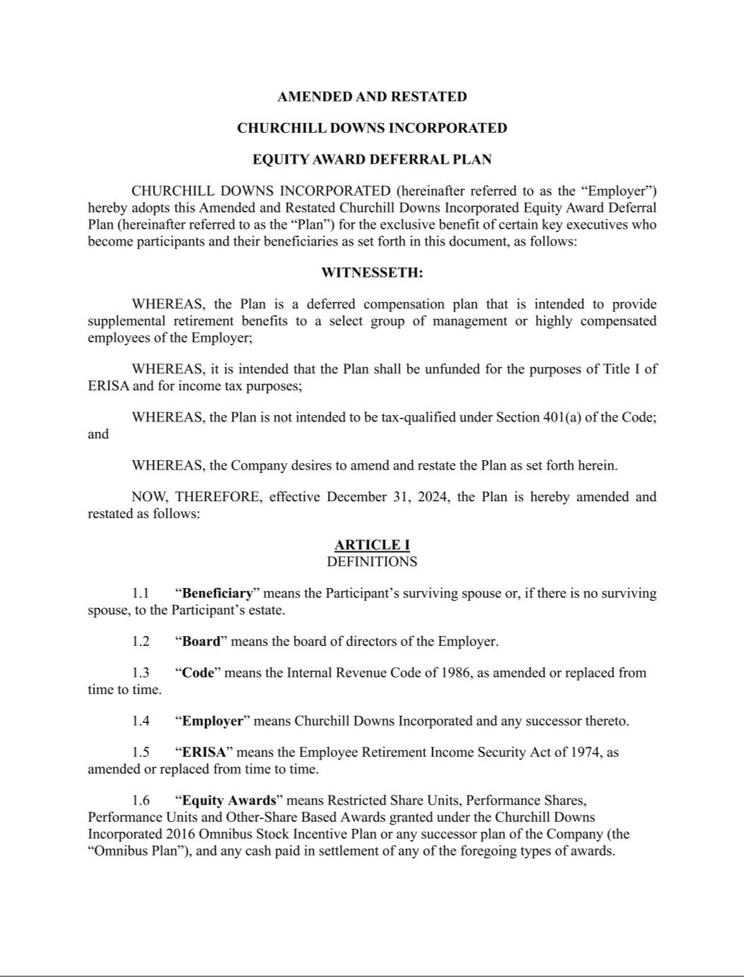

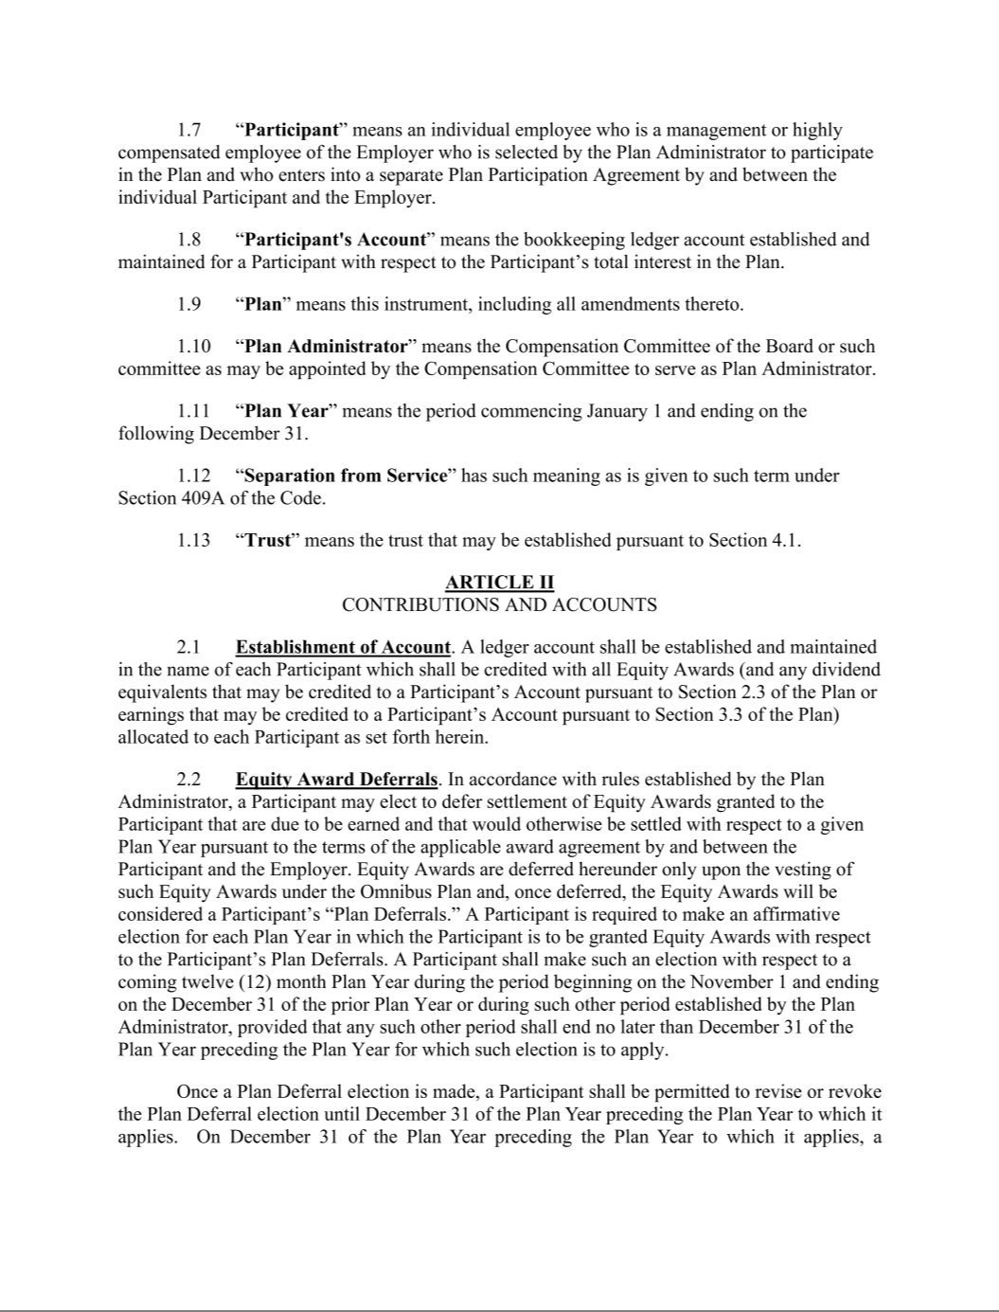

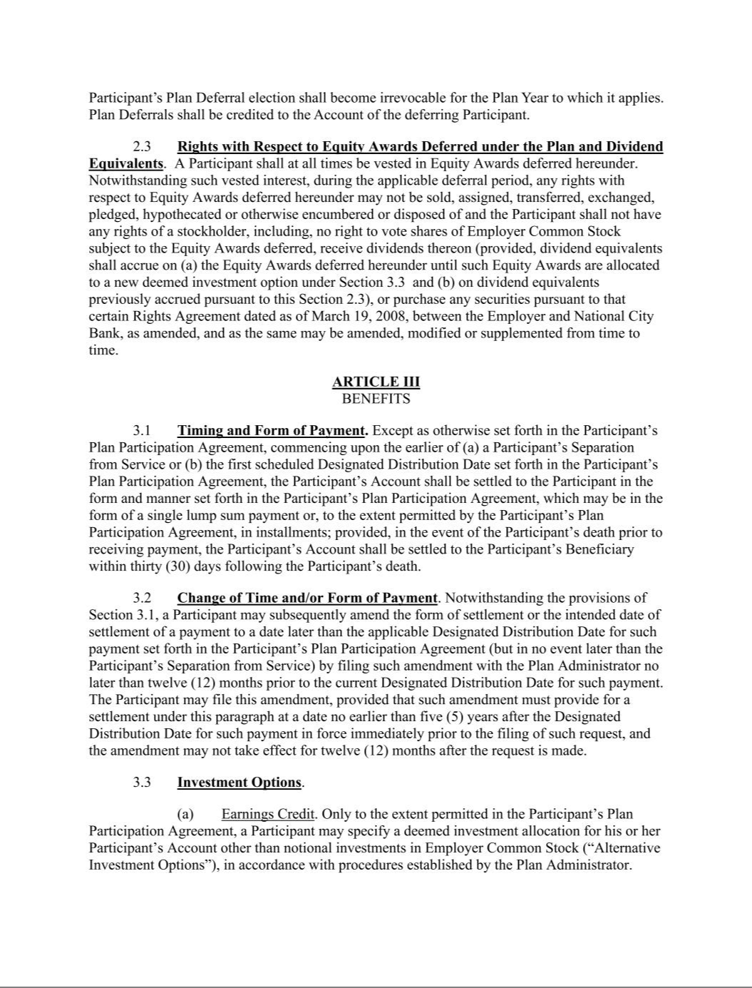

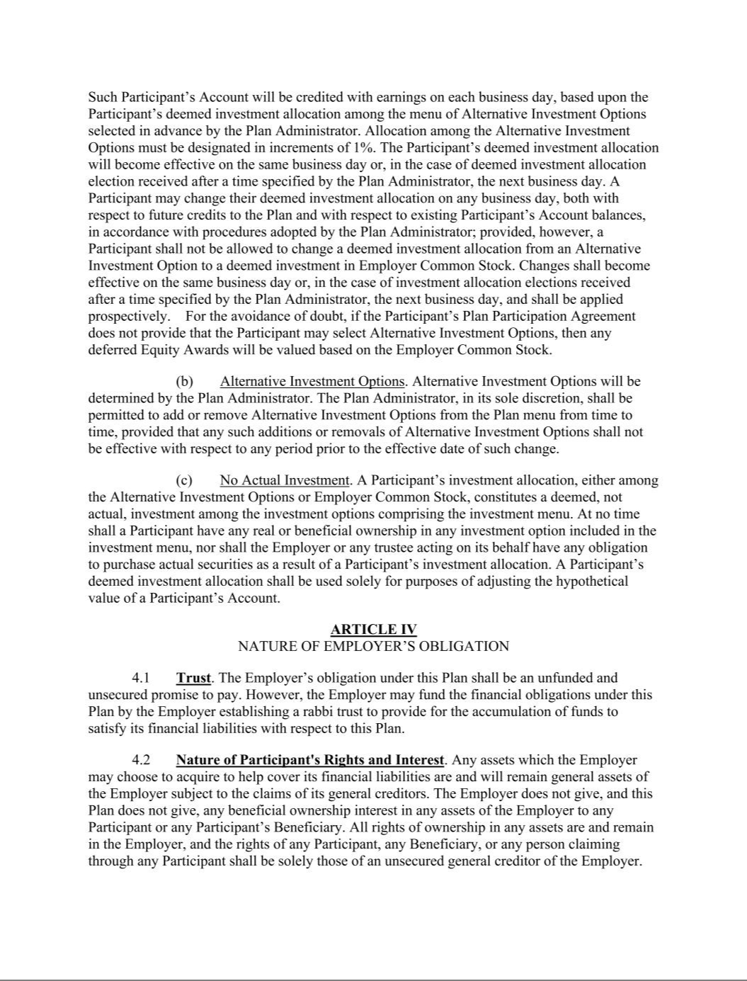

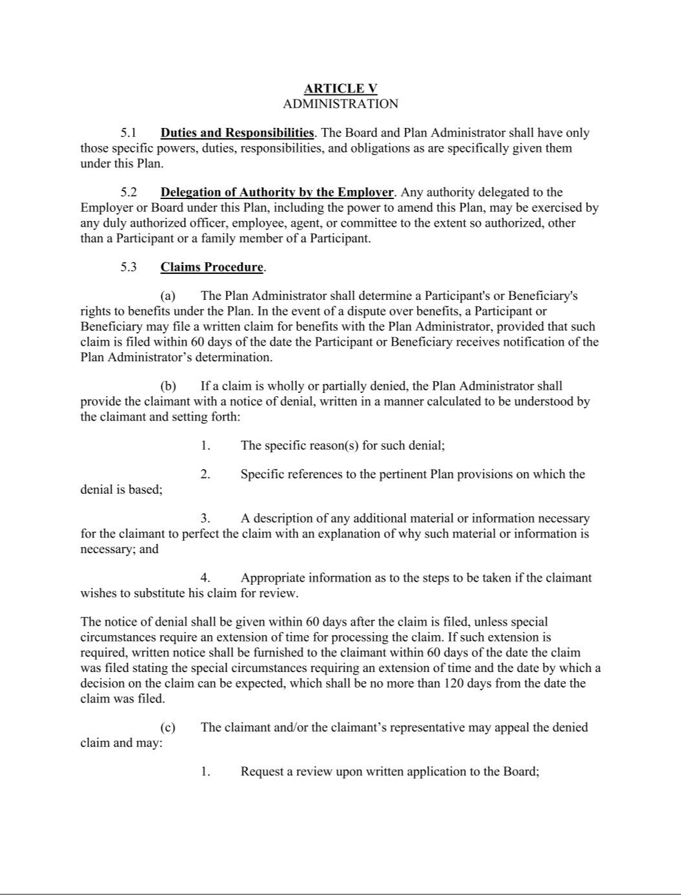

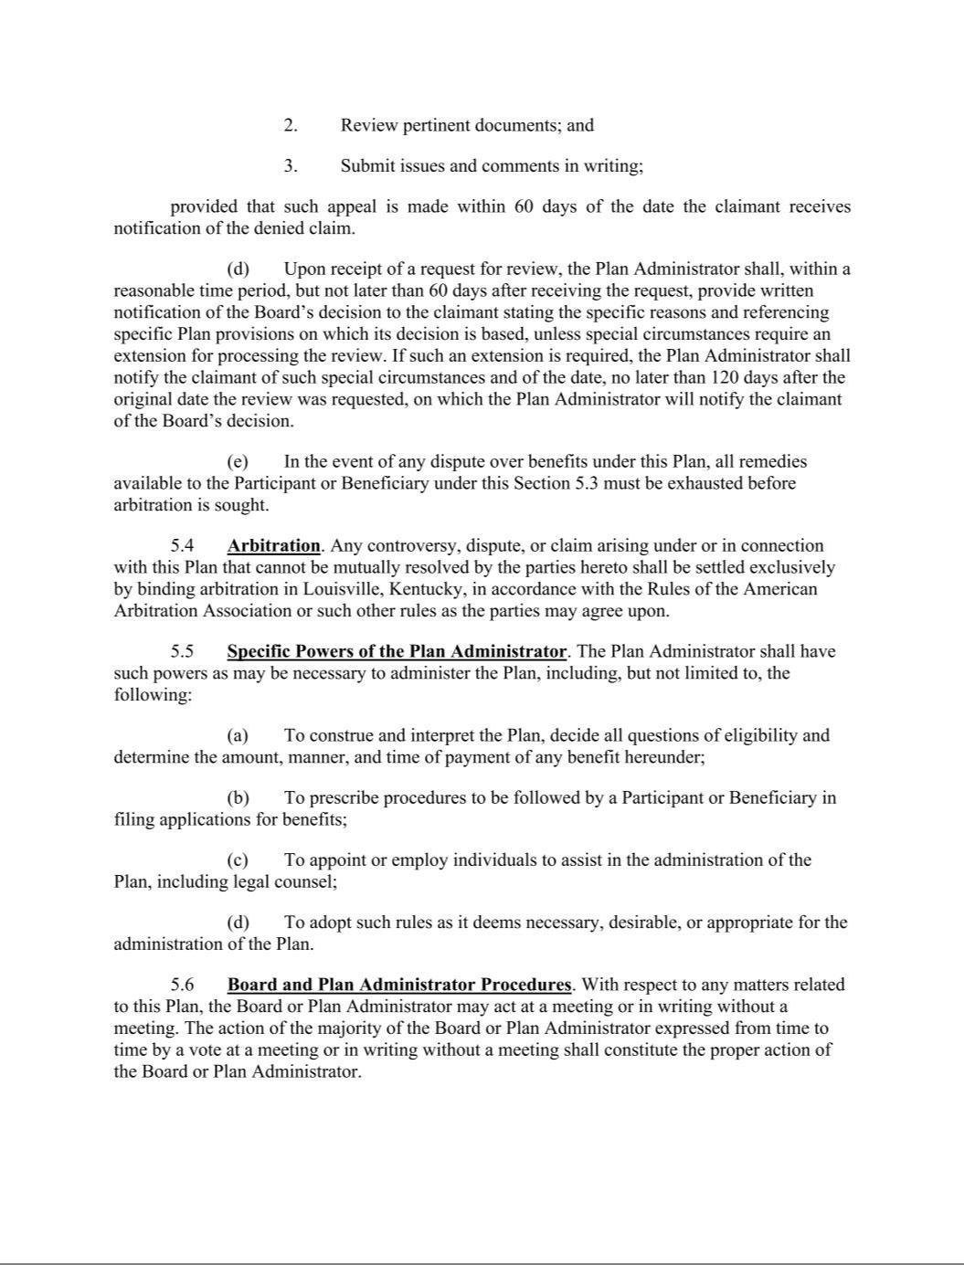

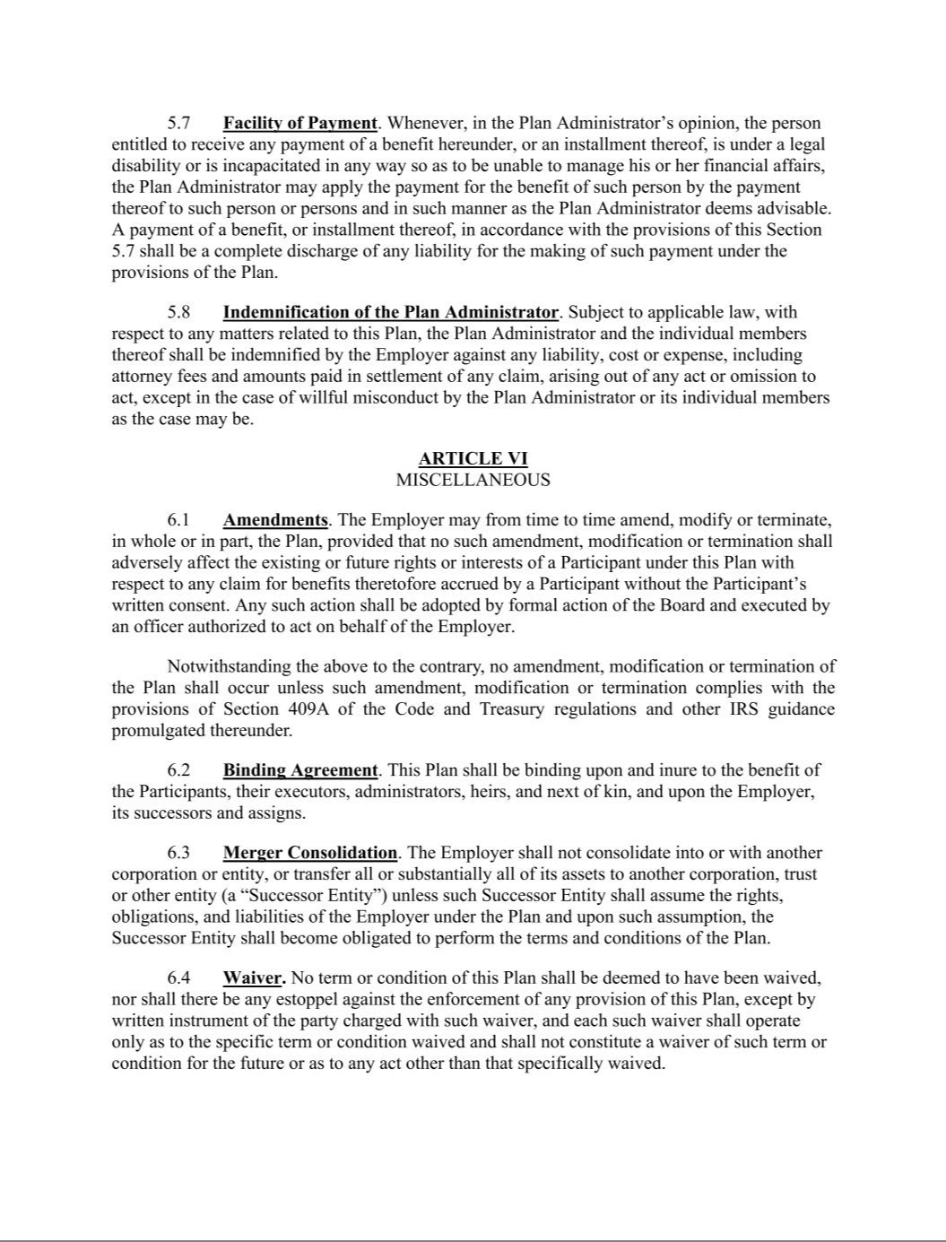

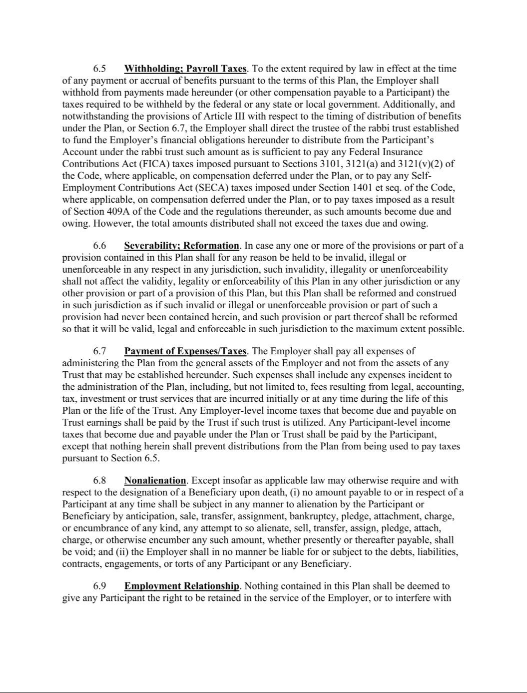

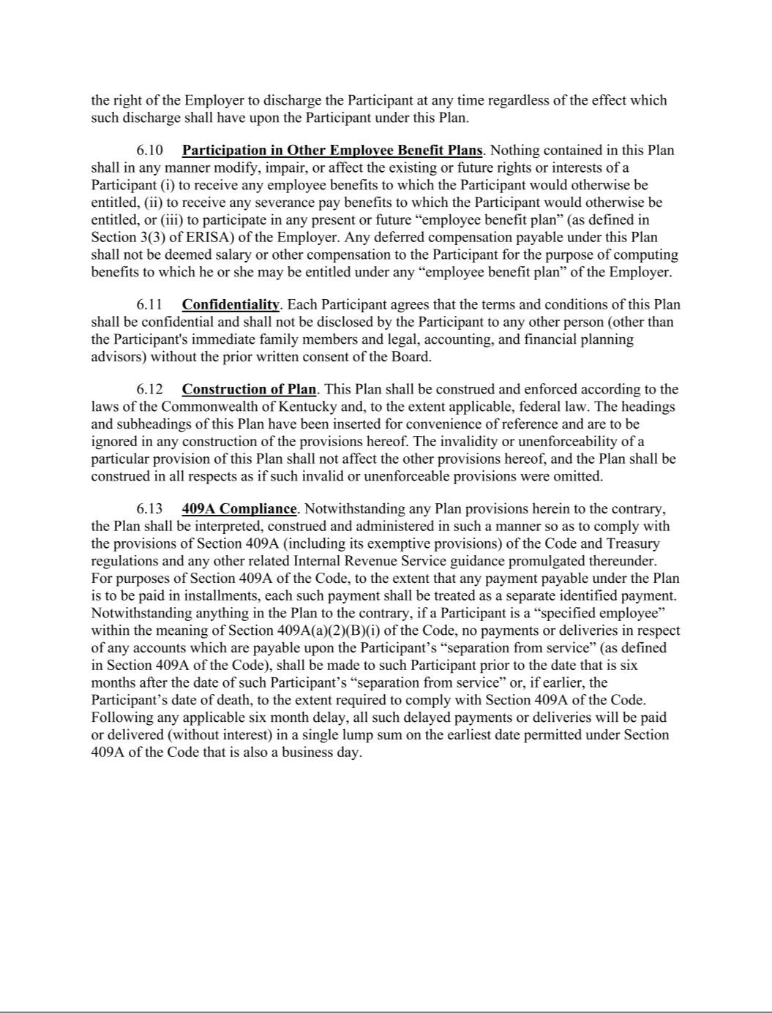

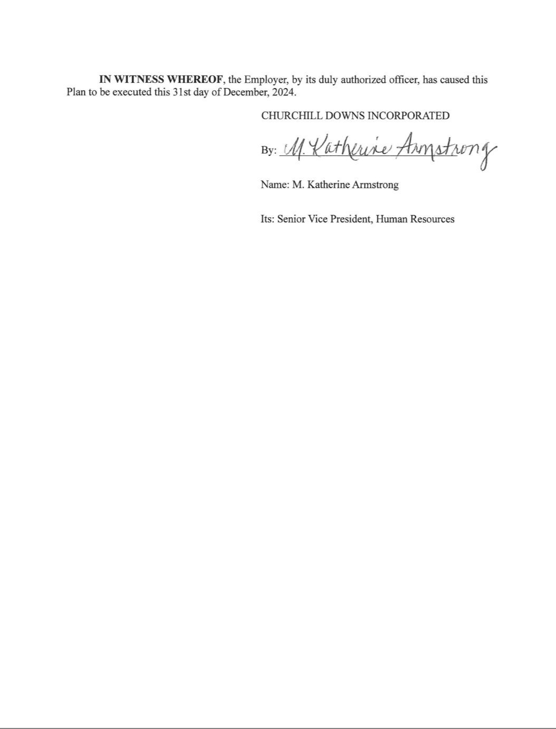

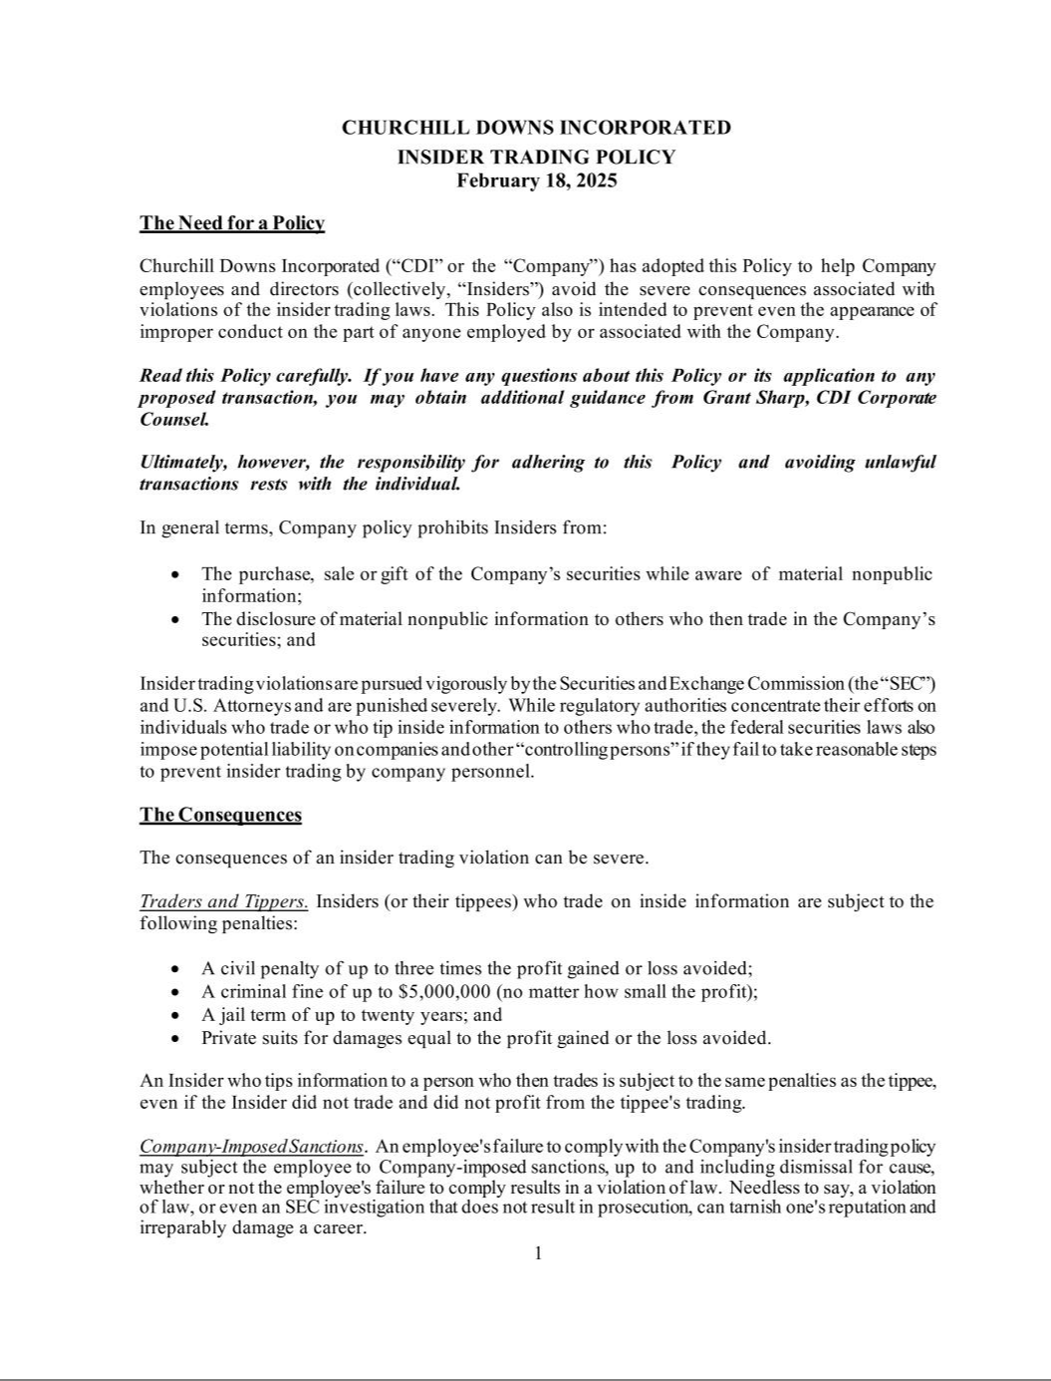

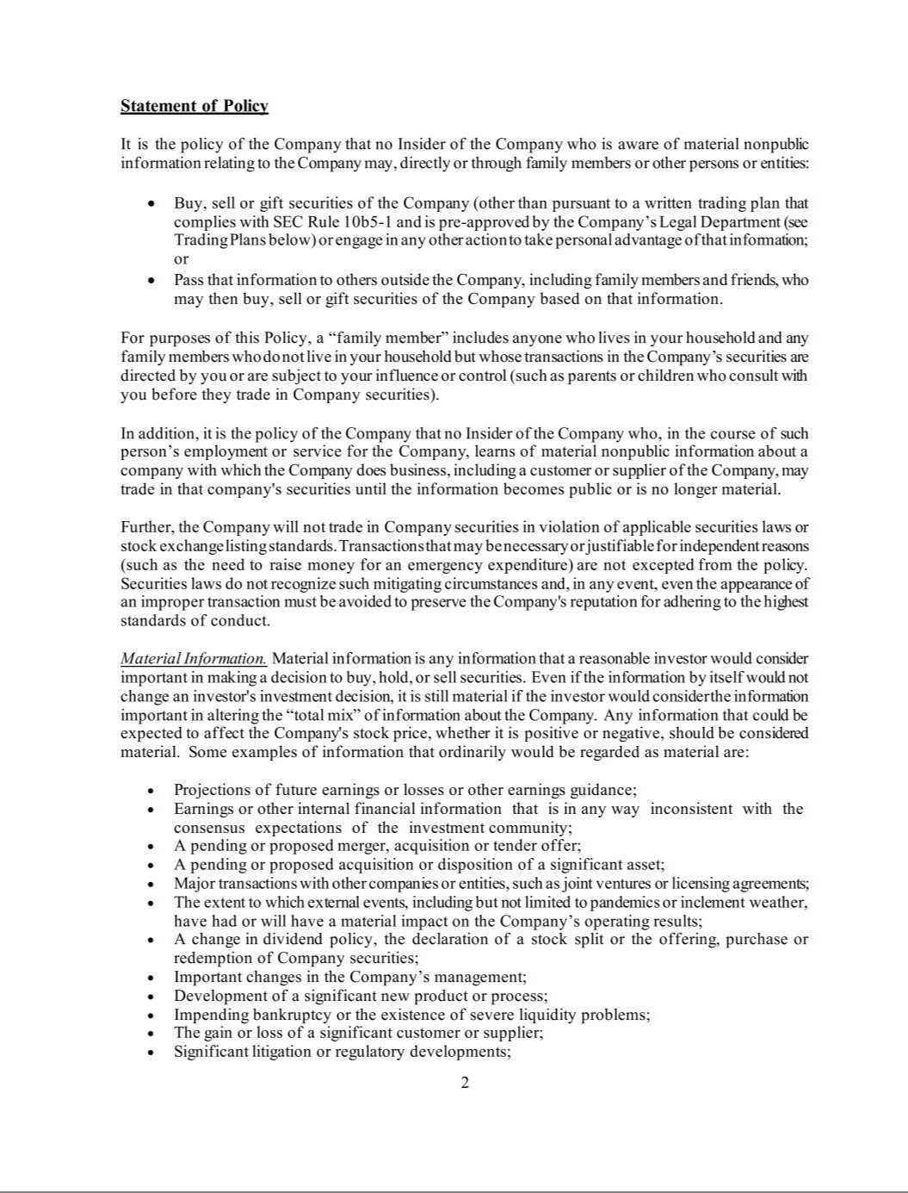

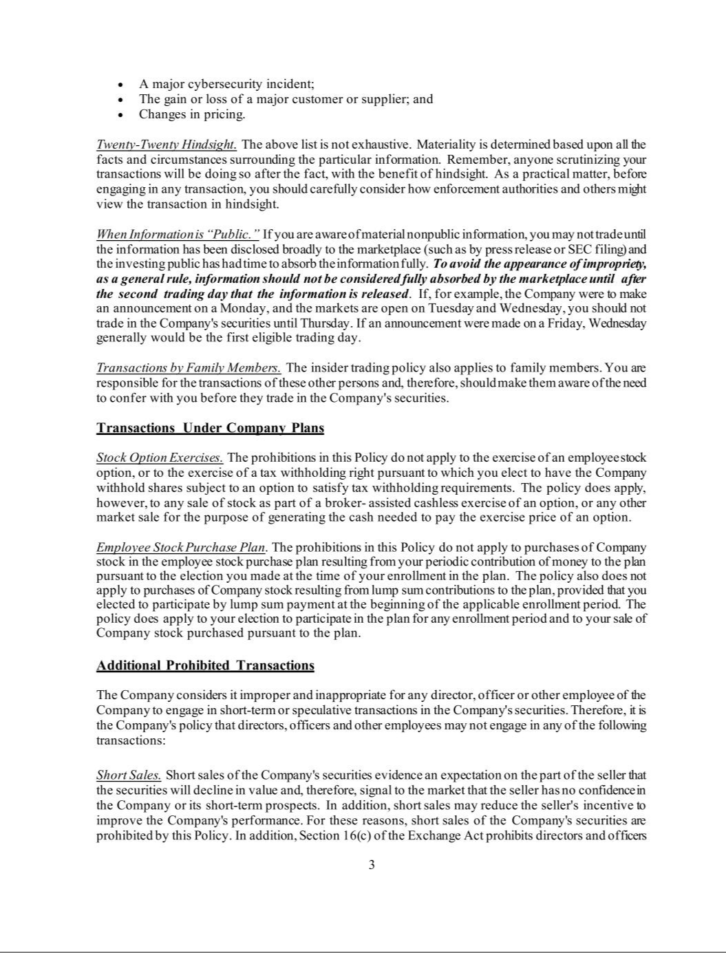

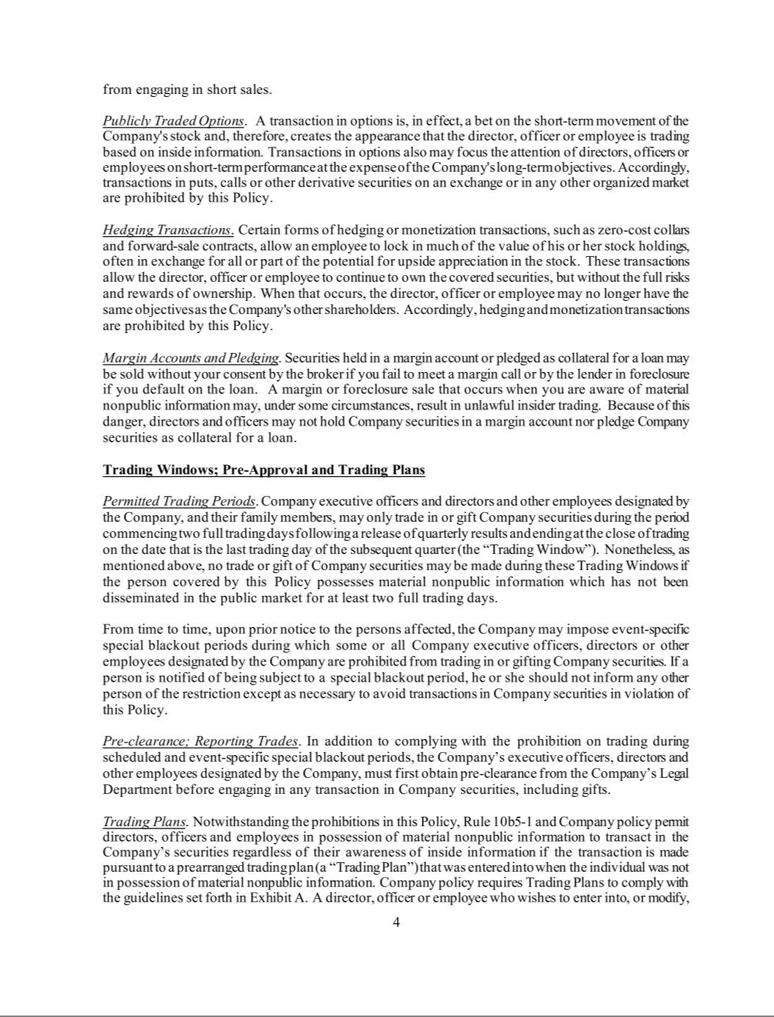

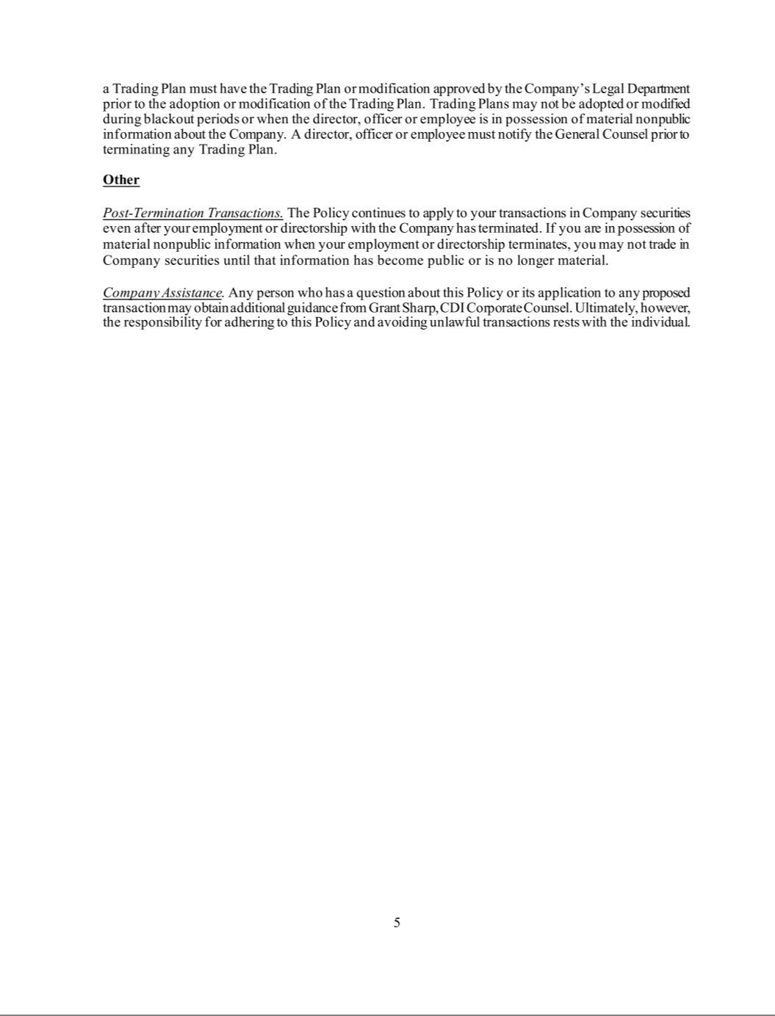

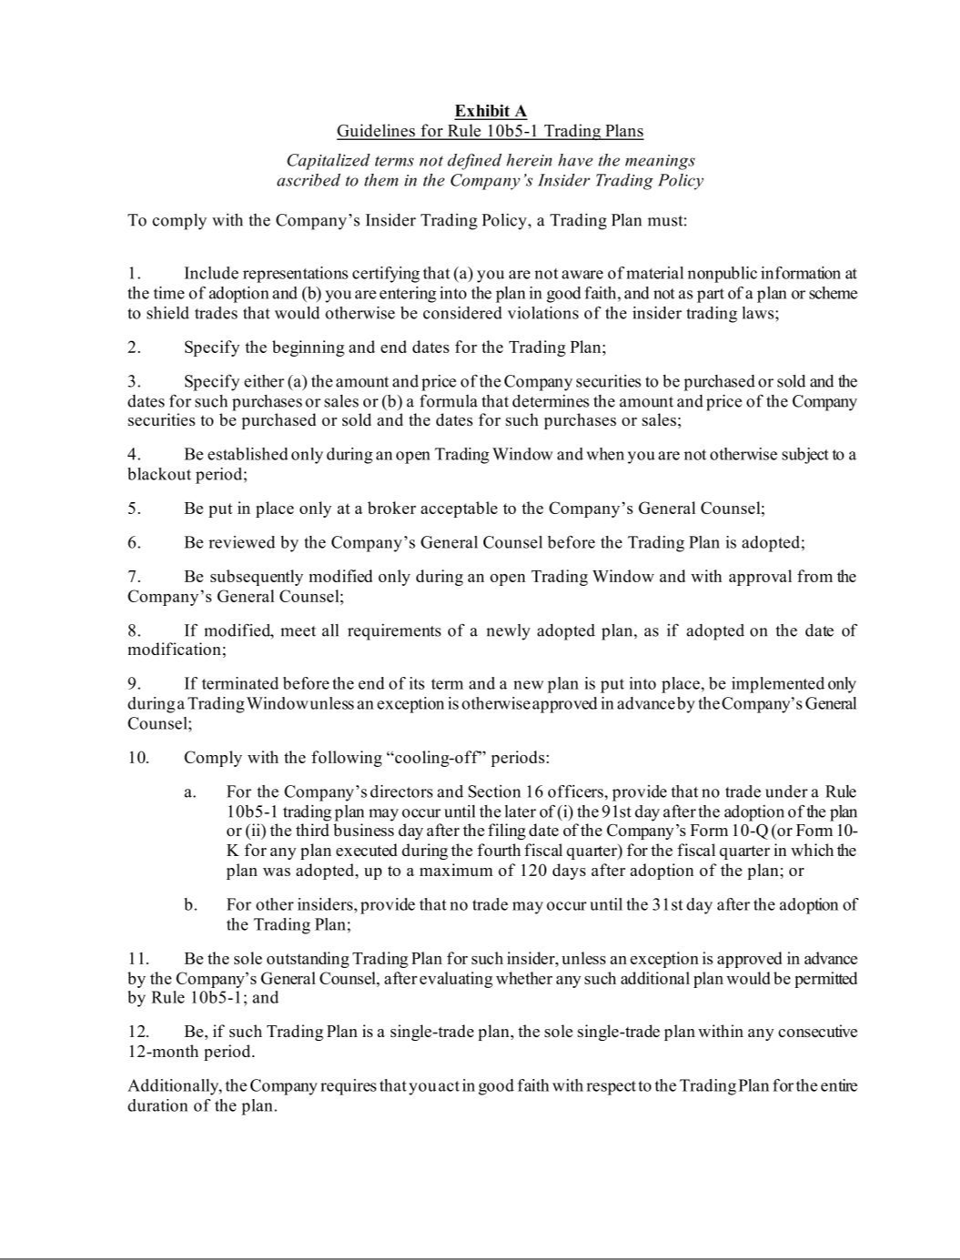

 |  | Exhibit 21
SUBSIDIARIES OF THE REGISTRANT
December 31, 2024
Subsidiary |  | State/Jurisdiction of
Subsidiary |  | Incorporation/Organization
Arlington Park Racecourse, LLC |  | Illinois
BB Development, LLC d/b/a Oxford Casino |  | Maine
BetAmerica LLC |  | Delaware
CCRG, LLC |  | Kentucky
CDIHC, LLC |  | Delaware
CDITH, LLC |  | Delaware
CEP IV Chicago Holdco LLC |  | Delaware
Calder Race Course, Inc., d/b/a Calder Casino and Race Course |  | Florida
Churchill Downs Insurance Company, LLC |  | Kentucky
Churchill Downs Interactive Canada Ltd. |  | British Columbia
Churchill Downs Interactive Gaming, LLC |  | Delaware
Churchill Downs Louisiana Horseracing Company, L.L.C. d/b/a Fair Grounds Race Course & Slots |  | Louisiana
Churchill Downs Louisiana Video Poker Company, L.L.C. |  | Louisiana
Churchill Downs Management Company, LLC |  | Kentucky
Churchill Downs Racetrack, LLC |  | Kentucky
Churchill Downs Technology Initiatives Company d/b/a TwinSpires.com |  | Delaware
Colonial Downs Group, LLC |  | Delaware
DCGD, LLC |  | Delaware
Derby City Gaming, LLC |  | Kentucky
Derby City Gaming Downtown, LLC |  | Kentucky
Ellis Entertainment, LLC |  | Kentucky
Exacta Systems, LLC |  | Indiana
Exacta Services, Inc |  | Delaware
HCRH, LLC |  | Delaware
KYCR Holdings, LLC |  | Delaware
Kymalimi, LLC |  | New Hampshire
Lago Resort & Casino LLC |  | Delaware
Magnolia Hill, LLC d/b/a Riverwalk Casino Hotel, LLC |  | Delaware
Miami Valley Gaming & Racing, LLC |  | Delaware
Midwest Gaming Holdings, LLC |  | Delaware
Midwest Gaming & Entertainment, LLC |  | Delaware
MVGR, LLC |  | Delaware
NKYRG, LLC |  | Delaware
Ocean Downs LLC |  | Maryland
Ocean Downs Enterprise 589 LLC |  | Maryland
Old Bay Gaming and Racing, LLC |  | Delaware
Owensboro Racing & Gaming, LLC |  | Kentucky
PID, LLC d/b/a Presque Isle Downs & Casino |  | Pennsylvania
Quad City Downs Inc |  | Iowa
Racing Services, LLC |  | Maryland
SCE Partners, LLC |  | Iowa

Exhibit 21

SW Gaming, LLC d/b/a Harlow's Casino Resort & Spa | Mississippi
Tropical Park, LLC | Florida
Turfway Park, LLC | Delaware
United Tote Canada, Inc. | Ontario
United Tote Company | Montana
United Tote Gaming Services, LLC | Kentucky
Video Services, L.L.C. | Louisiana
WKY Development, LLC | Delaware
Youbet.com, LLC | Delaware

Exhibit 23

CONSENT OF INDEPENDENT REGISTERED PUBLIC ACCOUNTING FIRM

We hereby consent to the incorporation by reference in the Registration Statements on Form S-8 (Nos. 333-210943, 333-197102, 333-182929, 333-182928, 333-144192, 333-144191, 333-144182, 333-135360, 333-127057, 333-116734, 333-116733, 333-106310, 333-100574, 333-43486, 333-41376, 333-62013, 033-61111) of Churchill Downs Incorporated of our report dated February 19, 2025 relating to the financial statements, financial statement schedule and the effectiveness of internal control over financial reporting, which appears in this Form 10-K.

/s/ PricewaterhouseCoopers LLP

Louisville, Kentucky

February 19, 2025

EXHIBIT 31(a)

CERTIFICATION OF CHIEF EXECUTIVE OFFICER

I, William C. Carstanjen, certify that:

- I have reviewed this Annual Report on Form 10-K of Churchill Downs Incorporated;

- Based on my knowledge, this report does not contain any untrue statement of a material fact or omit to state a material fact necessary to make the statements made, in light of the circumstances under which such statements were made, not misleading with respect to the period covered by this report;

- Based on my knowledge, the financial statements, and other financial information included in this report, fairly present in all material respects the financial condition, results of operations and cash flows of the registrant as of, and for, the periods presented in this report;

- The registrant’s other certifying officer(s) and I are responsible for establishing and maintaining disclosure controls and procedures (as defined in Exchange Act Rules 13a-15(e) and 15d-15(e)) and internal control over financial reporting (as defined in Exchange Act Rules 13a-15(f) and 15d-15(f)) for the registrant and have:

  - Designed such disclosure controls and procedures, or caused such disclosure controls and procedures to be designed under our supervision, to ensure that material information relating to the registrant, including its consolidated subsidiaries, is made known to us by others within those entities, particularly during the period in which this report is being prepared;

  - Designed such internal control over financial reporting, or caused such internal control over financial reporting to be designed under our supervision, to provide reasonable assurance regarding the reliability of financial reporting and the preparation of financial statements for external purposes in accordance with generally accepted accounting principles;

  - Evaluated the effectiveness of the registrant’s disclosure controls and procedures and presented in this report our conclusions about the effectiveness of the disclosure controls and procedures, as of the end of the period covered by this report based on such evaluation; and

  - Disclosed in this report any change in the registrant’s internal control over financial reporting that occurred during the registrant’s most recent fiscal quarter (the registrant’s fourth fiscal quarter in the case of an annual report) that has materially affected, or is reasonably likely to materially affect, the registrant’s internal control over financial reporting; and

- The registrant’s other certifying officer(s) and I have disclosed, based on our most recent evaluation of internal control over financial reporting, to the registrant’s auditors and the audit committee of the registrant’s board of directors (or persons performing the equivalent functions):

  - All significant deficiencies and material weaknesses in the design or operation of internal control over financial reporting which are reasonably likely to adversely affect the registrant’s ability to record, process, summarize and report financial information; and

  - Any fraud, whether or not material, that involves management or other employees who have a significant role in the registrant’s internal control over financial reporting.

Date: February 19, 2025 /s/ William C. Carstanjen

William C. Carstanjen
Chief Executive Officer
(Principal Executive Officer)

EXHIBIT 31(b)

CERTIFICATION OF PRINCIPAL FINANCIAL OFFICER

I, Marcia A. Dall, certify that:

- I have reviewed this Annual Report on Form 10-K of Churchill Downs Incorporated;

- Based on my knowledge, this report does not contain any untrue statement of a material fact or omit to state a material fact necessary to make the statements made, in light of the circumstances under which such statements were made, not misleading with respect to the period covered by this report;

- Based on my knowledge, the financial statements, and other financial information included in this report, fairly present in all material respects the financial condition, results of operations and cash flows of the registrant as of, and for, the periods presented in this report;

- The registrant’s other certifying officer(s) and I are responsible for establishing and maintaining disclosure controls and procedures (as defined in Exchange Act Rules 13a-15(e) and 15d-15(e)) and internal control over financial reporting (as defined in Exchange Act Rules 13a-15(f) and 15d-15(f)) for the registrant and have:

  - Designed such disclosure controls and procedures, or caused such disclosure controls and procedures to be designed under our supervision, to ensure that material information relating to the registrant, including its consolidated subsidiaries, is made known to us by others within those entities, particularly during the period in which this report is being prepared;

  - Designed such internal control over financial reporting, or caused such internal control over financial reporting to be designed under our supervision, to provide reasonable assurance regarding the reliability of financial reporting and the preparation of financial statements for external purposes in accordance with generally accepted accounting principles;

  - Evaluated the effectiveness of the registrant’s disclosure controls and procedures and presented in this report our conclusions about the effectiveness of the disclosure controls and procedures, as of the end of the period covered by this report based on such evaluation; and

  - Disclosed in this report any change in the registrant’s internal control over financial reporting that occurred during the registrant’s most recent fiscal quarter (the registrant’s fourth fiscal quarter in the case of an annual report) that has materially affected, or is reasonably likely to materially affect, the registrant’s internal control over financial reporting; and

- The registrant’s other certifying officer(s) and I have disclosed, based on our most recent evaluation of internal control over financial reporting, to the registrant’s auditors and the audit committee of the registrant’s board of directors (or persons performing the equivalent functions):

  - All significant deficiencies and material weaknesses in the design or operation of internal control over financial reporting which are reasonably likely to adversely affect the registrant’s ability to record, process, summarize and report financial information; and

  - Any fraud, whether or not material, that involves management or other employees who have a significant role in the registrant’s internal control over financial reporting.

Date: February 19, 2025 /s/ Marcia A. Dall

Marcia A. Dall
Executive Vice President and Chief Financial Officer
(Principal Financial & Accounting Officer)

EXHIBIT 32

Certification of Chief Executive Officer and Chief Financial Officer Pursuant to

18 U.S.C. Section 1350,

As Adopted Pursuant to

Section 906 of the Sarbanes-Oxley Act of 2002

In connection with the Annual Report on Form 10-K of Churchill Downs Incorporated (the “Company”) for the year ended December 31, 2024, as filed with the Securities and Exchange Commission on the date hereof (the “Report”), William C. Carstanjen, as Chief Executive Officer (Principal Executive Officer) of the Company, and Marcia A. Dall, as Executive Vice President and Chief Financial Officer (Principal Financial & Accounting Officer) of the Company, each hereby certifies, pursuant to 18 U.S.C. § 1350, as adopted pursuant to § 906 of the Sarbanes-Oxley Act of 2002, to the best of his or her knowledge, that:

- The Report fully complies with the requirements of section 13(a) or 15(d) of the Securities Exchange Act of 1934, as amended; and

- The information contained in the Report fairly presents, in all material respects, the financial condition and results of operations of the Company.

/s/ William C. Carstanjen

William C. Carstanjen
Chief Executive Officer
(Principal Executive Officer)

February 19, 2025

/s/ Marcia A. Dall

Marcia A. Dall
Executive Vice President and Chief Financial Officer
(Principal Financial & Accounting Officer)

February 19, 2025

This certification is being furnished to the Securities and Exchange Commission as an exhibit to the Report and shall not be deemed filed by the Company for purposes of § 18 of the Securities Exchange Act of 1934, as amended.

A signed original of this written statement required by Section 906, or other document authenticating, acknowledging, or otherwise adopting the signature that appears in typed form within the electronic version of this written statement required by Section 906, has been provided to Churchill Downs Incorporated and will be retained by Churchill Downs Incorporated and furnished to the Securities and Exchange Commission or its staff upon request.

